DEEP LEARNING:

Deep learning is a subset of artificial intelligence (AI) and machine learning, has emerged as a powerful tool in transforming the way computers process data and learn from it. It mimics the human brain's ability to learn and make decisions by analysing vast amounts of data. The term "deep" in deep learning refers to the multiple layers of interconnected nodes, known as artificial neural networks. The neural networks can grasp intricate patterns and relationships from extensive datasets.

NEURAL NETWORKS:

Neural networks serve as the cornerstone of deep learning algorithms. These networks are composed of interconnected nodes, or neurons, structured into layers. Each neuron receives input signals, undergoes processing via a mathematical function, and generates an output signal. By stacking multiple layers of neurons, neural networks can progressively learn abstract representations of data.

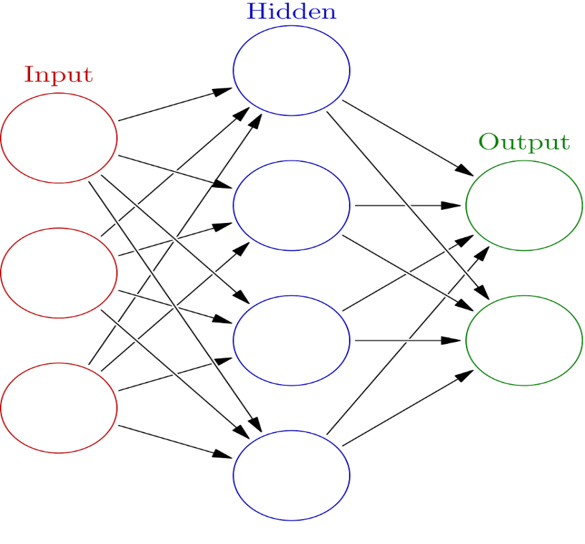

There several types of neural networks commonly employed in deep learning:

Feedforward Neural Networks (FNNs): FNNs facilitate the unidirectional flow of information, from input to output, devoid of any feedback loops. They represent the simplest form of neural networks and find application in tasks such as classification and regression.

Recurrent Neural Networks (RNNs): Engineered to handle sequential data, RNNs maintain a memory or state of previous inputs. This characteristic makes them well-suited for tasks such as speech recognition, language modelling , and time series prediction.

Convolutional Neural Networks (CNNs): Tailored for processing grid-like data, particularly images, CNNs comprise convolutional layers that autonomously learn spatial hierarchies of features. CNNs have revolutionized computer vision tasks, including image classification, object detection, and image segmentation.

Generative Adversarial Networks (GANs):

GANs consist of two neural networks, a generator and a discriminator, engaged in a competitive game. The generator aims to produce realistic data samples, such as images, while the discriminator seeks to distinguish between real and generated samples. Through adversarial training, GANs can generate highly realistic synthetic data, making them valuable for tasks like image generation, data augmentation, and anomaly detection.

Autoencoder Neural Networks:

Autoencoders are neural networks designed for unsupervised learning, aiming to learn efficient representations of input data. They comprise an encoder network that compresses the input data into a latent space representation, followed by a decoder network that reconstructs the original input from the compressed representation. Autoencoders find applications in dimensionality reduction, data denoising, and feature learning.

Long Short-Term Memory Networks (LSTMs):

LSTMs are a variant of recurrent neural networks (RNNs) designed to address the vanishing gradient problem and capture long-term dependencies in sequential data. Unlike traditional RNNs, LSTMs incorporate memory cells and gating mechanisms to selectively retain and forget information over time. LSTMs excel in tasks involving sequential data processing, such as natural language understanding, speech recognition, and time series prediction.

Transformer Networks:

Transformers are a class of neural networks that have gained prominence in natural language processing tasks, particularly since the introduction of the Transformer architecture in the seminal paper "Attention is All You Need." Transformers rely on self-attention mechanisms to capture dependencies between input tokens, enabling parallel processing of input sequences. They have demonstrated state-of-the-art performance in tasks such as language translation, text generation, and document summarization.

Deep neural networks, with their multiple hidden layers, excel at learning complex patterns from data. However, training them presents hurdles like gradient problems, overfitting, and the need for substantial computational resources.

TRAINING DEEP LEARNING MODELS:

Top of Form

Training deep learning models entails optimizing their parameters to minimize a loss function, which gauges the disparity between the model's predictions and the actual labels in the training data. Typically, this involves employing an optimization algorithm like gradient descent, along with backpropagation, a method for efficiently calculating the gradients of the loss function concerning the model's parameters.

Supervised learning is the predominant approach in deep learning, wherein the model learns from labelled data pairs comprising input features and corresponding target labels. Throughout training, the model adjusts its parameters based on observed errors to effectively map input features to output predictions.

To mitigate overfitting, where the model performs well on the training data but struggles with unseen data, various regularization techniques can be utilized. These may include dropout, which randomly deactivates a portion of neurons during training to discourage co-adaptation, as well as L1 or L2 regularization, which penalizes large parameter values to promote simpler models.

Hyperparameter tuning is another crucial aspect of training deep learning models, involving the optimization of parameters that govern the learning process itself, such as the learning rate, batch size, and network architecture. This iterative process often requires experimentation and refinement to achieve optimal performance.

APPLICATIONS OF DEEP LEARNING:

Deep learning's versatility has led to its extensive adoption across various fields, encompassing applications ranging from image and speech recognition to natural language understanding and medical diagnosis.

In computer vision, deep learning models have attained human-level performance, particularly in tasks like image classification, accurately identifying objects from vast categories. Convolutional neural networks, notably, have played a pivotal role in advancing object detection, image segmentation, and facial recognition.

Natural language processing (NLP) is another domain where deep learning has made substantial progress. Models such as recurrent neural networks (RNNs) and transformer architectures like BERT and GPT have transformed tasks like machine translation, sentiment analysis, and text generation, achieving remarkable fluency and coherence.

Speech recognition and synthesis have also benefited from deep learning techniques, powering virtual assistants like Siri and Alexa, as well as dictation systems and voice-controlled devices. Deep neural networks, especially recurrent and convolutional architectures, have enabled highly accurate and robust speech recognition systems.

Beyond these domains, deep learning has found applications in healthcare, finance, autonomous vehicles, and numerous other sectors, underscoring its profound impact on both society and industry.

DEEP LEARNING BENEFITS:

Benefits of deep learning include the following:

* **Automatic feature learning.** Deep learning systems can perform feature extraction automatically, meaning they don't require supervision to add new features.
* **Pattern discovery.** Deep learning systems can analyze large amounts of data and uncover complex patterns in images, text and audio and can derive insights that it might not have been trained on.
* **Processing of volatile data sets.** Deep learning systems can categorize and sort data sets that have large variations in them, such as in transaction and fraud systems.
* **Data types.** Deep learning systems can process both structured and unstructured data.
* **Accuracy.** Any additional node layers used aid in optimizing deep learning models for accuracy.
* **Can do more than other machine learning methods.** When compared to typical machine learning processes, deep learning needs less human intervention and can analyse data that other machine learning processes can't do as well.

DEEP LEARNING ESSENTIALS:

Activation Function

In neural networks, an activation function is a mathematical function applied to the output of each neuron. It introduces non-linearity into the network, enabling it to learn complex patterns and relationships in the data. Without activation functions, a neural network would be limited to representing linear transformations, severely restricting its expressive power.

Types of Activation Functions

Sigmoid: The sigmoid function squashes the output of a neuron to a range between 0 and 1. It is commonly used in binary classification tasks, where the output represents probabilities.

Hyperbolic Tangent (Tanh): Similar to the sigmoid function, but squashes the output to a range between -1 and 1. Tanh is often used in hidden layers of neural networks.

Rectified Linear Unit (ReLU): ReLU sets negative values to zero and leaves positive values unchanged. It has become the default choice for activation functions in most deep learning models due to its simplicity and effectiveness.

Leaky ReLU: A variant of ReLU that allows a small, non-zero gradient for negative inputs. It helps mitigate the issue of "dying ReLU" where neurons stop learning due to consistently zero gradients.

Softmax: Typically used in the output layer of a neural network for multi-class classification tasks. Softmax normalizes the output vector into a probability distribution, making it suitable for selecting the most likely class.

Activation functions play a critical role in determining the capacity and behavior of a neural network. Choosing the appropriate activation function depends on the task at hand and the characteristics of the data.

Loss Function

In machine learning, a loss function, also known as a cost function or objective function, quantifies the difference between the predicted values of a model and the actual ground truth labels. The goal during training is to minimize this loss function, thereby improving the model's performance.

Types of Loss Functions

Mean Squared Error (MSE): Commonly used for regression tasks, MSE calculates the average squared difference between the predicted and actual values. It penalizes large errors more heavily than small errors.

Binary Cross-Entropy: Used for binary classification tasks, binary cross-entropy measures the dissimilarity between two probability distributions—the predicted probabilities and the true labels. It is particularly suited for problems where each instance belongs to one of two classes.

Categorical Cross-Entropy: Similar to binary cross-entropy, but used for multi-class classification tasks. It computes the cross-entropy loss between the predicted class probabilities and the true class labels.

Sparse Categorical Cross-Entropy: A variant of categorical cross-entropy used when the target labels are integers instead of one-hot encoded vectors.

Hinge Loss: Commonly used in support vector machines (SVMs) and for margin-based classification tasks. Hinge loss encourages correct classification by penalizing predictions that fall on the wrong side of the decision boundary.

The choice of loss function depends on the nature of the problem being solved and the output of the model. Selecting an appropriate loss function is crucial for training a neural network effectively.

Optimizer

An optimizer is an algorithm used to adjust the parameters of a neural network during training to minimize the loss function. It determines how the model's weights are updated in response to the calculated gradients of the loss function with respect to the parameters.

Types of Optimizers

Stochastic Gradient Descent (SGD): The classic optimization algorithm used to update model parameters by taking small steps in the direction of the negative gradient of the loss function. SGD is computationally efficient but can struggle with local minima and saddle points.

Adam: A popular adaptive optimization algorithm that combines the advantages of AdaGrad and RMSProp. Adam dynamically adjusts the learning rate for each parameter based on estimates of the first and second moments of the gradients.

Adagrad: Adagrad adapts the learning rate for each parameter based on the historical gradients. It performs well for sparse data but may suffer from diminishing learning rates over time.

RMSProp: RMSProp addresses the diminishing learning rate issue of Adagrad by using a moving average of squared gradients to normalize the learning rate. It is particularly effective for training recurrent neural networks.

AdamW: An extension of Adam that incorporates weight decay regularization to prevent overfitting.

The choice of optimizer can significantly impact the convergence speed and performance of a neural network. Experimentation with different optimizers and learning rates is often necessary to find the optimal configuration for a given task.

Parameters: Parameters are the variables that the model learns from the training data. They represent the internal state of the model and are updated during the training process to minimize the loss function. In a neural network, parameters include the weights and biases of the neurons in each layer.

Hyperparameters: Hyperparameters are configuration settings external to the model that control its learning process. They are typically set before training and remain constant throughout the training process. Examples of hyperparameters include the learning rate, batch size, number of hidden layers, activation functions, and regularization strength.

The key difference between parameters and hyperparameters is that parameters are learned from the data, while hyperparameters are set by the practitioner and guide the learning process. Tuning hyperparameters effectively is crucial for achieving optimal model performance.

TENSORFLOW

Introduction:

Overview: TensorFlow, developed by Google Brain, is a powerful open-source framework for machine learning and deep learning tasks.

Purpose: It facilitates the development, training, and deployment of a wide range of machine learning models.

History and Development by Google Brain:

TensorFlow was initially developed by the Google Brain team and released as an open-source project in 2015. Since then, it has evolved significantly with contributions from developers worldwide.

Key Features and Components:

TensorFlow Core:

Description: Foundational library for numerical computation, providing support for tensors, mathematical operations, and automatic differentiation.

Role: Forms the backbone of TensorFlow's computational graph and execution engine.

TensorFlow Extended (TFX):

Description: Platform for deploying end-to-end machine learning pipelines at scale.

Components: Encompasses data validation, preprocessing, model training, evaluation, and serving.

Purpose: Streamlines the development and deployment of machine learning applications in production environments.

TensorFlow Lite:

Description: Optimized version of TensorFlow for mobile and embedded devices.

Functionality: Enables on-device machine learning inference, allowing models to run efficiently on resource-constrained devices.

TensorFlow.js:

Description: Library for running machine learning models in web and Node.js environments.

Usage: Enables the execution of pre-trained models directly in the browser, expanding the reach of machine learning applications.

Ease of Use and Accessibility

TensorFlow 2.x: Introduces improvements in usability, including eager execution by default and simplified APIs.

Keras Integration: Tight integration with Keras simplifies model development and prototyping.

TensorFlow Playground: Web-based interface for experimenting with neural networks, suitable for beginners and experts alike.

Versatility in Model Development

High-Level APIs:

Keras: Provides a user-friendly interface for building and training neural networks.

Estimators: High-level API for building TensorFlow models, suitable for distributed training and production deployment.

Customization:

Custom Layers and Models: Support for creating custom layers and models to implement specialized functionalities.

Flexibility: Allows researchers and developers to tailor models to specific use cases and requirements.

Scalability and Performance

Distributed Training

Capabilities: TensorFlow's distributed training enables models to be trained across multiple GPUs or devices.

Efficiency: Facilitates efficient scaling for large datasets and complex models.

Model Optimization

Techniques: Support for model optimization techniques, including quantization and pruning.

Purpose: Improves inference performance and reduces model size for deployment on resource-constrained devices.

Deployment and Production Readiness

TensorFlow Serving

Purpose: Tool for deploying trained models in production environments.

Efficiency: Ensures efficient and scalable inference for deployed models.

Model Optimization Toolkit

Functionality: Offers techniques for optimizing models for deployment, such as post-training quantization and pruning.

Role: Streamlines the process of preparing models for efficient inference.

Real-World Applications

Diverse Applications: TensorFlow is widely adopted across industries and domains, including healthcare, finance, automotive, and more.

Examples: Applications range from image and speech recognition to natural language processing, recommendation systems, and reinforcement learning.