**SIGMA WEDGE**

**Introduction:**

The objective of this report is to outline the process of analyzing and optimizing a trading strategy using price data for Apple stock (sid='AAPL') obtained from Quantrocket. The analysis involves preprocessing the data, identifying outliers, classifying market states, developing a simplistic value function, calculating maximum portfolio values, constructing a transition probability matrix, determining optimal buy points, optimizing the portfolio, and forecasting the price of the next 20 days.

**Preprocessing:**

The first step is to ensure the ability to pull price data, specifically daily close prices, for Apple stock (sid='AAPL'). Once the data is obtained, preprocessing techniques are applied to clean and prepare it for analysis.

**Outliers:**

Outliers in the data are identified and addressed to prevent them from affecting the analysis results.

**State Classification:**

The % returns on each day (r(d)) are calculated using the formula:

r(d) = (p(d) - p(d-1))/p(d-1)

Based on the % returns, each day is classified into one of three states:

Bull (+1) if r(d) >= 0.1

Flat (0) if -0.1 < r(d) < 0.1

Bear (-1) if r(d) <= -0.1

**Simplistic Value Function:**

A simplistic value function is developed to determine the portfolio's value on each trading day based on the state transitions.

**Max Portfolio Values:**

The probability distribution of transitioning from one state to another is calculated to determine the maximum portfolio values.

**Transition Probability Matrix:**

A transition probability matrix is constructed to model the probabilities of transitioning from one market state to another.

**Optimal Buy Points:**

The dates of optimal buy points are identified based on specific criteria defined in the analysis.

**Portfolio Optimization:**

The portfolio is optimized using the identified optimal buy points and other relevant factors.

**Forecasting:**

Finally, a forecast of the price for the next 20 days is generated using the developed trading strategy and analysis results.

**Conclusion:**

This report outlines the process of analyzing and optimizing a trading strategy for Apple stock using Quantrocket data. By following the steps outlined in this report, traders can develop a systematic approach to making informed trading decisions and optimizing their portfolio for maximum returns.

**PLOTS DISPLAYED:**

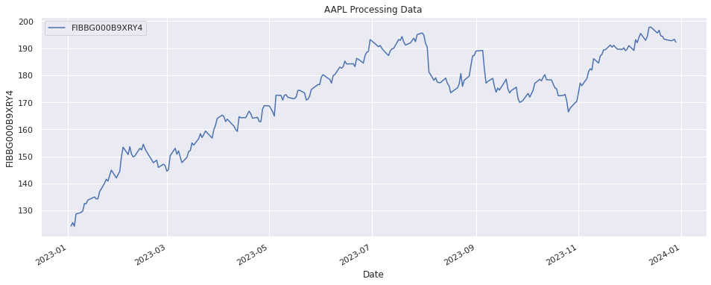

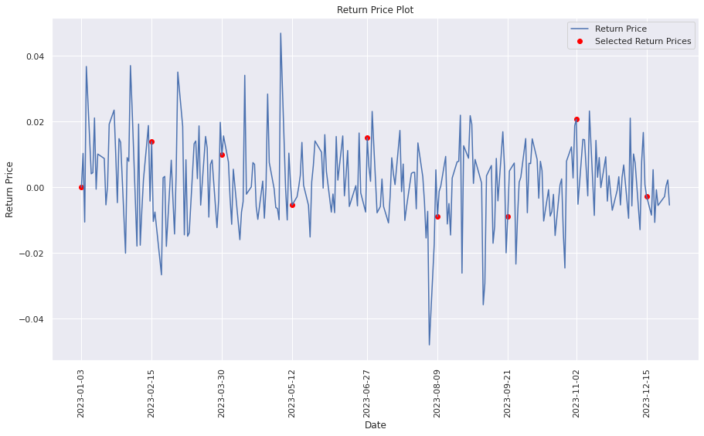

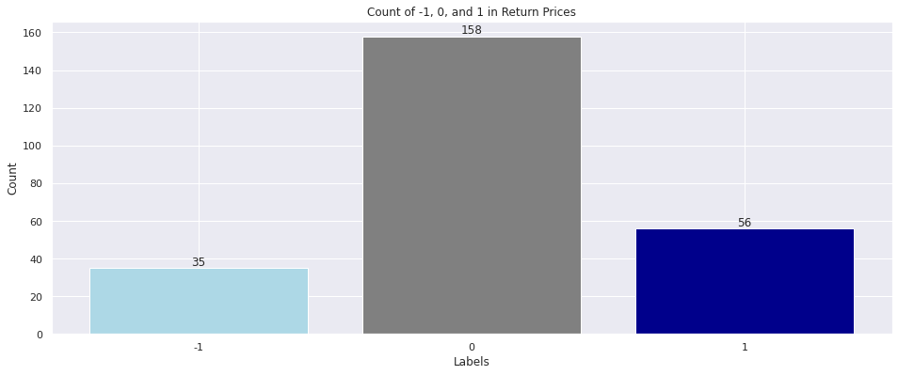

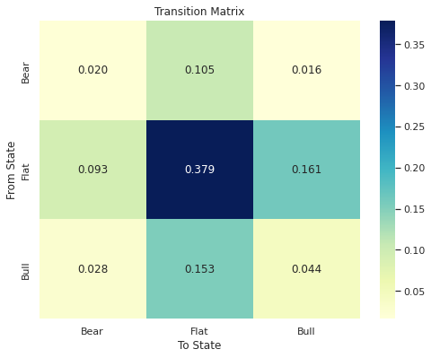

**Outputs**

