Step1) Log into aws management console

Click on “CodeDeploy” from Developer Tools and Click on “Get Started Now”

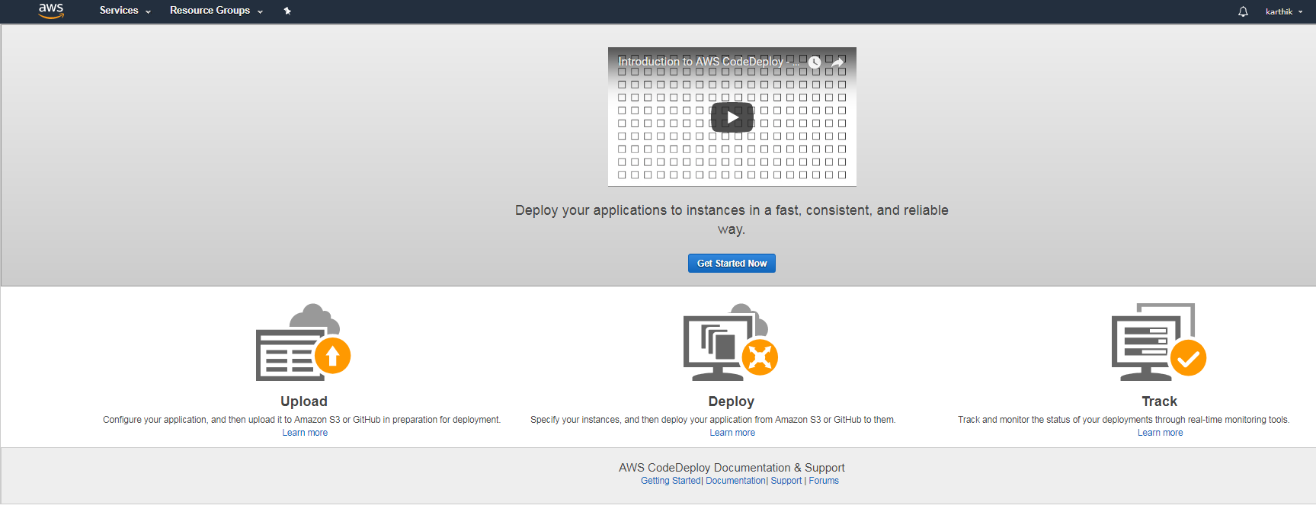

select “Sample Deployment” and click on “Next”

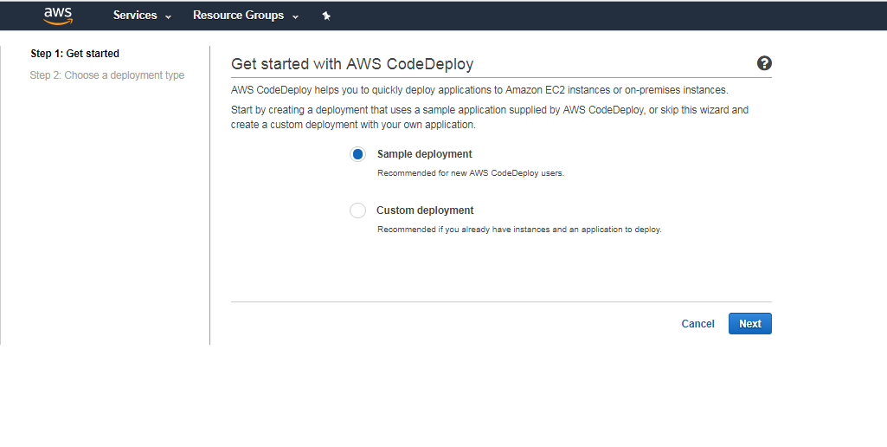

Select “In-place-deployment” and click on “Next”

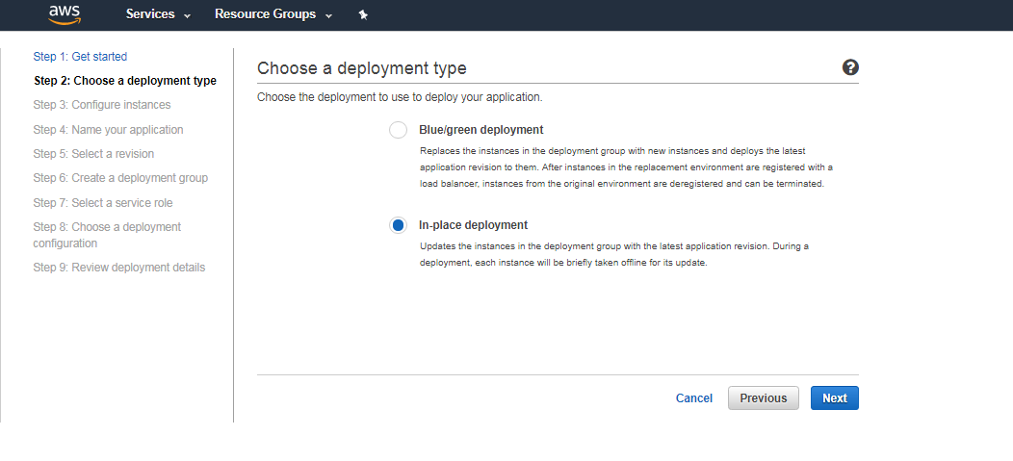

Select “Operating System” and “Instance type and “Keypair name” and click on “Launch instances”

Note: Keep all default values Ex: Tag key and Value

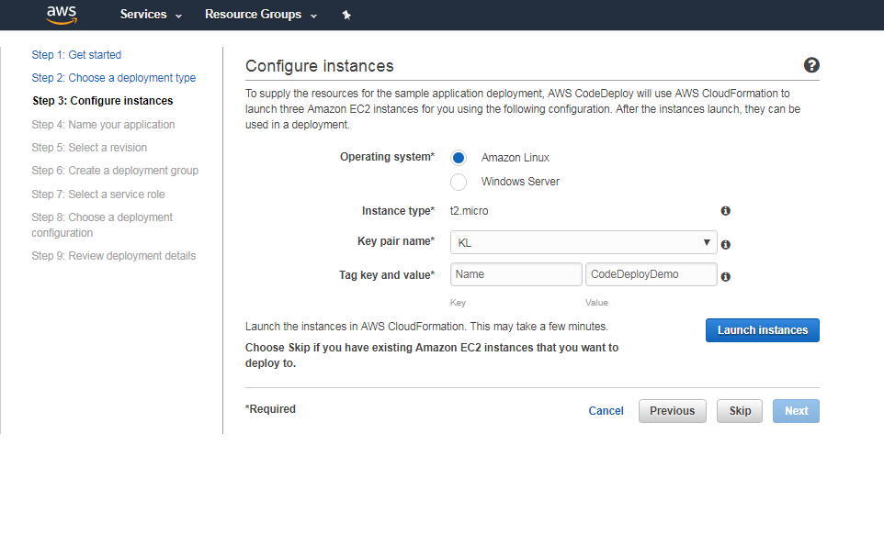

This will launch 3 EC2instances in the Region which you logged in , It takes couple of min to create

Once instances created click on “Next”, Keep Application name “DemoApplication” as default and click “Next”

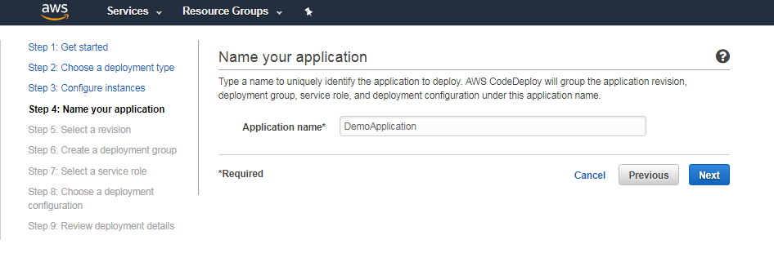

Click on “Next”

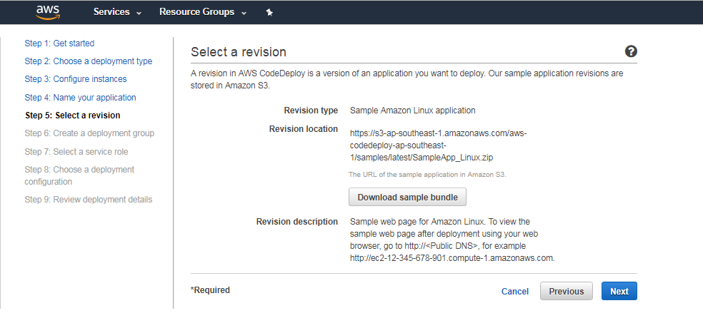

Click on “Next”

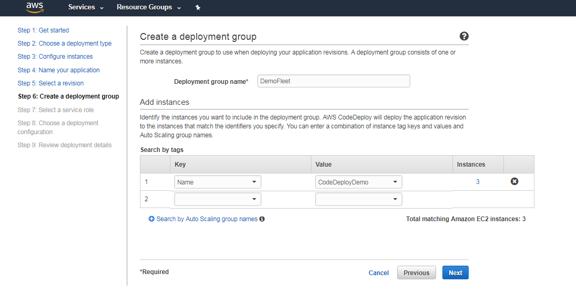

Pick “Create a service role” And Click on “Next”

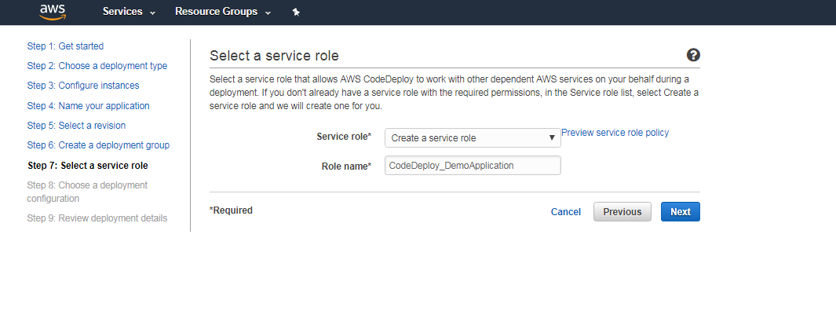

Select “use a default deployment configuration” and click on “Next”

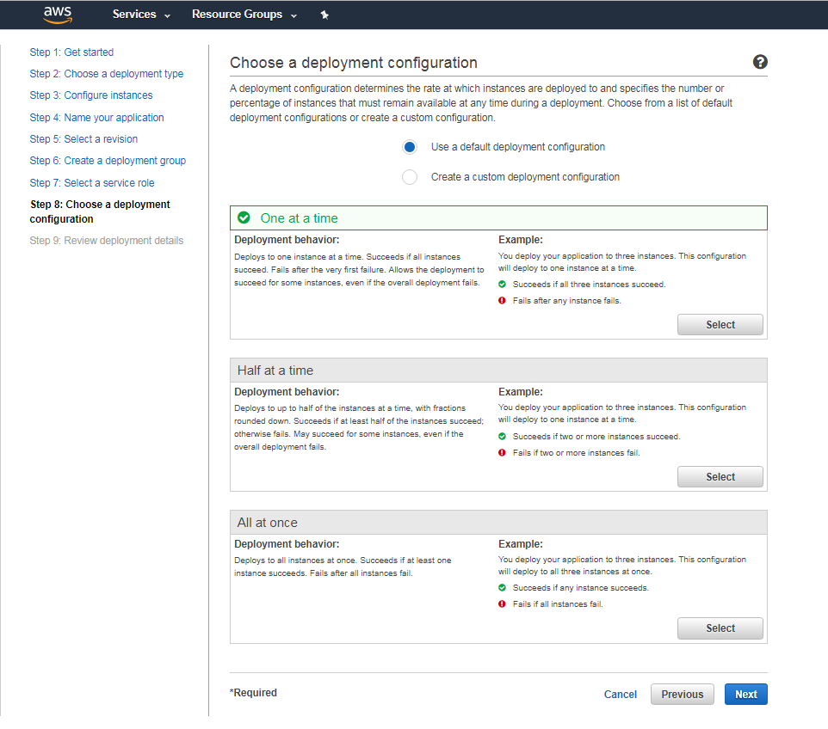

Click on “Deploy”

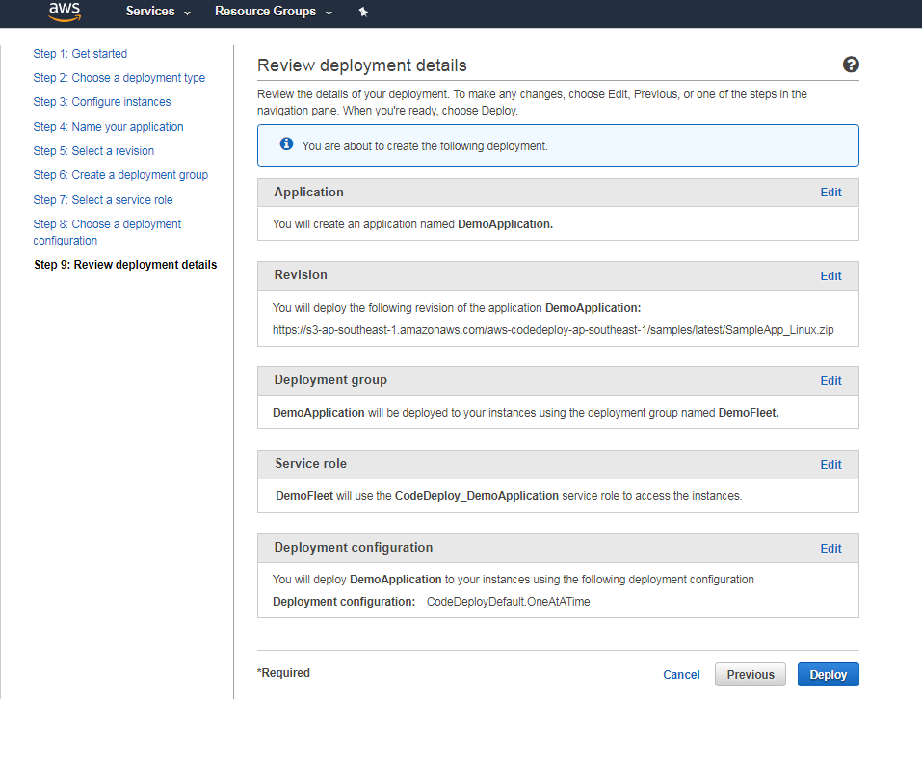

This will deploy your web Application on EC2 Instances you can access that with EC2 Public IP.