Step1)

Login to aws

Step2)click on code build under “Developer Tools” from aws management console

Click on “Create Project”

And fill the details according to your repository created at code commit

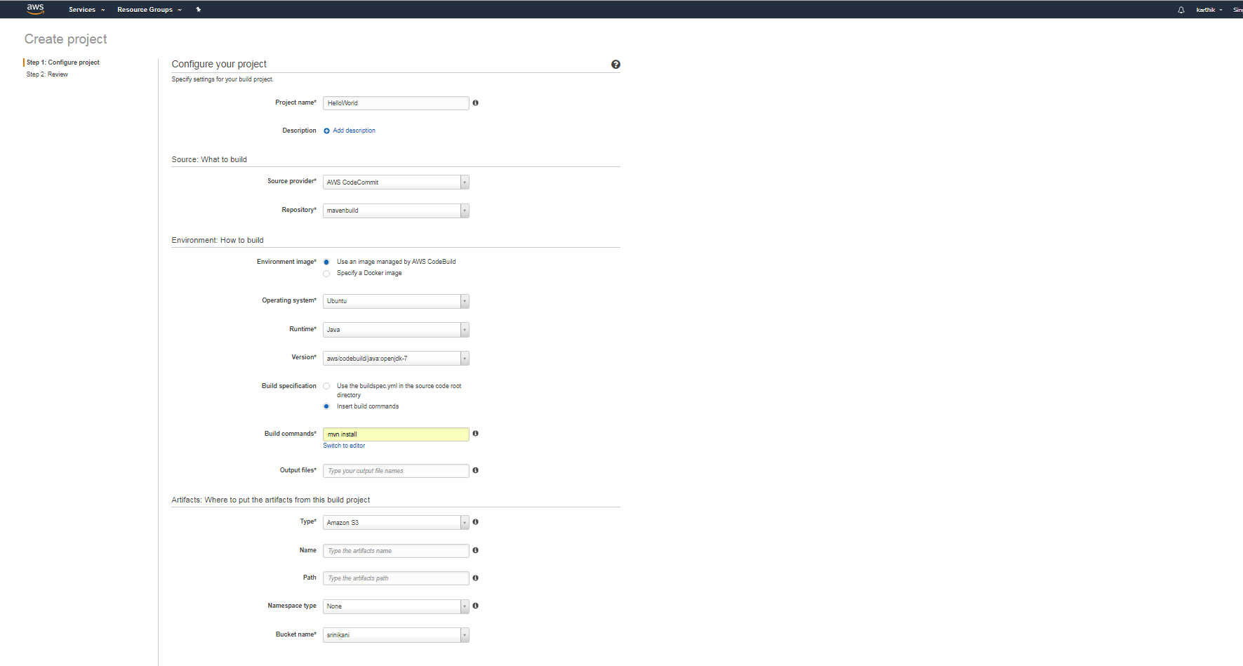

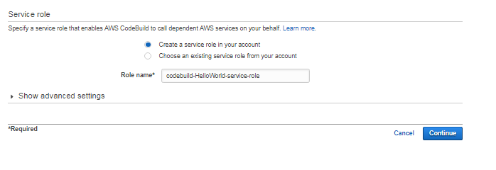

And Click on continue

Note: under output files fill with target/\*.war

After click on continue you would get below screen

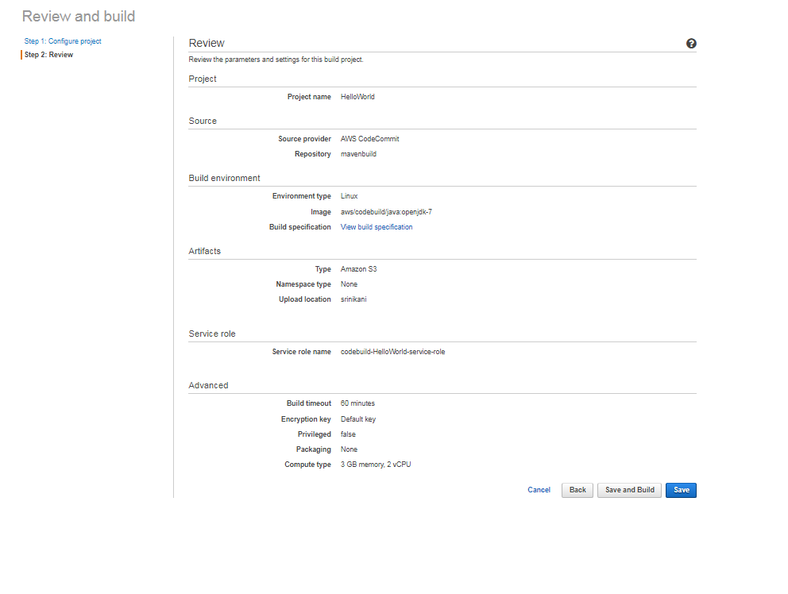

Click on “save and Build” after that select “project name” and “branch” and click on “StartBuild”

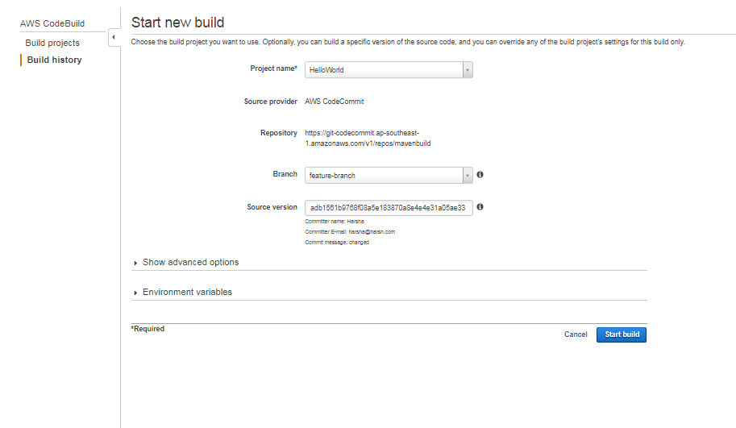

Once build suceeded you would get BuildArtifact (war file) into AWS S3 Bucket.