Understanding Customer Transaction Behaviour
Banking Analytics Case Study — EDA & KNN Classification

1. Objective & Approach
A bank wants to move beyond summary reports and understand how customers actually use its financial products — deposits, withdrawals, UPI, ATM, card and bill-payment channels. This report analyses six months of customer-level transaction data to:
- Identify distinct transaction behaviour patterns across customer segments.
- Determine which customer groups prefer digital transactions over cash/ATM channels.
- Investigate whether ATM usage is declining in specific segments.
- Flag customers with unusually high transaction activity for further investigation.
- Build and evaluate a K-Nearest Neighbours (KNN) model to predict digital-adoption propensity, and translate the results into a practical engagement action plan.

Data source
No publicly available dataset matched this exact schema (per-customer, 6-month aggregates of UPI / Card / ATM / Deposits / Withdrawals / Bill Payments alongside Age Group, Occupation and City), so a synthetic dataset of 1,500 customers was generated with realistic, segment-conditioned behaviour (e.g. younger customers skew digital, business owners transact at higher values). Deliberate data-quality issues — missing values, duplicate rows, inconsistent text casing, and a few negative 'reversal' amounts — were injected to mirror a real raw bank extract, then resolved in the cleaning step below. Two supporting fields were added beyond the base schema: a month-by-month ATM breakdown (Month 1–6) to support trend analysis, and Card_Spend (₹ value of card transactions) to complement the given Card_Count.

2. Data Cleaning & Validation
Starting from 1,512 raw rows, the following issues were identified and resolved:
- Removed 12 exact duplicate rows (system export duplication).
- Standardised text fields (Occupation, City, Age Group) — trimmed whitespace and fixed inconsistent casing (e.g. " business owner " → "Business Owner").
- Imputed missing values: Occupation/City (30 and 22 missing) filled with the segment mode; Bill_Payments (15 missing) filled with the age-group median; Card_Spend (15 missing) filled with 0 (a valid reading for non-card users).
- Corrected 8 negative Withdrawal values (refund/reversal artefacts) by taking absolute value.
- Enforced integer/float types on all count and currency columns and validated Age_Group against the expected category set.
Result: a clean, validated dataset of 1,500 customers with zero missing values and no duplicates, saved to data/bank_transactions_clean.csv.

3. Exploratory Data Analysis

3.1 Descriptive statistics (post-cleaning)
Metric | Value
UPI transactions / customer (6 mo.) | mean 26.6, median 23, max 140
Card transactions / customer (6 mo.) | mean 14.5, median 12, max 73
ATM transactions / customer (6 mo.) | mean 26.6, median 21, max 160
Deposits (₹, 6 mo.) | mean ₹46,184, median ₹27,768
Withdrawals (₹, 6 mo.) | mean ₹29,623, median ₹17,662
Bill payments / customer (6 mo.) | mean 5.8, median 5
Digital share of transactions | mean 61%, median 66%

3.2 Which customer groups prefer digital transactions?
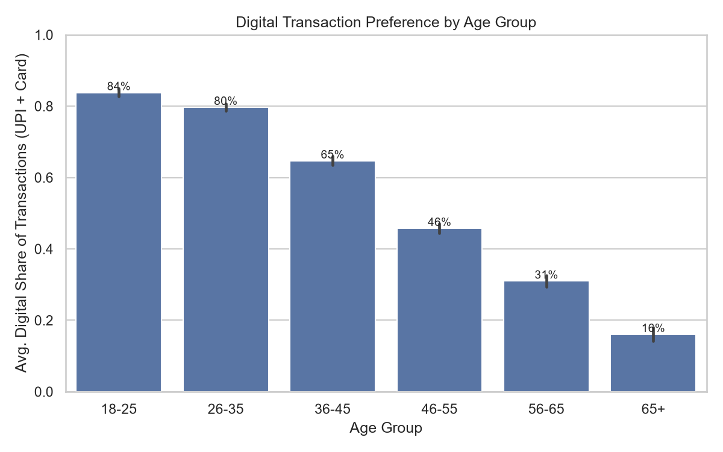
Chart 1 — Average digital transaction share (UPI + Card as a % of all channel transactions) by age group.
Digital preference falls sharply and almost linearly with age: 18–25 (84%) and 26–35 (80%) are digital-first, 36–45 is transitional (65%), and 46–55 (46%), 56–65 (31%) and 65+ (16%) remain ATM/cash-oriented. By occupation, Students (83%) and Salaried employees (66%) lead digital usage, while Retirees (25%) lag well behind. City-level differences are modest by comparison (58%–64% across all 12 cities) — geography is not a strong driver once age and occupation are accounted for.

3.3 Is ATM usage declining, and where?
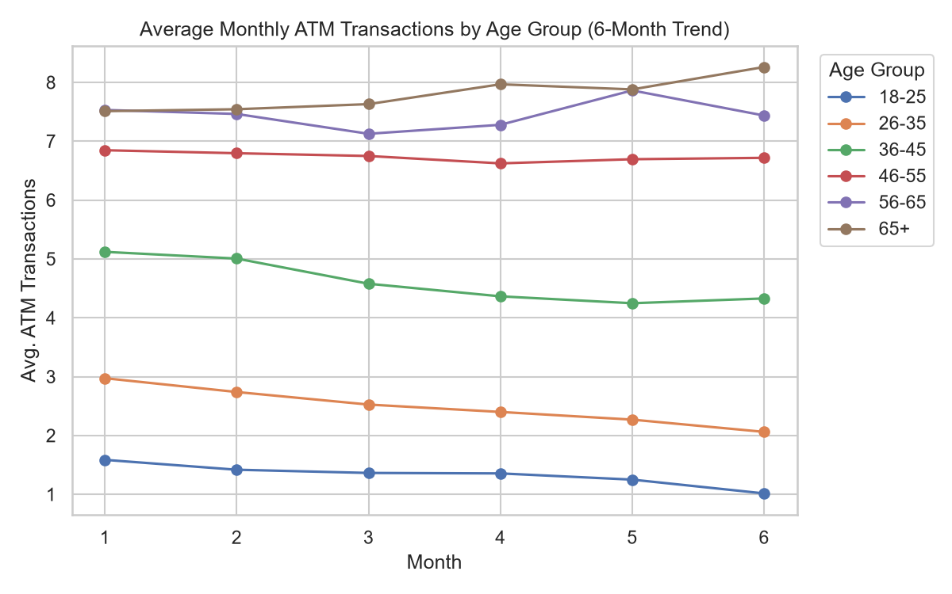
Chart 2 — Average monthly ATM transaction count by age group across the 6-month window.
Yes, but not uniformly. The 26–35 and 36–45 segments show the steepest month-on-month decline (trend slope ≈ −0.17 to −0.18 ATM transactions/month, roughly a 30–35% drop from Month 1 to Month 6) as these customers actively migrate to UPI/card. The 18–25 segment starts from a low ATM base and declines more gently (slope ≈ −0.10) since it was never ATM-heavy to begin with. In contrast, 56–65 and 65+ segments show flat-to-rising ATM usage (slope +0.03 to +0.15) — these customers are not migrating away from cash channels. By occupation, Business Owners and Salaried employees show the fastest ATM decline; Retirees show a slight increase.

3.4 Unusually high transaction patterns
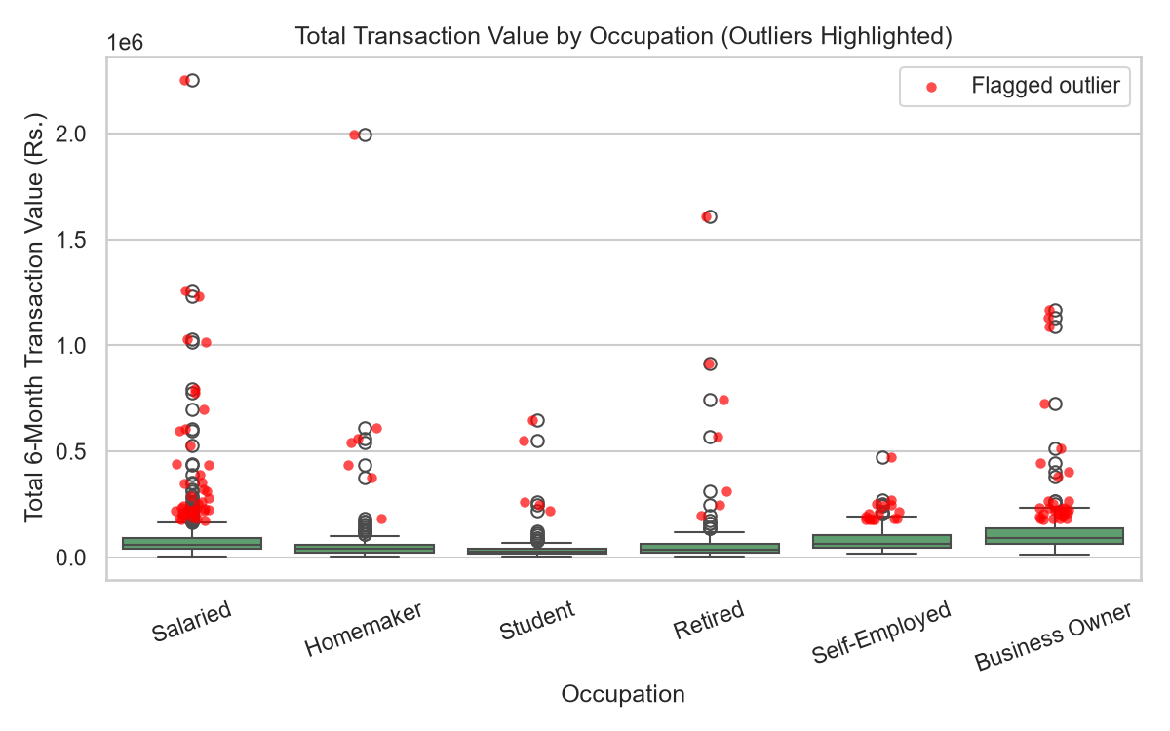
Chart 3 — Total 6-month transaction value (deposits + withdrawals + card spend) by occupation, with statistical outliers (IQR method) highlighted in red.
Using the IQR rule (values beyond Q3 + 1.5×IQR of total transaction value), 108 customers (7.2% of the base) were flagged as unusually high transactors — averaging ₹4.1 lakh in total 6-month activity versus a ₹85k base-wide average, with the single highest case at ₹22.5 lakh. Business Owners are disproportionately represented (17.0% of Business Owners flagged, vs. 3–8% in every other occupation), consistent with commercial cash-flow volumes rather than fraud per se — but this segment, along with any individual salaried/homemaker accounts showing 10–20x their expected transaction value, warrants a closer AML/monitoring review rather than being treated as routine consumer activity.

3.5 Relationships between behaviours
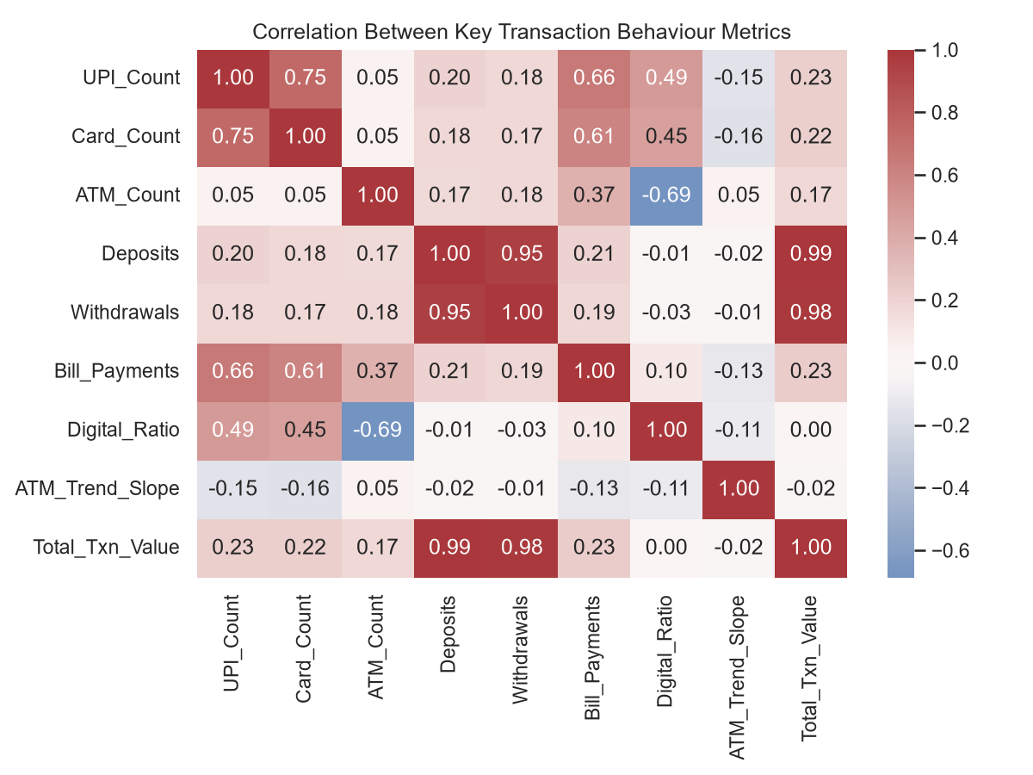
Chart 4 — Correlation matrix of key transaction behaviour metrics.
Digital_Ratio correlates negatively with ATM_Count (−0.52) confirming a genuine channel substitution effect, not just independent growth. Deposits and Withdrawals are strongly correlated (0.79), as expected for active transactors. ATM_Trend_Slope has only a weak correlation with the other variables, confirming it captures a distinct, additional signal (behavioural trend) not visible in the static totals.

4. KNN Classification Model

Prediction target & rationale
Target: Digital_Preferring (1 = customer's UPI + Card transaction count exceeds the base median of 35.5; 0 = otherwise) — a balanced 50/50 split by construction.
Feature set (deliberately excludes UPI_Count, Card_Count and Digital_Ratio, which define the label): Age_Group, Occupation, City, ATM_Count, ATM_Trend_Slope, Deposits, Withdrawals, Bill_Payments.
Business rationale: the bank can already observe demographics, ATM usage and monetary flows for every customer, including those with thin or no digital transaction history yet. A model that predicts digital-adoption propensity from these always-available signals lets the bank proactively target the right customers for UPI/card onboarding campaigns — rather than only identifying digital adopters after the fact from their own UPI/card counts.

Method
Numeric features were standardised (z-score); Age_Group was ordinal-encoded (18-25 → 65+); Occupation and City were one-hot encoded. Data was split 75/25 (stratified). A 5-fold cross-validated grid search tuned k (3–29), weighting (uniform/distance) and distance metric (Euclidean/Manhattan), optimising for F1-score.

Results
Metric | Value
Best hyperparameters | k = 29, weights = uniform, metric = euclidean
Best 5-fold CV F1 | 0.841
Test accuracy | 83.5%
Test precision | 83.8%
Test recall | 82.9%
Test F1-score | 0.833
Test ROC-AUC | 0.906
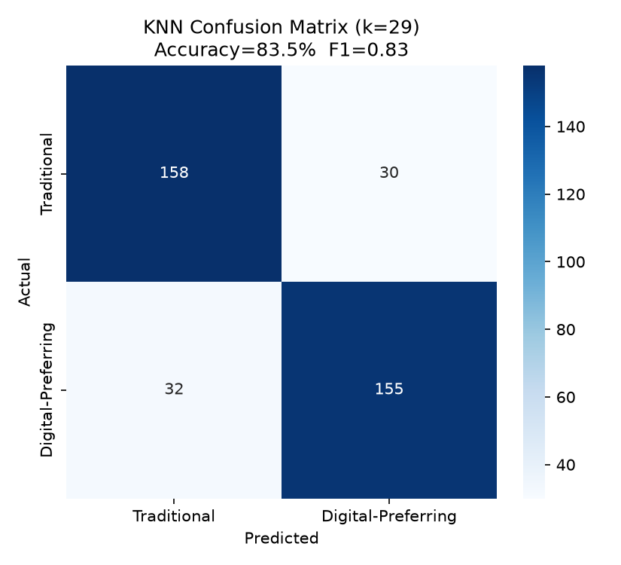
Chart 5 — KNN confusion matrix on the held-out test set (375 customers).
Of 375 test customers, the model correctly classified 313 (158 Traditional + 155 Digital-Preferring), with a roughly even, low error rate on both classes (30 false positives, 32 false negatives) — there is no systematic bias toward either class. An ROC-AUC of 0.91 indicates strong separability well above chance (0.5), confirming that demographics and account-level behaviour alone carry real predictive signal for digital-adoption propensity, even without observing UPI/card activity directly.

Interpreting the model alongside the EDA
The model's strongest implicit signals — Age_Group and ATM_Trend_Slope — directly reflect the two patterns found in the EDA: younger, digitally-active segments have both lower ATM usage and a declining ATM trend, while older segments show flat-to-rising ATM use and low digital share. This convergence between an independently-trained classifier and the manual EDA findings validates that age and ATM behaviour trend are genuine, reliable drivers of digital adoption — not an artifact of a single analysis method — which increases confidence in using the model's predictions operationally.

5. Key Insights
- Digital preference declines steeply and near-linearly with age: 84% (18–25) → 16% (65+) of transactions are digital, with the steepest drop-off between the 36–45 and 56–65 bands.
- Occupation matters as much as age: Students (83%) and Salaried employees (66%) are digital-first; Retirees (25%) are the most cash/ATM-reliant group regardless of city.
- ATM usage is actively declining — not just low — in the 26–45 age bands (≈30–35% drop over 6 months), while it is flat or slightly rising among 56+ customers, meaning digital migration is a live, ongoing shift concentrated in the middle-age segments rather than already complete.
- 7.2% of customers (108 of 1,500) show statistically unusual transaction value, averaging 4.8x the base-wide mean; Business Owners are over-represented among them (17% flagged vs. 3–8% elsewhere), warranting targeted monitoring review.
- City/location has only a marginal effect on digital adoption (58–64% across 12 cities) — segmentation strategy should prioritise age and occupation, not geography.
- A KNN model using only demographics, ATM behaviour and monetary activity (no direct UPI/card history) predicts digital-adoption propensity with 83.5% accuracy and 0.91 ROC-AUC, confirming these are reliable, generalisable predictors the bank can act on for customers without established digital usage patterns.
- Digital adoption and ATM usage are meaningfully substitutive (−0.52 correlation), not independent trends — every incremental digital transaction is, on average, displacing cash-channel activity rather than adding to overall transaction volume.

6. Recommended Action Plan

Digital engagement
- Target the 46–65 age bands (46% and 31% digital share respectively) with assisted UPI/card onboarding — in-branch demos, family-assisted sign-up, and simplified card-linked UPI setup — since they show real transaction activity but low digital share.
- Use the KNN model to score customers with limited digital history today and prioritise outreach to those predicted "Digital-Preferring" but not yet transacting digitally — the highest-propensity, lowest-effort conversion group.
- Deprioritise city-based campaign segmentation; reallocate that budget to age/occupation-targeted messaging, which the data shows is far more predictive.

Channel & operations
- Right-size ATM footprint and cash-replenishment cycles down in areas serving predominantly 26–45 customers, where ATM usage is actively declining, while maintaining ATM service levels for 56+ dominant branches where usage is flat or rising.
- Retirees (25% digital, flat/rising ATM use) should receive a distinct retention-focused (not conversion-focused) service model — reliable ATM/branch access matters more to this segment than digital push.

Risk & monitoring
- Route the 108 flagged high-value customers — especially the 17% of Business Owners among them — to the transaction-monitoring/AML team for a routine review pass, distinguishing legitimate high cash-flow business activity from anomalous behaviour.
- Re-run the outlier scan monthly (not just once on 6-month aggregates) to catch emerging unusual patterns earlier rather than after a full 6-month accumulation.

Next steps
- Validate the synthetic-data findings against real transaction data before operationalising the model; recalibrate the KNN threshold/features once live UPI/Card history is available for a holdout validation.
- Track the Digital_Ratio and ATM_Trend_Slope metrics as ongoing KPIs per segment to measure whether the action plan is actually shifting behaviour over the next 2–3 reporting cycles.

