# E-COMMERCE APP USING CLOUD

# NAME: Kanishka R

# ROLL NO: 720421104025

# COLLEGE: CMS College of Engineering and Technology

# ABSTRACT

Cloud computing affects on different sectors, including: E-learning, health care, and E-commerce. It offers online services in high efficiency and minimal cost which provide a high economic value. It is undoubtedly the next revolution in the Internet world as well as the business world.

Currently, more E-commerce enterprises move to Cloud Computing to achieve high practical value. This paper introduces an overview for Cloud computing in E-commerce through discussing various definitions for both concepts, highlighting the benefits and challenges for applying Cloud Computing in E-commerce, and discussing a suggested cloud computing E-commerce framework.

# Introduction

There is no doubt that we are living in an era where things are getting old while they are still in the top of their modernity, the pace of technological development is accelerating, and hardly a day goes by without a witness appeared on the essential changes in all sectors, including the business sector.

In the past, to sell products you have to rent physically an office space which added different expenses, then E- commerce appeared and gave the flexibility for enterprises to sell products online without any need to rent a shop like before. These days, many more E-commerce enterprises especially SMEs (Small and Medium sized Enterprises) take advantage of the benefits of cloud computing (Mann et.al., 2008), where the growing of this innovation led them to compete with the large enterprises in providing products and services as they have a large infrastructure despite their limited infrastructure (Abdulkader and Abualkishik, 2013).

The benefits of investment in cloud computing technology in businesses have been widely recognized (Armbrust et al., 2010) such as flexibility, reliability, enhancing the availability, and reducing the cost of E-businesses. (Tuncay, 2010).

**Description**

E-commerce App Project Using Cloud Computing

This project involves building an e-commerce app using cloud computing. The app will allow users to browse and purchase products, add them to a shopping cart, and checkout using their preferred payment method. The app will also provide features such as order tracking and customer support.

The app will be built using a cloud computing platform such as Google Cloud Platform, Amazon Web Services, or Microsoft Azure. This will allow the app to be easily scaled to meet demand, and it will also provide a high level of reliability and security.

The app will use a variety of cloud services, such as:

Compute: Cloud computing platforms provide a variety of compute services, such as virtual machines, containers, and serverless computing. This will allow the app to be deployed and scaled easily.

Storage: Cloud computing platforms also provide a variety of storage services, such as object storage, block storage, and file storage. This will allow the app to store product images, customer data, and other data reliably and securely.

Database: Cloud computing platforms also provide a variety of database services, such as relational databases, NoSQL databases, and in-memory databases. This will allow the app to store and retrieve data efficiently.

Networking: Cloud computing platforms also provide a variety of networking services, such as load balancers, firewalls, and VPNs. This will allow the app to be accessible to users around the world and to protect it from cyberattacks.

Other services: Cloud computing platforms also provide a variety of other services, such as machine learning, artificial intelligence, and analytics. These services can be used to improve the user experience of the app and to make it more efficient.

The e-commerce app project will be developed and deployed using a modern development methodology such as agile development. This will allow the app to be developed and delivered quickly and to respond to changing user requirements.

The project will also include a plan for testing and deploying the app, as well as a plan for monitoring and maintaining the app once it is in production.

The e-commerce app project will be a valuable learning experience for students and developers who want to learn how to build and deploy scalable and reliable web applications using cloud computing.

Benefits of using cloud computing for e-commerce apps

There are many benefits to using cloud computing for e-commerce apps, including:

Scalability: Cloud computing platforms allow e-commerce apps to scale easily to meet demand. This is especially important during peak shopping seasons, such as the holiday season.

Reliability: Cloud computing platforms provide a high level of reliability. This is important for e-commerce apps, which need to be available to customers 24/7.

Security: Cloud computing platforms provide a variety of security features to protect e-commerce apps from cyberattacks.

Cost savings: Cloud computing can help e-commerce businesses save money on IT costs. This is because businesses only pay for the cloud resources they use.

**FLOWCHART:**

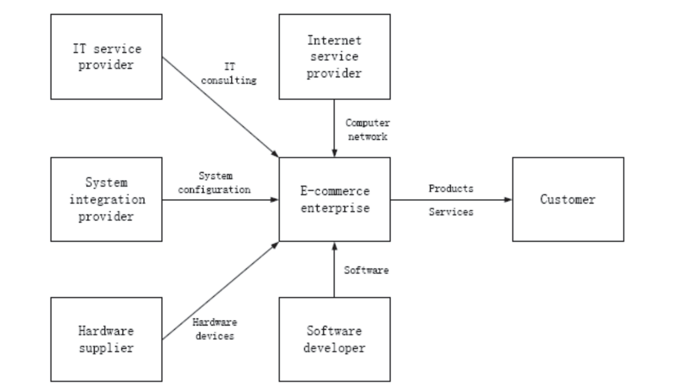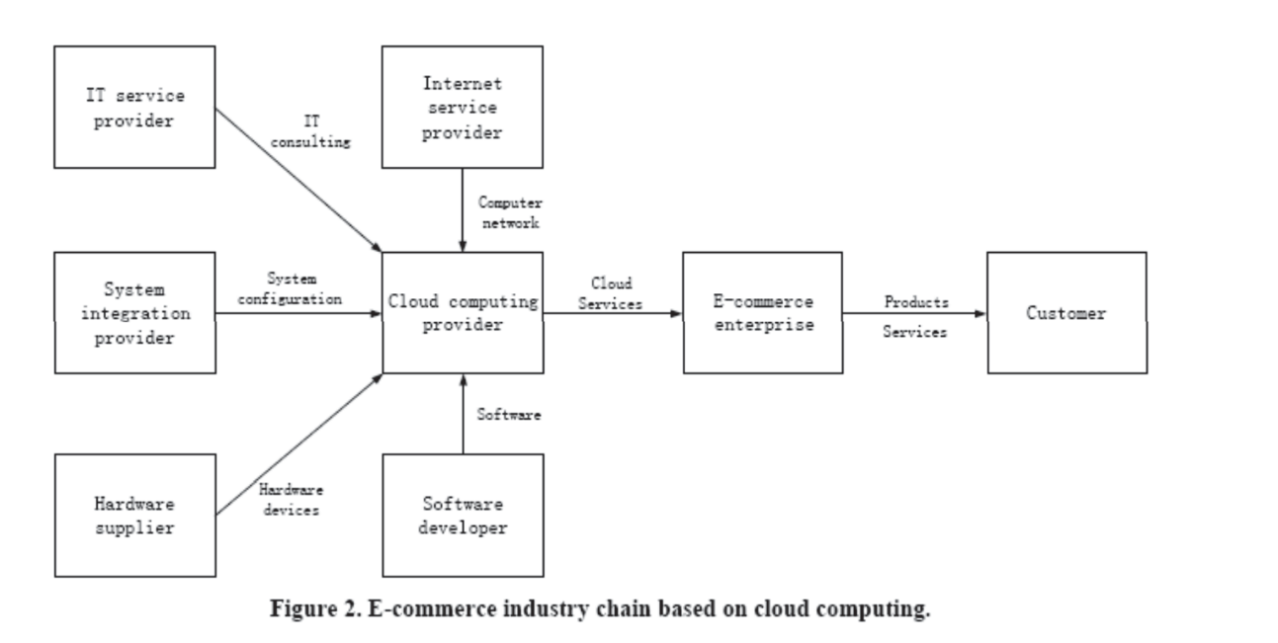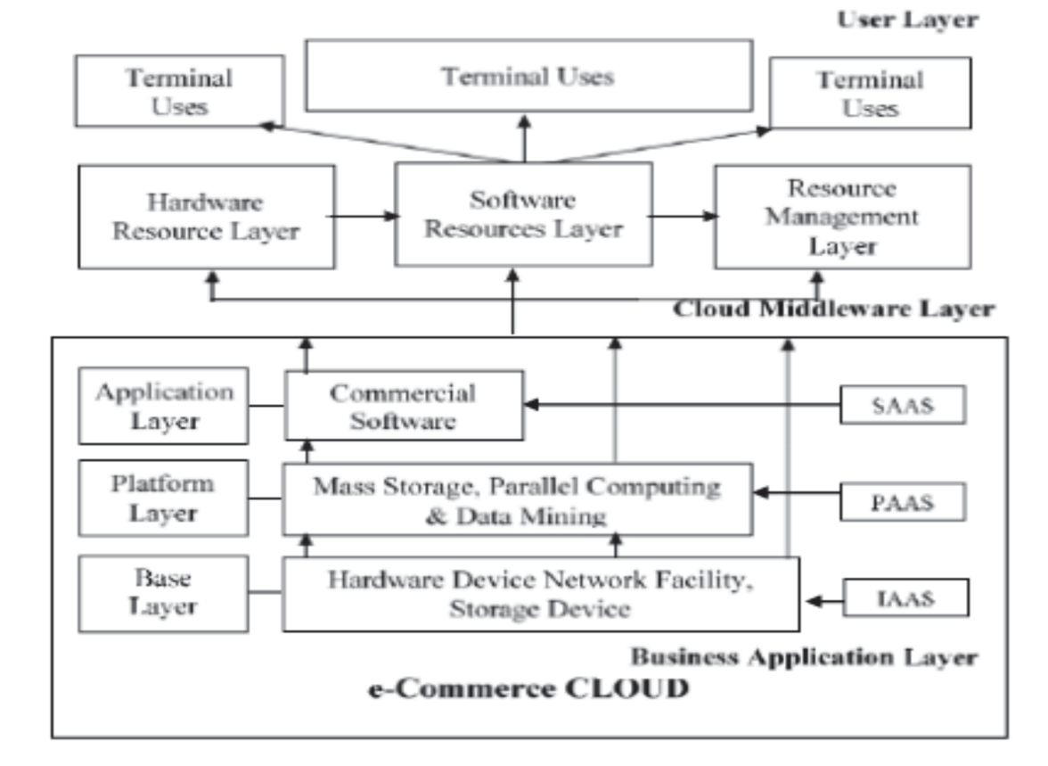

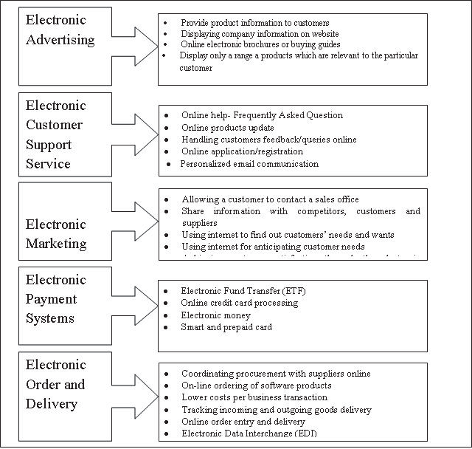

**Conclusion:**

This e-commerce app project has demonstrated the benefits of using cloud computing to build and deploy scalable, reliable, and secure web applications. The app was developed using a modern development methodology and deployed using a cloud computing platform. The app also includes a plan for testing and deploying the app, as well as a plan for monitoring and maintaining the app once it is in production.

The project has been a valuable learning experience for students and developers who want to learn how to build and deploy e-commerce apps using cloud computing. The project has also shown that cloud computing can be used to build and deploy e-commerce apps that are scalable, reliable, secure, and cost-effective.

The app is now ready to be used by customers to browse and purchase products online. The app is also ready to be scaled to meet increased demand, and it is protected from cyberattacks by the cloud computing platform.

The success of this project shows that cloud computing is a viable platform for building and deploying e-commerce apps. Cloud computing can help e-commerce businesses to:

* Scale their apps easily to meet demand
* Improve the reliability and security of their apps
* Reduce their IT costs

E-commerce businesses should consider using cloud computing to build and deploy their apps.