
MAJOR PROJECT

SYNOPSIS REPORT
For
Autonomous Research Report Agent: A Multi-Agent AI System for Automated Research
Submitted By
Specialization/Batch | SAP ID | Name
AIML, B8 | 500119031 | Devansh Saini
AIML, B8 | 500119592 | Yash Thakur
AIML, B7 | 500121743 | Kanishk Vikram Singh
AIML, B7 | 500119644 | Sumit Kumar

School Of Computer Science
UNIVERSITY OF PETROLEUM & ENERGY STUDIES,
DEHRADUN- 248007. Uttarakhand
Dr. Anish Kumar Vishwakarma
Project Mentor

Table of Contents
- Introduction
- Technical Concepts (Algorithms)
- Motivation
- Problem Statement
- Area of application
- Dataset and input format
- Literature Review
- Objectives
- Methodology
- Reference Software model
- Steps
- Timeline
- References

1. Introduction
a) Technical Concepts (Algorithms)
The proposed system is an autonomous multi-agent research system that takes a complex research question and progressively converts it into a structured, evidence-supported answer. Rather than treating a large language model (LLM) as a single-shot question-answering chatbot, the research task is divided among specialized agents, each responsible for a distinct stage of the research process. The major technical concepts underlying the system are as follows.
- Large Language Models (LLMs): used for reasoning, planning, evidence interpretation, and synthesis.
- Multi-Agent Architecture: the overall research task is divided among specialized components/agents rather than relying on a single LLM prompt.
- Research Planning: a Planner agent converts the user’s topic into a structured research plan.
- Query Generation: research questions are converted into targeted search queries.
- Web Information Retrieval: external search tools/APIs retrieve relevant sources.
- Source Selection: retrieved sources are filtered and evaluated for relevance and usefulness.
- Structured Evidence Extraction: claims, quantitative information, supporting evidence, and source metadata are extracted into a structured format.
- Evidence-Based Reasoning: conclusions are grounded in collected evidence rather than generated purely from the LLM’s internal knowledge.
- Hypothesis Testing: the planner considers a working hypothesis, competing hypotheses, evaluation criteria, and falsification criteria.
- Iterative Research: later stages determine whether available evidence is sufficient or whether additional searches are required.
- Citation/Source Tracking: evidence remains associated with its source so the final output is traceable.
The current implementation uses Python, the Gemini API, the Tavily Search API, structured JSON outputs, environment-based API key configuration, and modular Python components.
b) Motivation
LLMs can produce fluent and convincing answers, but their responses may contain hallucinations, unsupported claims, outdated information, incomplete research, or weak source attribution. At the same time, conducting high-quality research manually requires several steps: understanding the question, decomposing it, searching multiple sources, checking competing explanations, extracting evidence, comparing findings, and finally producing a conclusion.
The motivation behind this project is to investigate how these activities can be organized into an autonomous AI research pipeline in which specialized agents systematically plan, retrieve, evaluate, and synthesize information. Instead of treating an LLM simply as a question-answering chatbot, the system treats research as a multi-stage process with explicit evidence requirements.
c) Problem Statement
Conventional LLM-based question-answering systems often generate responses directly from model knowledge or a limited amount of retrieved context. Such approaches may provide answers without sufficiently verifying claims, considering alternative explanations, or determining whether the collected evidence is actually sufficient. The proposed project aims to develop an autonomous multi-agent research system that decomposes complex research questions into structured research plans, retrieves relevant external information, extracts evidence in a machine-readable form, evaluates competing hypotheses, and ultimately produces conclusions grounded in traceable sources.
d) Area of application
- Academic and literature research
- Technology research
- Market and industry analysis
- Scientific evidence exploration
- Competitive intelligence
- Technical due diligence
- Policy and background research
- Automated literature surveys
- Fact-checking assistance
- Research report generation
The system is intended primarily as a research-assistance tool, not as an unquestionable source of truth.
e) Dataset and input format
This project does not require a conventional fixed training dataset such as an image or CSV classification dataset. The primary input is a natural-language research question, for example: “Is RAG actually effective at reducing hallucinations in LLMs?” The system then dynamically obtains research information from external sources through search/retrieval APIs.
Input:
- Natural-language text
- Research topic/question
Intermediate data:
- JSON research plans
- Search queries and search results
- URLs and source metadata
- Extracted claims/evidence and quantitative evidence
- Evidence quality/relevance information
Final output:
- Structured research findings
- Evidence-backed conclusions
- Citations/references
- A synthesized research report
The dataset for this project is therefore best described as dynamically retrieved web/research information rather than a fixed dataset.

2. Literature Review
The design of the proposed system draws on prior work in retrieval-augmented generation, tool-using language agents, and multi-agent LLM systems. Six representative works are summarized below.
- Lewis et al. (2020) introduced Retrieval-Augmented Generation (RAG), a framework that combines a pre-trained language model with a non-parametric retrieval component so that generated text can be grounded in retrieved documents. This work established the core idea that external retrieval can reduce hallucination and improve factual accuracy, which underlies the evidence-retrieval stage of the proposed system.
- Yao et al. (2023) proposed ReAct, a paradigm that interleaves reasoning traces with task-specific actions, allowing a language model to plan, act, and update its reasoning based on observations from the environment. This interleaved reason-and-act loop informs the way the proposed planner and search agents coordinate.
- Schick et al. (2023) presented Toolformer, showing that a language model can learn, in a largely self-supervised manner, when and how to call external tools such as search engines and calculators to improve its outputs. This supports the proposed system’s use of external search and retrieval tools as callable agent actions.
- Asai et al. (2024) developed Self-RAG, which trains a model to adaptively decide when retrieval is necessary and to critique its own generations using reflection tokens, rather than retrieving a fixed number of passages indiscriminately. This motivates the proposed system’s evidence-sufficiency and gap-identification mechanisms.
- Park et al. (2023) introduced generative agents that simulate believable individual and social behavior by combining an LLM with a memory, reflection, and planning architecture. This work informs the modular, role-specialized multi-agent architecture adopted in the proposed system.
- Shinn et al. (2023) proposed Reflexion, in which language agents verbally reflect on task feedback and store the reflection in memory to improve decision-making in subsequent attempts. This iterative self-critique mechanism parallels the proposed system’s iterative research and gap-detection stages.

3. Objectives
- Design a modular multi-agent architecture capable of performing autonomous research on user-provided topics.
- Develop a structured research planner that converts a broad research question into hypotheses, sub-questions, evaluation criteria, evidence requirements, source requirements, and search strategies.
- Implement automated information retrieval and evidence extraction from multiple external sources.
- Develop mechanisms for evaluating evidence sufficiency, competing hypotheses, and contradictory information before forming conclusions.
- Generate a structured, source-grounded research output with traceable evidence and references while reducing unsupported LLM-generated claims.

4. Methodology
a) Reference Software model
The project follows an Agile / Iterative development model rather than a Waterfall model. The system naturally evolves through independent research modules — Planning, Retrieval, Evidence Extraction, Evaluation, and Synthesis — each of which can be implemented, tested, evaluated, and improved independently. An iterative model is particularly appropriate because LLM prompts, schemas, validation rules, retrieval strategies, and evidence-quality mechanisms generally require repeated experimentation.
b) Steps
The proposed system follows a four-phase pipeline. The complete architecture is illustrated in Figure 1.
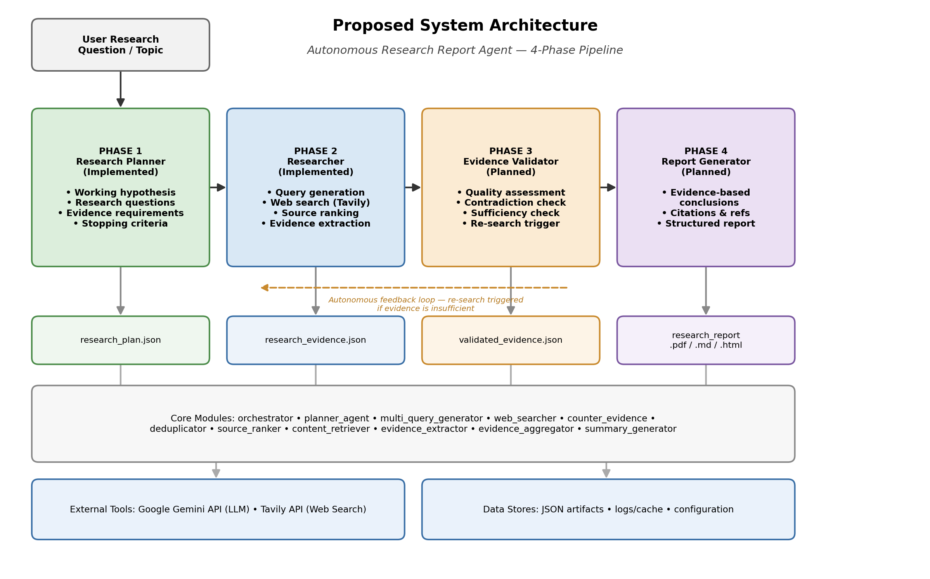
Figure 1. Proposed four-phase system architecture (planner, researcher, evidence validator, report generator)
A more detailed reference view of the same architecture, showing the internal pipeline steps, core software modules, external tools/services, data stores, and the end-to-end system flow, is provided in Figure 2.
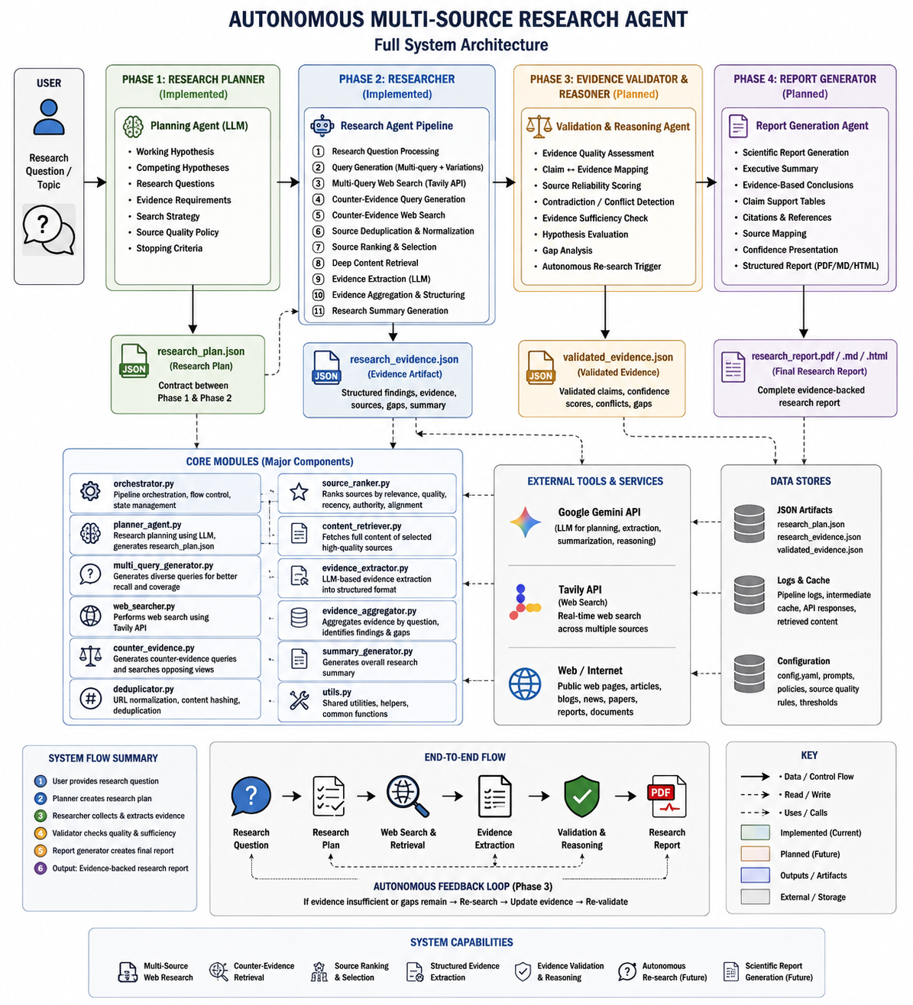
Figure 2. Detailed reference architecture of the Autonomous Multi-Source Research Agent, including pipeline steps, core modules, external services, and data stores
Phase 1 — Research Planner
A Planning Agent (LLM) converts the user’s research question/topic into a structured research_plan.json, which defines the working hypothesis, competing hypotheses, research questions, evidence requirements, search strategy, source quality policy, and stopping criteria. This plan acts as the contract between Phase 1 and Phase 2.

Phase 2 — Researcher
The Research Agent Pipeline consumes the research plan and executes the following sequence: (1) research question processing, (2) multi-query generation with variations, (3) multi-query web search using the Tavily API, (4) counter-evidence query generation, (5) counter-evidence web search, (6) source deduplication and normalization, (7) source ranking and selection, (8) deep content retrieval, (9) LLM-based evidence extraction, (10) evidence aggregation and structuring, and (11) research summary generation. The output is a structured research_evidence.json artifact containing findings, evidence, sources, gaps, and a summary.
Phase 3 — Evidence Validator and Reasoner
A Validation and Reasoning Agent will assess evidence quality, map claims to evidence, score source reliability, detect contradictions and conflicts, check evidence sufficiency, evaluate hypotheses, analyze remaining gaps, and autonomously trigger further research where required. This stage will produce a validated_evidence.json artifact and forms the basis of the system’s autonomous feedback loop: if evidence is found to be insufficient or gaps remain, the system re-searches, updates the evidence, and re-validates.
Phase 4 — Report Generator
A Report Generation Agent will produce the final scientific report, including an executive summary, evidence-based conclusions, claim-support tables, citations and references, source mapping, and confidence presentation, output as a structured PDF, Markdown, or HTML document (research_report.pdf/.md/.html).
c) Timeline
The tentative project timeline, to be adapted to the university’s academic calendar, is presented below.
Stage | Major Work
1 | Problem identification and requirement analysis
2 | Literature review and architecture design
3 | Phase 1 – Research Planner development
4 | Planner validation and structured-output testing
5 | Phase 2 – Search and source-selection development
6 | Structured evidence extraction
7 | Evidence evaluation and contradiction handling
8 | Iterative research / gap-detection mechanism
9 | Evidence synthesis and conclusion generation
10 | Citation/report-generation module
11 | End-to-end system testing and evaluation
12 | Optimization, documentation and final presentation

To complement the stage-wise timeline above, Figure 3 presents the same schedule as a PERT (Program Evaluation and Review Technique) activity network, showing the sequential dependency between activities and an indicative duration in weeks for each.
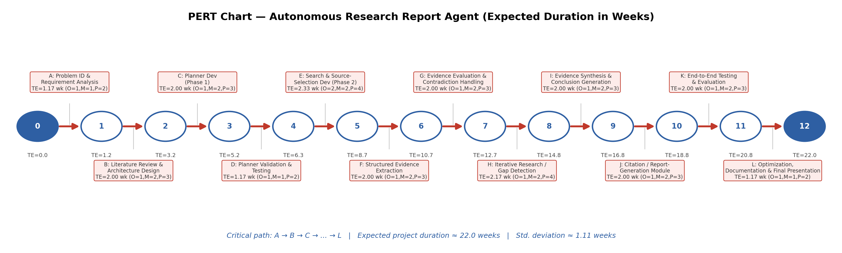
Figure 3. PERT chart showing the project activity network and estimated activity durations

5. References
Asai, A., Wu, Z., Wang, Y., Sil, A., & Hajishirzi, H. (2024). Self-RAG: Learning to retrieve, generate, and critique through self-reflection. In Proceedings of the Twelfth International Conference on Learning Representations (ICLR 2024). https://openreview.net/forum?id=hSyW5g00v8
Lewis, P., Perez, E., Piktus, A., Petroni, F., Karpukhin, V., Goyal, N., Küttler, H., Lewis, M., Yih, W., Rocktäschel, T., Riedel, S., & Kiela, D. (2020). Retrieval-augmented generation for knowledge-intensive NLP tasks. Advances in Neural Information Processing Systems, 33, 9459–9474.
Park, J. S., O’Brien, J., Cai, C. J., Morris, M. R., Liang, P., & Bernstein, M. S. (2023). Generative agents: Interactive simulacra of human behavior. In Proceedings of the 36th Annual ACM Symposium on User Interface Software and Technology (UIST ’23). https://doi.org/10.1145/3586183.3606763
Schick, T., Dwivedi-Yu, J., Dessì, R., Raileanu, R., Lomeli, M., Zettlemoyer, L., Cancedda, N., & Scialom, T. (2023). Toolformer: Language models can teach themselves to use tools. Advances in Neural Information Processing Systems, 36.
Shinn, N., Cassano, F., Berman, E., Gopinath, A., Narasimhan, K., & Yao, S. (2023). Reflexion: Language agents with verbal reinforcement learning. Advances in Neural Information Processing Systems, 36.
Yao, S., Zhao, J., Yu, D., Du, N., Shafran, I., Narasimhan, K., & Cao, Y. (2023). ReAct: Synergizing reasoning and acting in language models. In Proceedings of the Eleventh International Conference on Learning Representations (ICLR 2023).

