Game Design Document

Fill up the following document

1. Write the title of your project. Save Planet Earth
2. What is the goal of the game? The goal of the game is to kill all the Bad Aliens and to finish the game .It is basically a fighting and running game.
3. Write a brief story of your game.

The world is in danger . The aliens have attacked Planet Earth

and they are destroying the Earth . Now the scientists of the

World are making a robot name PS-1(Planet Saver -1) who will fight

against the aliens and save our Earth…….

1. Which are the playing characters of this game?

* Playing characters are the ones who respond to the user based on the input from the user.
* Cars, monkeys, dinos, wizards, etc., are the playing characters in the game.

|  |  |  |
| --- | --- | --- |
| Number | Character Name | What can this character do? |
| 1 | Robot | It can run , shoot. |
| 2 |  |  |
| 3 |  |  |
| 4 |  |  |
| 5 |  |  |
| 6 |  |  |
| 7 |  |  |
| 8 |  |  |

1. Which are the Non-Playing Characters of this game?

* Non-Playing characters are the ones that don't have an action or behavior when the user interacts with the game.
* Hurdles, stones, bananas, coins, etc., are non-playing characters in the game.

|  |  |  |
| --- | --- | --- |
| Number | Character Name | What can this character do? |
| 1 | Coins | Increase points |
| 2 | Bad Aliens | Kill the Robot |
| 3 | Energy Bar | Decreases gradually as the player moves. |
| 4 | Energy Can | Increases the energy bar when collected. |
| 5 | Life Bar | Decreases as the aliens beat the player. |
| 6 |  |  |
| 7 |  |  |
| 8 |  |  |

Draw your imagination of this game. What does this game look like?

* Draw the game either on your computer or on paper.
* Add images of the game scenes to show each of the playing and non-playing characters at least once.

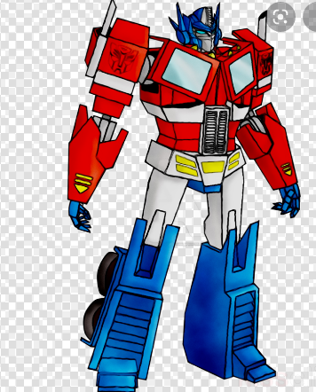

How do you plan to make your game engaging?

I will make the game engaging by giving enemies which will beat

the player and it will be difficult to encounter them ...