**Loyalty Program – Customer Segmentation & EDA Report**

**Insight** 1: **Young Adults Spend the Most:**

Based on age group analysis

* The **18–25 age group** has the highest average spend (₹14,951.85), followed closely by:
  + - 26–35 at ₹14,302.40
    - 60+ at ₹13,965.98
* Even though <18 group is smaller, they still show decent spend (₹12,635.42).

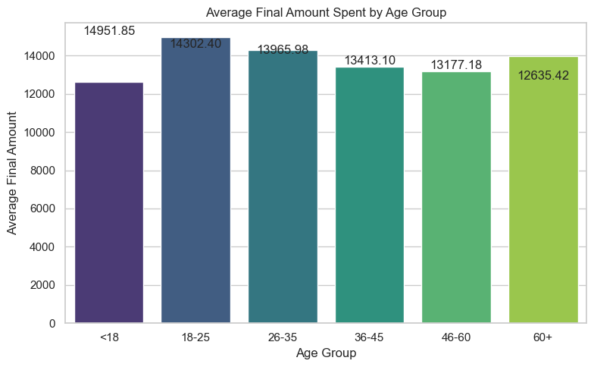

**Action:** Focus marketing campaigns and product targeting on **young adults (18–35)** as they exhibit the highest average purchase behavior.

**Insight 2: High Value Comes from Premium and Platinum Members:**

Based on membership_status and top customers

* Platinum, Silver, and Gold members contribute over **₹10 million** each in total spending.
* Top spending customers (e.g**., Matthew Murray, Kelly Soto**) each spent nearly **₹50,000+.**
* These customers are likely part of loyalty programs and may show high lifetime value.

**Action:** Strengthen loyalty programs, offer exclusive discounts, and personalized offers to retain top-tier members and high-spending individuals.

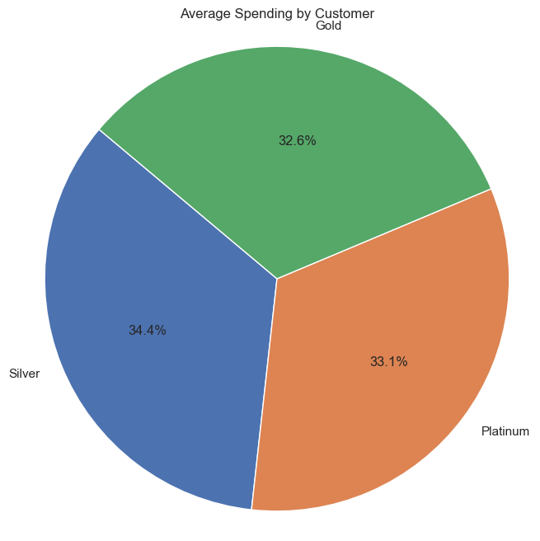

**Top Customers**

|  |  |  |
| --- | --- | --- |
| **customer_id** | **customer_name** | **final_amount** |
| CUST7916 | Matthew Murray | 49703.8 |
| CUST6853 | Kelly Soto | 49415.15 |
| CUST7272 | Marisa Ramirez | 49360.95 |
| CUST4623 | Kathryn Vaughn | 49233.3 |
| CUST9144 | Shawn Haney | 49023.65 |
| CUST8657 | Kimberly Gross | 48789.2 |
| CUST6930 | Bruce Paul | 48668.15 |
| CUST8360 | Maxwell Goodwin | 48455.55 |
| CUST9727 | Curtis Henderson | 48043.5 |
| CUST4559 | Tracy Bean | 47782.05 |

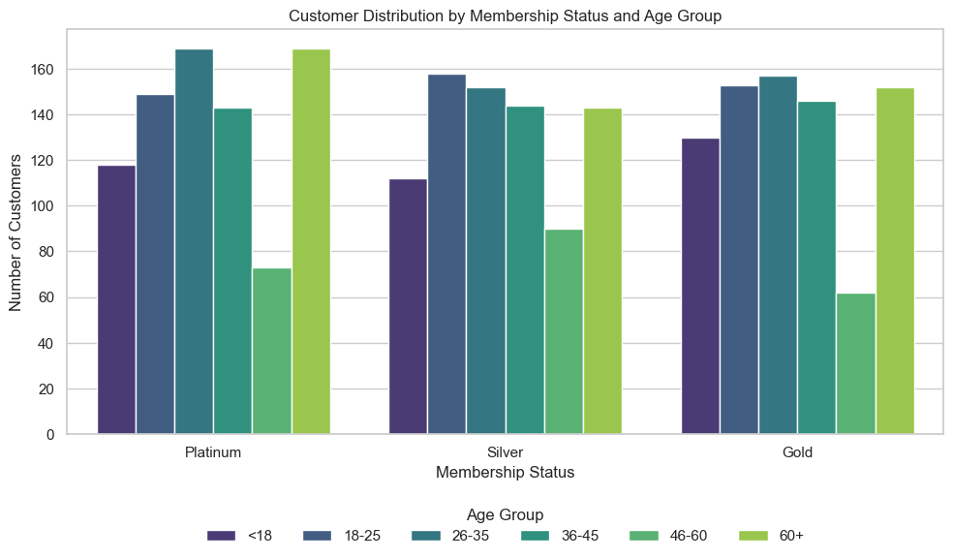

**Insight 3**: **Customer Clusters Reveal Four Distinct Segments:**

Based on K-Means clustering of frequency, spend, and discount use

| **Cluster** | **Behavior** | **Insights** |
| --- | --- | --- |
| 0 | Low spend, avg discount | Typical one-time buyers. Could be incentivized to return. |
| 1 | High spend, low discount | High-value premium customers. Loyal & price-insensitive. |
| 2 | Medium spend, frequent buyers | Loyal mid-tier shoppers, may respond well to upselling. |
| 3 | Low spend, low discount | Cost-conscious, not very engaged. Dormant risk group. |

**Action:**

* Reward **Cluster 1** with early access or VIP treatment.
* Encourage **Cluster 2** with product bundles or targeted offers.
* Re-engage **Cluster 0 & 3** using email, retargeting, or loyalty upgrades.

**Summary**:

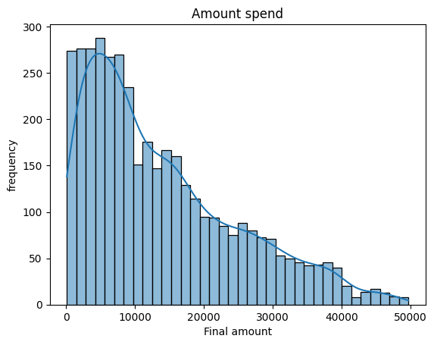

The analysis reveals that young adults aged 18–25 are the highest spenders, averaging ₹14,951.85 per purchase, making them a prime target for marketing and engagement efforts. Loyalty members, especially those in Platinum and Silver tiers, contribute significantly to revenue, with top individual customers spending over ₹49,000, highlighting the value of maintaining and rewarding high-tier members. Customer segmentation through clustering uncovered four distinct groups, including premium loyalists with high spending and low discount usage, and dormant or low-value customers with minimal engagement, suggesting opportunities for personalized retention strategies and targeted marketing to maximize customer lifetime value.