## CHANDIGARH UNIVERSITY

## UNIVERSITY INSTITUTE OF NGINEERING

**DEPARTMENT OF COMPUTER SCIENCE & ENGINEERING**



|  |  |
| --- | --- |
| **Submitted By: Komal Sharma Submitted To:Mr.Syed Abdul Basit Andrabi sir** | |
| **Subject Name** | Competitive Coding |
| **Subject Code** | 20CSP-314 |
| **Branch** | BE.CSE. |
| **Semester** | 5th |

**Experiment 1.**

**Student Name: Komal Sharma UID: 20BCS1115**

**Branch: BE.CSE Section/Group: 707_WM_B**

**Semester: 5th Date of Performance:19/8/22**

**Subject Name:CC_LAB**

**Subject Code: 20CSP-314**

**1. Aim/Overview of the practical:**

Understanding the concept of arrays.

**2. Task to be done/ Which logistics used:**

The tasks involve finding the sum of an array,comparing triplets,reversing the array and finding the difference of sum of diagonal elements of an array.

**3. Algorithm**

1. **Steps for experiment/practical/Code:**

**a)Reverse array:<https://www.hackerrank.com/challenges/30-arrays/problem>**

#include <bits/stdc++.h>

using namespace std;

int main(){

int n, i; cin>>n;

int a[n];

for(i=0; i<n; ++i){

cin>>a[i];

}

for(i=n-1; i>=0; --i){

cout<<a[i]<<" ";

}

return 0;

}

**b)Simple array sum:<https://www.hackerrank.com/challenges/simple-array-sum/problem?isFullScreen=true>**

#include <bits/stdc++.h>

using namespace std;

int main(){

int n, sum=0, i; cin>>n;

int a[n];

for(i=0; i<n; ++i){

cin>>a[i];

sum += a[i];

}

cout<<sum;

return 0;

}

1. **Compare the triplets:**

**<https://www.hackerrank.com/challenges/compare-the-triplets/problem?isFullScreen=true>**

#include <bits/stdc++.h>

using namespace std;

int main() {

int i, a[3], b[3], ap=0, bp=0;

for(i=0; i<3; i++) {

cin>>a[i];

}

for(i=0; i<3; i++) {

cin>>b[i];

if(a[i] > b[i]) {

ap++;

} else if(a[i] < b[i]) {

bp++;

}

}

cout<<ap<<" "<<bp;

return 0;

}

**D)diagonal difference:**

**<https://www.hackerrank.com/challenges/diagonal-difference/problem?isFullScreen=true>**

#include <bits/stdc++.h>

using namespace std;

#define X 1000

int abs(int x){

if(x<0){

return (-1) * x;

}

return x;

}

int diagDiff(int n, int ar[X][X]){

int d1=0, d2=0, i;

for(i=0; i<n; i++){

d1 += ar[i][i];

d2 += ar[i][n-1-i];

}

return abs(d1 - d2);

}

int main() {

int n, i, j, d1=0, d2=0; cin>>n;

int a[X][X];

for(i=0; i<n; i++) {

for(j=0; j<n; j++){

cin>>a[i][j];

}

}

for(i=0; i<n; i++){

d1 += a[i][i];

d2 += a[i][n-1-i];

}

cout<<diagDiff(n, a);

return 0;

}

1. **Result/Output/Writing Summary:**
2. **Reverse Output:**

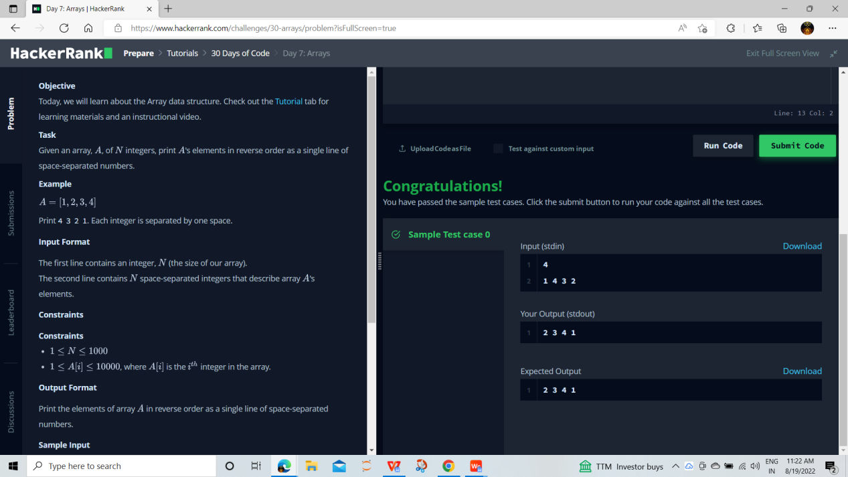

1. **Compare the triplets**

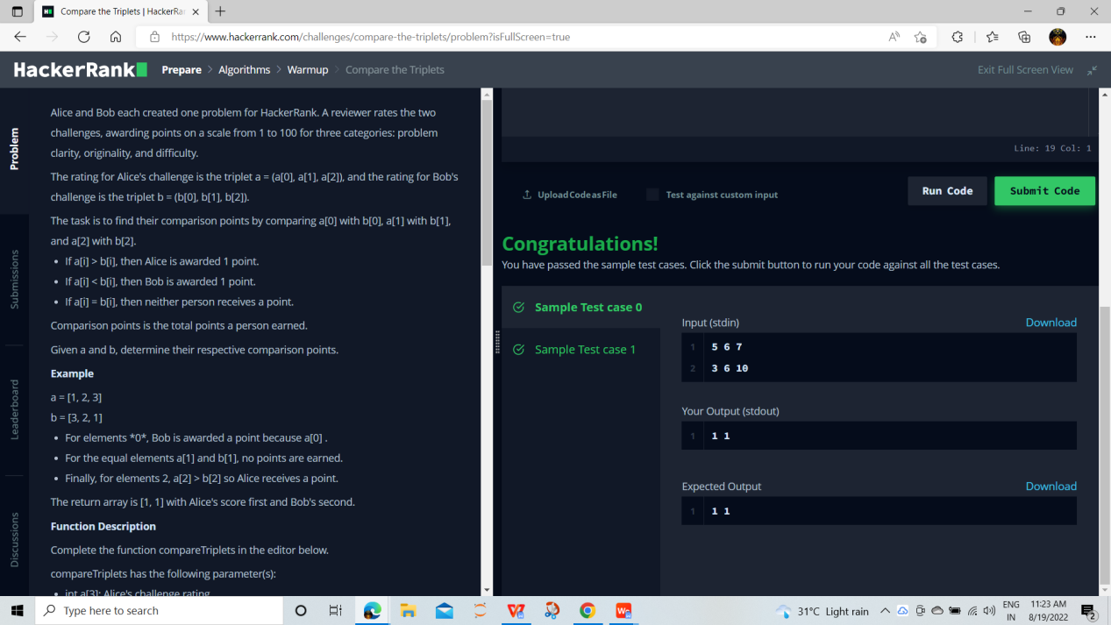

**C)Simple array sum**

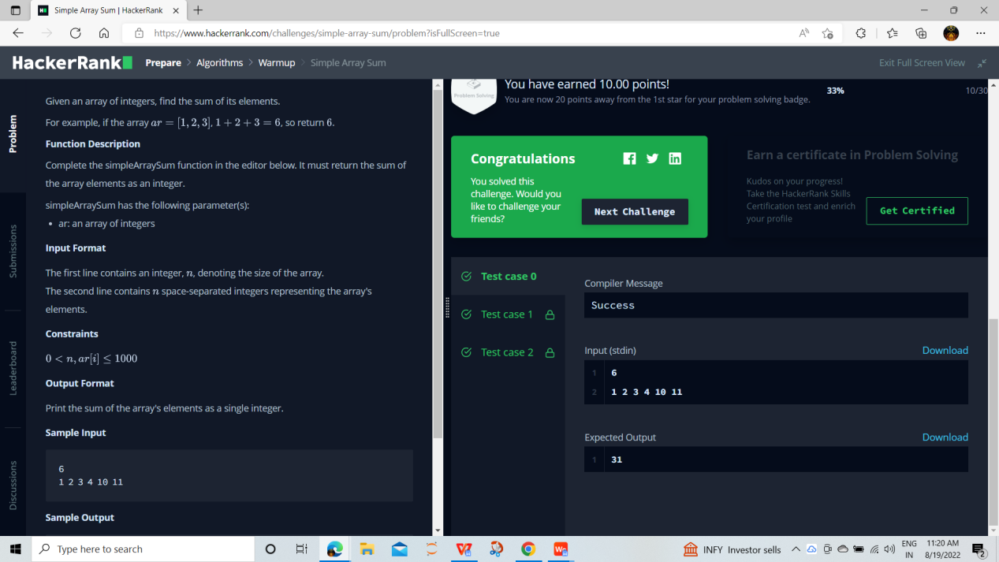

1. **Diagonal difference**

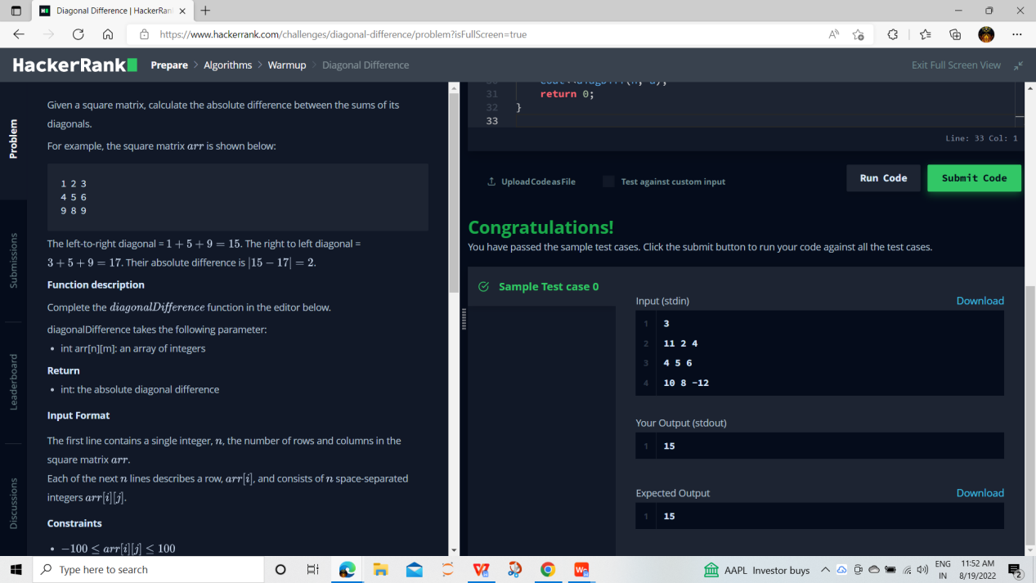

**Learning outcomes (What I have learnt):**

1. Understand the concept of arrays

**2.**Solved question based on arrays to get a better understanding the data structure.

**Evaluation Grid (To be created as per the SOP and Assessment guidelines by the faculty):**

|  |  |  |  |
| --- | --- | --- | --- |
| Sr. No. | Parameters | Marks Obtained | Maximum Marks |
| 1. |  |  |  |
| 2. |  |  |  |
| 3. |  |  |  |
|  |  |  |  |