**CHANDIGARH UNIVERSITY**

**UNIVERSITY INSTITUTE OF ENGINEERING**

**DEPARTMENT OF COMPUTER SCIENCE & ENGINEERING**



|  |  |
| --- | --- |
| **Submitted By: Kanishk Soni Submitted To: Mr. Syed Abdul Basit Andrabi** | |
| **Subject Name** | CC LAB |
| **Subject Code** | 20CSP-314 |
| **Branch** | Computer Science |
| **Semester** | 5th |

**Practical Evaluation Sheet**

|  |  |  |  |  |  |  |  |
| --- | --- | --- | --- | --- | --- | --- | --- |
| **Sr.No** | **Program** | **Date** | **Evaluation** | | | | **Sign** |
| **Conduct**  **(12)** | **Viva(8)** | **Worksheet(10)** | **Total (30)** |
| 1 | Concept of Arrays |  |  |  |  |  |  |
| 2 | Concept of Stack and Queues |  |  |  |  |  |  |
| 3 |  |  |  |  |  |  |  |
| 4 |  |  |  |  |  |  |  |
| 5 |  |  |  |  |  |  |  |
| 6 |  |  |  |  |  |  |  |
| 7 |  |  |  |  |  |  |  |
| 8 |  |  |  |  |  |  |  |
| 9 |  |  |  |  |  |  |  |
| 10 |  |  |  |  |  |  |  |

**Experiment 2**

**Student Name: Kanishk Soni UID: 20BCS9398**

**Branch: CSE Section/Group: 20BCSWM707A**

**Semester: 5th Date of Performance: 24/08/2022**

**Subject Name: Competitive Coding - I Subject Code: 20CSP-314**

1.**Aim:** To demonstrate the use of Stacks and Queues.

2. **Questions:**

**A. Equal Stacks Problem**

Code:

int vsum(vector<int> x){

return accumulate(x.begin(), x.end(), 0);

}

int equalStacks(vector<int> h1, vector<int> h2, vector<int> h3) {

int a = vsum(h1), b = vsum(h2), c = vsum(h3);

while(a != b || a != c) {

if(a>b && a>c) {

// h1.erase(h1.begin());

a -= h1.back();

h1.pop_back();

} else if (b>c) {

// h2.erase(h2.begin());

b -= h2.back();

h2.pop_back();

} else {

// h3.erase(h3.begin());

c -= h3.back();

h3.pop_back();

}

}

return a;

}

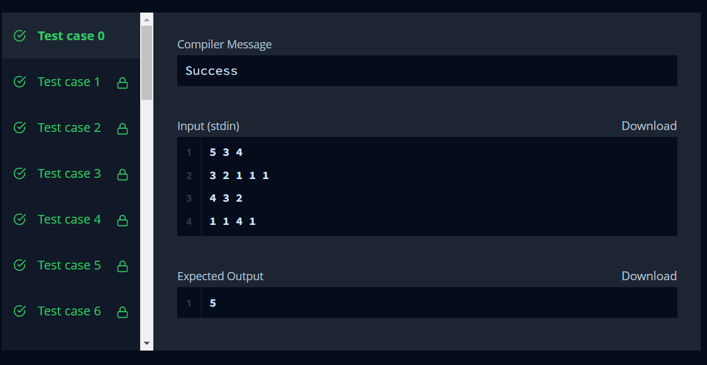

**B. Balanced Brackets Problem**

string isBalanced(string s) {

string isBalanced(string s) {

stack<char> st;

for (auto c: s) {

switch (c) {

case '{':

case '(':

case '[':

st.push(c);

break;

case '}':

if (st.empty() || (st.top() != '{')) {

return "NO";

}

st.pop();

break;

case ')':

if (st.empty() || (st.top() != '(')) {

return "NO";

}

st.pop();

break;

case ']':

if (st.empty() || (st.top() != '[')) {

return "NO";

}

st.pop();

break;

}

}

return st.empty() ? "YES" : "NO";

}

}

