

**UNIVERSITY INSTITUTE OF ENGINEERING**

**Department of Computer Science & Engineering**

**Subject Name:** Competitive coding-I

**Subject Code:** 20CSP-314

|  |  |
| --- | --- |
| **Submitted By:** Kanishk Soni **Submitted To: Mr. Syed Abdul Basit** | |
| **Subject Name** | CC LAB |
| **Subject Code** | 20CSP-314 |
| **Branch** | Computer Science |
| **Semester** | 5th |

**Practical Evaluation Sheet**

|  |  |  |  |  |  |  |  |
| --- | --- | --- | --- | --- | --- | --- | --- |
| **Sr.No** | **Program** | **Date** | **Evaluation** | | | | **Sign** |
| **Conduct**  **(12)** | **Viva(8)** | **Worksheet(10)** | **Total (30)** |
| 1 | Concept of Arrays |  |  |  |  |  |  |
| 2 | Concept of Stack and Queues |  |  |  |  |  |  |
| 3 | Concept of Linked List |  |  |  |  |  |  |
| 4 | Concept of Searching and Sorting |  |  |  |  |  |  |
| 5 | Concept of Graph |  |  |  |  |  |  |
| 6 | Concept of Trees |  |  |  |  |  |  |
| 7 | Concept of String |  |  |  |  |  |  |
| 8 | Concept of Dynamic Programming |  |  |  |  |  |  |
| 9 | Concept of Backtracking |  |  |  |  |  |  |
| 10 | Concept of Greedy and Branch and Bound |  |  |  |  |  |  |

**Experiment 10**

**Student Name: Kanishk Soni UID: 20BCS9398**

**Branch: CSE Section/Group:707_WM_B**

**Semester: 5th Date of Performance: 07/11/2022**

**Subject Name: Competitive Coding - I Subject Code: 20CSP-314**

**Question1: Marc's Cakewalk**

**Code:**

long marcsCakewalk(vector<int> calorie) {

sort (calorie.begin(), calorie.end(), greater<int>());

long sum = 0;

for (int i = 0; i < calorie.size(); i++) {

sum += pow(2, i) * calorie[i];

}

return sum;

}

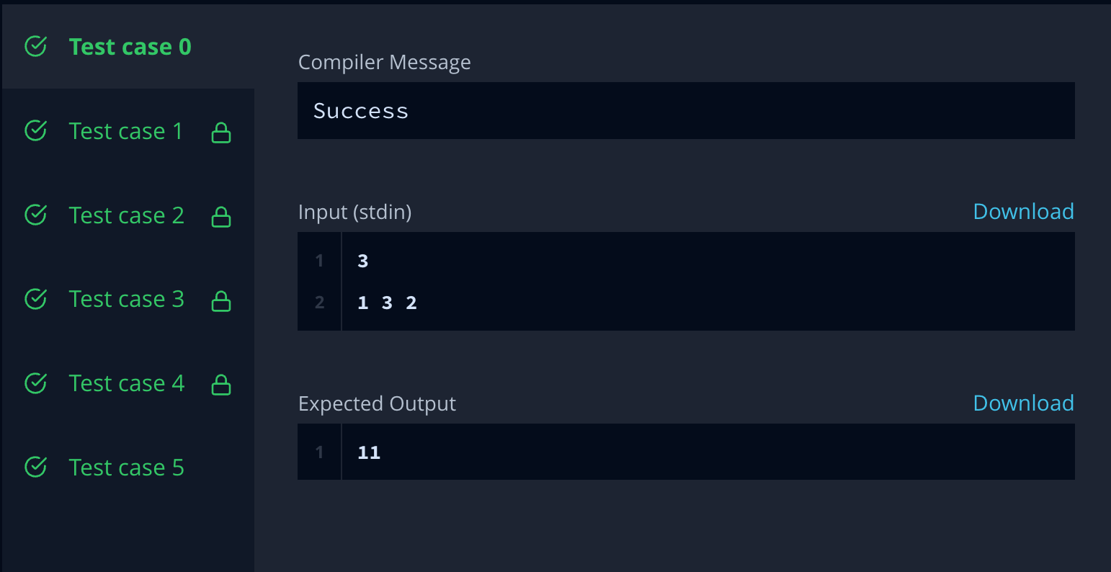

**Question 2:** **Grid Challenge**

**Code:**

string gridChallenge(vector<string> grid) {

for(int i=0;i<grid.size();i++) {

sort(grid[i].begin(),grid[i].end());

}

for(int i=1;i<grid.size();i++) {

for(int j=0;j<grid.size();j++) {

if(grid[i-1][j]>grid[i][j]) {

return "NO";

}

}

}

return "YES";

}

