

**UNIVERSITY INSTITUTE OF ENGINEERING**

**Department of Computer Science & Engineering**

**Subject Name:** Competitive coding-I

**Subject Code:** 20CSP-314

|  |  |
| --- | --- |
| **Submitted By: Kanishk Soni Submitted To: Mr. Syed Abdul Basit Andrabi** | |
| **Subject Name** | CC LAB |
| **Subject Code** | 20CSP-314 |
| **Branch** | Computer Science |
| **Semester** | 5th |

**Practical Evaluation Sheet**

|  |  |  |  |  |  |  |  |
| --- | --- | --- | --- | --- | --- | --- | --- |
| **Sr.No** | **Program** | **Date** | **Evaluation** | | | | **Sign** |
| **Conduct**  **(12)** | **Viva(8)** | **Worksheet(10)** | **Total (30)** |
| 1 | Concept of Arrays |  |  |  |  |  |  |
| 2 | Concept of Stack and Queues |  |  |  |  |  |  |
| 3 | Concept of Linked List |  |  |  |  |  |  |
| 4 | Concept of Searching and Sorting |  |  |  |  |  |  |
| 5 |  |  |  |  |  |  |  |
| 6 |  |  |  |  |  |  |  |
| 7 |  |  |  |  |  |  |  |
| 8 |  |  |  |  |  |  |  |
| 9 |  |  |  |  |  |  |  |
| 10 |  |  |  |  |  |  |  |

**Experiment 4**

**Student Name: Kanishk Soni UID: 20BCS9398**

**Branch: CSE Section/Group:707_WM_B Semester: 5th Date of Performance: 7/9/2022**

**Subject Name: Competitive Coding - I Subject Code: 20CSP-314**

**Question1:** Given two arrays of integers, find which elements in the second array are missing from the first array.

**Code:**

#include <bits/stdc++.h>

using namespace std;

int main(){

long long n,m,t;

cin>>n;

vector<int> a;

for(long long i=0;i<n;i++) {

cin >> t;

a.push_back(t);

}

cin>>m;

vector<int> b;

for(long long i=0;i<m;i++){

cin >> t;

b.push_back(t);

}

sort(a.begin(),a.end());

sort(b.begin(),b.end());

long long i=0,j=0;

while(i<n && j<m){

if(a[i]==b[j]) {

i++;j++;

b[j-1]=0;

}

else if(a[i]>b[j])j++;

else i++;

}

set<int> st;

for(i=0;i<m;i++) {

if(b[i]!=0) st.insert(b[i]);

}

for(set<int>::iterator it = st.begin();it!=st.end();it++){

cout<<*it<<" ";

}

cout<<endl;

return 0;

}

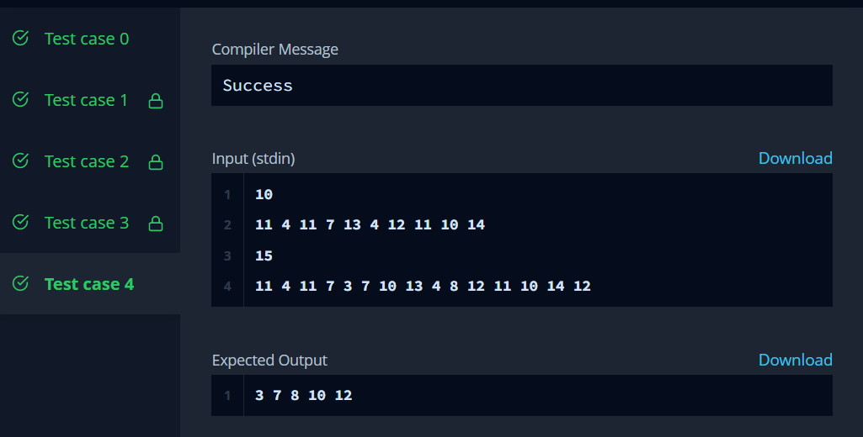

**Question 2:** Given an array of integers and a target value, determine the number of pairs of array elements that have a difference equal to the target value.

int pairs(int k, vector<int> arr) {

int c = 0;

set<long> s;

for(int i = 0; i < arr.size(); i++) s.insert(arr[i]);

for(int i = 0; i < arr.size(); i++){

long b = arr[i] - k;

if(s.count(b)) c ++;

}

return c;

}

