

**UNIVERSITY INSTITUTE OF ENGINEERING**

**Department of Computer Science & Engineering**

**Subject Name:** Competitive coding-I

**Subject Code:** 20CSP-314

|  |  |
| --- | --- |
| **Submitted By:** Kanishk Soni **Submitted To: Mr. Syed Abdul Basit** | |
| **Subject Name** | CC LAB |
| **Subject Code** | 20CSP-314 |
| **Branch** | Computer Science |
| **Semester** | 5th |

**Practical Evaluation Sheet**

|  |  |  |  |  |  |  |  |
| --- | --- | --- | --- | --- | --- | --- | --- |
| **Sr.No** | **Program** | **Date** | **Evaluation** | | | | **Sign** |
| **Conduct**  **(12)** | **Viva(8)** | **Worksheet(10)** | **Total (30)** |
| 1 | Concept of Arrays |  |  |  |  |  |  |
| 2 | Concept of Stack and Queues |  |  |  |  |  |  |
| 3 | Concept of Linked List |  |  |  |  |  |  |
| 4 | Concept of Searching and Sorting |  |  |  |  |  |  |
| 5 | Concept of Graph |  |  |  |  |  |  |
| 6 | Concept of Trees |  |  |  |  |  |  |
| 7 | Concept of String |  |  |  |  |  |  |
| 8 | Concept of Dynamic Programming |  |  |  |  |  |  |
| 9 | Concept of Backtracking |  |  |  |  |  |  |
| 10 | Concept of Greedy and Branch and Bound |  |  |  |  |  |  |

**Experiment 8**

**Student Name: Kanishk Soni UID: 20BCS9398**

**Branch: CSE Section/Group:707_WM_B**

**Semester: 5th Date of Performance: 07/11/2022**

**Subject Name: Competitive Coding - I Subject Code: 20CSP-314**

**Question1: Construct-the-Array**

**Code:**

#include<bits/stdc++.h>

using namespace std;

#define ll long long

#define MOD 1000000007

int main(){

ios_base::sync_with_stdio(false);

cin.tie(NULL);

int t=1;

while(t--){

ll n,k,x;

cin>>n>>k>>x;

vector<ll> path(n+1),dp(n+1);

path[1]=1;

if(x==1) {

dp[1]=1;

} else{

dp[1]=0;

}

for(ll i=2;i<=n;i++){

path[i]=(path[i-1]*(k-1))%MOD;

dp[i]=(path[i-1]-dp[i-1]+MOD)%MOD;

}

cout<<dp[n]<<endl;

}

return 0;

}

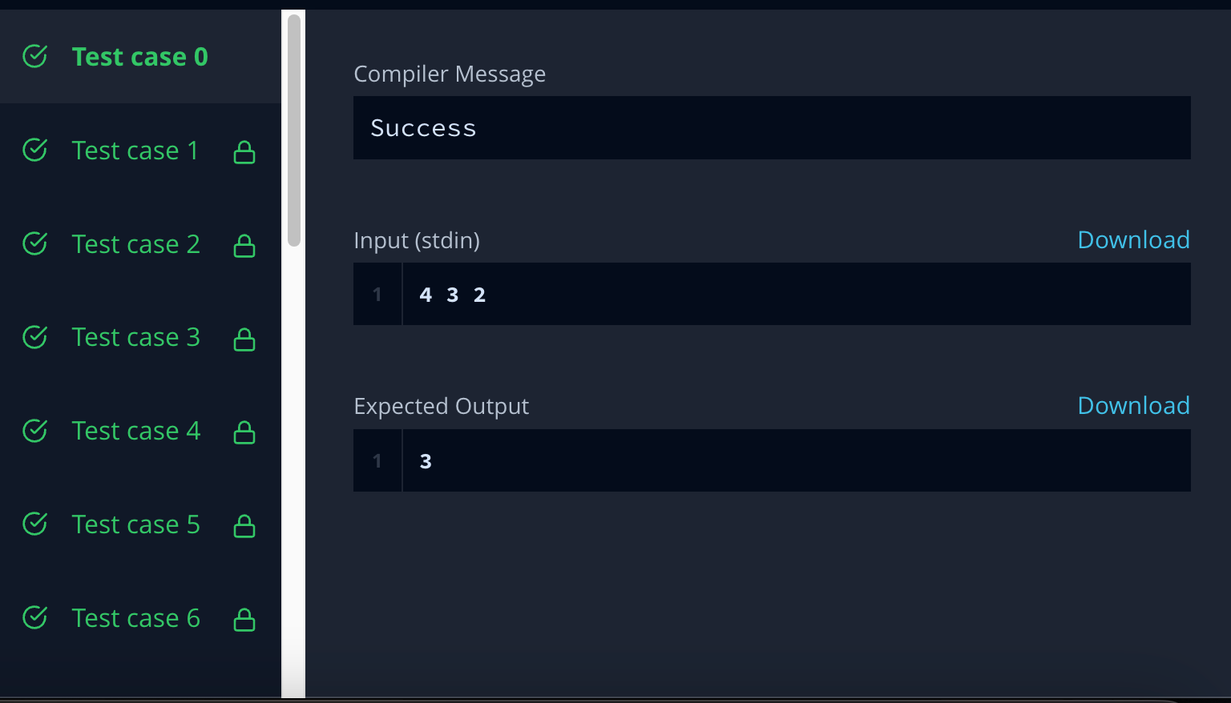

**Question 2:** **Sam-and-substrings**

**Code:**

#include<bits/stdc++.h>

using namespace std;

#define ll long long

#define ar array

const int mxN=2e5, M=1e9+7; int n;

string t; ll dp[mxN];

int main() {

cin >> t;

n=t.size();

dp[0]=t[0]-'0';

for(int i=1; i<n; ++i) {

dp[i]=(dp[i-1]*10%M+(t[i]-'0')*(i+1))%M;

}

ll ans=0;

for(int i=0; i<n; ++i) {

ans=(ans+dp[i])%M;

}

cout << ans;

return 0;

}

