**CHANDIGARH UNIVERSITY**

**UNIVERSITY INSTITUTE OF ENGINEERING**

**DEPARTMENT OF COMPUTER SCIENCE & ENGINEERING**



|  |  |
| --- | --- |
| **Submitted By: Pratham Mittal Submitted To: Mr. Syed Abdul Basit Andrabi** | |
| **Subject Name** | **Competitive Coding** |
| **Subject Code** | **20CSP-314** |
| **Branch** | **BE.CSE** |
| **Semester** | **5th** |

**Experiment 2.3**

**Student Name: Pratham Mittal UID: 20BCS1040**

**Branch: CSE Section/Group:707_WM_B**

**Semester: 5th Date of Performance: 02/11/2022**

**Subject Name: Competitive Coding - I Subject Code: 20CSP-314**

**Question1. Pangram Problem**

**Code:**

string pangrams(string s) {

vector<int> a(256, 0);

for (int i = 0; i < s.length(); i++){

a[s[i]]++;

}

for (char c = 'a'; c <= 'z'; c++){

if (a[c] + a[c - 'a' + 'A'] == 0){

return "not pangram";

return 0;

}

}

return "pangram";

}

**Output:**

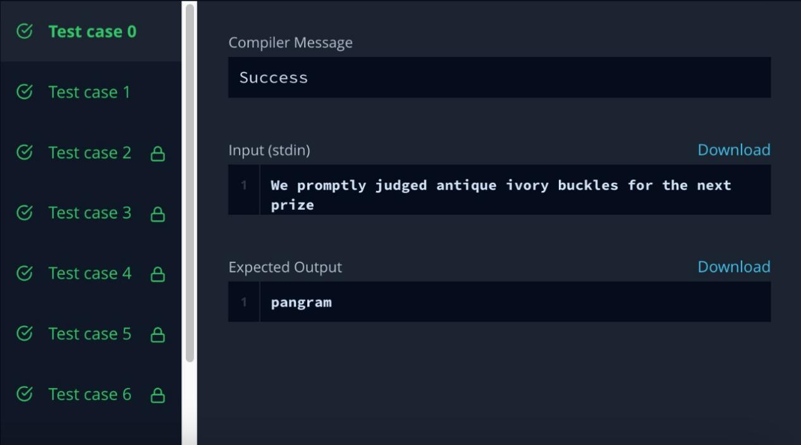

**Question 2. CamelCase Problem**

**Code:**

int camelcase(string s) {

int c=1;

for(int i=0; i<s.length(); i++) {

if(isupper(s[i])) {

c++;

}

}

return c;

}

**Output:**

