**CHANDIGARH UNIVERSITY**

**UNIVERSITY INSTITUTE OF ENGINEERING**

**DEPARTMENT OF COMPUTER SCIENCE & ENGINEERING**



|  |  |
| --- | --- |
| **Submitted By: Kanishk Soni Submitted To: Er. Tanu Dhiman** | |
| **Subject Name** | **Design and Analysis of Algorithm Lab** |
| **Subject Code** | **20CSP-312** |
| **Branch** | **BE-CSE** |
| **Semester** | **5th** |

**Worksheet - 7**

**Student Name:** Kanishk Soni **UID:** 20BCS9398

**Branch:** BE CSE **Section/Group:** 20BCS_WM_707-B

**Semester:** 5 **Date of Performance:** 02/10/2022

**Subject Name:** Design & Analysis of Algorithm **Subject Code:** 20CSP-312

1. **Aim/Overview of the practical:** Code to implement 0-1 Knapsack using Dynamic Programming.
2. **Task to be done:** Dynamic 0-1 knapsack Problem.
3. **Algorithms:**
4. Calculate the profit-weight ratio for each item or product.
5. Arrange the items on the basis of ratio in descending order.
6. Take the product having the highest ratio and put it in the sack.
7. Reduce the sack capacity by the weight of that product.
8. Add the profit value of that product to the total profit.
9. Repeat the above three steps till the capacity of sack becomes 0 i.e. until the sack is full.

for w = 0 to W do

c[0, w] = 0

for i = 1 to n do

c[i, 0] = 0

for w = 1 to W do

if wi ≤ w then

if vi + c[i-1, w-wi] then

c[i, w] = vi + c[i-1, w-wi]

else c[i, w] = c[i-1, w]

else c[i, w] = c[i-1, w]

1. **Code:**

#include <iostream>

#define MAX 10

using namespace std;

struct product {

int product_num;

int profit;

int weight;

float ratio;

float take_quantity;

};

int main() {

product P[MAX], temp;

int i, j, total_product, capacity;

float value = 0;

cout<<"ENTER NUMBER OF ITEMS : ";

cin>>total_product;

cout<<"ENTER CAPACITY OF SACK : ";

cin>>capacity;

cout<<"\n";

for(i = 0; i < total_product; ++i) {

P[i].product_num = i + 1;

cout << "ENTER PROFIT AND WEIGHT OF PRODUCT " << i + 1 << " : ";

cin >> P[i].profit >> P[i].weight;

P[i].ratio = (float)P[i].profit / P[i].weight;

P[i].take_quantity = 0;

}

for (i = 0; i < total_product; ++i) {

for (j = i + 1; j < total_product; ++j) {

if (P[i].ratio < P[j].ratio) {

temp = P[i];

P[i] = P[j];

P[j] = temp;

}

}

}

for(i = 0; i < total_product; ++i) {

if (capacity == 0) {

break;

} else if (P[i].weight < capacity) {

P[i].take_quantity = 1;

capacity -= P[i].weight;

} else if (P[i].weight > capacity) {

P[i].take_quantity = (float)capacity / P[i].weight;

capacity = 0;

}

}

cout<<"\n\nPRODUCTS TO BE TAKEN -";

for(i = 0; i < total_product; ++i) {

cout<<"\nTAKE PRODUCT "<<P[i].product_num<<" : "<<P[i].take_quantity * P[i].weight<<" UNITS ";

value += P[i].profit * P[i].take_quantity;

}

cout<<"\nTHE KNAPSACK VALUE IS : "<<value;

return 0;

}

1. **Complexity:**

This algorithm takes θ(n, w) times as table c has (n + 1).(w + 1) entries, where each entry requires θ(1) time to compute.

1. **Result/Output:**

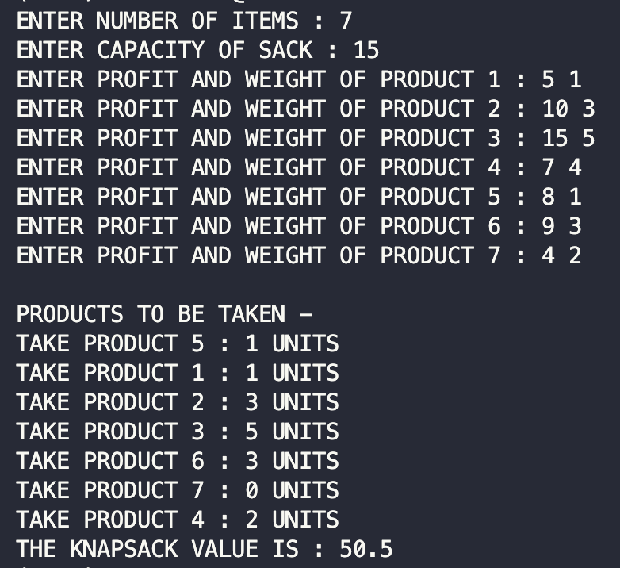

**Learning outcomes (What I have learnt):**

1. Create a program keeping in mind the time complexity
2. Create a program keeping in mind the space complexity
3. Steps to make optimal algorithm
4. Learnt about how to implement 0-1 Knapsack problem using dynamic programming.