**EXPERIMENT-5**

**Student’s Name: Kanishk Soni UID: 20BCS9398**

**Section/Group: 707_WM_B Subject Code: 20CSP-317**

**Subject Name: ML Lab Date of performance:28/10/2022**

**Branch: BE CSE Semester:5th**

**Aim:** Implement Naïve bayes theorem.

**Objective:** To do Naïve bayes theorem on data set.

**Software/Hardware Requirements:** Windows 7 & above version.

**Tools to be used:**

1. Anaconda Jupyter Notebook,
2. numpy, pandas, matplotlib, seaborn, sklearn.

**Introduction to Bayes’ Theorem:**

Bayes’ Theorem provides a way that we can calculate the probability of a piece of data belonging to a given class, given our prior knowledge.

**Code:**

--

from sklearn.naive_bayes import GaussianNB

from sklearn.model_selection import train_test_split

from sklearn.metrics import confusion_matrix

import numpy as np

import pandas as pd

import matplotlib.pyplot as plt

import seaborn as sns

sns.set()

--

train = pd.read_csv('data/iris_train.csv')

test = pd.read_csv('data/iris_test.csv')

x_train = train.drop('Species', axis=1)

y_train = train.loc[:, 'Species']

x_test = test.drop('Species', axis=1)

y_test = test.loc[:, 'Species']

model = GaussianNB()

model.fit(x_train, y_train)

pred = model.predict(x_test)

mat = confusion_matrix(pred, y_test)

names = np.unique(pred)

sns.heatmap(mat, square=True, annot=True, fmt='d', cbar=False,

xticklabels=names, yticklabels=names)

plt.xlabel('Truth')

plt.ylabel('Predicted')

**Output:**

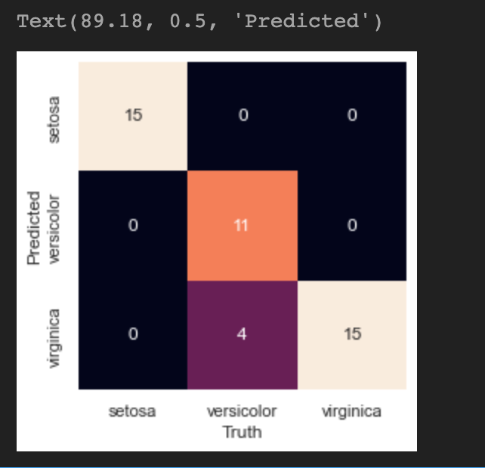

**Learning Outcomes:**

1. We learned about Naïve bayes theorem.