TABS: AN EXPENSE-SHARING AND DEBT-BALANCING ANDROID APPLICATION
A REPORT
Submitted by
KANISHKA SHARMA
SAP ID: 70572400199
RINKAL DUGGAL
SAP ID: 70572400170
SHRESTHA KOCHER
SAP ID: 70572400205
of
BACHELOR OF TECHNOLOGY
IN
COMPUTER SCIENCE AND ENGINEERING (DATA SCIENCE)
SUBMITTED FOR THE SUBJECT OF MOBILE APPLICATION DEVELOPMENT

DEPARTMENT OF COMPUTER SCIENCE AND ENGINEERING
SCHOOL OF TECHNOLOGY MANAGEMENT AND ENGINEERING, CHANDIGARH, 160114, U.T. (INDIA)
OCTOBER 2026

DECLARATION
We declare that this project report titled “TABS: An Expense-Sharing and Debt-Balancing Android Application” has been prepared for the subject of Mobile Application Development. It describes the problem, requirements, design, implementation, testing and limitations of the TABS Android application. The work is our own team effort. Sources of information are acknowledged in the References.

Kanishka Sharma (SAP ID 70572400199)
Rinkal Duggal (SAP ID 70572400170)
Shrestha Kocher (SAP ID 70572400205)

CERTIFICATE
This is to certify that the project report titled “TABS: An Expense-Sharing and Debt-Balancing Android Application”, submitted by Kanishka Sharma (SAP ID 70572400199), Rinkal Duggal (SAP ID 70572400170) and Shrestha Kocher (SAP ID 70572400205) in partial fulfilment of the requirements for the Bachelor of Technology in Computer Science and Engineering (Data Science), is a record of work carried out under supervision for the subject of Mobile Application Development at the School of Technology Management and Engineering, NMIMS Chandigarh.

Faculty / Guide: Dr. Preetjot Kaur

ACKNOWLEDGEMENT
We would like to express our gratitude to the faculty of the School of Technology Management and Engineering, NMIMS Chandigarh, and in particular to our subject faculty for guidance throughout the Mobile Application Development course. We also acknowledge the documentation and tools provided for Android Studio, Java, Firebase and the Google Maps SDK, which made this project possible, and our classmates and friends who tested the application and shared their experience of splitting expenses.

ABSTRACT
TABS is a native Android application, written in Java with XML layouts, that helps friends, flatmates and travel groups record shared expenses and know exactly who owes whom. Shared spending becomes hard to manage when many bills are paid by different people, when participants consume different things, and when reciprocal debts are tracked separately. TABS addresses this through real accounts and friend requests, direct and group spaces with real-time chat, equal, custom and itemised expense splitting, net balances with debt simplification, location-tagged expenses on a map, receipt photo capture and export of balances.
This report presents the application as a mobile application development project. It explains the problem and user needs, the requirements, the three-layer architecture, the navigation and lifecycle design, the Firestore data storage design, and the implementation with Android Activities, Fragments, Intents, RecyclerView adapters, the ActivityResult API, FileProvider, Firebase Authentication, Cloud Firestore and the Google Maps SDK. Three design decisions are central: money is stored as integer paise so that shares always add up exactly; a payment counts only after the payee confirms it; and authorisation is enforced by server-side security rules. Testing combines 32 JVM unit tests, executed worked examples, a backend verification script and functional test cases covering validation and error handling. The report states the current limitations, including simulated receipt recognition and the remaining Play Store release steps, and proposes future work.

TABLE OF CONTENTS
CHAPTER NO. | TITLE | PAGE NO.
 | DECLARATION | i
 | CERTIFICATE | ii
 | ACKNOWLEDGEMENT | iii
 | ABSTRACT | iv
 | TABLE OF CONTENTS | v
 | LIST OF FIGURES | vii
 | LIST OF TABLES | viii
 | LIST OF ABBREVIATIONS | ix
1 | INTRODUCTION | 1
1.1 | General | 1
1.2 | Problem Statement | 1
1.3 | Objectives | 2
1.4 | Scope | 2
1.5 | Proposed Solution | 2
1.6 | Relevance to Mobile Application Development | 3
1.7 | Organisation of the Report | 4
1.8 | Problem Originality and User Needs | 4
1.9 | Compliance with the Project Rules | 5
2 | TECHNOLOGY CHOICES | 6
2.1 | Existing Approaches | 6
2.2 | Choice of Mobile Platform and Approach | 6
2.3 | Choice of Backend and Data Storage | 6
2.4 | Architecture Guidance for Android | 7
3 | REQUIREMENT ANALYSIS | 8
3.1 | Target Users | 8
3.2 | Functional Requirements | 8
3.3 | Android Platform Requirements | 9
3.4 | Development and Test Environment | 9
4 | APPLICATION DESIGN | 10
4.1 | Application Architecture | 10
4.2 | Client-Server Communication | 11
4.3 | Navigation Design | 12
4.4 | Lifecycle Design | 13
4.5 | Data Storage Design | 14
4.6 | User Interface Design | 16
4.7 | Security Design | 17
5 | IMPLEMENTATION | 19
5.1 | Technology Stack | 19
5.2 | Project Structure | 19
5.3 | Manifest, Components and the Application Class | 20
5.4 | User Interface Implementation | 20
5.5 | Navigation and Intents | 21
5.6 | Lifecycle and Listener Management | 22
5.7 | Data Layer: Repository, Listeners and Offline Cache | 22
5.8 | Authentication | 23
5.9 | Core Business Logic | 23
5.10 | Feature Modules | 25
5.11 | Permissions and Device Features | 27
5.12 | Error Handling and Validation | 27
5.13 | Engineering Problems and How They Were Solved | 27
5.14 | Code Quality and Known Technical Debt | 28
5.15 | New Concepts Learned Beyond the Classroom | 28
6 | TESTING AND QUALITY ASSURANCE | 30
6.1 | Testing Strategy | 30
6.2 | Unit Tests | 30
6.3 | Verification of Worked Examples | 31
6.4 | Functional Test Cases | 31
6.5 | Backend Security Verification | 32
6.6 | Play Store Readiness and Material Design Check | 33
7 | RESULTS, DISCUSSION AND FUTURE SCOPE | 34
7.1 | User Interface Screens | 34
7.2 | Objectives Versus Outcomes | 37
7.3 | Demonstration Plan and Module Integration | 37
7.4 | Limitations | 37
7.5 | Future Enhancements | 38
8 | CONCLUSION | 39
 | REFERENCES | 40
 | APPENDIX A - RUBRIC COMPLIANCE MATRICES | 41
 | APPENDIX B - FIRESTORE SECURITY RULES (EXCERPT) | 43
 | APPENDIX D - REPOSITORY, BUILD AND DEMO DETAILS | 44

LIST OF FIGURES
Figure 4.1: Layered architecture of the TABS application 10
Figure 4.2: Package and component structure of TABS 11
Figure 4.3: Client-server communication of TABS 12
Figure 4.4: Screen navigation flow of TABS 13
Figure 4.5: Activity and Fragment lifecycle handling in TABS 14
Figure 4.6: Cloud Firestore collection hierarchy 15
Figure 5.1: Debt simplification worked example 25
Figure 7.1: Login screen 34
Figure 7.2: Registration with validation message 34
Figure 7.3: Dashboard, "you owe" view 34
Figure 7.4: Groups with dispute badges 35
Figure 7.5: Create-group dialog 35
Figure 7.6: Ledger and chat with settle action 35
Figure 7.7: Space chat with payment request 35
Figure 7.8: Add expense with receipt option 35
Figure 7.9: Receipt captured (sample items) 35
Figure 7.10: Itemised split 36
Figure 7.11: Trip map with pins and route 36
Figure 7.12: Trip map filtered by day 36
Figure 7.13: Profile and export 36
Figure 7.14: "All square" empty state 36

LIST OF TABLES
Table 1.1: Mapping of MAD concepts to the TABS application 3
Table 1.2: User needs and the TABS response 4
Table 1.3: Project rules and compliance 5
Table 2.1: Native, cross-platform and web approaches 6
Table 2.2: Custom server versus Firebase (BaaS) 7
Table 3.1: Functional requirements (modules) and implementation status 8
Table 3.2: Platform, device and permission requirements 9
Table 3.3: Software and hardware used 9
Table 4.1: Unit used at each layer 15
Table 4.2: Colour palette defined in res/values/colors.xml 16
Table 4.3: Android controls, dialogs and feedback used 16
Table 4.4: Screens and their principal elements 17
Table 4.5: Summary of Firestore security rules 17
Table 5.1: Tools, libraries and versions used (from the Gradle build files) 19
Table 5.2: Components declared in the manifest 20
Table 5.3: Intent extras exchanged between screens 21
Table 5.4: CRUD operations on stored data 22
Table 5.5: Defects and design problems found and fixed 27
Table 5.6: New concepts self-learned and where they are demonstrated 28
Table 6.1: Testing levels 30
Table 6.2: Unit test suites 30
Table 6.3: Results of executing the logic classes 31
Table 6.4: Functional test cases 31
Table 6.5: Play Store and Material Design readiness checklist 33
Table 7.1: Achievement of the objectives 37

LIST OF ABBREVIATIONS
Abbreviation | Meaning
AAB | Android App Bundle
FR | Functional Requirement
CRUD | Create, Read, Update, Delete
AGP | Android Gradle Plugin
API | Application Programming Interface
APK | Android Package
BaaS | Backend as a Service
BoM | Bill of Materials (Firebase library versions)
CSV | Comma-Separated Values
INR | Indian Rupee
JVM | Java Virtual Machine
MAD | Mobile Application Development
OCR | Optical Character Recognition
SDK | Software Development Kit
UI / UX | User Interface / User Experience
UID | Unique Identifier of a user
XML | Extensible Markup Language

CHAPTER 1
INTRODUCTION

1.1 General
Smartphones have become the primary computing device for most people, and the Android platform alone runs on billions of devices. Mobile Application Development (MAD) is the discipline of designing and building software that exploits the strengths of these devices: a touch interface, always-on connectivity, a camera, location services and a rich set of operating-system services such as intents, sharing and background execution. Unlike desktop software, a mobile application must also cope with a constrained screen, interruptions (calls, rotation, the user switching apps), unreliable networks and a strict permission model.
In student groups, shared flats, outings and trips, one person usually pays a bill while the cost is divided among several people. Over a few weeks the number of small payments grows and nobody remembers who paid, who took part and how much each person must give back. TABS is an Android application built to solve this everyday problem. It records shared expenses, calculates each participant's share, keeps a running ledger between friends, and lets two people agree that a debt has been paid.
This report documents TABS as a mobile application development project. It describes the problem, the requirements, the design of the application, the Android components and APIs used to implement it, the testing carried out and the limitations that remain. The emphasis is on the mobile engineering decisions: how the screens are organised into Activities and Fragments, how data flows between the interface and the cloud, how the application behaves across the Android lifecycle, how permissions and device features are handled, and how correctness of money calculations is protected by tests.

1.2 Problem Statement
Manual methods such as chat messages, notes, spreadsheets or repeated mental arithmetic make shared spending hard to manage. The specific problems addressed by TABS are:
- Reciprocal debts are tracked separately even when they can be reduced to one net amount.
- Equal splitting is unfair when people consume different things, for example when only some members share a starter at a restaurant.
- Entering a receipt by hand is slow and invites calculation errors, and the record rarely keeps the place and date of the spending.
- There is no trustworthy way to mark a debt as paid: if the payer alone can say "I have paid", the payee has no control over their own balance.
- Rounding errors silently move small amounts between people when a bill does not divide evenly.
- Group members cannot challenge a split they disagree with, and the history of who agreed to what is lost in chat scroll-back.

1.3 Objectives
- Design and implement a native Android application in Java that lets registered users sign in securely and manage a list of friends.
- Provide direct (one-to-one) and group "spaces" in which expenses, chat messages and settlements are recorded in real time.
- Support equal, custom and item-by-item (itemised) expense splitting with exact-to-the-paisa arithmetic.
- Show net balances between friends and reduce the number of payments needed to settle a group through debt simplification.
- Make settlement a two-step process: the payer proposes a payment and only the payee can confirm that it was received.
- Allow a member to raise a dispute against an expense and resolve it by removing themselves from the split or adjusting the amount.
- Attach a place to an expense and display location-tagged expenses on a Google Map with a day filter.
- Let the user attach a receipt photo (camera or gallery) and export balances as CSV or TXT through the Android share sheet.
- Demonstrate sound Android practice: lifecycle-aware listeners, a single source of truth for data, least-privilege permissions, server-side security rules and unit-tested business logic.

1.4 Scope
The project covers an Android client (minimum Android 7.0, API 24) with authentication, friends and friend requests, groups, chat, expense recording, balance calculation, settlements, disputes, a trip map, receipt photo capture and balance export. Firebase Authentication and Cloud Firestore provide identity and cloud data; Google Maps provides the map. TABS records settlements as data; it does not move money, does not integrate with UPI or any bank, and does not store payment credentials.
Out of scope in this release: real text recognition on receipts (the receipt flow captures the image and fills a clearly labelled sample item list), push notifications, a web or iOS client, multi-currency support and automatic payment collection. These are listed as future work in Chapter 7.

1.5 Proposed Solution
TABS combines expense entry with a ledger and a chat. When an expense is added, the application splits it, stores the expense as an immutable record and recomputes balances from the stored records. When two people owe each other, the application shows only the net amount. A payment is first proposed by the payer (status PENDING) and only counts once the payee confirms it (status CONFIRMED). All authorisation is enforced by Firestore security rules on the server, so a modified client cannot forge a friendship, confirm its own payment or read another user's private data.
For example, if Kanishka owes Aman ₹300 and Aman later owes Kanishka ₹150, TABS displays one figure: Kanishka owes Aman ₹150. This behaviour was verified directly against the application's balance classes (Section 6.3).

1.6 Relevance to Mobile Application Development
Table 1.1 maps the main topics of a Mobile Application Development course to the places where they are used in TABS, so that the report can be read against the course outcomes.
Table 1.1: Mapping of MAD concepts to the TABS application
MAD concept | How TABS uses it | Where (report section)
Android project structure and Gradle build | Gradle (Kotlin DSL) with a version catalog, release shrinking, Google Services plugin | 5.1, 5.2
AndroidManifest, components, permissions | 6 Activities, 1 content provider (FileProvider), location and network permissions, package-visibility query | 5.3, 5.11
Activities and navigation with Intents | Login, Register, Main, AddFriends, Ledger, Chat linked by explicit Intents with extras | 5.5
Fragments and bottom navigation | MainActivity hosts 5 Fragments swapped into one container | 5.4
Layouts, resources and theming | 20 XML layouts, 17 drawables, Material 3 theme, custom colour palette | 4.6, 5.4
RecyclerView and adapters | People, Group, Ledger and Activity adapters | 5.4
Activity and Fragment lifecycle | Listeners attached on resume and removed on destroy | 4.4, 5.6
Data persistence and cloud storage | Cloud Firestore with a persistent on-device cache for offline use | 5.7
Authentication | Firebase email/password sign-in, session restore, password reset | 5.8
Device features | Camera (via Intent and ActivityResult API), gallery, Maps, Geocoder, share sheet | 5.10, 5.11
Background and asynchronous work | Firestore snapshot listeners, asynchronous callbacks, geocoding off the main thread | 5.7, 5.10
Image handling | Camera and gallery receipt photo, preview in an ImageView, FileProvider URI | 5.10.4
Text/CSV file handling | Balances formatted as CSV or TXT and sent through the share sheet | 5.10.8
Dialogs, Toasts, pickers | AlertDialog, DatePickerDialog, Spinner, CheckBox, 78 Toast messages | 4.6, 5.4
Testing | JUnit 4 unit tests for all money logic | Chapter 6
Security and privacy | Server-side Firestore rules, least-privilege permissions | 4.7, 5.11

1.7 Organisation of the Report
Section 1.8 explains the originality of the problem and the user needs, and Section 1.9 checks the project against the course rules. Chapter 2 explains the technology choices. Chapter 3 states the requirements. Chapter 4 presents the application design: architecture, navigation, lifecycle, data storage and interface. Chapter 5 describes the implementation using the Android components and APIs involved. Chapter 6 reports testing. Chapter 7 presents the screens, results, limitations and future scope, and Chapter 8 concludes. Appendices hold the rubric matrices, the security rules, the individual contribution record and the submission checklist.

1.8 Problem Originality and User Needs
Splitting shared costs is a common, long-standing problem, so the novelty of TABS lies in how it treats trust and correctness rather than in the idea of a ledger. The societal need is concrete: students and young earners live in shared flats, travel in groups and pay for each other daily, and disputes about small sums strain friendships. The needs that follow from this scenario are listed in Table 1.2, each linked to the feature that answers it.
Table 1.2: User needs and the TABS response
User need | Why it matters | TABS response
"I paid, I need to know exactly what each friend owes." | Memory and mental arithmetic fail over many small bills | Exact split engine and a live ledger
"I only had a drink, I should not pay for the starter." | Equal splitting feels unfair and causes friction | Itemised splitting per line item
"Nobody can say I paid when I did not." | One-sided claims erode trust | Payment counts only after payee confirmation
"I disagree with this bill." | Disagreement should be visible and resolvable | Dispute with remove or adjust resolution
"Where did we spend on the trip?" | Trip memories and costs are tied to places | Location-tagged expenses on a day-filtered map
"My data should be private." | Money and contact details are sensitive | Server-side rules, private profiles, minimal permissions
Technical aspects. The tools and components used for these needs are explained in Chapters 2 and 5 and summarised in Table 1.1: native Android with Java and XML for full access to the camera, map and share features; Firebase for authentication, real-time data and server-side rules; and a pure-logic package for exact arithmetic.

1.9 Compliance with the Project Rules
The course rules for the final project require a functional mobile application with several connected screens, persistent storage, image handling, text or CSV file handling, suitable Android controls, validation and a complete demonstration. Table 1.3 states how TABS meets each rule and where it falls short.
Table 1.3: Project rules and compliance
Rule | Status | How TABS meets it
Functional application, not a UI prototype | Met | 39 Java source files; real sign-in, cloud data, calculations and map; device run results to be recorded in Table 6.4
Multiple interconnected screens | Met | 6 Activities and 5 Fragments joined by Intents and bottom navigation (Figure 4.4)
Persistent storage using SQLite and/or Firebase | Met | Cloud Firestore with a persistent on-device cache (Section 5.7); no SQLite is used
At least one image-handling feature | Met | Receipt photo from camera or gallery, shown in an ImageView (Section 5.10.4)
TXT/CSV file handling | Partly met | CSV and TXT content is generated and shared as text (Section 5.10.8); writing it to a real .csv/.txt file is the remaining step
Appropriate Android UI controls | Met | Spinner, CheckBox, RecyclerView, ImageView, ProgressBar, date picker, dialogs and Toasts (Table 4.3); no options menu yet
Location projects must use Google Maps | Met | Trip map and location picker (Section 5.10.7)
Validation and error handling | Met | Section 5.12 and Table 6.4
Complete working application demonstrated | To do | Demo script in Section 7.3
Submit source code, APK, report and presentation | To do | Checklist in Appendix D
Not merely a copied project | Met | Own design decisions and defects recorded in Section 5.13; new concepts in Section 5.15

CHAPTER 2
TECHNOLOGY CHOICES

2.1 Existing Approaches
Shared expenses are commonly managed with notes, spreadsheets, group chats, payment histories or dedicated expense-splitting applications. Notes and chats do not calculate balances; spreadsheets must be maintained by hand and are awkward on a phone; payment histories show transfers but not why a payment was made. Dedicated applications show the value of group ledgers, participant-based splits and settlement records. TABS adopts these ideas and adds a two-sided confirmation of payments, itemised splitting, location-tagged expenses and server-enforced security.

2.2 Choice of Mobile Platform and Approach
A mobile developer can build a native application for one platform, use a cross-platform framework, or deliver a web application. TABS needs the camera, a map, the share sheet and offline behaviour, and it is developed to learn the Android platform itself, so a native Android implementation in Java was chosen.
Table 2.1: Native, cross-platform and web approaches
Criterion | Native Android (chosen) | Cross-platform framework | Mobile web / PWA
Access to device APIs | Complete and immediate | Through plugins; may lag new APIs | Limited by browser
Performance and UI fidelity | Best; platform widgets | Good; extra abstraction layer | Depends on browser
Learning value for MAD | Direct use of Activities, Fragments, Intents, lifecycle | Hides some platform concepts | Little Android content
Reach | Android only | Android and iOS | Any device with a browser
Offline behaviour | Full control (local cache, queued writes) | Possible via plugins | Limited

2.3 Choice of Backend and Data Storage
The application needs user accounts, shared data that updates on several phones at once, and access control. Building and hosting a custom server would add cost and risk that does not serve the learning objectives, so a Backend-as-a-Service was used. Firebase Authentication supplies identity; Cloud Firestore supplies a document database with real-time listeners, an on-device persistent cache and a declarative rules language. Firestore therefore provides both the client-server communication and the persistent storage the project requires; a local SQLite database was not added because the Firestore cache already stores data on the device.
Table 2.2: Custom server versus Firebase (BaaS)
Criterion | Custom REST server + database | Firebase Auth + Firestore (chosen)
Setup effort | Server, database, hosting, deployment | Console configuration and a rules file
Real-time updates | Needs WebSockets or polling | Built-in snapshot listeners
Offline support | Must be written by hand | Persistent on-device cache with queued writes
Authorisation | Application code on the server | Declarative security rules evaluated by the service
Constraint | Full freedom of logic | Rules language is limited (no ternary operator); data must fit documents

2.4 Architecture Guidance for Android
Android's guidance recommends separating the user interface from data handling, keeping a single source of truth for data and letting the interface observe that data. TABS follows this in a lightweight way: a single TabRepository object holds the live cache of friends, groups and balances, registers every Firestore listener and notifies screens through a DataChangeListener interface (the Singleton and Observer patterns of Gamma et al., 1994, and the Repository pattern of Fowler, 2002). Calculation code is kept in a separate package without Android dependencies so that it can be unit tested on a plain JVM.

CHAPTER 3
REQUIREMENT ANALYSIS

3.1 Target Users
The target users are students, flatmates, friends on a trip and small groups who share costs regularly and own Android phones. Their needs are listed in Table 1.2. In short, they need to sign in, find friends, create groups, record who paid and who took part, see what they owe or are owed, mark a payment as made, and keep a record they can export.

3.2 Functional Requirements
Table 3.1 lists the application modules as functional requirements with their implementation status in the current build. Status is stated honestly so that the report can be checked against the code.
Table 3.1: Functional requirements (modules) and implementation status
ID | Requirement | Priority | Status in current build
FR-01 | Account registration, login, logout and password reset. | High | Implemented; sign-in tested, registration test failed (TC-01); signup uses a demo code
FR-02 | Find friends by email or username and exchange friend requests. | High | Implemented
FR-03 | Create groups and direct spaces and chat in them. | High | Implemented
FR-04 | Record expenses with title, amount, payer, participants and date. | High | Implemented
FR-05 | Equal, custom and itemised splitting with exact totals. | High | Implemented
FR-06 | Net balances between users and group debt simplification. | High | Implemented
FR-07 | Settlements that take effect only when the payee confirms. | High | Implemented
FR-08 | Raise and resolve an expense dispute. | Medium | Implemented (remove from split, adjust amount, dismiss); no voting
FR-09 | Attach a place to an expense; show it on a map with a day filter. | Medium | Implemented
FR-10 | Attach a receipt photo (camera or gallery). | Medium | Implemented; text recognition is a labelled sample, not real OCR
FR-11 | Export balances as CSV or TXT. | Medium | Partial: content is shared as text through the share sheet; not yet saved as a file
FR-12 | Reminders and notifications. | Low | Not implemented

3.3 Android Platform Requirements
Table 3.2: Platform, device and permission requirements
Item | Requirement
Minimum / target / compile SDK | API 24 (Android 7.0) / API 36 / API 36
Application ID and version | com.example.tab_able, versionCode 1, versionName 1.0
Normal permissions | INTERNET, ACCESS_NETWORK_STATE (granted at install)
Dangerous permissions declared | ACCESS_FINE_LOCATION, ACCESS_COARSE_LOCATION (optional "my location" dot on the location picker)
Permission deliberately not declared | CAMERA - the camera app captures the photo through ACTION_IMAGE_CAPTURE, so TABS never holds the camera permission
Hardware features | Camera and autofocus declared with required="false" so the app installs on devices without a camera
Services needed on device | Google Play services (Maps), network access for sign-in and cloud data

3.4 Development and Test Environment
Table 3.3: Software and hardware used
Item | Details
Development machine | Windows PC (project scripts are PowerShell); 8 GB RAM or more recommended
IDE and JDK | Android Studio with its bundled JetBrains Runtime; source and target compatibility Java 17
Build system | Gradle wrapper, Kotlin DSL build files, version catalog, Android Gradle Plugin 9.3.0
Cloud services | Firebase project (Email/Password authentication, Cloud Firestore, published security rules), Google Maps API key
Test targets | Android emulator and/or a physical Android device running Android 7.0 or later
Version control | [Git / GitHub repository link]
Assumptions: users own Android phones with network access; the app does not make real payments.

CHAPTER 4
APPLICATION DESIGN

4.1 Application Architecture
TABS has three layers with a one-way dependency: UI to repository to Firestore. The presentation layer contains Activities, Fragments, RecyclerView adapters and XML resources, and only renders data and forwards user actions. The application layer contains TabRepository, which keeps the live cache of friends, groups, spaces and balances, and the pure-logic classes that do the arithmetic. The data and services layer consists of Firebase Authentication, Cloud Firestore, the Google Maps SDK and the Android operating-system services used for intents, files and activity results.
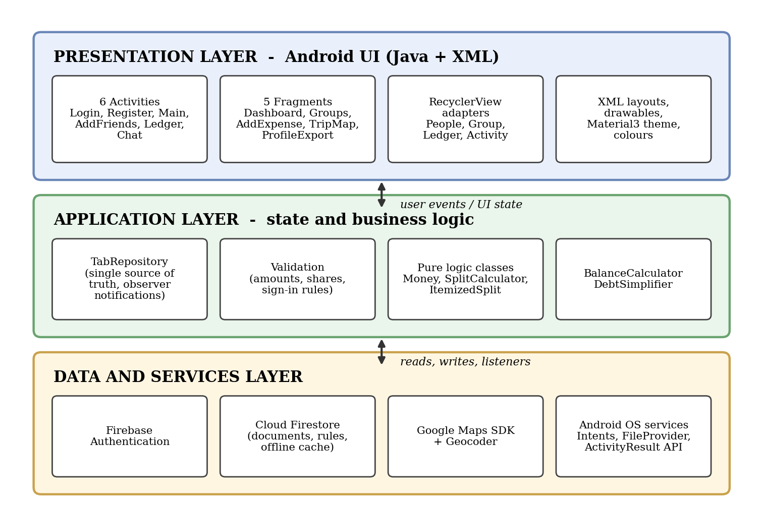
Figure 4.1: Layered architecture of the TABS application
Figure 4.2 shows the same structure at package level. There is no dependency from the logic package back to Android or Firebase classes, which is what allows its tests to run on a plain JVM.
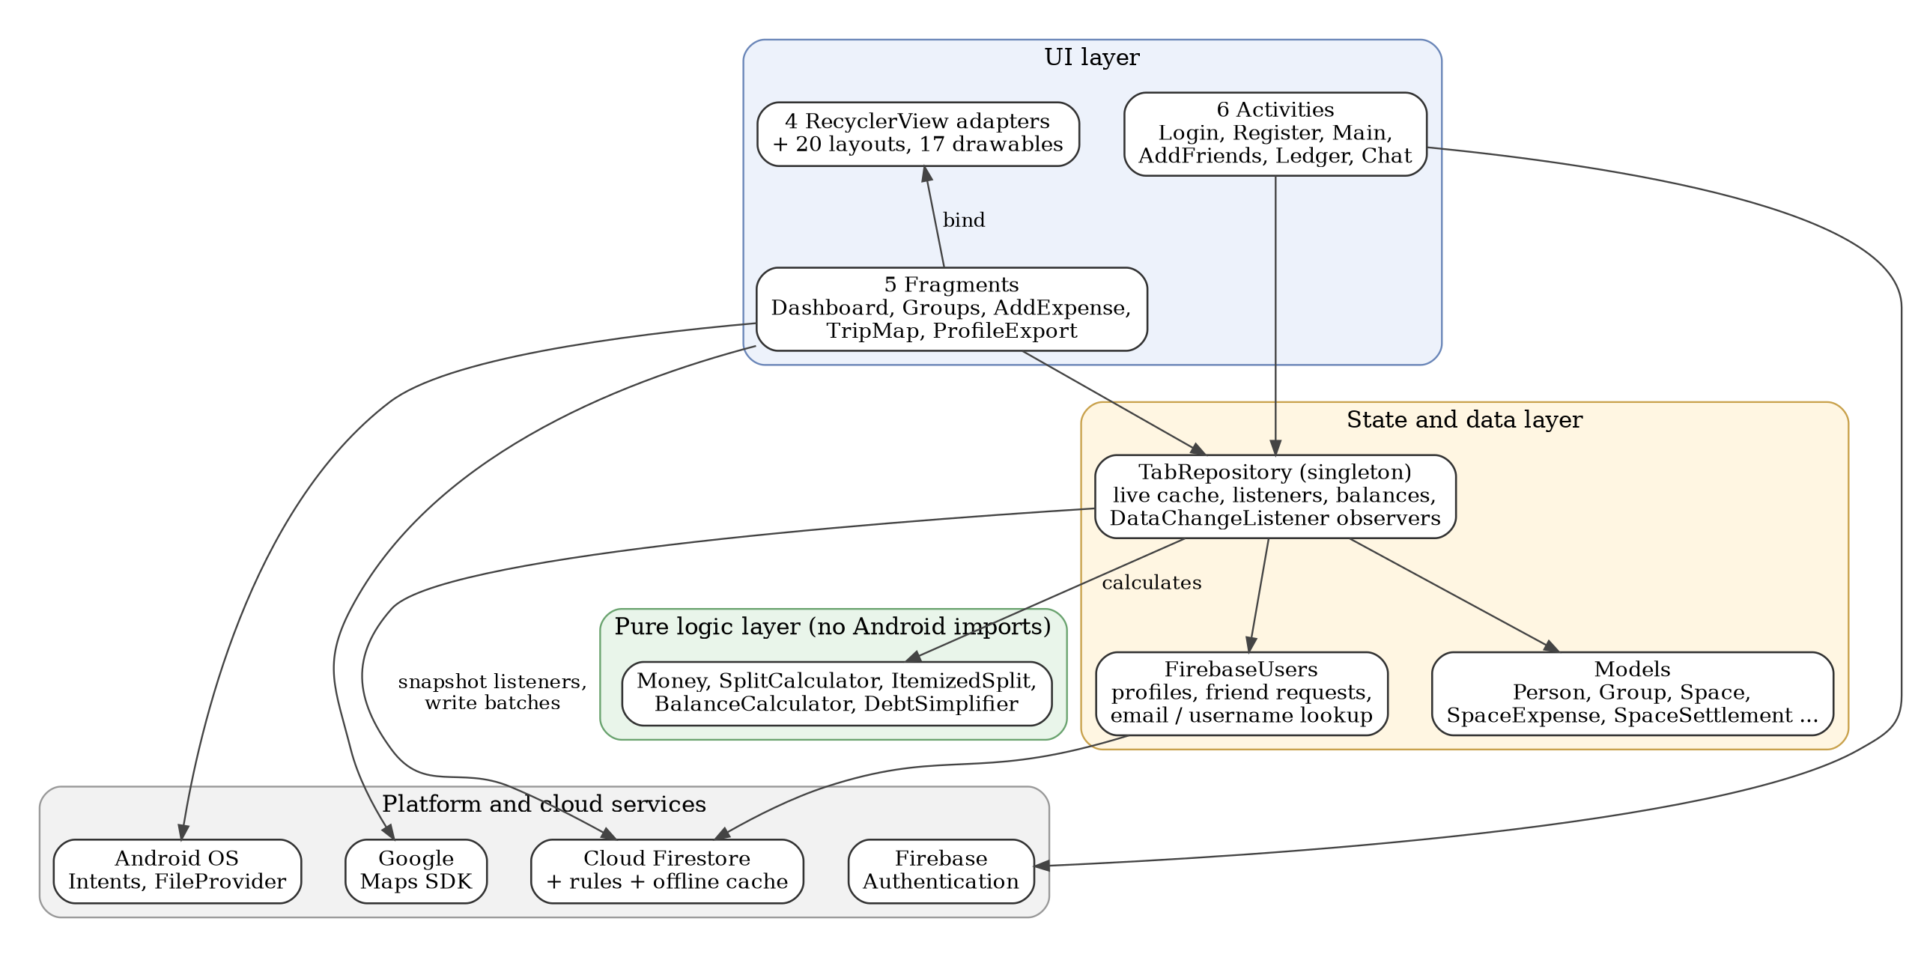
Figure 4.2: Package and component structure of TABS
Why a repository. Balances are derived values, not stored values. TabRepository recomputes pairwise balances whenever an expense or settlement changes and pushes the result to every registered listener. Screens read synchronously from the cache and only observe changes, so no two screens can disagree about a total.

4.2 Client-Server Communication
The installed APK talks to Google services over HTTPS. Firestore requests pass through the security rules before reaching the database. A persistent on-device cache (limited to 100 MB) allows reads and queued writes to work without a connection; queued writes are replayed when the device is online again. Camera and share operations are delegated to other apps through Intents.
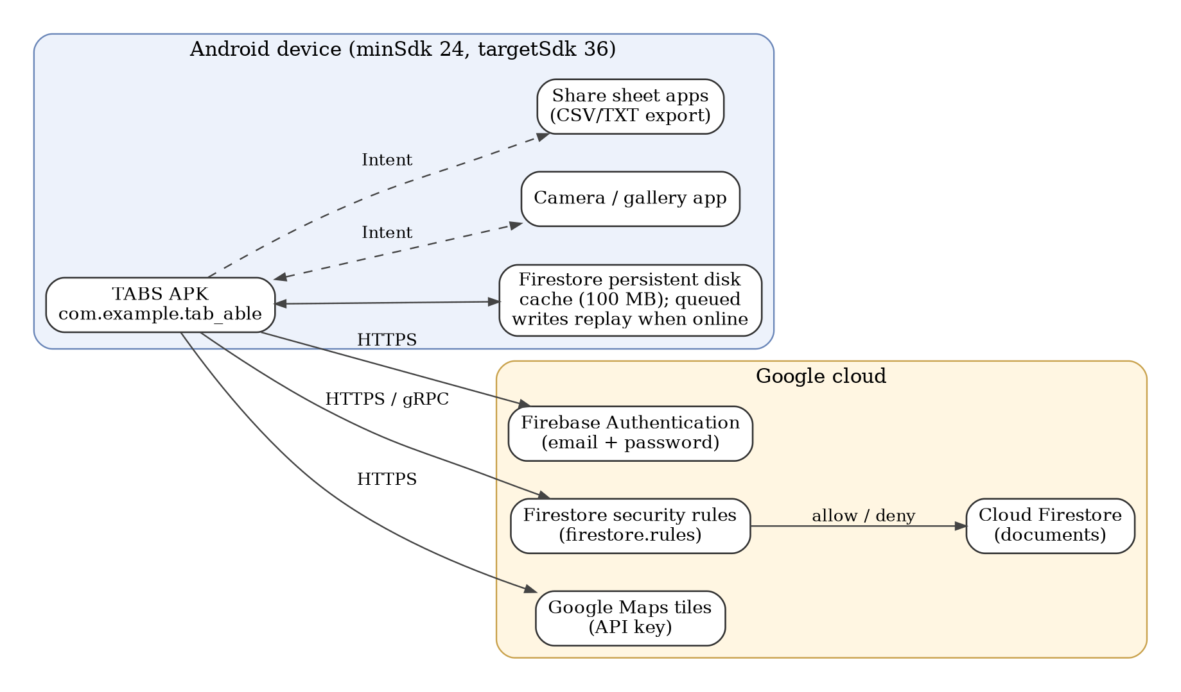
Figure 4.3: Client-server communication of TABS

4.3 Navigation Design
LoginActivity is the launcher. After sign-in, MainActivity hosts a bottom navigation bar with five tabs; each tab is a Fragment swapped into a single container. Detail screens (per-friend ledger, chat, add friends) are separate Activities started with explicit Intents that carry the identifiers of the person or space. Log-out and sign-in use the CLEAR_TASK flag so the Back button can never return a signed-out user to a private screen.
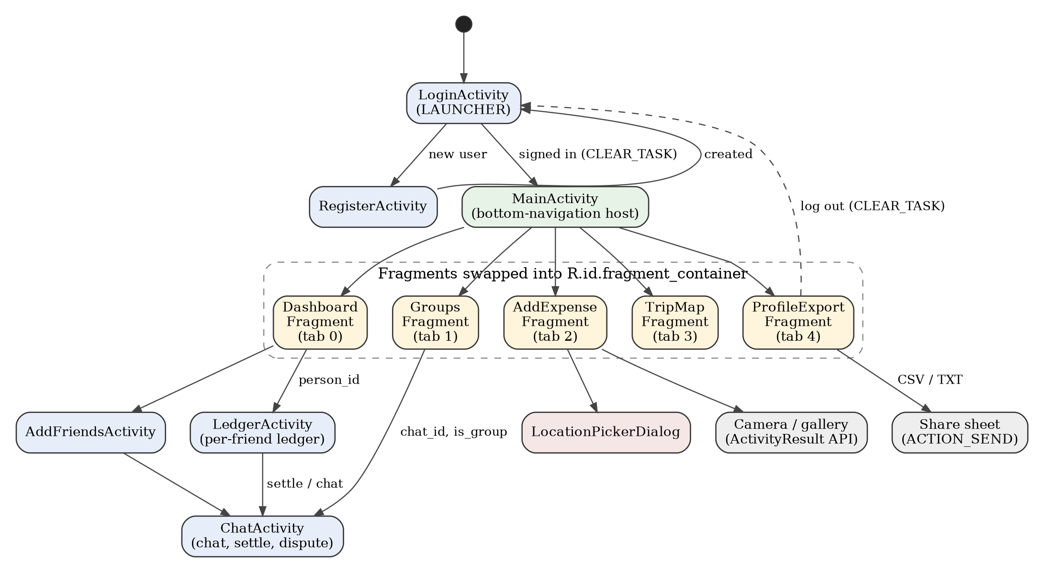
Figure 4.4: Screen navigation flow of TABS

4.4 Lifecycle Design
Android may stop and destroy screens at any time. A Firestore listener that outlives its screen would keep calling into views that no longer exist, causing leaks and crashes. TABS therefore repaints from the repository cache in onResume, registers as an observer while the screen is alive and removes every listener when the screen is destroyed. Figure 4.5 shows the callbacks and what the application does in each.
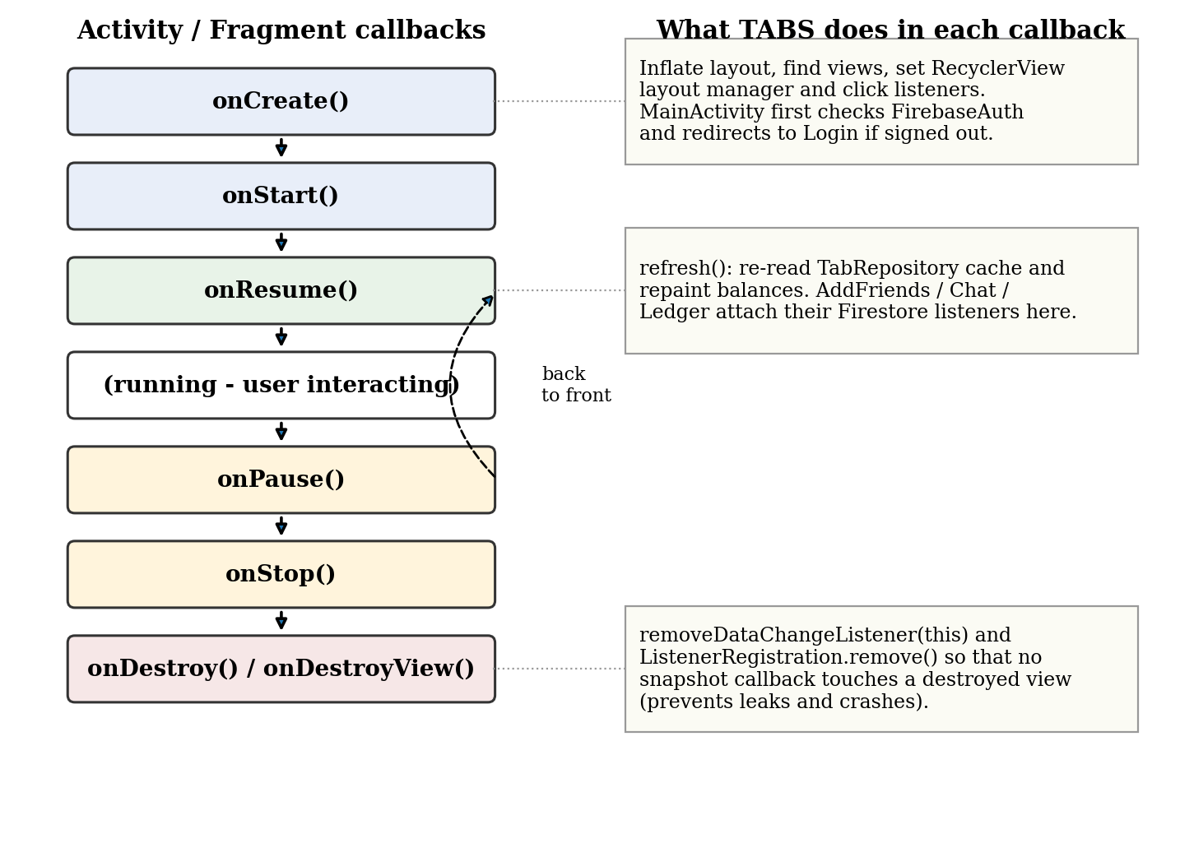
Figure 4.5: Activity and Fragment lifecycle handling in TABS

4.5 Data Storage Design
Cloud Firestore is a document database: data lives in collections of documents and sub-collections, shown in Figure 4.6. Each user has a profile document with friends beneath it. A space is the unit in which people share money: a DIRECT space has two members and is keyed by the two user ids in sorted order, so both people reach the same space without a handshake; a GROUP space has a name, a leader and any number of members. Expenses, messages and settlements are sub-collections of a space and only members may read or write them.
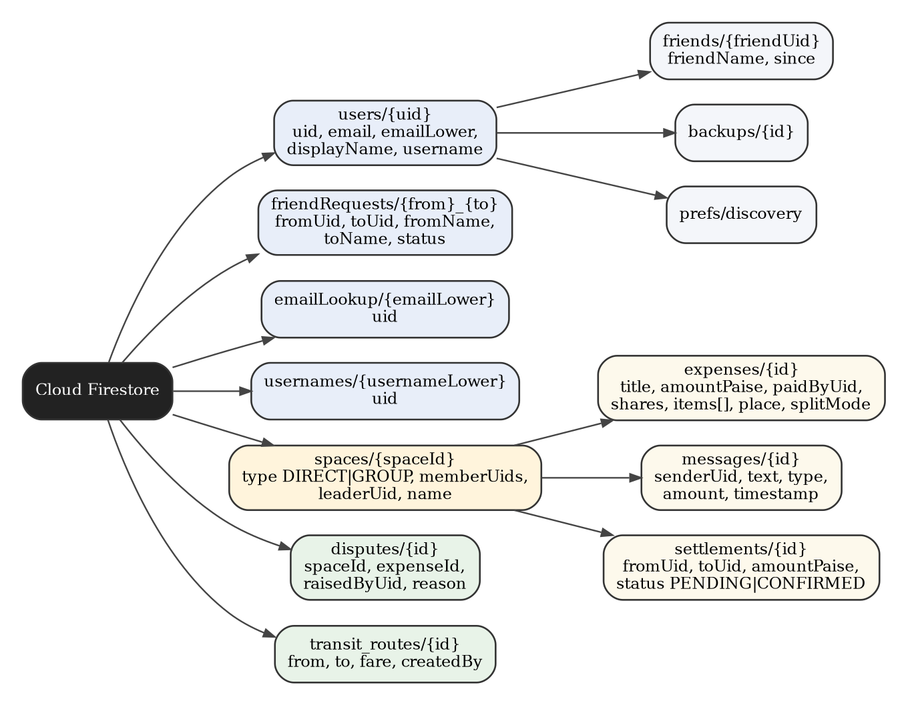
Figure 4.6: Cloud Firestore collection hierarchy
Money units. All money is stored as integer paise so that no rounding error accumulates. The display models use whole rupees, and the conversion happens exactly once, at the boundary. The formatter Money.formatInr builds the string itself with Indian digit grouping and the rupee sign instead of relying on device locale data.
Table 4.1: Unit used at each layer
Component | Unit
Firestore fields, SplitCalculator, ItemizedSplit, BalanceCalculator, DebtSimplifier | Paise (long)
Person.getNetAmount(), Group.getTotalSpent(), LedgerItem (display models) | Rupees (int)
Money.formatInr(paise) | Takes paise, prints rupees with Indian digit grouping
Append-only records. Expenses and settlements are never edited in place. A balance is never stored; it is derived from the records, so a balance can always be explained by listing the documents that produced it.

4.6 User Interface Design
The interface uses a neo-brutalist style: a warm cream background, paper-coloured cards with thick dark outlines and hard shadows, and bright pill-shaped buttons. Colour carries meaning: green marks money owed to the user, red marks money the user owes, lime is the primary action colour, pink and yellow separate secondary states. The theme extends Theme.Material3.DayNight.NoActionBar so that standard Material components keep their behaviour while TABS supplies its own drawables.
Table 4.2: Colour palette defined in res/values/colors.xml
Resource name | Hex value | Use
bg_cream | #F2EFE4 | Screen background
card_paper | #FDFBF3 | Card surface
ink / black | #25232B | Text, outlines and shadows
primary_lime | #B8F04E | Primary actions, selected tab, "owed to you" highlights
accent_pink | #F2A9DD | "You owe" highlights and secondary actions
pop_yellow | #F2C14E | Pending states and attention chips
owe_red | #D63A2F | Amounts the user owes, disputes
owed_green | #1F9D55 | Amounts owed to the user
muted_chip / text_secondary | #EAE5D8 / #666170 | Inactive chips and secondary text
Reusable drawables (bg_card_brut_*, bg_pill_*, bg_input_brut, bg_dashed_box, bg_bottom_nav) give every screen the same look. Empty states ("zero groups", "all square", "you have no friends") tell the user what to do next. The screens themselves are shown in Chapter 7. Table 4.3 lists the Android controls used, so that the interface is not built from text fields and buttons alone.
Table 4.3: Android controls, dialogs and feedback used
Control | Where used | Purpose
EditText (15 in layouts) | Login, Register, Add Expense, Chat, Add Friends | Text and amount input with validation
Spinner + ArrayAdapter | Add Expense | Choose the space (group or friend) for an expense
CheckBox | Add Expense | Select who took part in the split
RecyclerView + adapters | Dashboard, Groups, Ledger, Activity lists | Scrolling lists of people, groups and history
ImageView | Add Expense | Preview of the receipt photo
ProgressBar (3) | Login, Register, Add Expense | Feedback while the network call runs
DatePickerDialog (2) | Add Expense, Ledger | Choose the expense date
AlertDialog (14) | Create group, receipt source, dispute, adjust amount, log out | Choices and confirmations
Toast (78 messages) | All screens | Short feedback and error messages
GoogleMap, markers, polyline | Trip Map, location picker | Location display and picking
Bottom navigation tabs, chips | MainActivity, Trip Map, Groups | Switching sections and filtering by day
An options menu is not implemented in the current build; it is listed under future enhancements.
Table 4.4: Screens and their principal elements
Screen | Main elements
Login / Register | Email and password fields, validation messages, progress indicator, forgot-password link
Dashboard (tab 0) | Totals owed to you and owed by you, people list, groups strip, recent activity
Groups (tab 1) | Groups and one-to-one spaces, dispute badges, create-group dialog
Add Expense (tab 2) | Receipt capture, title, amount, date, space, payer, split mode (equal, custom, items), place picker
Trip Map (tab 3) | Google Map with expense pins, day filter chips, route line, pin detail card
Profile / Export (tab 4) | Account details, friends, balance export as CSV or TXT, recent activity, log out
Ledger | Per-friend history of expenses, settlements and offsets with settle action
Chat | Messages, expense cards, payment proposals with confirm button, dispute dialogs

4.7 Security Design
All authorisation is enforced in firestore.rules on the server; checks inside an app are advisory and can be bypassed by a modified client. Anything not explicitly allowed is denied.
Table 4.5: Summary of Firestore security rules
Collection | Read | Write
users/{uid} | Owner, friends, or someone with a request in flight; listing denied | Owner only
users/{uid}/friends | Owner | Owner, and only with an ACCEPTED request behind it
friendRequests | Either participant | Sender creates; only the recipient accepts or declines
emailLookup, usernames | Any signed-in user, no listing | Claim once, never re-point
spaces and sub-collections | Members only | Members only
settlements | Members | Payee confirms; payer may only keep PENDING or cancel
Anything else | Denied | Denied
Four properties follow from these rules and were checked against the live project: (1) a user cannot write into another user's private data; (2) a friendship cannot be forged because an accepted request must exist; (3) a payer cannot confirm their own payment; (4) the user directory cannot be listed and unrelated profiles are unreadable. An earlier revision let any signed-in user read every profile and email address; this was tightened, and a friend's display name is now stored on the friendship record.

CHAPTER 5
IMPLEMENTATION

5.1 Technology Stack
Table 5.1: Tools, libraries and versions used (from the Gradle build files)
Area | Tool / library | Purpose
Language | Java, source and target compatibility 17 | All application and logic code
SDK levels | minSdk 24, targetSdk 36, compileSdk 36 | Android 7.0 and above
Build | Gradle (Kotlin DSL), version catalog, Android Gradle Plugin 9.3.0, Google Services plugin | Dependency management, APK build, Firebase configuration
UI | AppCompat 1.8.0, Material Components 1.14.0, ConstraintLayout 2.2.2, Activity 1.13.0; XML layouts | Screens, theme, edge-to-edge support
Authentication | Firebase Authentication (BoM 33.7.0) | Email and password sign-in, password reset
Database | Cloud Firestore (BoM 33.7.0) | Cloud documents, real-time listeners, offline cache, rules
Maps | play-services-maps 18.2.0, android.location.Geocoder | Trip map, location picker, reverse geocoding
Testing | JUnit 4.13.2 (unit); Espresso 3.7.0 and AndroidX JUnit 1.3.0 (instrumented template) | Logic tests on the JVM
Release build | R8 shrinking and resource shrinking enabled, ProGuard rules file | Smaller, obfuscated release APK
Utility scripts | PowerShell: validate-rules, verify-firebase, backfill-users | Rules compilation, live-backend checks, profile repair

5.2 Project Structure
com.example.tab_able
LoginActivity, RegisterActivity, MainActivity, AddFriendsActivity,
LedgerActivity, ChatActivity, LocationPickerDialog, TabApp (Application)
adapters/ PeopleAdapter, GroupAdapter, LedgerAdapter, ActivityAdapter
fragments/ DashboardFragment, GroupsFragment, AddExpenseFragment,
TripMapFragment, ProfileExportFragment
data/ TabRepository, FirebaseUsers, models (Person, Group, Space,
SpaceExpense, SpaceSettlement, SpaceMessage, Dispute, ...)
logic/ Money, SplitCalculator, ItemizedSplit,
BalanceCalculator, DebtSimplifier (no Android imports)
res/ 20 layouts, 17 drawables, values (colors, strings, themes),
values-night, xml (backup rules, file_paths), mipmap icons
test/ MoneyTest, ItemizedSplitTest, LogicTest, ExampleUnitTest

The main source set contains 39 Java files (about 9,200 lines across main sources). The three layers of Chapter 4 map directly onto the packages: the UI classes at the top level and in fragments and adapters, state and data access in data, and arithmetic in logic.

5.3 Manifest, Components and the Application Class
AndroidManifest.xml registers six Activities and one content provider. Only LoginActivity is exported because it carries the MAIN and LAUNCHER intent filter; every other Activity has exported set to false so that other apps cannot start it. All Activities use adjustResize for the soft keyboard so that input fields stay visible while typing.
Table 5.2: Components declared in the manifest
Component | Exported | Role
LoginActivity (launcher) | Yes | Sign-in, session restore, password reset
RegisterActivity | No | Account creation with validation
MainActivity | No | Host of five Fragments and the bottom navigation
AddFriendsActivity | No | Find friends by email or username, handle requests, invite by email Intent
LedgerActivity | No | History of expenses and settlements with one friend
ChatActivity | No | Messages, expense cards, settlement and dispute dialogs for a space
FileProvider (androidx.core) | No | Hands a temporary file URI to the camera app, authority applicationId.fileprovider
TabApp (Application) | n/a | Initialises the Maps renderer and enables the Firestore persistent cache before any other Firestore call
The Application subclass TabApp runs once per process. It turns on Firestore's on-disk cache (100 MB) and falls back to the in-memory cache if that fails, so a configuration problem can never stop the app from starting:
FirebaseFirestoreSettings settings = new FirebaseFirestoreSettings.Builder()
.setLocalCacheSettings(PersistentCacheSettings.newBuilder()
.setSizeBytes(100L * 1024 * 1024).build())
.build();
FirebaseFirestore.getInstance().setFirestoreSettings(settings);

5.4 User Interface Implementation
Layouts. Each screen is an XML layout; there are 20 in total, including item layouts for list rows (item_person, item_group, item_ledger_expense, item_ledger_settle, item_ledger_offset, item_activity). Bottom navigation. MainActivity swaps Fragments into the FrameLayout fragment_container with a FragmentTransaction. The tab bar is built from LinearLayouts so that the selected tab can be drawn as a lime pill:
public void selectTab(int tabIndex) {
Fragment fragment;
switch (tabIndex) {
case 1: fragment = new GroupsFragment(); break;
case 2: fragment = new AddExpenseFragment(); break;
case 3: fragment = new TripMapFragment(); break;
case 4: fragment = new ProfileExportFragment(); break;
default: fragment = new DashboardFragment(); break;
}
getSupportFragmentManager().beginTransaction()
.replace(R.id.fragment_container, fragment).commit();
updateBottomNavUI(tabIndex);
}

RecyclerView adapters. PeopleAdapter, GroupAdapter, LedgerAdapter and ActivityAdapter bind model objects to row layouts; the adapters also start detail Activities when a row is tapped. Guard on entry. MainActivity's onCreate checks FirebaseAuth and the repository identity first and, if the user is signed out, redirects to LoginActivity with NEW_TASK and CLEAR_TASK flags and finishes, so a private screen is never shown to a signed-out user. Dialogs. Create-group, receipt-source, dispute and adjust-amount interactions use AlertDialog; the location picker is a DialogFragment containing a map.

5.5 Navigation and Intents
Detail screens are started with explicit Intents. The identifiers travel as string extras, and the receiving Activity reads them in onCreate. Table 5.3 lists the extras used.
Table 5.3: Intent extras exchanged between screens
Extra | Sent from | Used by / meaning
person_id | PeopleAdapter, GroupsFragment, AddFriendsActivity | LedgerActivity and ChatActivity: uid of the friend
chat_id | GroupAdapter, GroupsFragment, LedgerActivity | ChatActivity: space id (falls back to person_id)
person_name | Adapters, LedgerActivity | ChatActivity header title
is_group | GroupAdapter (true), others (false) | ChatActivity: group or direct layout
EXTRA_SUBJECT / EXTRA_TEXT | AddFriendsActivity, ProfileExportFragment | System email client and share sheet (implicit Intents)
Two implicit Intents hand work to other apps: ACTION_SENDTO with a mailto target invites a friend by email, and ACTION_SEND wrapped in Intent.createChooser shares the exported CSV or TXT text.

5.6 Lifecycle and Listener Management
Every long-lived subscription has an owner and a release point. Fragments register with the repository and remove themselves in onDestroyView; Activities that open Firestore listeners (ChatActivity, AddFriendsActivity) keep the returned ListenerRegistration objects and call remove() in onDestroy. onResume repaints from the cache so a screen is correct after returning from another Activity:
@Override protected void onDestroy() {
super.onDestroy();
if (chatListener != null) chatListener.remove();
if (settlementListener != null) settlementListener.remove();
}

Fragments also guard asynchronous callbacks with isAdded() so that a late result cannot touch a detached Fragment. This is the practical meaning of the diagram in Figure 4.5.

5.7 Data Layer: Repository, Listeners and Offline Cache
TabRepository is a synchronised singleton. After sign-in it registers snapshot listeners on the user's friends, the spaces the user belongs to, and, for each space, its expenses and settlements. Each callback updates the cache, recomputes balances with the logic classes, converts paise to rupees once for the display models and calls every registered DataChangeListener. Screens implement onDataChanged() and repaint. Writes that touch several documents use a Firestore WriteBatch so that they succeed or fail together (for example, accepting a friend request writes the request status and both friendship records).
Offline behaviour is configured, not assumed. With the persistent cache enabled in TabApp, a write made without a connection is applied locally at once, survives an app restart and is replayed to the server when the device is online. Without it, writes can be dropped and the app merely looks as if it did not save. The Firestore client therefore also serves as the app's local storage layer; no SQLite, Room or SharedPreferences code is used.

5.7.1 Create, read, update and delete operations
Table 5.4 summarises how each kind of data is created, read, updated and deleted in Firestore. Records that carry money are append-only by design, so deletion is deliberately limited.
Table 5.4: CRUD operations on stored data
Data | Create | Read | Update | Delete
Profile | Registration writes the profile and lookup documents | loadProfile at login | syncProfile, preferences (merge) | Not provided
Friend request | sendFriendRequest | Live request listener | Accept or decline sets the status | Not provided
Space (group / direct) | createGroup, direct space on demand | Spaces snapshot listener | Not provided | Not provided
Message | Send in chat | Chat snapshot listener | Not provided | Not provided
Expense | addExpense | Expenses listener per space | Shares or amount recomputed by dispute resolution | Not provided (append-only)
Settlement | createSettlement (PENDING) | Settlements listener | updateSettlementStatus (CONFIRMED) | Payer may withdraw (allowed by rules)
Dispute | raiseDispute | Disputes listener | Resolution edits the expense | Removed when resolved
Backup | Backup document written from the app | Not provided | Not provided | Not provided

5.8 Authentication
LoginActivity validates the email with Patterns.EMAIL_ADDRESS and a non-empty password, calls signInWithEmailAndPassword and, on success, pushes the identity into the repository, loads the stored profile from Firestore and only then opens MainActivity. If a session already exists, the form is skipped but the same profile load happens first, so a returning user always sees their real name and balances. Firebase error text is translated into plain messages such as "wrong email or password".
auth.signInWithEmailAndPassword(email, password)
.addOnCompleteListener(task -> {
if (!task.isSuccessful()) { showProgress(false, null);
toast("Login failed: " + describe(task.getException())); return; }
completeSignIn(auth.getCurrentUser(), false);
});

Registration creates the Firebase account, then writes the profile document and the emailLookup and usernames documents so that the user can be found by email or username. Passwords are handled only by Firebase Authentication and are never stored in the application database. A password-reset email can be requested from the login screen.

5.9 Core Business Logic
The logic package contains the only code in which a mistake silently changes who owes whom, so it is isolated, free of Android classes and unit tested.

5.9.1 Money
Money.parsePaise accepts a plain positive amount with an optional single rupee sign and at most two decimals and rejects everything else. An earlier version stripped every non-digit character, so "12abc" silently became 12; it is now strict and the user is told rather than having a wrong number saved. Money.formatInr prints rupees with Indian digit grouping.

5.9.2 Equal and custom split
For a total of T paise shared by n people, each share is T / n and the first T mod n people receive one extra paisa, so shares always add up to exactly T. A custom split succeeds only when the entered amounts add up to the total, and otherwise reports the difference.
long base = totalPaise / n;
long remainder = totalPaise % n;
for (int i = 0; i < n; i++) {
long share = base + (i < remainder ? 1L : 0L);
shares.put(uids.get(i), share);
}

5.9.3 Itemised split
ItemizedSplit divides each line item among only the people who had it, using SplitCalculator for each item, so the garlic bread is paid for by those who shared it and not by the person who only had a drink. An item with a price but nobody selected is not spread over everyone: it blocks submission and reports the amount, because there is no honest way to charge an item to nobody.
Execution of the actual class on a ₹1,210 bill (pizza ₹650 shared by three, garlic bread ₹180 by You and Meher, cold coffee ₹160 by Arjun, mojito ₹220 by Meher) gave You ₹306.67, Meher ₹526.67 and Arjun ₹376.66; in paise 30,667 + 52,667 + 37,666 = 121,000, exactly the bill. Adding a ₹60 item with nobody selected made the result incomplete with 6,000 paise unassigned.

5.9.4 Net balance and pairwise balance
BalanceCalculator credits the payer with the full amount and debits each participant's share; a settlement increases the payer's balance and decreases the payee's. A positive value means the person is owed money. The pairwise function reduces reciprocal debts: when K owes Aman ₹300 and Aman owes K ₹150, the result is ₹150 owed by K, confirmed by running the class (15,000 paise).

5.9.5 Debt simplification
DebtSimplifier takes the net balance of each person and repeatedly pairs the largest debtor with the largest creditor, transferring the smaller of the two amounts, until everything is balanced. Figure 5.1 shows the run on four people. It produced three payments, the minimum that the greedy method yields here.
Collections.sort(entries); // debtors first, creditors last
BalanceEntry debtor = entries.get(0);
BalanceEntry creditor = entries.get(entries.size() - 1);
long transfer = Math.min(-debtor.getAmount(), creditor.getAmount());
transfers.add(new Transfer(debtor.getUid(), creditor.getUid(), transfer));

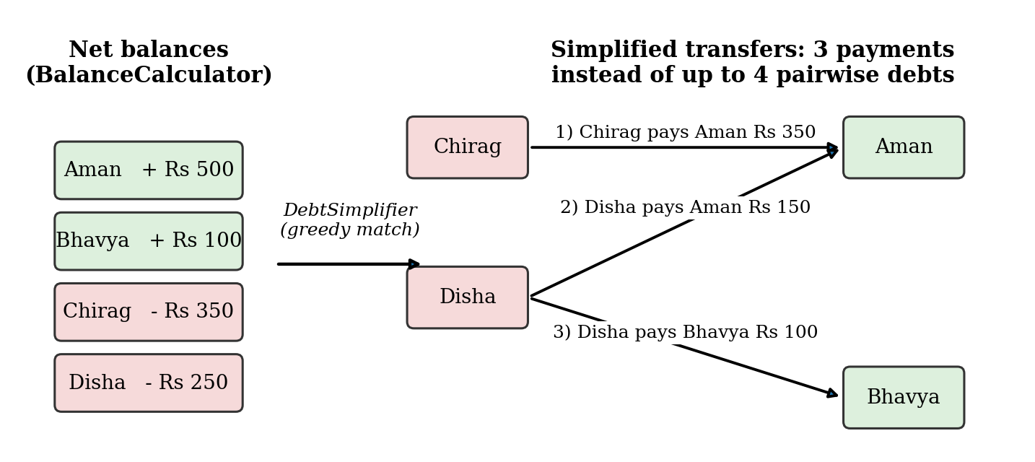
Figure 5.1: Debt simplification worked example

5.10 Feature Modules

5.10.1 Friends and requests
A user searches by exact email or username through the lookup collections (the user directory itself cannot be listed). Sending a request writes a friendRequests document; only the recipient can accept or decline it, and accepting writes both friendship records in one batch. A listener shows incoming requests live. If the person is not yet on TABS, the app opens the email client with an invitation.

5.10.2 Groups, spaces and chat
Creating a group resolves member emails or usernames to uids, creates a GROUP space with the creator as leader and navigates members into a chat. A DIRECT space is created on demand with the sorted-id key. Messages are documents in the space; the chat screen renders text, expense and payment cards from them through a snapshot listener keyed strictly by space id.

5.10.3 Expense entry
AddExpenseFragment collects the title, amount, date (DatePickerDialog), space, payer and split mode (equal, custom or items) and an optional place. The amount is parsed to paise, the shares are computed by the logic classes, and a single expense document with the shares map (and items list for itemised bills) is written. Validation stops zero amounts, non-numeric input, custom shares that do not add up and itemised bills with unassigned items.

5.10.4 Receipt capture
The receipt button asks whether to use the camera or the gallery. Both paths use the modern ActivityResult API: GetContent for the gallery and TakePicture for the camera, with the photo written to a temporary file exposed through FileProvider. No storage or camera permission is needed:
pickReceiptImage = registerForActivityResult(
new ActivityResultContracts.GetContent(),
uri -> { if (uri == null) return; receiptUri = uri; showReceiptPreview(); });
takeReceiptPhoto = registerForActivityResult(
new ActivityResultContracts.TakePicture(),
success -> { if (success == null || !success) return; showReceiptPreview(); });

The photo is saved as a temporary JPEG in the app's cache folder (cache/receipts), shown with ImageView.setImageURI, and never leaves the device: no Firebase Storage dependency is used, so the image is not uploaded. Honest limit: after the image is shown, the screen runs a short progress animation and fills a sample item list that is labelled as a sample in the interface. Real text recognition would need ML Kit or a cloud vision API and is listed as future work.

5.10.5 Settlements
A payment is first written to the space's settlements collection with status PENDING and affects no balance. The payee sees a proposed payment with a confirm action; confirming sets the status to CONFIRMED, after which BalanceCalculator includes it. The rules allow only the payee to confirm and only the payer to cancel or delete. This prevents a user from clearing their own debt unilaterally.

5.10.6 Disputes
From an expense card a member can raise a query with a reason, which creates a dispute document shown as a badge on the group. A member can then resolve it by removing themselves from the split (shares are recomputed equally among the rest), adjusting the amount (shares are recomputed for the new total) or dismissing it. The dispute document is deleted when resolved.

5.10.7 Trip map and location picker
TripMapFragment loads located expenses, builds day filter chips only for days that have a located expense, draws numbered markers and a route polyline with the Google Maps SDK, and shows a detail card when a pin is tapped. In AddExpenseFragment, LocationPickerDialog lets the user tap the map to drop a pin; the place name is reverse-geocoded with android.location.Geocoder on a background thread because geocoding does blocking network input and output.

5.10.8 Text and CSV file handling
ProfileExportFragment builds the balances as either CSV text (header row Name, Username, Direction, Amount (INR), Status, with values escaped for commas and quotes) or a formatted plain-text balance receipt, and hands it to the Android share sheet with ACTION_SEND through Intent.createChooser. The filename tabs-balances.csv or tabs-balances.txt is used in the chooser title and a Toast confirms. If there is nothing to export, a Toast explains why instead of sharing an empty file.
Honest limit: the content is sent as shared text; the current code does not write a physical .csv or .txt file to storage, and the scope and period chips on the screen are not yet applied. The remaining step is small and reuses components already in the project: write the string with FileOutputStream into a folder under getCacheDir(), expose it through the existing FileProvider (adding an exports path to file_paths.xml) and send the content URI with EXTRA_STREAM and the text/csv or text/plain MIME type. This is recorded as the next task so that the file-handling rule of the course is fully met.

5.11 Permissions and Device Features
TABS follows the principle of least privilege. INTERNET and ACCESS_NETWORK_STATE are normal permissions granted at install. Location permissions are declared only to show the optional "my location" dot on the picker map; the call is wrapped so that a SecurityException simply leaves the dot off, and panning and tapping still work. The current build does not show a runtime permission prompt for location, which is listed as an improvement. CAMERA is deliberately not declared because ACTION_IMAGE_CAPTURE lets the camera app take the picture; declaring it would make Android demand a runtime grant that was never requested. A queries element for IMAGE_CAPTURE is declared so that, on Android 11 and later, resolveActivity can see the camera app. Camera features are marked required="false".

5.12 Error Handling and Validation
- Every repository write accepts a result callback; failures are shown as messages and never reported as success.
- Inputs are validated before they reach the repository: empty or malformed email, empty password, zero or non-numeric amount, shares that do not add up, itemised bills with unassigned items.
- Firebase exceptions are mapped to readable text; network failures say so.
- Loading and progress states disable the action button to prevent duplicate submissions.
- Listener errors are logged and ignored rather than allowed to crash a screen; empty states tell the user what to do.

5.13 Engineering Problems and How They Were Solved
Table 5.5: Defects and design problems found and fixed
No. | Problem | Cause | Fix
1 | A real ₹350 balance showed as ₹35,000 | Three call sites divided paise by 100 and three did not | Convert once at the boundary; unit test paiseBalance_isNotRenderedHundredTimesTooLarge
2 | Every receipt photo failed with a permission denial | CAMERA declared in the manifest but never requested at runtime | Remove the declaration; use ACTION_IMAGE_CAPTURE through TakePicture
3 | Device appeared to have no camera app on Android 11+ | Package visibility filtering | Add a queries element for IMAGE_CAPTURE
4 | Security rules would not publish | Rules language forbids the ternary operator and bool-to-string concatenation | Unsorted friend-request id accepted in both orders; compile rules with the real compiler before publishing
5 | A new account could list every user and email | Rule allowed any signed-in user to read profiles | Profiles readable only by owner, friends or in-flight request; names stored on the friendship record
6 | Writes lost when offline | No persistent cache | Enable persistent cache in TabApp
7 | Chat messages from other rooms appeared | Listeners matched ids by substring | Strict equality on space id
8 | Typed text vanished while typing | View rebuilt on every keystroke | Separate cheap updates (labels, colours) from structural rebuilds
9 | Some accounts could be found but not receive requests | Auth account without a Firestore profile | Repair at login (repairLookupIndex) and a backfill script
10 | A mock receipt scanner put invented numbers into real expenses | Fixed fake item list presented as a result | Label the output as a sample in the UI

5.14 Code Quality and Known Technical Debt
The following items are known and documented rather than hidden. CustomMapView, PlaceRepository with its GeoJSON asset, and TabsCourtDialogFragment are unreferenced leftovers of earlier prototypes and are candidates for deletion. TripMapFragment and AddExpenseFragment still query Firestore directly instead of going through TabRepository. Fragments and Activities are large (AddExpenseFragment about 1,250 lines, ChatActivity about 800), which a future refactor could split.

5.15 New Concepts Learned Beyond the Classroom
The project required learning tools and techniques that go beyond the basic Activity, layout and Intent material of the course. Each is demonstrated in the application and is relevant to its requirements.
Table 5.6: New concepts self-learned and where they are demonstrated
No. | New concept | What was learned and applied | Evidence
1 | Firebase Authentication | Account creation, sign-in, session persistence, password reset | Section 5.8
2 | Cloud Firestore and real-time snapshot listeners | Document modelling, sub-collections, live updates, WriteBatch | Sections 4.5, 5.7
3 | Firestore security rules | Server-side authorisation, rules compiler limits, live-backend verification script | Sections 4.7, 5.13; Appendix B
4 | Offline persistence | Persistent disk cache and queued writes | Section 5.7
5 | Google Maps SDK and Geocoder | Markers, polylines, bounds, tap-to-pick, reverse geocoding on a worker thread | Section 5.10.7
6 | ActivityResult API and FileProvider | Camera and gallery without storage or camera permission | Sections 5.10.4, 5.11
7 | Repository and Observer patterns | Single source of truth with change notification | Sections 2.4, 4.1, 5.7
8 | Exact money arithmetic | Integer paise, remainder distribution, boundary conversion | Sections 4.5, 5.9
9 | Algorithm design: debt simplification | Greedy net-balance matching | Section 5.9.5; Figure 5.1
10 | JVM unit testing of Android project logic | Separating pure logic so JUnit can run without a device | Chapter 6

CHAPTER 6
TESTING AND QUALITY ASSURANCE

6.1 Testing Strategy
Testing is layered. Unit tests check calculation and validation logic on the JVM in milliseconds. A backend verification script checks that the deployed security rules actually hold. Functional test cases exercise complete workflows on an emulator or device. Tests were concentrated where a bug is invisible rather than merely inconvenient: wrong money values look plausible on screen.
Table 6.1: Testing levels
Level | Focus | Example
Unit | Pure calculation and parsing | Equal split of 1000 paise among 3 sums to 1000
Backend / security | Rules enforced by the live project | Payer cannot confirm own payment (403)
Integration | UI, repository and Firestore together | Add expense then balances refresh
System | Complete workflow | Register, add friend, add expense, settle, confirm
Compatibility | Devices and screen sizes | Emulator and physical phone, Android 7.0 and later

6.2 Unit Tests
The project contains 32 JVM unit tests in four classes, as recorded in the project README. Test names describe behaviour, and two are named after real defects that shipped: paiseBalance_isNotRenderedHundredTimesTooLarge and parsePaise_rejectsDigitsMixedWithWords.
Table 6.2: Unit test suites
Suite | Tests | Covers
MoneyTest | 12 | Parsing rupees to paise, currency decoration, rejection of nonsense, Indian digit grouping, negative amounts, rupee sign, boundary conversion, equal and custom split sums
ItemizedSplitTest | 11 | Per-item splitting, remainder paise, unassigned items, zero or negative prices ignored, empty input, a consumer outside the participant list, every item accounted for
LogicTest | 8 | Equal split of 1000 by 3, custom mismatch, payer outside the split, settlement reducing a balance, four-person debt simplification, money parsing, GeoJSON parsing
ExampleUnitTest | 1 | Project template

6.3 Verification of Worked Examples
To obtain concrete results for this report, the logic classes were compiled and executed directly with a small driver program. The outputs are in Table 6.3.
Table 6.3: Results of executing the logic classes
Input | Expected | Actual result
splitEqually(1000 paise, 3 people) | Shares sum to 1000 | 334, 333, 333 (sum 1000)
splitEqually(₹600, 3 people) | ₹200 each | 20,000 paise each
K owes Aman ₹300, Aman owes K ₹150 | K owes Aman ₹150 | Pairwise 15,000 paise; net K -15,000, Aman +15,000
Net: Aman +500, Bhavya +100, Chirag -350, Disha -250 (₹) | 3 payments | Chirag to Aman ₹350, Disha to Aman ₹150, Disha to Bhavya ₹100
Itemised ₹1,210 bill, three people | Shares sum to the bill | 30,667 + 52,667 + 37,666 = 121,000 paise; complete
Same bill plus ₹60 item with nobody selected | Reported as incomplete | Incomplete, 6,000 paise unassigned
formatInr(123456789 paise) | Indian grouping | ₹12,34,567.89
formatInr(35000) and formatInr(-35000) | ₹350 and -₹350 | ₹350 and -₹350
parsePaise("350") and parsePaise("₹99.5") | 35,000 and 9,950 | 35,000 and 9,950
parsePaise("12abc") | Rejected | IllegalArgumentException: "Amount must be a number, e.g. 250 or 99.50"

6.4 Functional Test Cases
Table 6.4 lists the test cases and their results. TC-01 to TC-03 were run on a device by the team. TC-04, TC-06 and TC-07 are confirmed by executing the logic classes (Table 6.3). Rows marked "code review" were assessed by reading the code and the security rules against the expected result; they show that the behaviour is implemented, not that it was observed on a device. Rows marked "Not run" depend on the device environment and remain to be executed.
Table 6.4: Functional test cases
ID | Action | Expected result | Result
TC-01 | Register with valid email and password | Account created; user reaches the dashboard | Fail
TC-02 | Log in with wrong password | Message "wrong email or password"; no access | Pass
TC-03 | Open the app while signed in | Profile restored, dashboard opens directly | Pass
TC-04 | Equal split of ₹600 among 3 | Each share ₹200 | Pass (logic run, Table 6.3)
TC-05 | Enter amount 0 or "12abc" | Validation blocks saving | Pass (unit tests; amount checks in Add Expense code)
TC-06 | Custom shares not adding to total | Difference reported; save blocked | Pass (splitCustom test)
TC-07 | K owes ₹300, Aman owes ₹150 | Net K owes Aman ₹150 | Pass (Table 6.3)
TC-08 | Payer proposes payment | Status PENDING; balance unchanged | Pass (code review)
TC-09 | Payee confirms payment | Status CONFIRMED; both balances update | Pass (code review)
TC-10 | Payer tries to confirm own payment | Rejected by rules (403) | Pass (rules and UI review)
TC-11 | Non-member opens a space | Access denied by rules | Pass (rules review)
TC-12 | Itemised bill with an unassigned item | Submission blocked with the amount shown | Pass (unit test and code review)
TC-13 | Take a receipt photo; pick one from gallery | Preview appears; no permission prompt | Pass (code review)
TC-14 | Add expense with a map pin; open Trip Map | Pin shown; day filter works | Not run (needs a device with the Maps key)
TC-15 | Raise and resolve a dispute (adjust amount) | Shares recomputed; dispute removed | Pass (code review)
TC-16 | Add expense with airplane mode on, then reconnect | Expense appears locally and syncs later | Not run (offline cache is configured in TabApp)
TC-17 | Export balances as CSV and TXT | Share sheet opens with correct content | Pass (code review): text is shared; no file is saved
TC-18 | Rotate the device on Add Expense and Chat | No crash; state sensible | Not run
TC-19 | Log out and press Back | Returns to login, not a private screen | Pass (code review)
Defect found: TC-01 (registration) failed on the first device run, while sign-in (TC-02, TC-03) works. Registration is a three-step flow (email, a demo verification code, then name, username and password), creates a Firebase Authentication account, checks the username in Firestore and then writes the profile and lookup documents, rolling the account back if any step fails. It therefore depends on Email/Password sign-in being enabled, the Firestore rules being published and the device being online. The failure message shown on screen identifies the step, and the case must be re-run after correcting it.

6.5 Backend Security Verification
Unit tests cannot show that a security rule holds, so the project includes three tools. validate-rules.ps1 compiles firestore.rules with the real Firebase rules compiler and reports errors with line numbers; this caught both rules-language limitations described in Section 5.13. verify-firebase.ps1 creates disposable accounts, checks its own credentials first, asserts the four security properties of Section 4.7, runs a full friend-request handshake, writes a chat message and a settlement, deletes everything it created and prints ALL CHECKS PASSED when the backend behaves as specified. backfill-users.ps1 repairs accounts that exist in Authentication but lack a Firestore profile.

6.6 Play Store Readiness and Material Design Check
The project rubric asks for an application that is workable and prepared to the Play Store requirements, with Material Design followed. Table 6.5 states honestly where the build stands.
Table 6.5: Play Store and Material Design readiness checklist
Requirement | Status | Notes / action
Target API level meets current policy | Met | targetSdk 36, compileSdk 36
Unique application ID | Action needed | com.example.tab_able uses the reserved example prefix and cannot be published; change namespace and applicationId to your own domain
Versioning | Met | versionCode 1, versionName 1.0; increment for each upload
Release build optimisation | Met | R8 and resource shrinking enabled for release
Signing and app bundle | Action needed | Create an upload key and build an Android App Bundle (.aab)
Launcher icon | Met | Adaptive icon (mipmap-anydpi-v26) plus density images
Permissions justified, minimal | Met | No CAMERA or storage permission; location is optional
Privacy policy and Data safety form | Action needed | App collects email, display name and optional place data; write and link a policy
API key hygiene | Action needed | Maps key must be restricted to the app package and signing certificate
Material 3 theme and dark mode | Partly met | Theme.Material3.DayNight.NoActionBar and a values-night theme exist; custom drawables replace default Material component styling
Standard navigation component | Partly met | Bottom navigation is a custom LinearLayout; BottomNavigationView would give standard behaviour and accessibility
Accessibility | Not yet audited | Check content descriptions, touch target size and contrast with Accessibility Scanner
Stability across devices | Partly met | TC-01 to TC-03 were run on a device; the remaining cases of Table 6.4 still need a device or emulator run

CHAPTER 7
RESULTS, DISCUSSION AND FUTURE SCOPE

7.1 User Interface Screens
The figures below show the principal screens of TABS. They are the project's UI design screens; before final submission replace or supplement them with captures from the emulator or device build
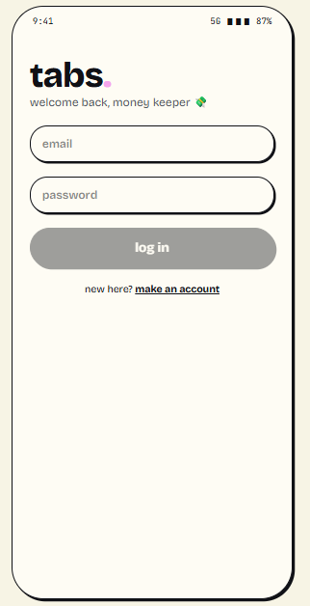  Figure 7.1: Login screen | 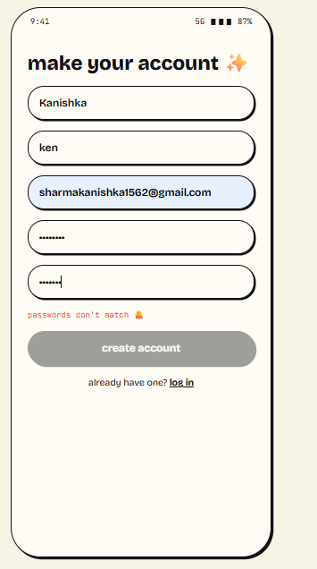  Figure 7.2: Registration with validation message | 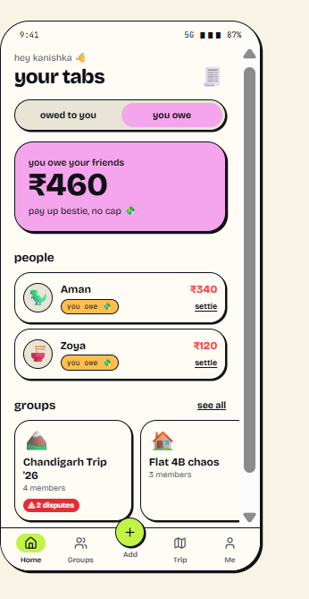  Figure 7.3: Dashboard, "you owe" view
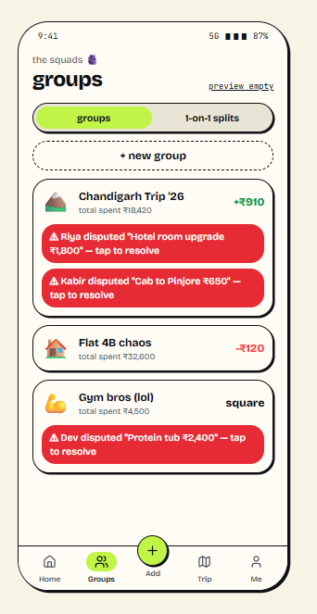  Figure 7.4: Groups with dispute badges | 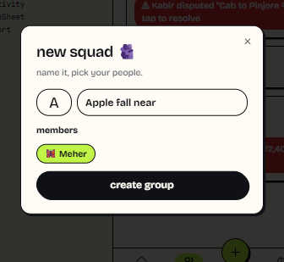  Figure 7.5: Create-group dialog | 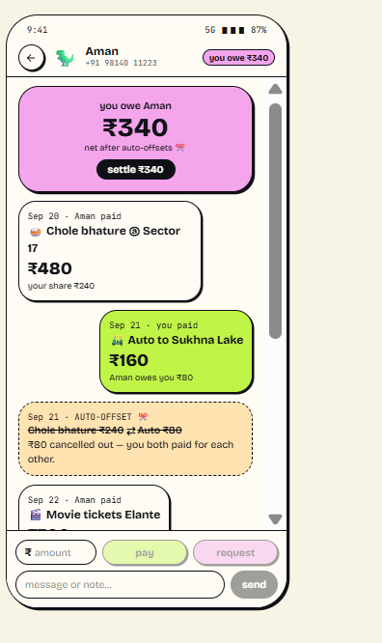  Figure 7.6: Ledger and chat with settle action
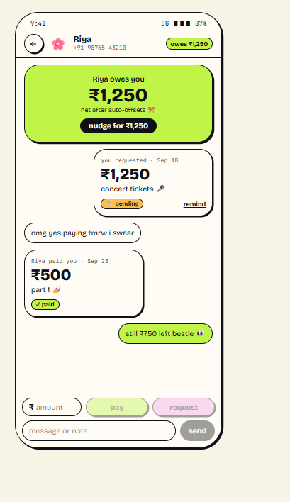  Figure 7.7: Space chat with payment request | 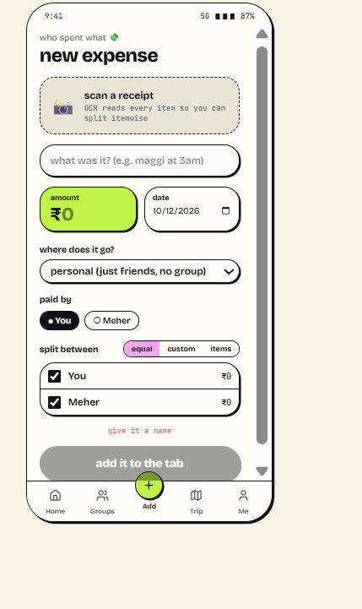  Figure 7.8: Add expense with receipt option | 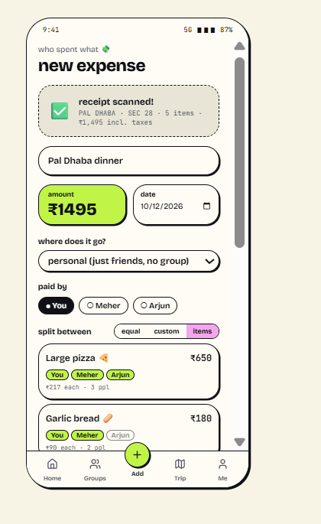  Figure 7.9: Receipt captured (sample items)
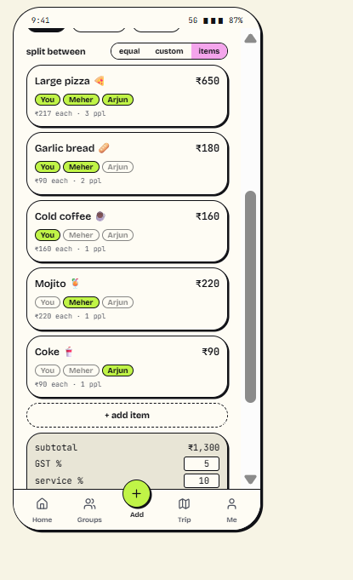  Figure 7.10: Itemised split | 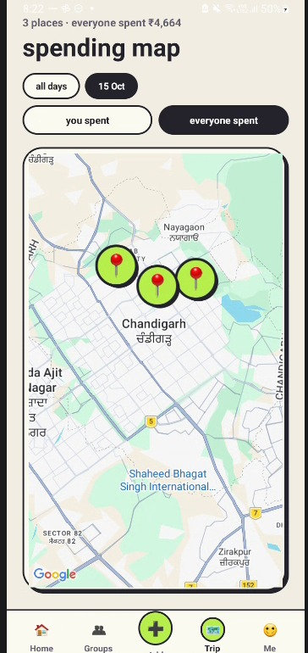  Figure 7.11: Trip map with pins and route
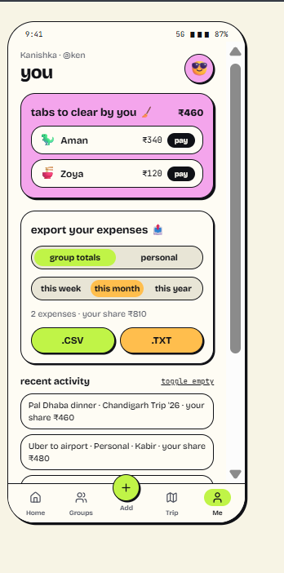  Figure 7.13: Profile and export | 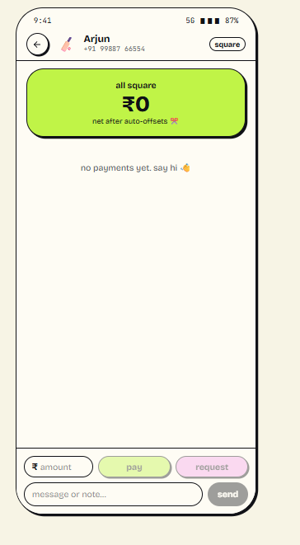  Figure 7.14: "All square" empty state

7.2 Objectives Versus Outcomes
Table 7.1: Achievement of the objectives
Objective | Achieved | Evidence
Secure sign-in, friends | Partly | Sections 5.8, 5.10.1; TC-02 and TC-03 pass; TC-01 (registration) failed and is to be re-run
Direct and group spaces with real-time chat | Yes | Section 5.10.2
Equal, custom and itemised splitting, exact arithmetic | Yes | Section 5.9; Table 6.3; unit tests
Net balances and debt simplification | Yes | Figure 5.1; Table 6.3
Two-step settlement confirmed by payee | Yes | Section 5.10.5; rules in Appendix B
Dispute raising and resolution | Yes (no voting) | Section 5.10.6
Location-tagged expenses on a map with day filter | Yes | Section 5.10.7; Figures 7.11, 7.12
Receipt photo and export | Partly | Photo capture and shared CSV/TXT text work; no real OCR; export is not yet saved as a file; filters not applied
Good Android practice (lifecycle, permissions, tests) | Yes | Sections 5.6, 5.11, Chapter 6

7.3 Demonstration Plan and Module Integration
The viva and demonstration assess whether each module works and whether the modules work together. The following script exercises the whole integrated flow with two accounts on two devices or emulators:
- Register accounts for two users and log in on both.
- User A sends a friend request by email; User B accepts it.
- User A creates a group and both users open the chat.
- User A adds an equal-split expense, then an itemised restaurant bill with a location pin.
- Show the dashboard balances, the ledger and the Trip Map with the day filter.
- User B proposes a payment; User A confirms it; show that the balance changes only after confirmation.
- Raise a dispute on an expense and resolve it by adjusting the amount.
- Export balances as CSV through the share sheet, then log out.
Points to be ready to explain: why money is stored in paise, why balances are derived rather than stored, why the payee alone confirms, how listeners are released, why CAMERA is not declared, and which limits are honestly stated in Section 7.4.

7.4 Limitations
- Receipt scanning does not recognise text; it fills a labelled sample list.
- Registration failed its first device test (TC-01) and must be re-run after the cause is fixed (Table 6.4).
- Sign-up uses a fixed demo verification code (1234); no real code is emailed, although Firebase sends a standard verification link after the account is created.
- No real payment rail: settlements are records, not transfers, and need the payee's confirmation.
- No push notifications; a recipient learns of a request when they open the app.
- Per-person balances are shown in whole rupees; items and settlements are exact to the paisa.
- Location permission is declared but not requested at runtime.
- Export is shared as text and not yet saved as a .csv/.txt file; scope and period chips are not applied; disputes have no voting; there is no options menu.
- The application ID uses the reserved example prefix; the Play Store checklist in Table 6.5 lists the remaining release steps.
- End-to-end device testing is still to be recorded (Table 6.4).

7.5 Future Enhancements
- Real receipt OCR with ML Kit text recognition and manual correction of detected items.
- UPI deep links and payment reminders without storing bank credentials.
- Push notifications through Firebase Cloud Messaging for requests, expenses and settlements.
- Save exports as real .csv and .txt files; add an options menu; use the standard BottomNavigationView, run an accessibility audit and add tablet layouts.
- Migrate remaining direct Firestore calls into TabRepository and delete dead code.
- Spending charts by category, person and trip; multi-currency trips with explicit rates.
- Instrumented Espresso tests for the main flows.

CHAPTER 8
CONCLUSION
TABS applies mobile application development to a problem that students meet every week: keeping shared money fair and understandable. The application is a native Android program written in Java with XML layouts. It organises its screens into Activities and Fragments, passes data with Intents, observes a single repository, releases its listeners according to the Android lifecycle, uses the camera and maps through the platform's own mechanisms and asks for as few permissions as possible.
Its central ideas are engineering choices rather than features: money held as integer paise so that no rounding error accumulates; balances derived from an append-only record of expenses and settlements; payments that take effect only when the payee confirms; and authorisation enforced by server-side rules instead of client code. These choices were backed by unit tests and a backend verification script, and the defects found along the way are recorded in Chapter 5.
The project also shows the limits of a prototype. Receipt recognition is simulated, there is no payment integration or notification service, and the release checklist in Chapter 6 still has steps to complete. Within those limits, the learning outcomes of the subject have been exercised end to end: designing a mobile user interface, connecting it to cloud services, handling device features and permissions, and testing the logic that matters most.

REFERENCES
- Android Developers. Android developer documentation. https://developer.android.com/ (accessed October 2026).
- Android Developers. Guide to app architecture. https://developer.android.com/topic/architecture
- Android Developers. The activity lifecycle. https://developer.android.com/guide/components/activities/activity-lifecycle
- Android Developers. Get a result from an activity (Activity Result APIs). https://developer.android.com/training/basics/intents/result
- Android Developers. Sharing files securely with FileProvider. https://developer.android.com/training/secure-file-sharing
- Android Developers. Package visibility filtering on Android. https://developer.android.com/training/package-visibility
- Android Developers. Request runtime permissions. https://developer.android.com/training/permissions/requesting
- Firebase. Firebase Authentication documentation. https://firebase.google.com/docs/auth
- Firebase. Cloud Firestore documentation, including offline data and security rules. https://firebase.google.com/docs/firestore
- Google for Developers. Maps SDK for Android documentation. https://developers.google.com/maps/documentation/android-sdk
- Material Design 3. https://m3.material.io/
- JUnit 4. https://junit.org/junit4/
- Gamma, E., Helm, R., Johnson, R. and Vlissides, J. (1994) Design Patterns: Elements of Reusable Object-Oriented Software. Addison-Wesley.
- Fowler, M. (2002) Patterns of Enterprise Application Architecture. Addison-Wesley.
- Meier, R. and Lake, I. Professional Android, 4th ed. Wiley.

APPENDIX A - RUBRIC COMPLIANCE MATRICES
The project rubric carries 40 marks across five criteria. Table A.1 shows where this report and the project give evidence for each.
Table A.1: Course project rubric (5 criteria)
Criterion (as in rubric) | Marks | Evidence in report and project | Status
1. Originality of problem and user needs; expressing technical details of tools and components | 5 | Sections 1.2, 1.8 (needs table, survey), Chapter 2 (platform and backend choices), Table 5.1, Table 5.2, Sections 5.3 to 5.12 | Covered
2. Self-learning: new logic or component added (three or more for full marks) | 5 | Section 5.15, Table 5.6: ten new concepts including Firebase Auth, Firestore listeners, security rules, offline cache, Maps and Geocoder, ActivityResult and FileProvider, Repository pattern, debt simplification | Covered (more than three)
3. Standardised workable application: Play Store requirements and Material Design | 10 | Section 6.6, Table 6.5 (checklist), Section 4.6 (Material 3 theme, palette, controls), Chapter 6 testing, Chapter 7 screens | Partly: change application ID, sign bundle, privacy policy; run device tests
4. Individual contribution, evidence, problem solving and team spirit | 10 | Appendix C: contribution table, work-distribution criteria, problems tackled together (Table 5.5), evidence of commits and meetings | Needs your input
5. Viva, presentation and demo: objectives achieved, modules working and integrated | 10 | Table 7.1 (objectives), Section 7.3 (demo script), Section 6.5 (backend verification), Table 6.4 (test results to record) | Covered; rehearse demo on two devices

The common 40-mark evaluation rubric from the project brief has nine components. Table A.2 maps each to this report.
Table A.2: Common 40-mark evaluation rubric (9 components)
Component | Marks | Evidence in report and project | Status
1. Problem understanding and requirement analysis | 4 | Sections 1.2 to 1.5, 1.8, Chapter 3 (target users, Table 3.1 requirements) | Covered
2. UI/UX and Android components | 8 | Section 4.3 to 4.6 (navigation, Table 4.3 controls and dialogs), Sections 5.3 to 5.5, Chapter 7 screens | Covered; no options menu yet
3. Functional implementation | 8 | Sections 5.9, 5.10 (all modules), Table 3.1, Table 7.1 | Covered
4. Database and data management | 6 | Section 4.5, Section 5.7 and Table 5.4 (CRUD), Firestore rules in Appendix B | Covered (Firebase; no SQLite)
5. Image and file handling | 3 | Section 5.10.4 (image), Section 5.10.8 (CSV/TXT) | Image covered
6. Location or advanced feature | 3 | Section 5.10.7 (Google Maps, location picker, Geocoder) | Covered
7. Testing and error handling | 3 | Section 5.12, Chapter 6, Table 6.4 | Partly: TC-01 failed; 3 cases not run
8. Documentation and presentation | 3 | This report, screenshots (Chapter 7), architecture (Chapter 4), demo plan (Section 7.3) | Covered

APPENDIX B - FIRESTORE SECURITY RULES (EXCERPT)
Excerpt from firestore.rules showing the settlement and profile rules referred to in Sections 4.7 and 5.10.5. The complete file is part of the project repository and must be published for the application to work.
match /spaces/{spaceId} {
allow read: if isMemberOfSpace(spaceId);
match /settlements/{settlementId} {
allow read: if isMemberOfSpace(spaceId);
allow create: if isMemberOfSpace(spaceId)
&& request.resource.data.fromUid == uid()
&& request.resource.data.amountPaise is number
&& request.resource.data.amountPaise > 0;
allow update: if isMemberOfSpace(spaceId) && (
uid() == resource.data.toUid
|| (uid() == resource.data.fromUid
&& request.resource.data.status in ['PENDING', 'CANCELLED'])
);
allow delete: if isMemberOfSpace(spaceId) && uid() == resource.data.fromUid;
}
}
match /users/{userId} {
allow list: if false; // the directory cannot be listed
allow create, update: if isOwner(userId) && request.resource.data.uid == userId;
}

APPENDIX D - REPOSITORY, BUILD AND DEMO DETAILS
Item | Details
Source repository | [GitHub link]
Build command (Windows PowerShell) | set JAVA_HOME to the Android Studio JBR, then run gradlew.bat :app:assembleDebug; APK appears under app/build/outputs/apk/debug
Unit test command | gradlew.bat :app:testDebugUnitTest
Backend setup | Follow SETUP-FIREBASE.md: enable Email/Password sign-in, create Firestore, publish firestore.rules, add google-services.json and a restricted Maps API key
Verification scripts | validate-rules.ps1, verify-firebase.ps1, backfill-users.ps1 (run with -ExecutionPolicy Bypass where scripts are disabled)

