Enterprise Veeva CRM Operations & Configuration Management

Bachelor of Technology
in
Computer Science & Engineering

Submitted by
Kanishka Sharma (221030153)

Under the guidance & supervision of
Ms. Palak Aar
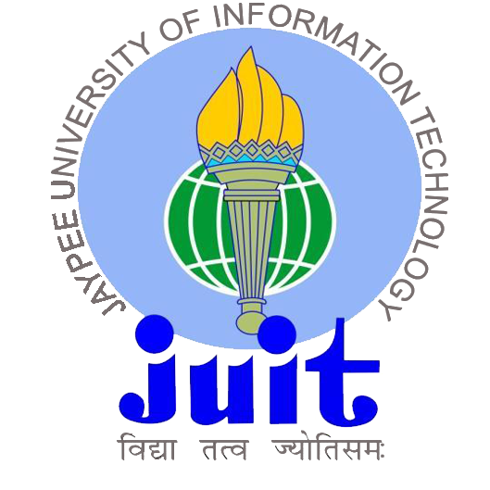

Department of Computer Science & Engineering and
Information Technology
Jaypee University of Information Technology, Waknaghat, Solan - 173234 (India)
May 2026

Week 1 (07-02-2026):

Project A – CRM Commercial Operations (Transition Phase)

Overview
This week focused on onboarding into the Commercial Operations (Comm Ops) structure of an enterprise CRM system. The project is currently in a transition phase where responsibilities for multiple European country operations will gradually be handed over to our team.

Key Activities
1) Understanding Local CRM Landscapes (EU Region)
Studied country-specific CRM configurations.
Analyzed differences in approval workflows, user hierarchies, and reporting structures.
Attended knowledge transfer sessions to understand:
- Local business processes
- Territory alignment logic
- Governance structure
- Data ownership and compliance mechanisms
Documented variations across regions to prepare for eventual operational takeover.
2) Observation of Operational Processes
Shadowed ongoing Comm Ops workflows.
Reviewed change request lifecycle from submission to deployment.
Observed incident resolution processes and ticket categorization.
Studied user access provisioning and deactivation protocols.
Understood escalation matrices and SLA monitoring.
3) Documentation and Configuration Review
Reviewed Standard Operating Procedures (SOPs).
Studied permission set architecture and role hierarchy.
Analyzed object structures, record types, page layouts, and field-level security.
Explored sandbox environments to understand configuration dependencies.
4) Risk Awareness During Transition
Identified potential transition risks such as:
i) Country-specific custom logic
ii) Reporting discrepancies
iii) Configuration dependencies
Began compiling structured notes to assist smoother transition.

Project B – Veeva CRM & Vault Implementation Support

Overview
This week focused on foundational configuration activities within Veeva CRM and Vault to support system implementation and structured access governance.

Key Activities
1) User Creation and Role Structuring
Created users aligned with defined business roles within Veeva CRM.
Configured profiles based on functional responsibilities.
Ensured appropriate object access and field visibility.
Structured user hierarchy to reflect reporting relationships.
2) Permission Set Design
Designed modular permission sets within CRM.
Applied principle of least privilege.
Segregated access to maintain scalability and security.
Tested access behavior through role-based login validation.
3) Access and Visibility Testing
Validated CRUD permissions.
Verified page layout visibility.
Ensured backend security configuration aligns with expected system behavior across CRM and Vault components.

Week 1 Learning Outcomes

Project A
Developed understanding of enterprise CRM governance models.
Learned how localized CRM systems operate within a global framework.
Gained exposure to transition management processes.
Improved ability to analyze operational documentation and configuration logic.

Project B
Strengthened knowledge of CRM access architecture.
Understood importance of scalable permission structuring.
Gained practical exposure to role-based system validation.
Improved backend security testing discipline within Veeva CRM environments.

Week 2 (14-02-2026):

Project A – CRM Commercial Operations (Deep Dive Phase)

Overview
The second week involved deeper exposure to operational readiness activities in preparation for system takeover.

Key Activities
1. Knowledge Transfer Workshops
Participated in structured sessions covering:
- Incident triaging
- SLA adherence
- Escalation frameworks
- Change management lifecycle
Studied historical change request examples to understand approval dependencies and risk assessment processes.
2. Multi-Country System Mapping
Compared CRM implementations across regions.
Documented variations in:
- Call reporting mechanisms
- Validation rules
- Territory logic
- Approval routing structures
Identified areas that may require harmonization during transition.
3. Compliance and Governance Understanding
Observed how compliance and audit trails are maintained.
Understood impact assessment processes before configuration changes.
Reviewed data governance controls and monitoring frameworks.
4. Operational Readiness Preparation
Structured transition documentation.
Identified open clarification points.
Prepared internal notes for smoother handover support.

Project B – Veeva CRM & Vault Implementation

Overview
This week focused on backend configuration and data structuring within Veeva CRM and Vault to support system implementation.

Key Activities
1. Data Palette Configuration
Created structured data palettes to support CRM modules.
Configured dynamic dropdown dependencies.
Ensured role-based data visibility logic.
Maintained consistent data formatting standards.
2. Backend–System Alignment
Validated field types and picklist dependencies.
Ensured mandatory field logic aligns with process requirements.
Structured objects for seamless interaction across CRM and Vault components.
3. Testing Data Flow
Tested record creation and update flows.
Validated validation rules.
Ensured data consistency across user roles.
4. Scalability Considerations
Designed modular data structures.
Avoided hardcoded configurations.
Planned structure for future enhancement and performance stability.

Week 2 Learning Outcomes

Project A
Gained exposure to structured CRM transition management.
Improved understanding of ticket triaging and SLA handling.
Strengthened system mapping and documentation skills.
Developed awareness of governance and compliance-heavy CRM environments.

Project B
Gained hands-on experience in backend preparation within Veeva CRM and Vault.
Understood importance of structured data architecture in enterprise systems.
Improved ability to align backend configuration with process requirements.
Strengthened validation and integration testing skills.
Developed scalable thinking during early-stage system design.

Week 3 (21-02-2026)

Project A – CRM Commercial Operations (Transition & Shadow Phase)

Overview
This week focused on continued transition calls and operational readiness. One country transition is nearing completion, and shadow support is about to begin.

Key Activities
1. Continued Transition Calls
Participated in detailed transition discussions.
Clarified operational workflows and configuration dependencies.
Reviewed final handover checkpoints for one country.
2. Pre-Shadow Preparation
Prepared documentation for active shadowing phase.
Reviewed open incidents and pending change requests.
Aligned understanding of SLAs and escalation protocols.
3. Process Alignment
Ensured configuration aligns with defined business workflows.
Validated integration points between CRM and Vault components.

Project B – Veeva CRM & Vault Enhancement Activities

Overview
This week focused on continued refinement of CRM configuration and enhancement of implementation components.

Key Activities
1. Configuration Refinement
Reviewed existing permission structures.
Optimized access visibility for improved governance control.
2. Learning Key CRM Functional Modules
Studied Rep Triggered Emails (RTE) configuration and workflow logic.
Understood email approval processes and tracking mechanisms.
Explored sampling management processes within Veeva CRM.
3. Sampling Implementation (Initial Stage)
Started configuring sampling functionality in Veeva CRM.
Reviewed product allocation rules and compliance considerations.
Tested sampling-related record flows in sandbox.

Week 3 Learning Outcomes

Project A
Gained hands-on exposure to near-live transition readiness.
Developed understanding of Rep Triggered Emails configuration logic.
Learned sampling process implementation within Veeva CRM.
Improved confidence in shadow support preparation and operational ownership.

Project B
Strengthened configuration refinement skills within enterprise CRM systems.
Improved governance-focused system validation approach.
Enhanced understanding of CRM–Vault integration dynamics.

