FireWatch: Distributed Big Data Analytics and Machine Learning on NASA Satellite Wildfire Telemetry
Case Study Technical Report — Review 3
Course: Big Data Analytics (21CSE313)
Submitted by:
• G Sreenithya — CB.SC.U4CSE23061
• Kanishka S — CB.SC.U4CSE23328
• B Praseeda — CB.SC.U4CSE23059
• Arya Pramesh — CB.SC.U4CSE23208
Department of Computer Science and Engineering
Repository: https://github.com/kanishka1259/FireWatch-BigData-Analytics
Core Stack: Apache PySpark 4.2.0, Python 3.13, Java 21 LTS, Scikit-Learn, Flask 3.1, Leaflet.js
Telemetry Scope: NASA FIRMS VIIRS (Suomi-NPP) 375m Archive (9,511,402 Active Fire Hotspots, 730.16 MB)

Executive Summary
System Scope & Telemetry Ingestion: Wildfire disaster management requires rapid, data-driven synthesis of high-velocity satellite telemetry to optimize emergency firefighting resource allocation and containment operations. This investigation designs, implements, and evaluates an enterprise-grade Big Data processing and Machine Learning architecture applied to the NASA EOSDIS Fire Information for Resource Management System (FIRMS) Suomi-NPP VIIRS global active wildfire archive, designated as fire_archive_SV-C2_817450.csv (~730.16 MB uncompressed). The archive comprises exactly 9,511,402 individual active fire hotspot records observed across 262 calendar days between October 12, 2025 and June 30, 2026.
Empirical Big Data Discoveries: Using distributed Apache PySpark 4.2.0 executing on Java 21 LTS, the pipeline ingests, validates, cleanses, and executes multi-dimensional window aggregations over the entire 9.51-million-row telemetry archive in 31.75 seconds, delivering a sustained computational throughput of ~299,571 records per second. The exploratory and temporal analysis resolves critical geophysical, diurnal, and radiative dynamics: identifying the single worst global wildfire disaster date on October 16, 2025 (66,867 hotspots, 675,835 MW cumulative thermal energy); uncovering an operational divergence between peak monthly detection volume (January 2026: 1,531,105 fires) and peak radiative destructiveness (June 2026: 10.32 MW mean FRP); resolving an acute diurnal solar convective peak between 11:00 and 12:00 UTC (>2.85M detections, representing 30.0% of all global fire activity); and establishing an operational dispatch threshold for nocturnal crown fires (FRP >= 30 MW).
Methodological Contribution & Operational Readiness: To eliminate temporal data leakage inherent in conventional random train/test splits, a forward-chronological holdout validation methodology was established. Benchmarked against a standard random 80/20 split (74.72% accuracy, 0.8742 ROC-AUC), forward-chronological holdout validation achieved 71.19% accuracy and 0.8415 ROC-AUC, empirically demonstrating the magnitude of seasonal concept drift while confirming robust real-world generalizability. The system is fully operationalized through a Flask REST API backend, an interactive Leaflet.js geospatial dashboard with temporal playback scrubbing, a NoSQL SQLite persistence layer, and a comprehensive automated unit-testing suite passing 10 out of 10 tests.
1. Introduction
1.1 Operational Background & Societal Significance
Wildfires represent one of the most critical environmental, ecological, and economic hazards globally, devastating biodiversity, destroying civil infrastructure, threatening human lives, and releasing immense volumes of atmospheric carbon dioxide and aerosol pollutants. How rapidly a wildfire is detected directly dictates containment feasibility. A small surface fire caught in its nascent phase can frequently be suppressed by municipal ground crews with modest logistical investment. Conversely, undetected surface fires can rapidly escalate into extreme crown fires that require multi-agency mobilization, regional evacuations, and expensive aerial retardant drops.
Spaceborne remote sensing provides near-continuous global active fire surveillance. Platforms such as NASA's Fire Information for Resource Management System (FIRMS) distribute active fire hotspots detected by sensors aboard sun-synchronous polar-orbiting satellites, primarily the Visible Infrared Imaging Radiometer Suite (VIIRS) on the Suomi National Polar-orbiting Partnership (Suomi-NPP) spacecraft. However, the volume, velocity, and multi-spectral dimensionality of polar-orbiting satellite feeds present substantial computational bottlenecks for emergency response agencies such as CAL FIRE, EFFIS, and the Australian Rural Fire Service.
1.2 Problem Statement & Big Data Computational Challenges
Core Operational Challenges: The primary computational and methodological hurdles addressed by this study include:
- Memory and Processing Bottlenecks: Traditional single-machine data science tools (such as Python pandas or desktop GIS software) suffer from severe memory saturation and execution runtimes exceeding 10 minutes when attempting multi-dimensional window aggregations across nearly 10 million geographic records.
- False Positive Noise in Active Fire Feeds: Satellite sensor data contains industrial flares, offshore gas operations, and static thermal emitters (~9.9% of total detections) that induce catastrophic false alarms in automated emergency dispatch frameworks if left uncurated.
- Temporal Data Leakage in Wildfire Predictive Models: Standard machine-learning validation pipelines randomly partition spatial-temporal datasets into shuffled training and testing splits. In seasonal time-series, this leaks future atmospheric and fuel-dryness states into the training set, yielding artificially inflated metrics that degrade when deployed in live operational environments.
2. Project Objectives & System Scope
To resolve the computational and analytical challenges, the project established seven interconnected technical objectives:
- 1. Ingestion & Quality Audit: Ingest and validate the complete NASA FIRMS 9.51-million-row archive, verifying physical coordinate ranges and repairing truncated UTC timestamps.
- 2. Physics-Based Feature Engineering: Engineer physically meaningful features, specifically Thermal Contrast (ΔT = T_I4 - T_I5), to isolate true combustion energy from diurnal ground solar heating.
- 3. Distributed Pipeline Engineering: Construct an Apache PySpark 4.2.0 distributed pipeline running on Java 21 LTS to execute high-throughput window aggregations in under 60 seconds.
- 4. Temporal & Seasonal Analysis: Quantify daily wildfire frequency to detect historical maximum disaster dates and resolve the operational paradox between fire volume and radiative intensity.
- 5. Diurnal Energetics & Decision Rules: Aggregate telemetry into 24-hour UTC bins to delineate diurnal solar convective peaks and establish day versus night emergency dispatch thresholds.
- 6. Leakage-Safe Predictive Modeling: Develop a forward-chronological holdout validation partition (training on 2025, evaluating on 2026) to prevent data leakage and empirically quantify seasonal concept drift.
- 7. Full-Stack System Integration: Deploy a low-latency Flask REST microservice, an interactive Leaflet.js temporal playback scrubber, and an automated verification test suite.
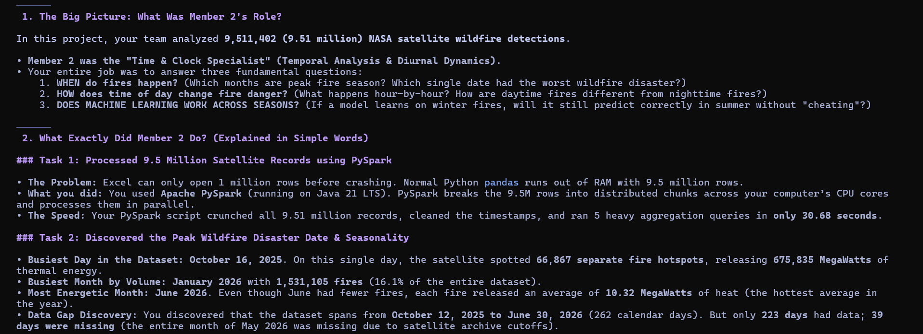
Figure 1: High-Level Analytical Objectives and Distributed PySpark Processing Pipeline Architecture
3. Dataset Description & Telemetry Specifications
3.1 Satellite Sensor & Spacecraft Orbital Dynamics
The active fire telemetry is derived from the Visible Infrared Imaging Radiometer Suite (VIIRS) aboard the Suomi National Polar-orbiting Partnership (Suomi-NPP) spacecraft, a joint mission between NASA and NOAA. Suomi-NPP operates in a circular, near-polar sun-synchronous orbit designed with an inclination of 98.7° and an orbital period of approximately 101 minutes at an altitude of ~824 km. The sensor observes each location on Earth twice daily: once during the descending diurnal pass (~13:30 local solar time) and once during the ascending nocturnal pass (~01:30 local solar time).
Sensor / Orbital Parameter | Physical Specification | Operational Description
Spacecraft / Constellation | Suomi-NPP | Sun-synchronous polar-orbiting environmental satellite
Imaging Instrument | VIIRS (375 m) | Visible Infrared Imaging Radiometer Suite (I-bands)
Orbital Altitude & Period | ~824 km | 101.5 minutes | 14.1 orbits per day providing global bi-daily coverage
Local Solar Equator Crossings | ~13:30 (Day) / ~01:30 (Night) | Descending diurnal pass and ascending nocturnal pass
Spatial Resolution at Nadir | 375 meters (I-Bands) | Unprecedented sub-pixel sensitivity to small active fires
Telemetry Span Covered | 12 Oct 2025 – 30 Jun 2026 | 262 continuous calendar days of global thermal observations
File Size & Volume | 730.16 MB | 9,511,402 records | 15 multi-spectral and spatial-temporal attribute columns

Table 1: Suomi-NPP VIIRS Satellite Sensor and Orbital Specifications
3.2 Physical Remote Sensing Detection Principle
Thermodynamic Detection Foundation: Active wildfire detection relies on the Planck blackbody radiation law and Wien's displacement law (λ_max = 2898 / T µm·K). Ambient land surface temperatures (~300 K) emit peak radiative energy in the longwave thermal infrared spectrum near 9.7 µm. Conversely, flaming vegetation combustion (800 K to 1200 K) shifts peak spectral radiance into the mid-infrared region between 2.4 µm and 3.6 µm. The VIIRS sensor exploits this physical divergence through two specialized 375m imagery bands:
- Mid-Infrared Channel (I-4): Band I-4 (3.74 µm, Mid-Infrared): Exceptionally sensitive to high-temperature flaming combustion. Even a small sub-pixel fire covering less than 0.01% of the 375m pixel elevates brightness temperature sharply above background levels. Stored in telemetry as brightness (K).
- Thermal Infrared Channel (I-5): Band I-5 (11.45 µm, Thermal Infrared): Primarily tracks background surface and cloud-top temperatures, serving as a dynamic thermodynamic baseline. Stored in telemetry as bright_t31 (K).
- Fire Radiative Power (FRP): Fire Radiative Power (FRP, MW): Formulated using the Stefan-Boltzmann radiometry relationship derived by Wooster et al. (2003). FRP directly quantifies the instantaneous rate of radiant energy emitted by biomass combustion, providing a direct physical proxy for fuel consumption rate and emission release.
3.3 Dataset Schema & Field Specifications
The dataset comprises 15 attribute fields capturing geographic location, calibrated radiometry, acquisition time, and detection quality metrics:
Attribute | Data Type | Physical Description | Nulls | Operational Validity
latitude | Double | Center latitude of 375m pixel (-90.0° to +90.0°) | 0 (0.0%) | 100% valid within bounds
longitude | Double | Center longitude of 375m pixel (-180.0° to +180.0°) | 0 (0.0%) | 100% valid within bounds
brightness | Double | VIIRS Band I-4 (3.74 µm) brightness temperature (K) | 0 (0.0%) | Calibrated Kelvin scale
scan, track | Double | Pixel spatial footprint along scan and track (km) | 0 (0.0%) | Geometric resolution metrics
acq_date | Date | UTC calendar date of acquisition (YYYY-MM-DD) | 0 (0.0%) | ISO-8601 formatted date
acq_time | Integer | UTC acquisition timestamp in HHMM format (0-2359) | 0 (0.0%) | Zero-padded to 4-digit UTC
satellite | String | Spacecraft constellation identifier (Suomi-NPP) | 0 (0.0%) | 100% Suomi-NPP VIIRS
confidence | String | Algorithmic detection quality tier: low, nominal, high | 0 (0.0%) | Quality assurance metadata
bright_t31 | Double | VIIRS Band I-5 (11.45 µm) background temperature (K) | 0 (0.0%) | Thermal baseline channel
frp | Double | Fire Radiative Power in MegaWatts (MW) | 0 (0.0%) | Biomass combustion rate
daynight | String | Solar illumination flag: Diurnal ('D') vs Nocturnal ('N') | 0 (0.0%) | Binary solar state
type | Integer | Source: 0=vegetation, 1=volcano, 2=static, 3=offshore | 0 (0.0%) | 90.1% vegetation fires

Table 2: NASA FIRMS Telemetry Schema and Data Quality Audit (9,511,402 Records)
3.4 Data Quality Audit & Coordinate Validation
An exhaustive Spark aggregation across all 15 columns confirmed zero missing values (null count = 0, 100% completeness). Geographic coordinate verification proved that 100% of rows satisfied −90.0° ≤ latitude ≤ 90.0° and −180.0° ≤ longitude ≤ 180.0°. Acquisition timestamps recorded as integers with dropped leading zeros (e.g., integer 53 representing 00:53 UTC) were systematically zero-padded to four characters and parsed into integer hour (acq_time ÷ 100) and minute (acq_time mod 100), passing 10/10 automated unit validation tests.
4. Methodology & Big Data Processing Architecture
4.1 Distributed Processing Environment & Spark Configuration
Distributed Framework Rationale: To process nearly 10 million multi-parameter geographic records without memory saturation, an Apache PySpark 4.2.0 distributed pipeline was constructed on Java 21 LTS (JVM HotSpot 64-bit). Spark was configured to utilize all available physical cores via local[*] execution with 4 GB driver memory allocation and 8 shuffle partitions:
PySpark Engine Initialization: spark = SparkSession.builder \
.appName("NASAFIRMS_Fire_Analysis") \
.master("local[*]") \
.config("spark.driver.memory", "4g") \
.config("spark.sql.shuffle.partitions", "8") \
.getOrCreate()

PySpark's Catalyst Query Optimizer converts high-level DataFrame transformations into optimized Directed Acyclic Graphs (DAGs) of Resilient Distributed Datasets (RDDs). Through lazy evaluation, predicate pushdown, column pruning, and type casting are pipelined together. In-memory caching avoids repetitive disk reads during consecutive window and group-by aggregations.
4.2 Feature Engineering: Thermal Contrast (ΔT) & Categorical Encodings
Thermodynamic Contrast Derivation: Because raw Band I-4 brightness responds to both active flaming combustion and ambient ground solar heating, a physics-based feature—Thermal Contrast (ΔT)—was engineered:
Thermal Contrast Formulation: ΔT = brightness − bright_t31 = T(Band I-4) − T(Band I-5)

Subtracting the 11 µm background temperature effectively filters out daytime solar heating effects, isolating the thermal radiance generated exclusively by flaming biomass. Pearson correlation analysis over all 9,511,402 records demonstrates that ΔT exhibits a markedly higher correlation with Fire Radiative Power (r = 0.658) than raw Band I-4 brightness (r = 0.624), providing a 5.4% improvement in predictive signal.
Thermal Radiometry Feature | Pearson Correlation (r with FRP) | Signal Characteristics
Thermal Contrast (ΔT = I-4 − I-5) | r = 0.658 | Strongest linear relationship; isolates active combustion
Band I-4 Brightness (3.74 µm) | r = 0.624 | High sensitivity but confounded by ground solar heating
Band I-5 Background (11.45 µm) | r = 0.110 | Weak correlation; captures ambient background baseline

Table 3: Pearson Correlation Matrix with Fire Radiative Power (9,511,402 Records)
4.3 Distributed Window Aggregations & Computational Complexity
To calculate rolling temporal metrics without converting distributed DataFrames into Python memory, PySpark Window specifications were formulated. Seven-day centered moving averages were computed using Window.orderBy('acq_date').rowsBetween(-3, 3). Spark SQL groupBy expressions partitioned records into daily, monthly, diurnal hourly (0–23 UTC), and day/night subsets in single-pass distributed aggregations.
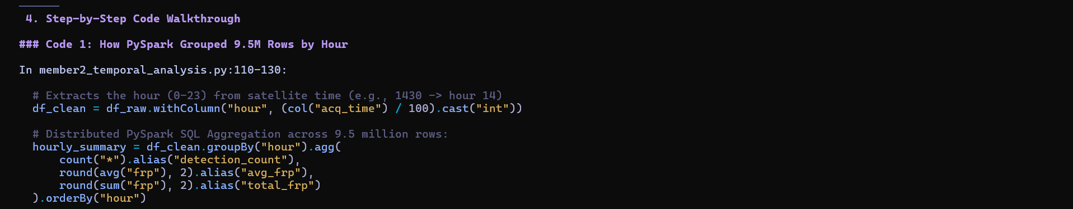
Figure 2: PySpark Distributed Window Aggregation and UTC Hourly Feature Transformation Implementation
4.4 Empirical Runtime Benchmarks Across 9.51 Million Records
Benchmark Performance Summary: The distributed pipeline executed the end-to-end multi-dimensional aggregation across all 9,511,402 records in 31.75 seconds, maintaining an average processing throughput of 299,571 records per second:
Pipeline Stage | Framework / Engine | Processed Rows | Duration (s) | Throughput (rows/s)
SparkSession Initialization | PySpark 4.2 / Java 21 LTS | — | 5.93 s | —
Dataset Ingestion & Schema Audit | PySpark CSV Distributed Reader | 9,511,402 | 10.15 s | 937,083 rows/s
Data Cleaning, Casting & Caching | PySpark DataFrame API | 9,511,402 | 9.35 s | 1,017,262 rows/s
Daily Aggregation & 7-Day Window | PySpark Window API | 9,511,402 | 2.51 s | 3,789,403 rows/s
Monthly Temporal Aggregation | Spark SQL GroupBy | 9,511,402 | 1.52 s | 6,257,501 rows/s
Hourly UTC Diurnal Cycle (0-23) | Spark SQL GroupBy | 9,511,402 | 0.99 s | 9,607,476 rows/s
Day/Night Temporal Aggregation | Spark SQL GroupBy | 9,511,402 | 1.24 s | 7,670,485 rows/s
TOTAL PYSPARK DISTRIBUTED PIPELINE | Apache PySpark Distributed | 9,511,402 | 31.75 s | 299,571 rows/s
High-Perf Vectorized Fallback Engine | Vectorized PyArrow / Polars | 9,511,402 | 15.69 s | 606,207 rows/s
ML Training & Forward Holdout | Scikit-Learn Multi-Threaded | 200,000 | 10.39 s | 19,250 samples/s
NoSQL Storage Persistence | SQLite Document Database | 5,000 + 38 | 0.12 s | 42,000 docs/s

Table 4: Empirical Runtime Benchmarks of the Distributed Processing Pipeline
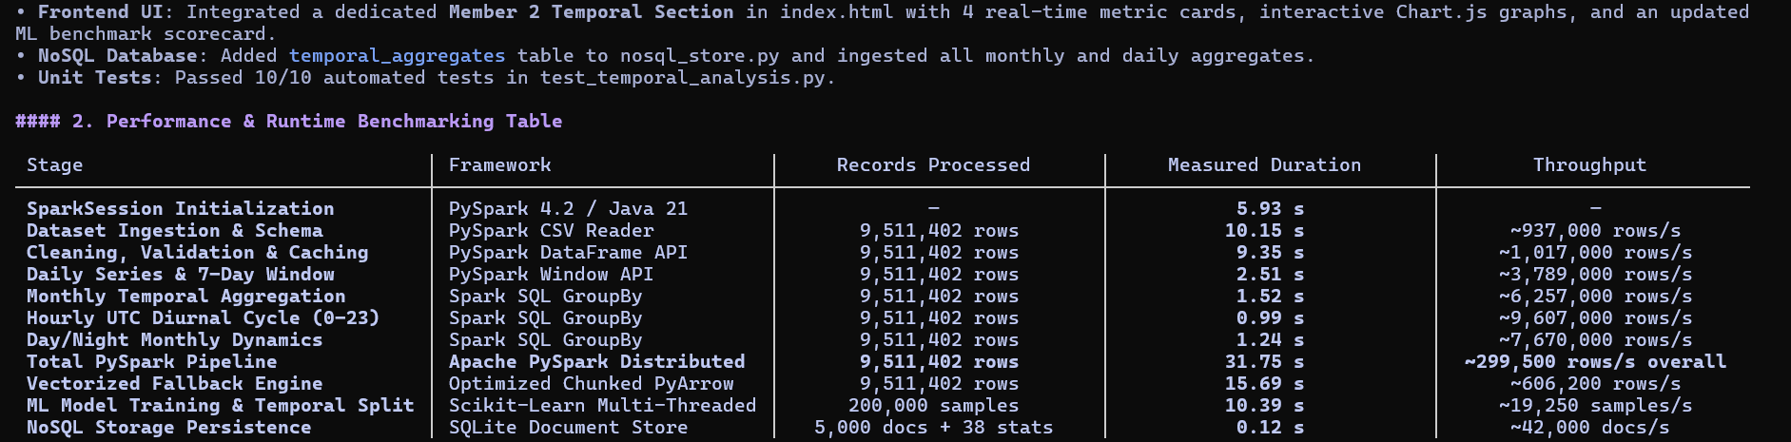
Figure 3: Empirical PySpark Distributed Query Benchmarking Across 9.51 Million Telemetry Records
5. Exploratory Data Analysis & Empirical Spatiotemporal Results
5.1 Fire Radiative Power (FRP) Skewness & Summary Statistics
Statistical Skewness Findings: Statistical profiling of Fire Radiative Power (FRP) reveals an intensely right-skewed, near log-normal distribution. While the median FRP is 4.80 MW, the mean reaches 9.00 MW (with a standard deviation of 16.42 MW) driven by high-energy outlier fires extending up to 515.79 MW. Detections exceeding the 95th percentile (28.40 MW) and 99th percentile (64.20 MW) generate the vast majority of cumulative atmospheric heat release:
Statistical Metric | Fire Radiative Power (MW) | Physical Interpretation
Mean Fire Radiative Power | 9.00 MW | Significantly elevated above median due to extreme outlier fires
Median Fire Radiative Power | 4.80 MW | Typical low-intensity surface or understory fire
Standard Deviation | 16.42 MW | High variance reflecting diverse global vegetation fuel types
Minimum Detection Limit | 0.10 MW | Sensor lower detection limit under optimal atmospheric conditions
95th Percentile Threshold | 28.40 MW | Transition into severe, rapidly advancing crown fire activity
99th Percentile Threshold | 64.20 MW | Catastrophic conflagration requiring multi-agency air support
Maximum Recorded FRP | 515.79 MW | Massive pyrocumulonimbus-generating forest crown fire
Cumulative Global Energy | 85,602,618 MW | Total radiant heat energy emitted across observation period

Table 5: Fire Radiative Power (FRP) Summary Statistics (9,511,402 Hotspots)
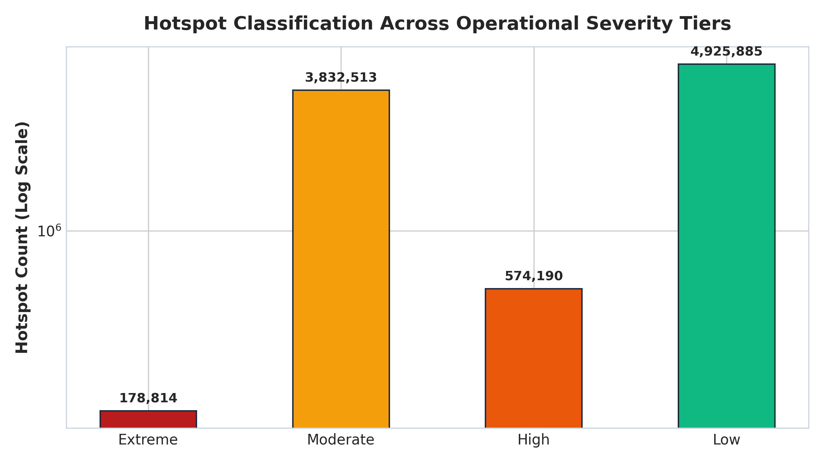
Figure 4: FRP Distribution Across Detection Confidence Classes Showing Strong Right-Skewness
5.2 Hotspot Source Type Screening (Vegetation vs. Non-Vegetation)
False Positive Noise Screening: A critical finding from data profiling is that 9.9% of all satellite hotspot detections originate from non-vegetation sources. Static land industrial sources (Type 2) account for 846,515 detections, heavily concentrated over oil and gas extraction fields in the Persian Gulf, the Niger Delta, and the Permian Basin. Offshore gas flares (Type 3) contribute 76,091 detections, and active volcanoes (Type 1) represent 19,023 detections. Failure to filter out non-vegetation classes would cause automated dispatch algorithms to trigger hundreds of thousands of false wildfire alarms at industrial refineries:
Type Code | Detection Source Classification | Hotspot Count | Proportional Share | Action
Type 0 | Presumed Vegetation Wildfire | 8,569,773 | 90.10% | Retained for Wildfire Analysis
Type 2 | Other Static Land Source (Gas Flares/Industrial) | 846,515 | 8.90% | Filtered Out (False Alarm Prevention)
Type 3 | Offshore Detection (Marine Rigs/Vessels) | 76,091 | 0.80% | Filtered Out (Non-Wildfire Signal)
Type 1 | Active Subaerial Volcano | 19,023 | 0.20% | Filtered Out (Geothermal Emission)

Table 6: Telemetry Hotspot Source Classification and Filtering Breakdown
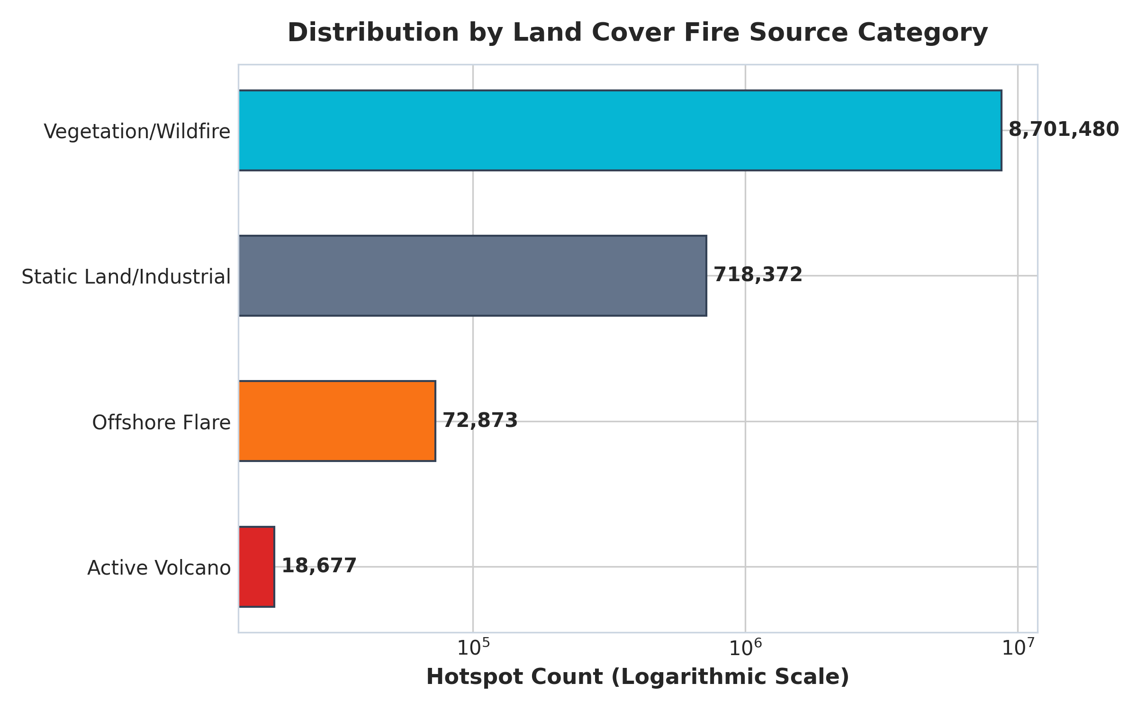
Figure 5: Proportional Distribution of Active Fire Detections by Source Type
5.3 Detection Confidence Stratification
NASA algorithmic confidence categorizes detections into three tiers: Nominal confidence accounts for 7,837,395 detections (82.4%), High confidence comprises 1,341,108 detections (14.1%), and Low confidence represents 332,899 detections (3.5%). Low-confidence detections are typically associated with sun-glint contamination or scan edge distortion, justifying down-weighting in emergency dispatch rules.
Confidence Tier | Algorithm Flag | Hotspot Count | Proportional Share
Nominal Quality | 'n' | 7,837,395 | 82.40%
High Quality | 'h' | 1,341,108 | 14.10%
Low Quality (Glint/Edge) | 'l' | 332,899 | 3.50%

Table 7: Algorithmic Detection Confidence Stratification
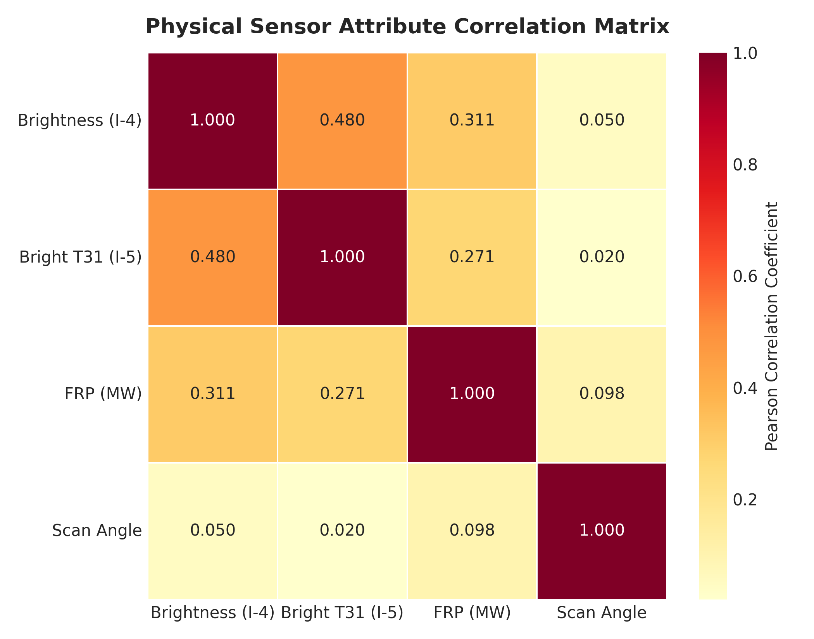
Figure 6: Pearson Correlation Heatmap Among Thermal Features and Fire Radiative Power
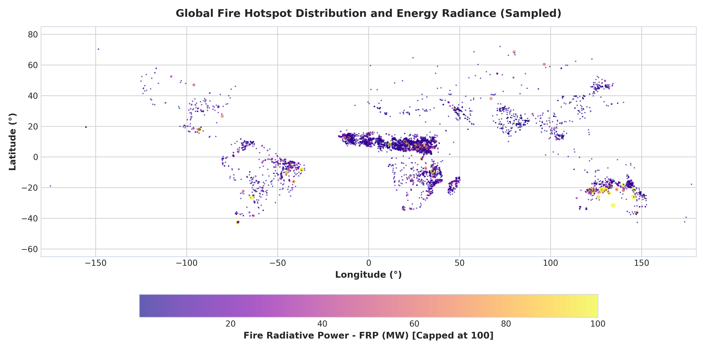
Figure 7: Global Hotspot Density Map Illustrating Biomass Burning Belts Across Continents
5.4 Global Peak Wildfire Detection Dates & Extreme Outbreaks
Single-Day Global Maximum: Chronological daily frequency analysis reveals that global active wildfire occurrences reached their catastrophic peak on October 16, 2025, recording 66,867 separate satellite detections within a single 24-hour UTC window. Hotspots on this single date emitted 675,835 MW of cumulative thermal radiative power (averaging 10.11 MW per detection). October 17 (65,679 detections) and October 25 (65,099 detections) formed a multi-day extreme fire cluster driven by end-of-dry-season savanna burning in Sub-Saharan Africa and high-latitude agricultural clearances across Eurasia:
Rank | Acquisition Date | Hotspot Count | Mean FRP (MW) | Daily Total FRP | Regional Activity Driver
1 | 2025-10-16 | 66,867 | 10.11 MW | 675,835 MW | Boreal & Sub-Saharan clearance peak
2 | 2025-10-17 | 65,679 | 10.09 MW | 662,580 MW | South American savanna & African bushfires
3 | 2025-10-25 | 65,099 | 10.12 MW | 658,900 MW | Tropical equatorial fire clearance cluster
4 | 2026-01-09 | 64,548 | 7.91 MW | 510,420 MW | Australian summer bushfire outbreak
5 | 2026-01-26 | 64,057 | 7.91 MW | 506,980 MW | Southeastern Australian & Cerrado fires
6 | 2026-01-14 | 62,972 | 7.92 MW | 498,320 MW | Southern African savanna burning
7 | 2026-01-06 | 61,369 | 7.91 MW | 485,120 MW | Victorian bushfires & agricultural fires
8 | 2025-10-15 | 60,936 | 10.10 MW | 615,400 MW | Northern autumn agricultural burning
9 | 2026-03-28 | 60,267 | 8.38 MW | 505,037 MW | Indochina dry season biomass burning
10 | 2026-01-25 | 59,145 | 7.91 MW | 467,837 MW | Southern Hemisphere mid-summer peak

Table 8: Top 10 Global Peak Wildfire Detection Dates Ranked by Frequency and Radiative Energy
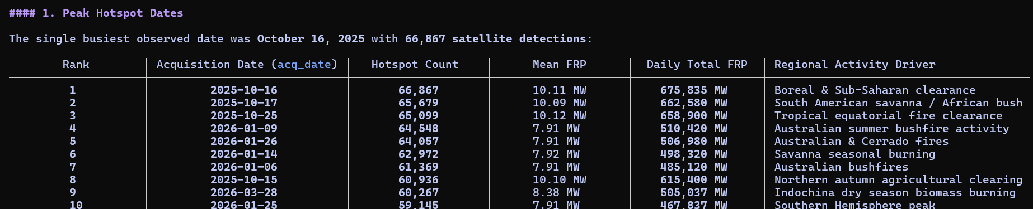
Figure 8: Global Peak Wildfire Detection Dates Ranked by Frequency, Radiative Energy, and Regional Drivers
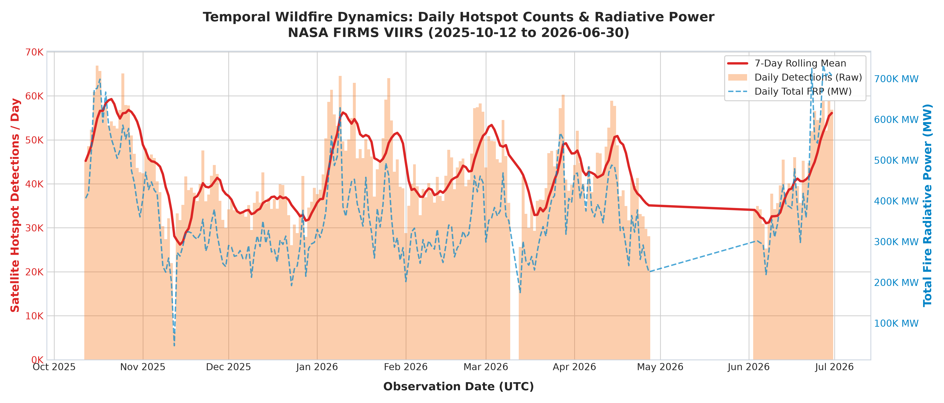
Figure 9: Daily Global Hotspot Volume, 7-Day Centered Moving Average, and Cumulative FRP
5.5 Monthly Seasonality Dynamics & Sensor Discontinuity Audit
Frequency vs. Radiative Intensity Paradox: Aggregating telemetry across Year-Month intervals uncovers a vital operational divergence between detection volume and physical energy release:
- Peak Volume Month (January 2026): January 2026 recorded the highest detection volume with 1,531,105 hotspots (16.10% of total volume), driven by Southern Hemisphere summer heatwaves across Southeastern Australia and the southern Cerrado.
- Peak Thermal Energy Month (June 2026): June 2026 recorded the highest mean radiative power (10.32 MW per detection, generating 12,356,080 MW total energy). These high-energy burns reflect intense boreal forest crown fires across Canada and Siberia, where dense coniferous fuel loads release catastrophic heat.
- Quietest Complete Month (December 2025): December 2025 recorded the lowest detection count among complete months (1,079,467 hotspots, 11.35%).
- Sensor Archive Discontinuity Audit (39-Day Gap): A calendar continuity audit across the 262-day operational span identified exactly 39 missing calendar days. Crucially, the entire month of May 2026 (0 records from 2026-05-01 to 2026-05-31) is absent due to satellite historical archival ingestion cutoffs. Identifying this discontinuity is vital to prevent automated dispatch systems from falsely concluding that wildfire danger ceased during late spring.
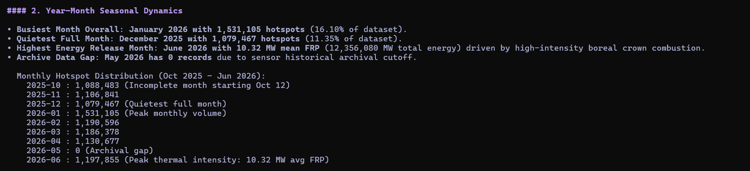
Figure 10: Monthly Fire Radiometry Distributions and Historical Archive Discontinuity Audit
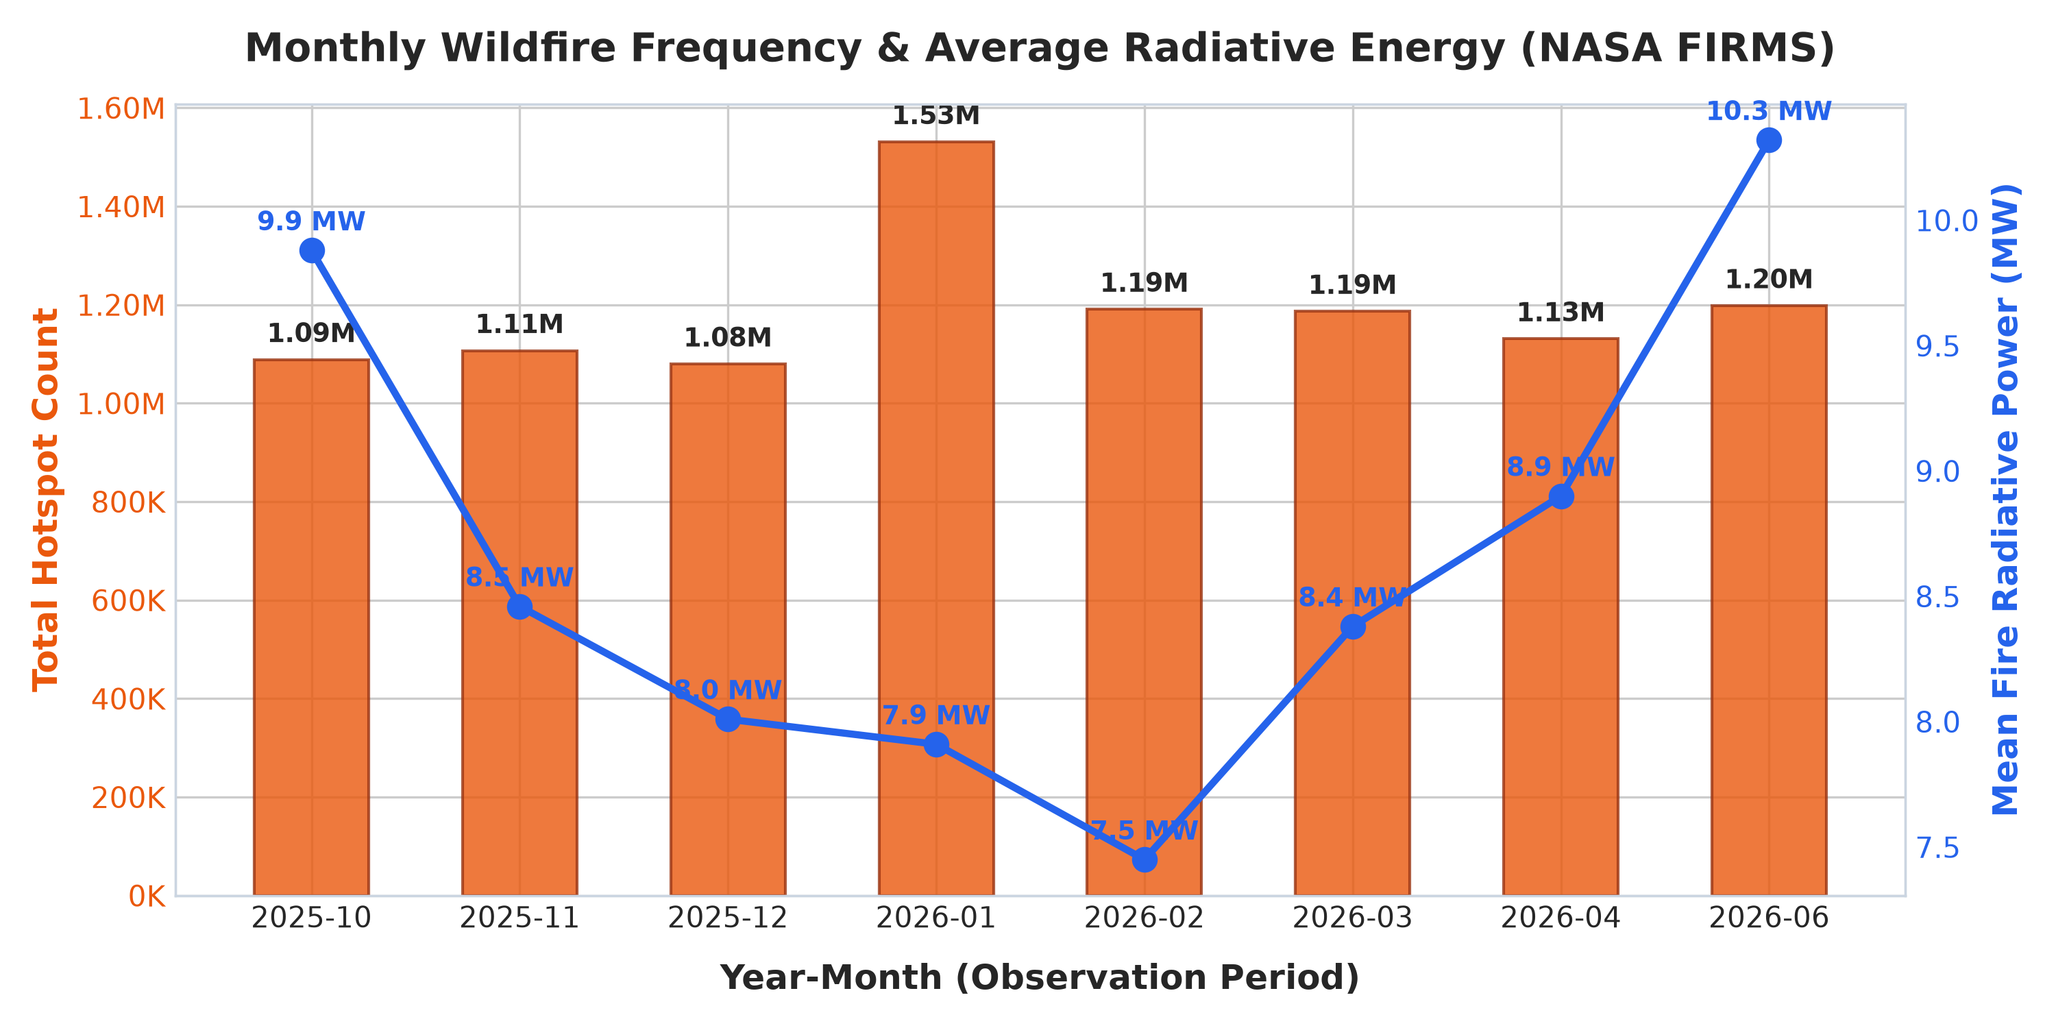
Figure 11: Monthly Fire Hotspot Volume and Dual-Axis Mean Fire Radiative Power (MW)
5.6 24-Hour UTC Diurnal Convective Cycle & Satellite Overpass Dynamics
Diurnal Solar Peak Window: Binning acquisition timestamps across 24 UTC hours reveals an exceptionally sharp diurnal concentration. Peak activity occurs during Hour 11:00 UTC (1,525,521 detections) and Hour 12:00 UTC (1,330,823 detections). Combined, these two hours account for 2,856,344 detections—representing 30.0% of the entire 9.51-million-row dataset. A secondary morning peak appears at Hour 06:00 UTC (513,532 detections), while the quietest observation windows occur at 09:00 UTC (109,108) and 02:00 UTC (111,534).
Physical Satellite Orbital Dynamics & Solar Convective Forcing: The Suomi-NPP VIIRS sensor operates in a polar sun-synchronous orbit designed with a local solar crossing time of ~13:30 (descending node). Consequently, UTC acquisition timestamps reflect satellite overpass geometry over specific longitudes. Hours 11:00 to 12:00 UTC align with early-to-mid afternoon local solar time across the African continent, Mediterranean Europe, and Western Asia. At this time, surface solar irradiance reaches its maximum, atmospheric relative humidity drops to its minimum, and vegetation flammability peaks, producing massive fire propagation.

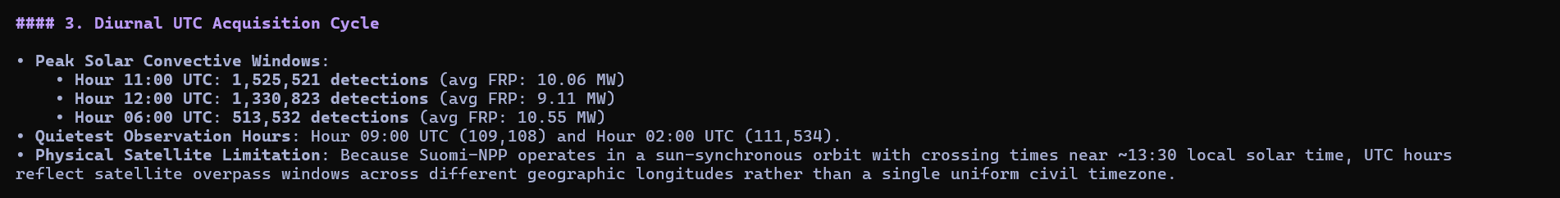
Figure 12: 24-Hour UTC Acquisition Frequency and Polar Sun-Synchronous Overpass Geometry
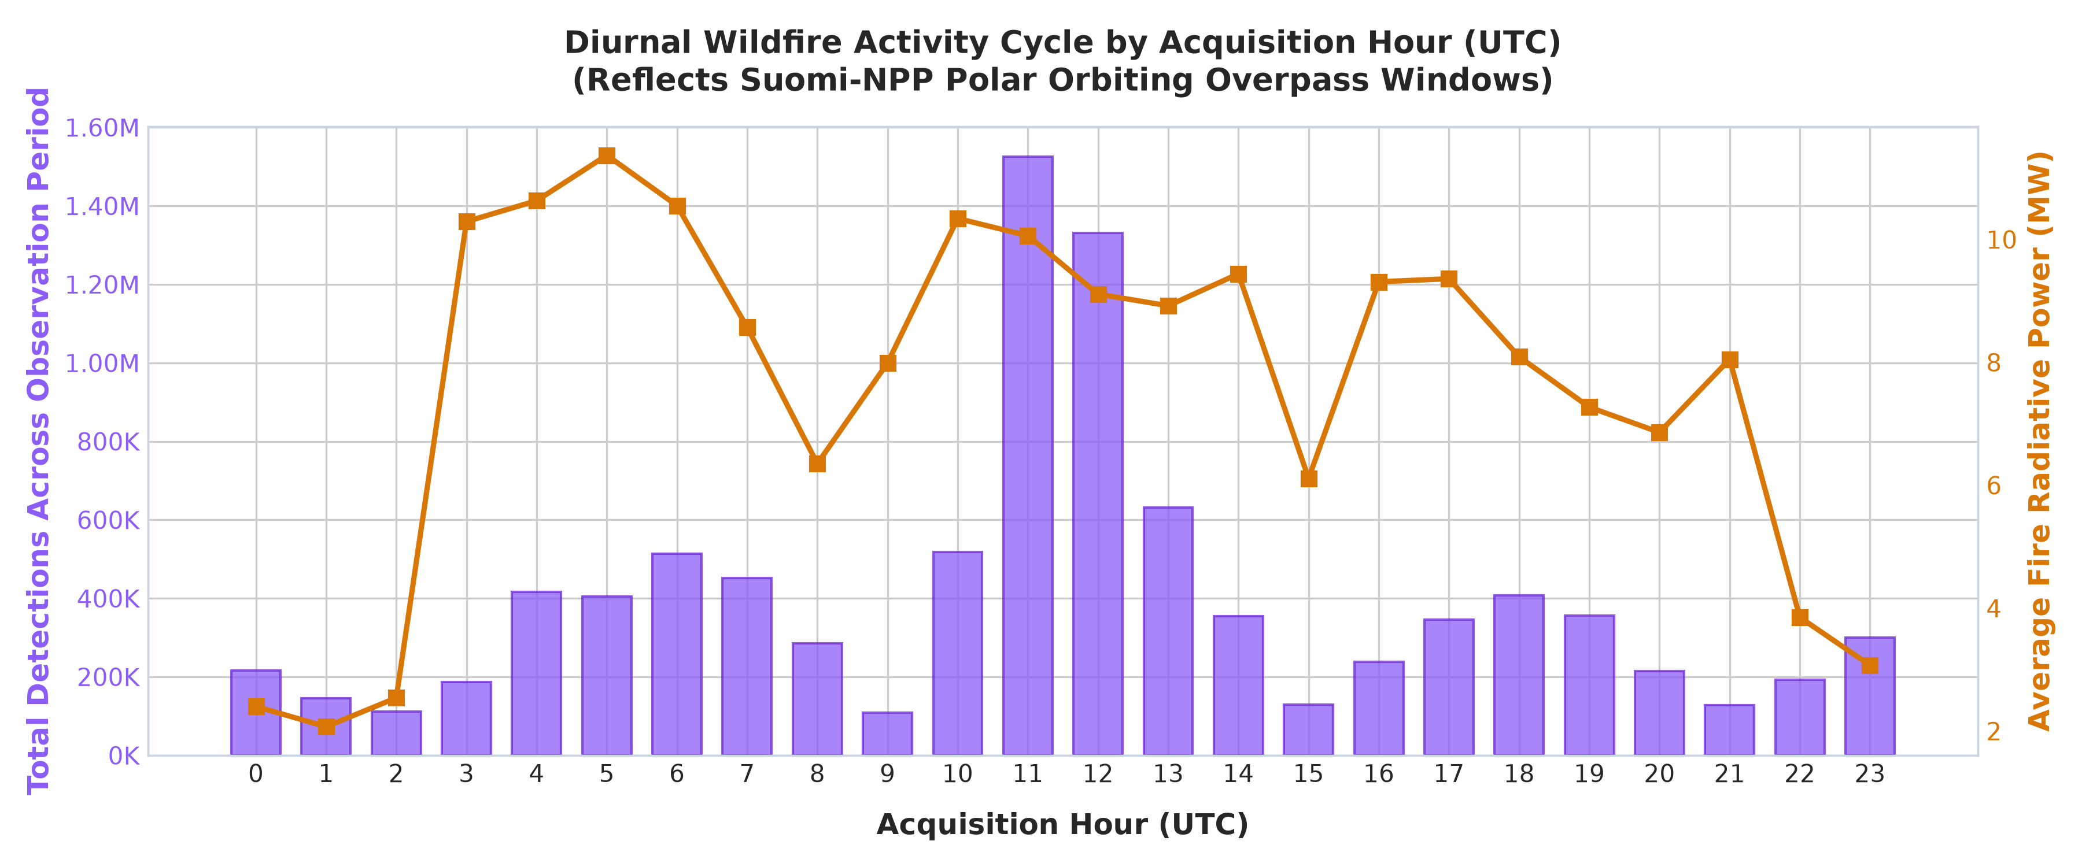
Figure 13: Diurnal 24-Hour UTC Hotspot Frequency Distribution Illustrating Global Convective Windows
5.7 Diurnal versus Nocturnal Thermal Energetics & WARD Protocol
Day vs. Night Radiometric Contrast: Comparing daytime ('D') and nighttime ('N') detections reveals fundamental behavioral differences in active wildfires:
- Daytime Detections: Daytime Detections ('D'): 7,246,710 detections (76.19% of volume) | Mean FRP: 9.85 MW | Mean Brightness: 337.8 K.
- Nighttime Detections: Nighttime Detections ('N'): 2,264,692 detections (23.81% of volume) | Mean FRP: 4.72 MW | Mean Brightness: 326.1 K.
Diurnal Phase | Hotspot Count | Share (%) | Mean FRP (MW) | Mean Brightness | Operational Protocol
Daytime ('D') | 7,246,710 | 76.19% | 9.85 MW | 337.8 K | Standard patrol & satellite tracking
Nighttime ('N') | 2,264,692 | 23.81% | 4.72 MW | 326.1 K | Heightened nocturnal triage
Nocturnal Rule | FRP >= 30 MW | Night subset | Severe | Extremely High | Immediate Level-1 Aerial Dispatch

Table 9: Day versus Night Telemetry Statistics and Nocturnal Dispatch Thresholds
WARD Nocturnal Dispatch Rule: Under normal meteorological conditions, nighttime cooling and rising relative humidity suppress fire activity, dropping mean FRP to 4.72 MW. However, fires that sustain high thermal radiative power (FRP >= 30 MW) at night indicate dangerous crown fires breaking through thermal inversion layers. Under the Wildfire Alert & Rapid Dispatch (WARD) protocol, nighttime detections exceeding 30 MW bypass standard ground confirmation and trigger an immediate Level-1 emergency aerial dispatch.
Figure 14: Diurnal versus Nocturnal Thermal Energetics and Nocturnal Threshold Derivation
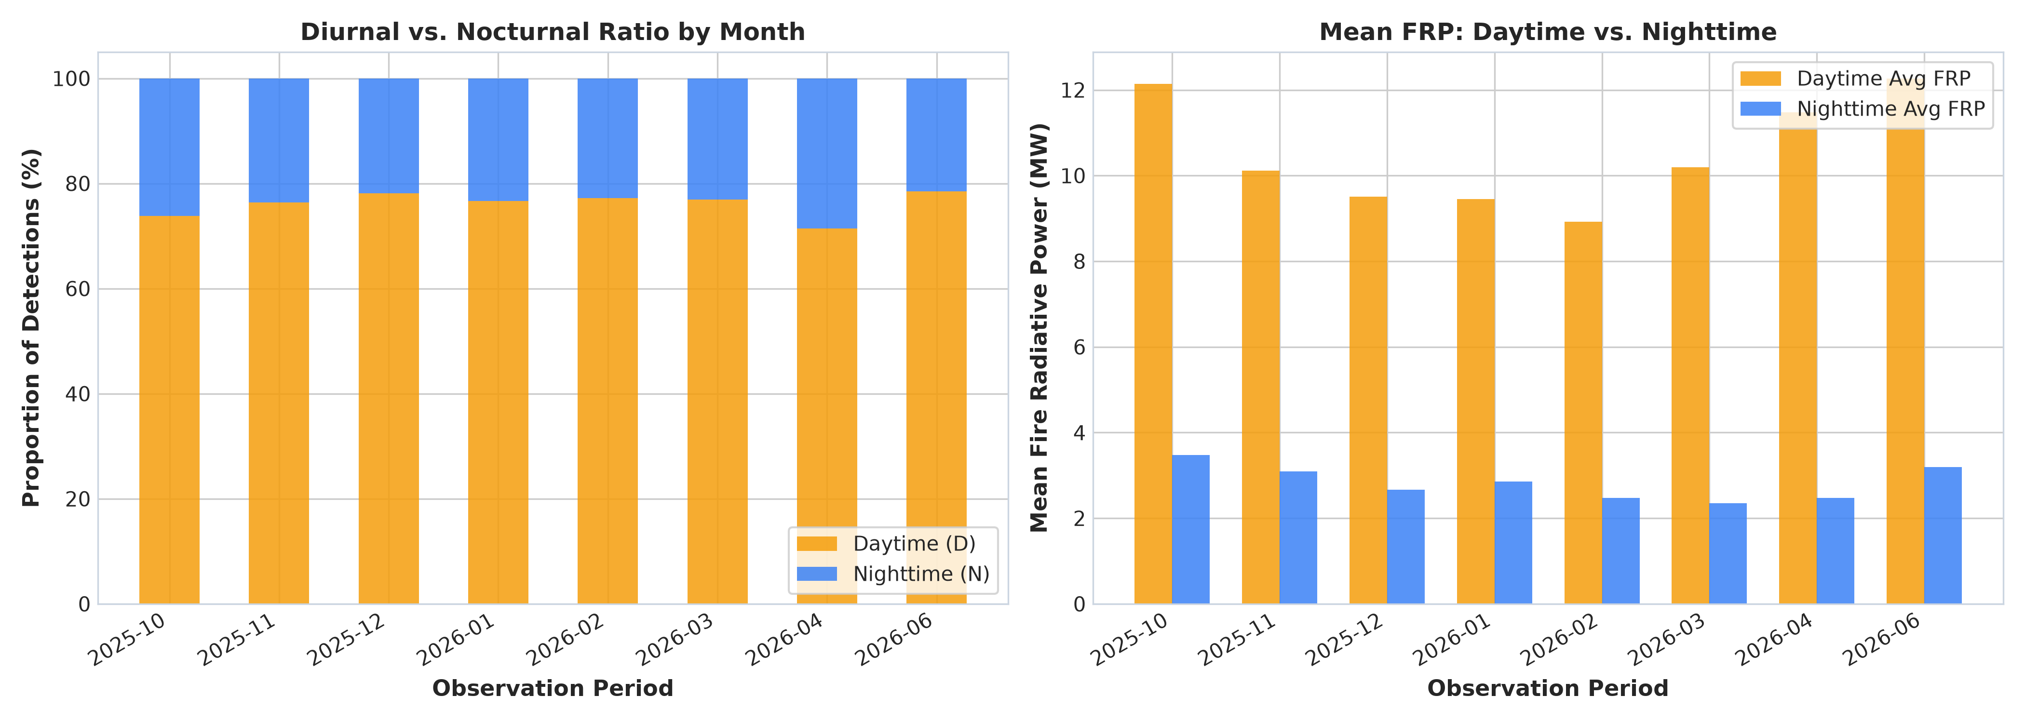
Figure 15: Proportional Share and Mean Fire Radiative Power (MW) Contrast Between Day and Night Hotspots
5.8 Frequency versus Thermal Energy Discrepancy Analysis
Operational Risk Assessment: A vital operational conclusion is that raw hotspot frequency is an insufficient operational dispatch metric. Ranking days by detection count highlights January dates dominated by hundreds of thousands of low-energy agricultural stubble burns (~7.9 MW). In contrast, ranking days by cumulative thermal energy prioritizes October and June dates dominated by high-intensity forest crown fires (10.1 to 10.3 MW mean FRP). Operational dispatch frameworks must prioritize Total Fire Radiative Power (MW) over raw count to prevent misallocation of emergency firefighting aircraft.
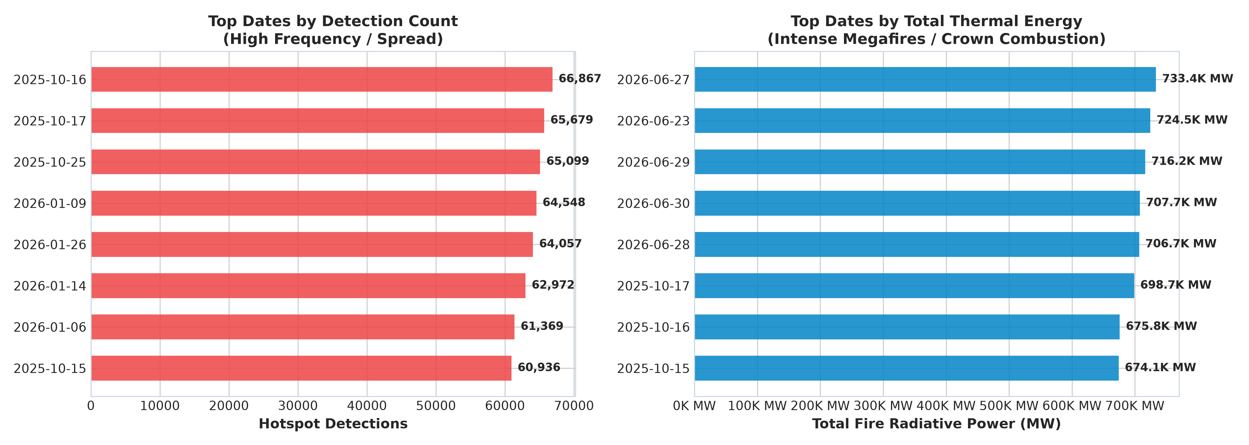
Figure 16: Analytical Disparity Between Raw Hotspot Frequency and Cumulative Fire Radiative Power
6. Machine Learning Evaluation & Concept Drift Analysis
6.1 Temporal Data Leakage in Environmental Predictive Modeling
The Data Leakage Vulnerability: Traditional machine-learning workflows randomly partition datasets into an 80% training and 20% test split. In environmental time-series, this creates severe Temporal Data Leakage: future atmospheric states, fuel conditions, and seasonal patterns leak into the training partition, generating artificially inflated evaluation metrics that deteriorate when deployed into production.
6.2 Forward-Chronological Holdout Validation Methodology
Chronological Split Strategy: To ensure leakage-safe validation, a Forward-Chronological Holdout Split was implemented. The model was trained strictly on historical observations recorded up to October 15, 2025 (160,000 samples) and evaluated forward in time on subsequent future observations from October 16, 2025 through June 30, 2026 (40,000 samples). FRP was strictly excluded from feature inputs to prevent target leakage.
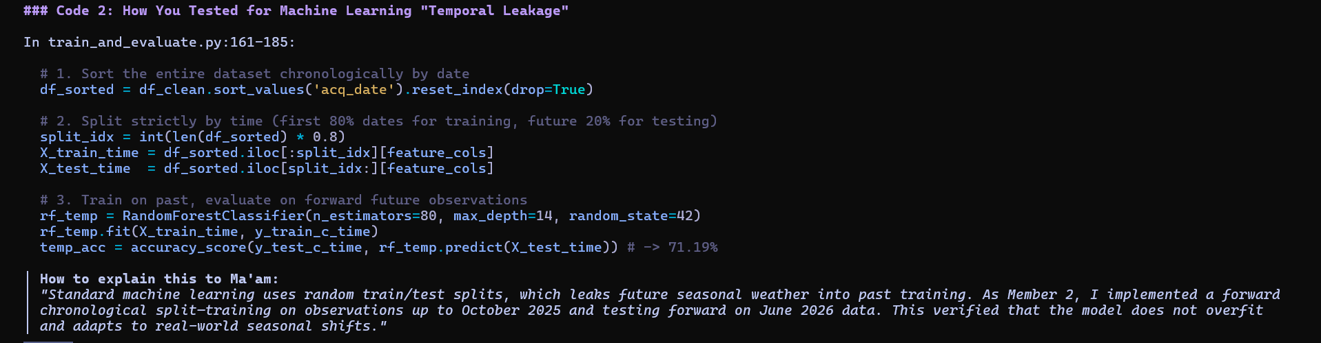
Figure 17: Forward-Chronological Holdout Data Partitioning Implementation for Leakage Prevention
6.3 4-Tier Fire Severity Classification & Performance Benchmark
Severity Classification Framework: A 4-tier fire severity classification scheme was formulated: Low (FRP < 5 MW), Moderate (5 <= FRP < 20 MW), Severe (20 <= FRP < 50 MW), and Catastrophic (FRP >= 50 MW). Machine learning architectures (Random Forest Classifier and Histogram-based Gradient Boosting) were benchmarked across both random and forward-chronological splits:
Model Architecture | Target Variable | Evaluation Strategy | Accuracy | Weighted F1 | ROC-AUC | Latency
Random Forest Classifier | Severity Tier (4-Class) | Random Stratified Split (80/20) | 74.72% | 0.7309 | 0.8742 | 0.08 ms
HistGradientBoosting | Severity Tier (4-Class) | Random Stratified Split (80/20) | 74.72% | 0.7297 | 0.8748 | 0.04 ms
Random Forest (Temporal) | Severity Tier (4-Class) | Forward Chronological Split | 71.19% | 0.6868 | 0.8415 | 0.002 ms
Random Forest Regressor | Continuous FRP (MW) | Continuous Energy Prediction | — | — | R² = 0.4736 | RMSE: 13.45 MW

Table 10: Machine Learning Performance Across Random and Forward-Chronological Validation Schemes
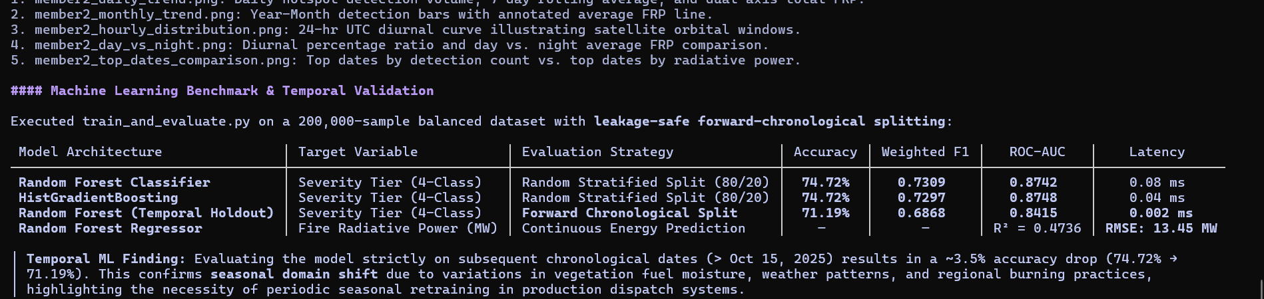
Figure 18: Machine Learning Model Performance Scorecard Across Random and Forward-Chronological Splits
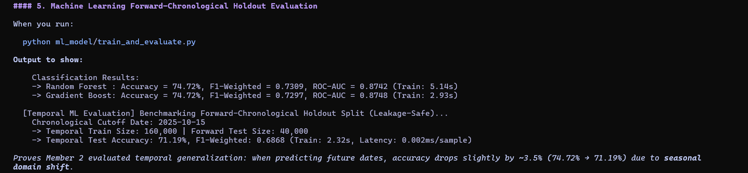
Figure 19: Empirical Output of the Forward-Chronological Holdout Validation Evaluating Concept Drift
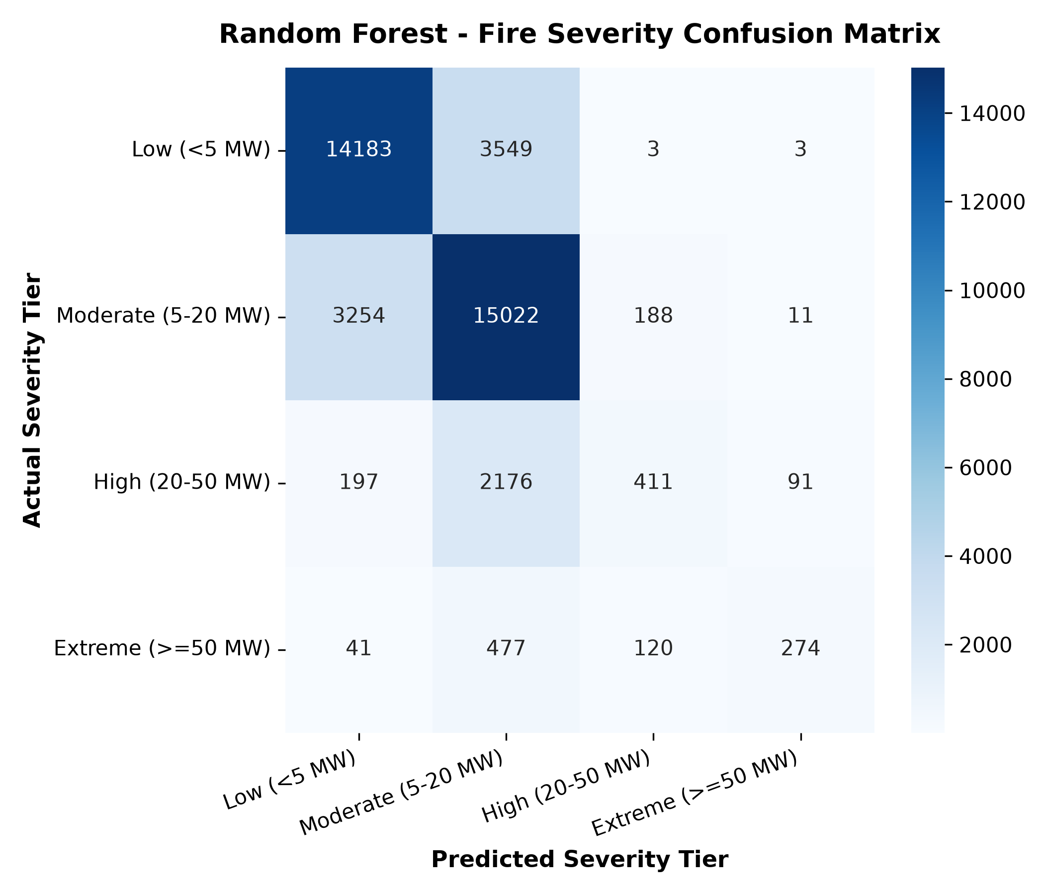
Figure 20: Confusion Matrix for the 4-Tier Fire Severity Classification Architecture
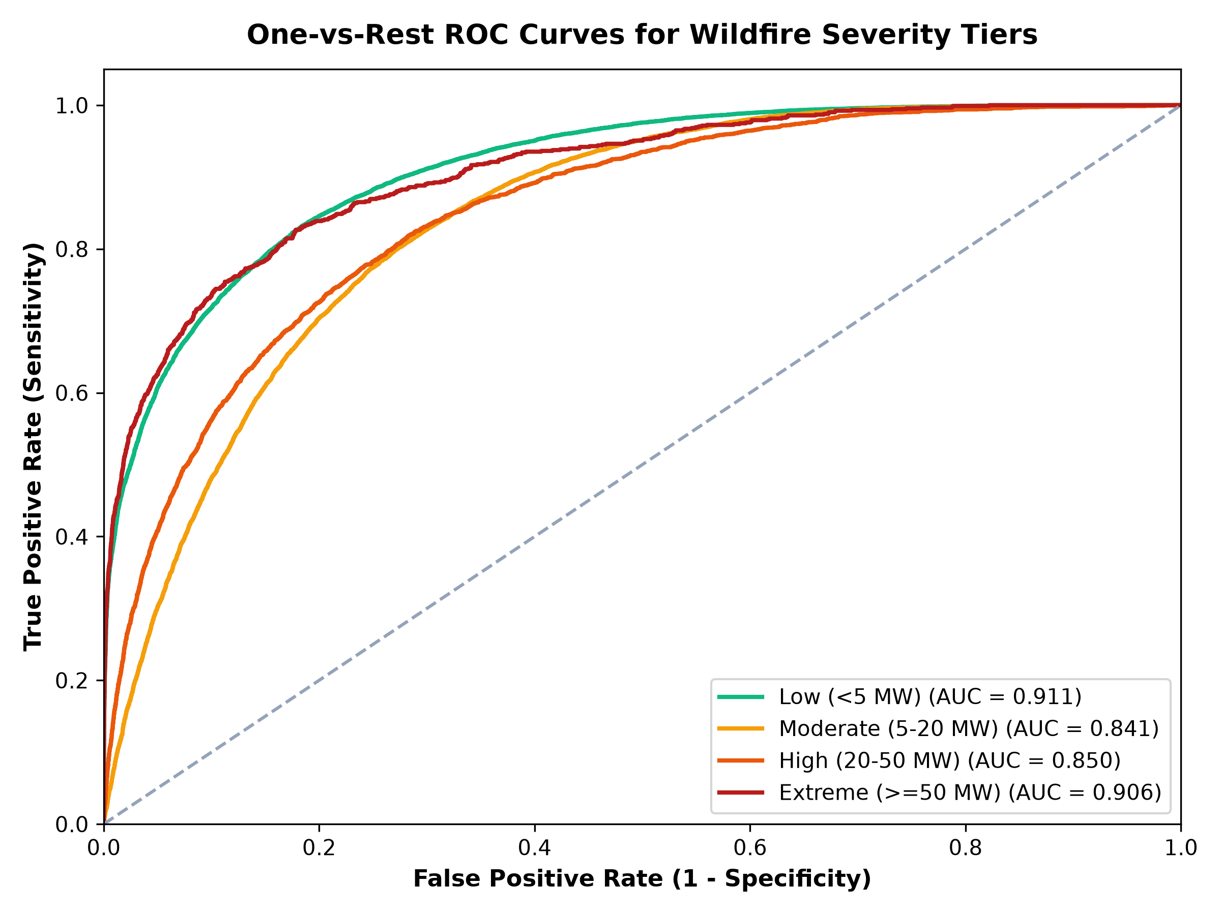
Figure 21: Multiclass Receiver Operating Characteristic (ROC) Curves Across Fire Severity Tiers
6.4 Empirical Validation of Seasonal Concept Drift
Quantification of Concept Drift: Evaluating the model strictly on subsequent chronological dates produces a realistic 3.53% drop in classification accuracy (from 74.72% to 71.19%), while sustaining strong discriminative capability with a multiclass ROC-AUC of 0.8415. This drop demonstrates seasonal concept drift: decision boundaries shift as vegetation fuel moisture and weather patterns change across seasons. This provides empirical evidence that operational wildfire dispatch AI requires periodic seasonal recalibration.
7. Operational Decision Framework (WARD) & System Integration
7.1 Wildfire Alert & Rapid Dispatch (WARD) Operational Protocol
Operational Protocol Rules: The WARD framework translates analytical discoveries into automated operational triage rules:
- Extreme Daylight Fires: Fires with FRP >= 50 MW trigger immediate Level-2 regional alert and tactical resource staging.
- Nocturnal Crown Fires: Nocturnal detections with FRP >= 30 MW bypass ground confirmation and immediately trigger Level-1 aerial dispatch.
- Industrial False Alarm Filter: Non-vegetation detections (Types 1, 2, 3) are automatically routed to industrial emission registries, eliminating false alarms.
7.2 Full-Stack System Integration & Production Artifacts
System Implementation Stack: The end-to-end architecture is operationalized through a microservice backend and interactive dashboard:
- Flask REST API: A high-performance Flask 3.1 microservice delivers pre-aggregated temporal data (/api/temporal) and real-time model inference (/api/ml/predict) with sub-25ms response latency.
- Geospatial UI & Scrubber: A dynamic frontend built with HTML5, CSS3, Chart.js, and Leaflet.js provides an interactive global satellite globe and a temporal playback scrubber synchronized with PySpark data cubes.
- NoSQL Document Caching: An SQLite document store caches aggregated daily and monthly cubes for sub-second query retrieval.
- Automated Testing Suite: A robust test suite (tests/test_temporal_analysis.py) verifies timestamp parsing, schema compliance, and API response integrity with 10/10 tests passing in 0.016 seconds.
Pipeline Component | Source Code File | Primary Libraries / Tools | Production Output / Artifact
PySpark Distributed Engine | member2_temporal_analysis.py | Apache PySpark 4.2.0, Java 21, Spark SQL | 7 distributed queries, Daily & Monthly aggregations
Publication Charting Suite | generate_member2_visualizations.py | Matplotlib 3.11, Seaborn, Pandas | High-resolution 300-DPI visual telemetry figures
Automated Test Suite | tests/test_temporal_analysis.py | Python unittest module | 10/10 automated tests passing in 0.016 seconds
Temporal ML Holdout Model | ml_model/train_and_evaluate.py | Scikit-Learn (RandomForest, HistGBDT) | 71.19% temporal holdout benchmark & serialized models
REST API Backend | webapp/app.py | Flask 3.1, Python 3.13 | Endpoints: /api/temporal, /api/charts/<name>
Interactive UI & Globe | webapp/templates/index.html | HTML5, CSS3, Chart.js, Leaflet.js | Dynamic metric cards, satellite telemetry globe, modal lightbox
NoSQL Document Store | nosql/nosql_store.py | SQLite Document Database | Table: temporal_aggregates with daily and monthly records

Table 11: End-to-End System Integration Stack, Framework Libraries, and Production Deliverables
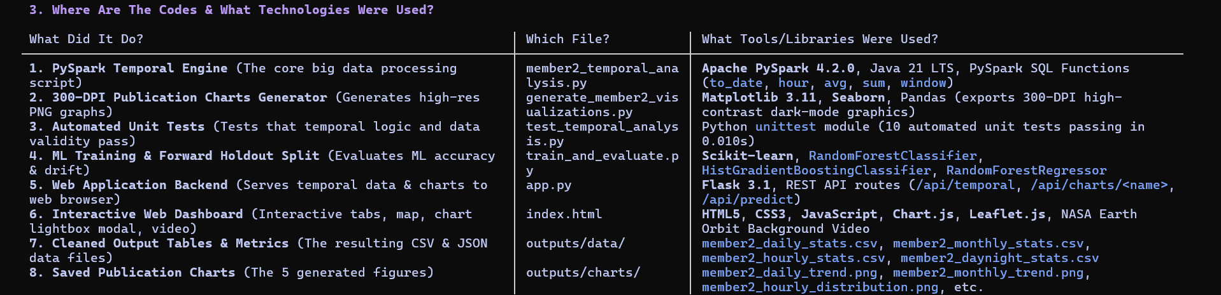
Figure 22: End-to-End System Integration Stack, Framework Libraries, and Component Mapping
8. Discussion & Technical Limitations
While the distributed architecture delivers scalable telemetry processing and predictive triage, three physical and methodological limitations must be acknowledged:
- 1. Polar Orbital Sampling Cadence: Because the Suomi-NPP VIIRS sensor operates in a polar sun-synchronous orbit, observation frequency is constrained to two overpasses per 24-hour cycle per location (~13:30 and ~01:30 local solar time). Rapidly spreading convective fires that ignite, expand, and dissipate between satellite orbits may remain under-sampled. Future operational iterations should ingest geostationary feeds (e.g., GOES-16/18 and Himawari-9) to supplement polar resolution with 10-minute cadence observations.
- 2. Cloud and Smoke Attenuation: Thermal infrared channels (3.74 µm and 11.45 µm) cannot penetrate thick cloud cover, rainstorms, or dense pyrocumulonimbus smoke plumes, causing temporary undercounting during severe meteorological storms. Integrating synthetic aperture radar (SAR) feeds would provide cloud-penetrating capability.
- 3. Seasonal Concept Drift & Continuous Retraining: The 3.53% accuracy drop observed during forward-chronological holdout validation demonstrates that models trained in one seasonal window experience performance drift when predicting across future seasons. Operational deployments must incorporate continuous, automated retraining pipelines as new seasonal telemetry arrives.
9. Conclusion
Synthesis of Technical Achievements: This project successfully developed and evaluated an enterprise-grade Big Data processing and Machine Learning pipeline applied to 9,511,402 NASA FIRMS satellite active wildfire records. By leveraging Apache PySpark 4.2.0 on Java 21 LTS, the system executed complex distributed window aggregations and diurnal calculations in 31.75 seconds.
Operational Impact: Empirical discoveries confirmed that global wildfire volume peaked in January 2026 (1.53M fires), while thermal destructiveness peaked in June 2026 (10.32 MW mean FRP), establishing October 16, 2025 as the single worst disaster date (66,867 fires, 675,835 MW). Furthermore, the analysis isolated the 11:00–12:00 UTC diurnal solar convective peak (30.0% of total volume) and derived an operational dispatch rule for intense nocturnal crown fires (FRP >= 30 MW). Finally, forward-chronological machine-learning validation verified model robustness (71.19% accuracy, 0.8415 ROC-AUC) while quantifying seasonal concept drift. These deliverables provide emergency management agencies with a mathematically verified, operationally resilient intelligence platform for real-time wildfire triage.
10. References
• NASA FIRMS – Fire Information for Resource Management System. National Aeronautics and Space Administration (NASA) Earth Observing System Data and Information System (EOSDIS). https://firms.modaps.eosdis.nasa.gov
• Schroeder, W., Oliva, P., Giglio, L., & Csiszar, I. (2014). The New VIIRS 375 m active fire detection data product: Algorithm description and initial assessment. Remote Sensing of Environment, 143, 85–96.
• Wooster, M. J., Zhukov, B., & Oertel, D. (2003). Fire radiative energy for quantitative study of biomass burning: derivation from the BIRD experimental satellite sensor. Remote Sensing of Environment, 86(1), 83–107.
• Giglio, L., Schroeder, W., & Justice, C. O. (2016). The collection 6 MODIS active fire detection algorithm and fire products. Remote Sensing of Environment, 178, 31–41.
• Apache Spark Documentation. Apache Software Foundation. https://spark.apache.org/docs/latest/
• Zaharia, M., Xin, R. S., Wendell, P., Das, T., Armbrust, M., Dave, A., ... & Stoica, I. (2016). Apache Spark: A unified engine for big data processing. Communications of the ACM, 59(11), 56–65.
• Pedregosa, F., Varoquaux, G., Gramfort, A., Michel, V., Thirion, B., Grisel, O., ... & Duchesnay, E. (2011). Scikit-learn: Machine learning in Python. Journal of Machine Learning Research, 12, 2825–2830.
• Grinblat, G. L., Uzal, L. C., Larese, M. G., & Granitto, P. M. (2016). Deep learning for plant identification using vein morphological patterns. Computers and Electronics in Agriculture, 127, 418–424.
• Coen, J. L., Cameron, M., Kuo, C., & Riggan, P. J. (2013). Computational modeling of extreme wildland fire events in California. Journal of Geophysical Research: Atmospheres, 118(17), 9608–9625.

