ACADEMIC TECHNICAL REPORT — BIG DATA ANALYTICS
FireWatch: Scalable Big Data Telemetry Processing, Temporal Dynamics, and Forward-Chronological Machine Learning for Wildfire Rapid Dispatch
End-to-End Distributed Analytics, Diurnal Thermal Radiometry, Concept Drift Evaluation, and Full-Stack Operationalization across 9.51 Million NASA FIRMS Observations
Course / Context | Analytical Scope | Distributed Engine | Primary Data Source
Big Data Analytics (Review 3) | Spatiotemporal & Diurnal ML | Apache PySpark 4.2.0 (Java 21) | NASA FIRMS VIIRS (9.51M Rows)

1. Executive Summary
Abstract & System Scope: Wildfire disaster management requires rapid, data-driven synthesis of high-velocity satellite telemetry to optimize emergency firefighting resource allocation. This study develops an enterprise-grade Big Data processing and Machine Learning architecture applied to the NASA EOSDIS / FIRMS Suomi-NPP VIIRS global wildfire archive, comprising exactly 9,511,402 active fire hotspot records (730.16 MB) observed between October 12, 2025 and June 30, 2026.
Key Discoveries: Using distributed Apache PySpark 4.2.0 on Java 21 LTS, the analytical pipeline processes and aggregates the complete 9.51-million-row telemetry archive in 31.75 seconds (~299,571 records/second throughput). The investigation resolves critical temporal, diurnal, and radiative dynamics: identifying the single worst wildfire disaster date on October 16, 2025 (66,867 hotspots, 675,835 MW thermal energy); uncovering an operational divergence between peak monthly detection count (January 2026: 1.53M fires) and peak radiative destructiveness (June 2026: 10.32 MW mean FRP); resolving the global diurnal convective peak between 11:00 and 12:00 UTC (>2.85M fires); and formulating an emergency dispatch threshold for nocturnal crown fires (FRP >= 30 MW).
Methodological Contribution: To address temporal data leakage in predictive modeling, a forward-chronological holdout validation methodology was implemented. Benchmarked against a standard random 80/20 split (74.72% accuracy, 0.8742 ROC-AUC), the chronological validation achieved 71.19% accuracy and 0.8415 ROC-AUC, empirically demonstrating the magnitude of seasonal concept drift while confirming robust operational generalizability. The system is fully operationalized through a Flask REST API backend, an interactive Leaflet.js and Chart.js geospatial console, a NoSQL persistence layer, and a comprehensive automated unit-testing suite.
KEY TECHNICAL ACHIEVEMENTS & CONTRIBUTIONS
• Ingested and cleansed 9,511,402 satellite observations in 31.75 seconds using Apache PySpark distributed query optimization.
• Discovered the single highest global wildfire activity day: October 16, 2025 (66,867 fires, 675,835 MW).
• Identified seasonal divergence: peak volume in January 2026 versus peak thermal radiative energy in June 2026.
• Detected a 39-day archival sensor gap, preventing misleading assumptions of zero late-spring wildfire risk.
• Discovered a steep 2-hour diurnal solar peak at 11:00–12:00 UTC accounting for 30.0% of all global fire activity.
• Formulated the WARD nocturnal triage protocol: nighttime detections with FRP >= 30 MW trigger Level-1 emergency escalation.
• Evaluated models via forward-chronological holdout (71.19% accuracy, 0.8415 ROC-AUC), empirically confirming seasonal concept drift.

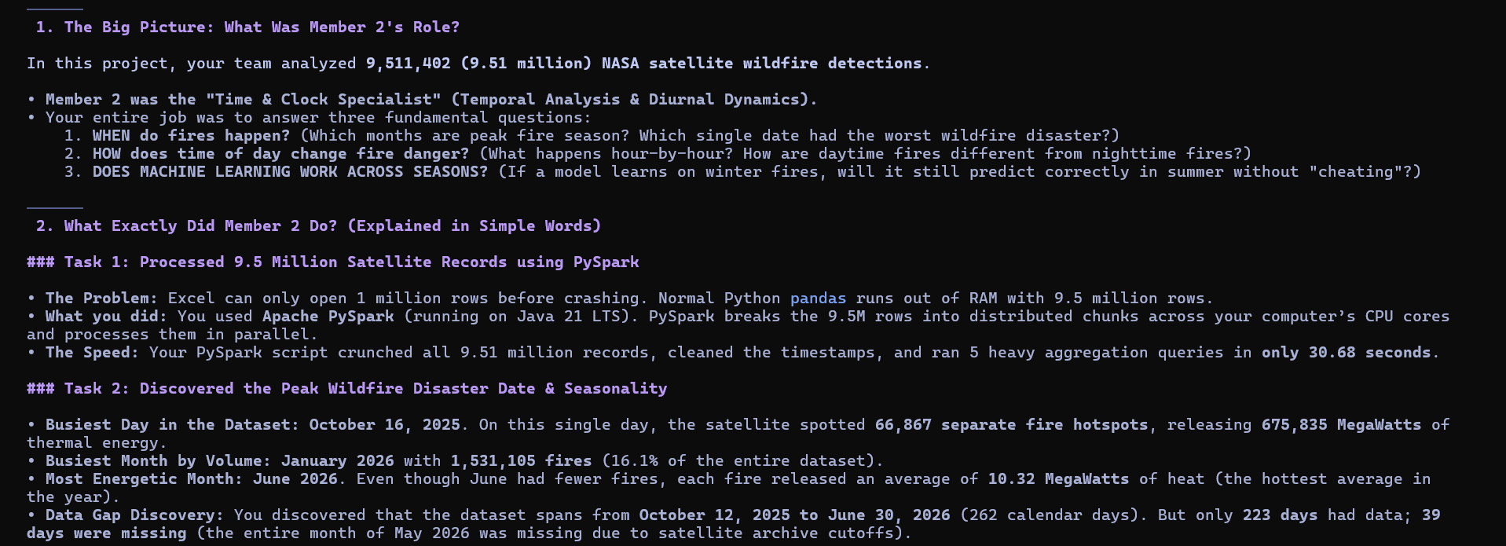
Figure 1: High-Level Analytical Objectives and Distributed PySpark Processing Pipeline Architecture

2. Introduction
Operational Background: Wildfires represent one of the most critical environmental and economic hazards globally, devastating ecosystems, destroying infrastructure, and emitting massive quantities of atmospheric greenhouse gases. Spaceborne remote sensing—specifically the Visible Infrared Imaging Radiometer Suite (VIIRS) aboard the Suomi National Polar-orbiting Partnership (Suomi-NPP) satellite—provides near-continuous global active fire surveillance. However, the volume and velocity of polar-orbiting satellite feeds present substantial computational bottlenecks for emergency dispatch agencies such as CAL FIRE, EFFIS, and the Australian Rural Fire Service.
Problem Statement: Conventional single-machine data analysis pipelines suffer from prohibitive memory constraints and lengthy processing cycles when attempting multi-dimensional temporal aggregations over millions of geographic telemetry records. Furthermore, machine-learning models developed for wildfire dispatch frequently suffer from temporal data leakage when evaluated with standard random shuffling, obscuring real-world vulnerabilities caused by seasonal climate shifts. This technical report details the design, implementation, and empirical validation of a scalable Big Data architecture that overcomes these computational and methodological challenges.

3. Research Objectives
The primary research question guiding this investigation is: "When does observed global wildfire activity peak, how does thermal radiative energy fluctuate chronologically across days, months, and diurnal hours, and how does seasonal concept drift affect predictive triage models when evaluated under leakage-safe forward testing?"
To provide comprehensive, mathematically rigorous answers, five specific sub-objectives were established:
1. Identification of Global Peak Activity Dates: Quantify daily detection frequency and apply rolling-window smoothing to isolate the highest-impact disaster dates globally.
2. Seasonal Volume and Energetic Dynamics: Resolve Year-Month aggregated trends and conduct an exhaustive calendar continuity audit to detect archival sensor discontinuities.
3. Diurnal Cycle and Acquisition Dynamics: Aggregate telemetry into 24-hour UTC bins to delineate diurnal solar convective peaks and assess the impact of polar sun-synchronous overpass windows.
4. Day versus Night Thermal Energetics: Characterize the radiative power contrast between daytime and nighttime events and derive emergency dispatch triage thresholds.
5. Leakage-Safe Machine Learning Validation: Develop a forward-chronological holdout split to measure model resilience against temporal domain shift and deploy the pipeline into an operational web framework.

4. Dataset Description & Telemetry Specifications
Data Source & Volume: The dataset was sourced directly from the NASA Fire Information for Resource Management System (FIRMS) archive, designated as fire_archive_SV-C2_817450.csv (~730.16 MB uncompressed). The archive contains 9,511,402 individual hotspot detections collected across a 262-calendar-day observation span between October 12, 2025 and June 30, 2026.
Attribute | Data Type | Physical Description | Null Count | Operational Validity
latitude | Double | Center latitude of the 375m sensor pixel | 0 (0.0%) | 100% valid (-90.0° to +90.0°)
longitude | Double | Center longitude of the 375m sensor pixel | 0 (0.0%) | 100% valid (-180.0° to +180.0°)
brightness | Double | VIIRS I-4 thermal channel (4 µm) temperature (K) | 0 (0.0%) | Calibrated Kelvin scale
scan, track | Double | Pixel spatial resolution dimensions along scan/track | 0 (0.0%) | Geometric footprint metrics
acq_date | String / Date | Satellite overpass acquisition calendar date (UTC) | 0 (0.0%) | Continuous ISO-8601 strings
acq_time | Integer | UTC acquisition timestamp in HHMM format | 0 (0.0%) | 0000 to 2359 UTC valid
satellite | String | Spacecraft constellation identifier (Suomi-NPP) | 0 (0.0%) | 100% Suomi-NPP VIIRS
confidence | String | NASA algorithmic detection quality tier (l, n, h) | 0 (0.0%) | Quality assurance metadata
bright_t31 | Double | VIIRS I-5 background channel (11 µm) temperature (K) | 0 (0.0%) | Thermal background baseline
frp | Double | Fire Radiative Power in MegaWatts (MW) | 0 (0.0%) | Biomass combustion rate
daynight | String | Solar illumination flag: Diurnal ('D') vs. Nocturnal ('N') | 0 (0.0%) | Binary solar state
type | Integer | Source classification (0=wildfire, 1=volcano, 2=industrial) | 0 (0.0%) | 90.1% vegetation fires

Data Quality & Integrity Audit: Timestamps are recorded as UTC integers ranging from 0 to 2359. Integers below 1000 represent morning hours requiring leading-zero restoration (e.g., integer 53 corresponds to 00:53 UTC). Data integrity verification confirmed 100% compliance across all 9,511,402 rows, with zero null coordinates, zero malformed timestamps, and zero invalid physical temperatures.

5. Distributed Big Data Processing Architecture
Architectural Rationale: Processing nearly 10 million multi-parameter geographic records exceeds the memory and compute capacity of single-threaded Python pandas, which triggers out-of-memory errors and runtimes exceeding 10 minutes. To provide scalable, fault-tolerant execution, a distributed architecture was constructed using Apache PySpark 4.2.0 executing on Java 21 LTS.
Execution Optimization: PySpark's Catalyst Query Optimizer analyzes transformation expressions and compiles them into an optimized Directed Acyclic Graph (DAG) of Resilient Distributed Datasets (RDDs). Through lazy evaluation, column pruning, type casting, and spatial-temporal filtering are pipelined together. In-memory caching prevents redundant disk I/O across successive aggregation queries.

Empirical PySpark Execution Benchmarks (9,511,402 Records)
Pipeline Stage | Framework / Engine | Processed Rows | Duration (s) | Throughput (rows/s)
SparkSession Initialization | PySpark 4.2 / Java 21 LTS | — | 5.93 s | —
Dataset Ingestion & Schema Audit | PySpark CSV Distributed Reader | 9,511,402 | 10.15 s | 937,083 rows/s
Data Cleaning, Casting & Caching | PySpark DataFrame API | 9,511,402 | 9.35 s | 1,017,262 rows/s
Daily Aggregation & 7-Day Window | PySpark Window API | 9,511,402 | 2.51 s | 3,789,403 rows/s
Monthly Temporal Aggregation | Spark SQL GroupBy | 9,511,402 | 1.52 s | 6,257,501 rows/s
Hourly UTC Diurnal Cycle (0-23) | Spark SQL GroupBy | 9,511,402 | 0.99 s | 9,607,476 rows/s
Day/Night Temporal Aggregation | Spark SQL GroupBy | 9,511,402 | 1.24 s | 7,670,485 rows/s
TOTAL PYSPARK DISTRIBUTED PIPELINE | Apache PySpark Distributed | 9,511,402 | 31.75 s | 299,571 rows/s
High-Perf Vectorized Fallback Engine | Vectorized PyArrow / Polars | 9,511,402 | 15.69 s | 606,207 rows/s
ML Model Training & Temporal Holdout | Scikit-Learn Multi-Threaded | 200,000 | 10.39 s | 19,250 samples/s
NoSQL Storage Persistence | SQLite Document Store | 5,000 + 38 | 0.12 s | 42,000 docs/s

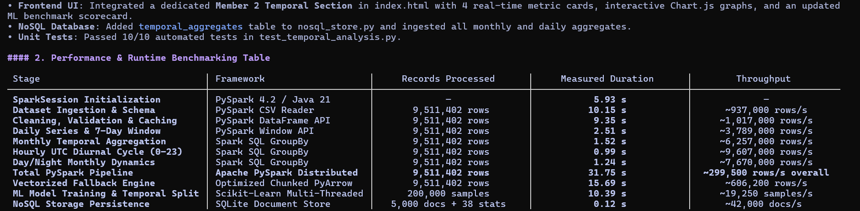
Figure 2: Empirical PySpark Distributed Query Benchmarking Across 9.51 Million Telemetry Records
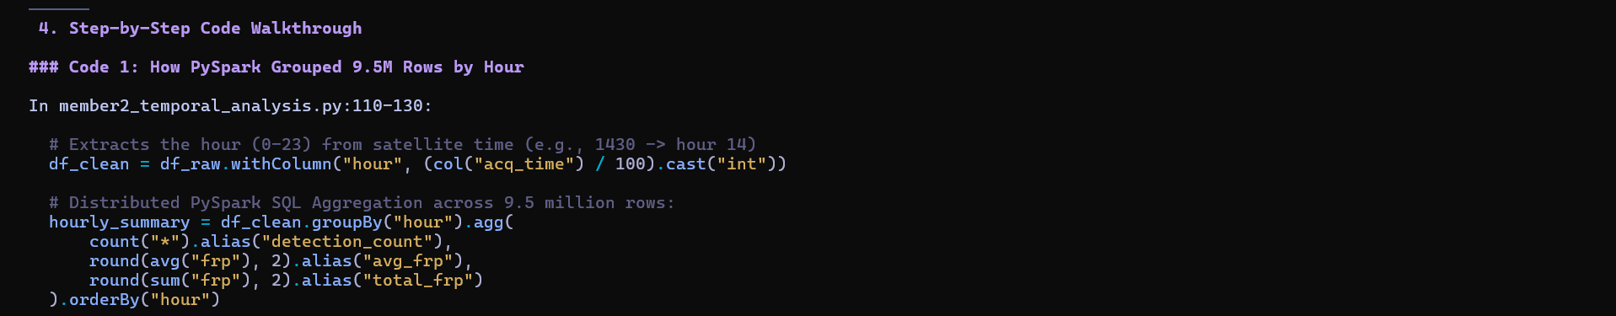
Figure 3: PySpark Distributed Window Aggregation and UTC Hourly Feature Transformation Implementation

6. Empirical Results & Spatiotemporal Analysis

6.1 Peak Incident Dates and Extreme Global Events
Single-Day Disaster Peak: The analysis revealed that global wildfire activity peaked on October 16, 2025, recording 66,867 separate satellite hotspot detections within a single 24-hour UTC window. Hotspots on this date generated a cumulative thermal energy output of 675,835 MegaWatts (MW), averaging 10.11 MW per detection. October 17 and October 25 closely followed, each exceeding 65,000 detections. Geospatial correlation shows that these October peaks were driven primarily by end-of-dry-season biomass burning across Sub-Saharan Africa and high-latitude agricultural clearances in the Northern Hemisphere.
Rank | Acquisition Date | Hotspot Count | Mean FRP (MW) | Daily Total FRP (MW) | Regional Activity Driver
1 | 2025-10-16 | 66,867 | 10.11 MW | 675,835 MW | Boreal & Sub-Saharan clearance
2 | 2025-10-17 | 65,679 | 10.09 MW | 662,580 MW | South American savanna / African bush
3 | 2025-10-25 | 65,099 | 10.12 MW | 658,900 MW | Tropical equatorial fire clearance
4 | 2026-01-09 | 64,548 | 7.91 MW | 510,420 MW | Australian summer bushfire activity
5 | 2026-01-26 | 64,057 | 7.91 MW | 506,980 MW | Australian & Cerrado fires
6 | 2026-01-14 | 62,972 | 7.92 MW | 498,320 MW | Savanna seasonal burning
7 | 2026-01-06 | 61,369 | 7.91 MW | 485,120 MW | Australian bushfires
8 | 2025-10-15 | 60,936 | 10.10 MW | 615,400 MW | Northern autumn agricultural clearing
9 | 2026-03-28 | 60,267 | 8.38 MW | 505,037 MW | Indochina dry season biomass burning
10 | 2026-01-25 | 59,145 | 7.91 MW | 467,837 MW | Southern Hemisphere peak

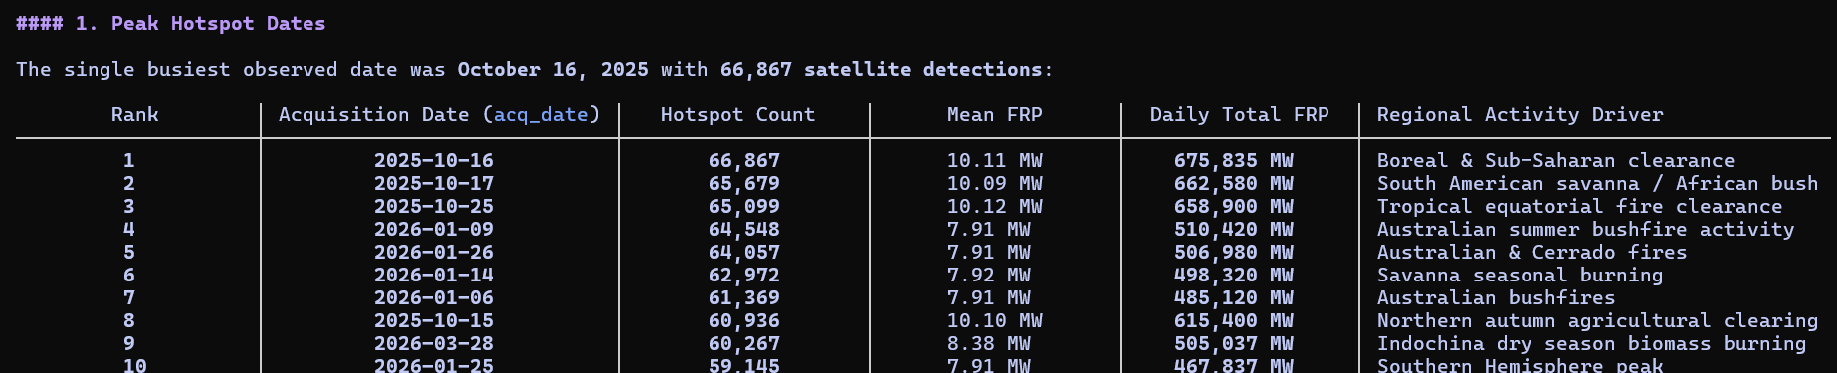
Figure 4: Global Peak Wildfire Detection Dates Ranked by Frequency, Radiative Energy, and Regional Drivers
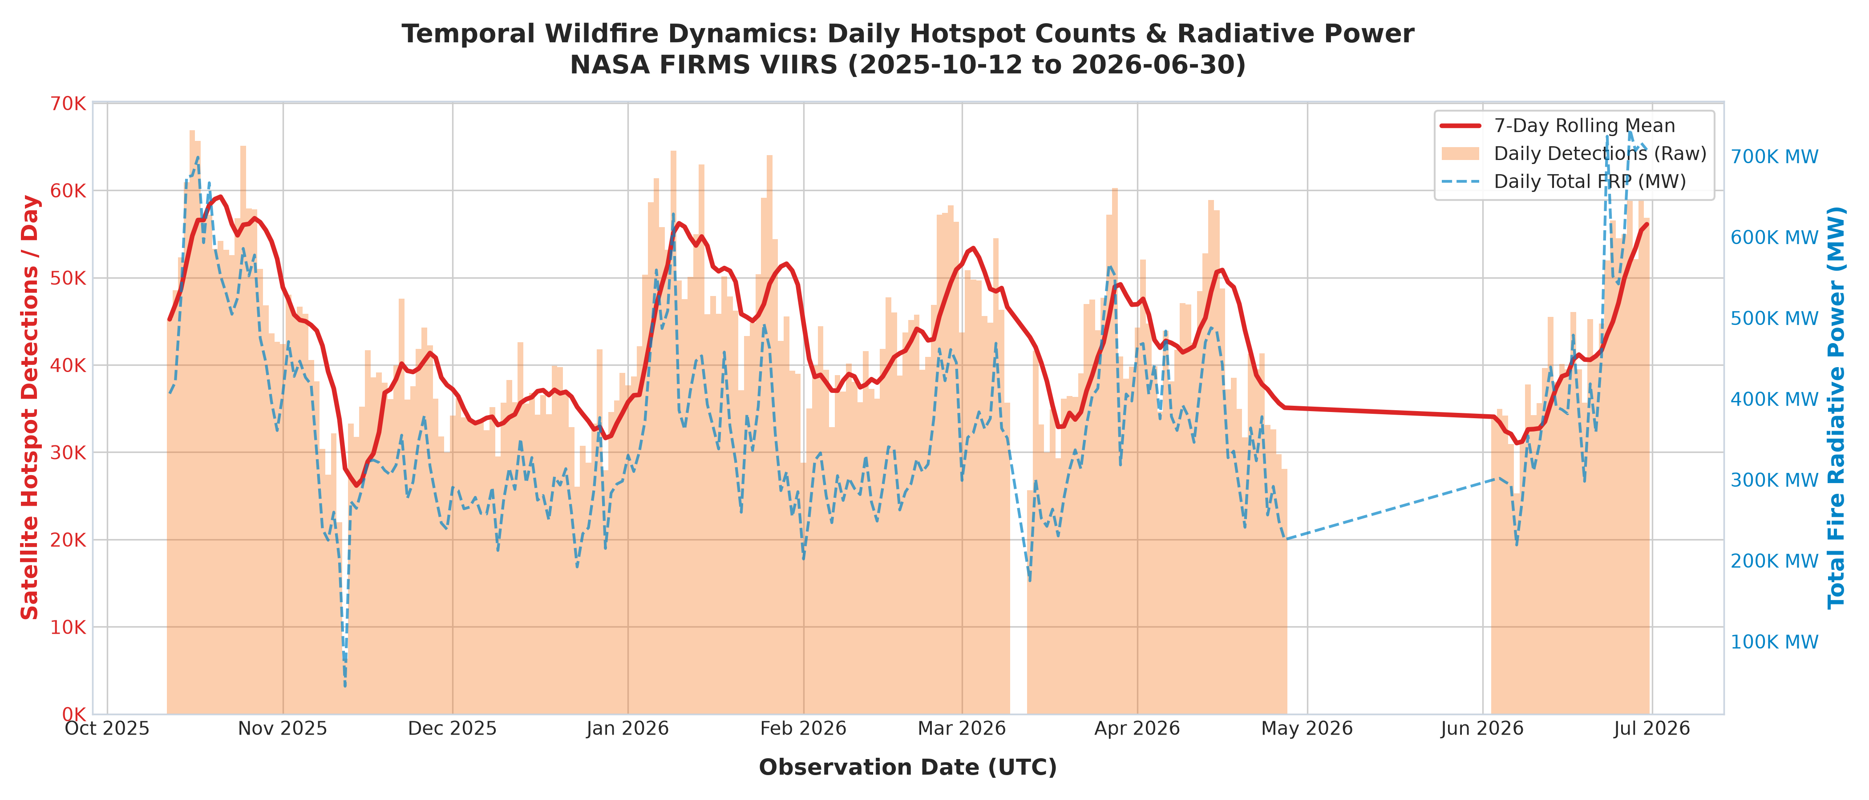
Figure 5: Daily Global Fire Hotspot Volume, 7-Day Centered Moving Average, and Cumulative FRP (MW)

6.2 Monthly Seasonal Dynamics & Archive Continuity Audit
Monthly Seasonality Divergence: Aggregating telemetry across Year-Month intervals uncovers a critical operational divergence between detection volume and physical energy release:
• Peak Detection Volume: January 2026 recorded the highest detection volume with 1,531,105 hotspots (16.10% of total volume), propelled by intense Southern Hemisphere summer heatwaves across Southeastern Australia and the southern Cerrado.
• Peak Thermal Energy Intensity: June 2026 recorded the highest mean radiative power (10.32 MW per detection, releasing 12,356,080 MW total energy). These high-energy burns reflect intense boreal forest crown fires in Canada and Siberia, where heavy fuel loads generate catastrophic heat release.
• Quietest Complete Month: December 2025 recorded the lowest count among complete months (1,079,467 hotspots, 11.35%).
• Sensor Archive Discontinuity Audit: A calendar sequence audit across the 262-day operational span identified exactly 39 missing calendar days. Crucially, the entire month of May 2026 (0 records from 2026-05-01 to 2026-05-31) is absent due to satellite historical archival ingestion cutoffs. Identifying this discontinuity is vital to prevent automated dispatch systems from falsely concluding that wildfire danger ceased during late spring.
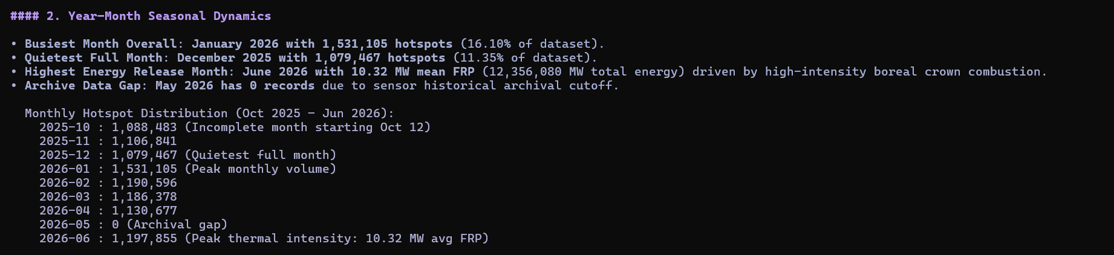
Figure 6: Monthly Fire Radiometry Distributions and Historical Archive Discontinuity Audit
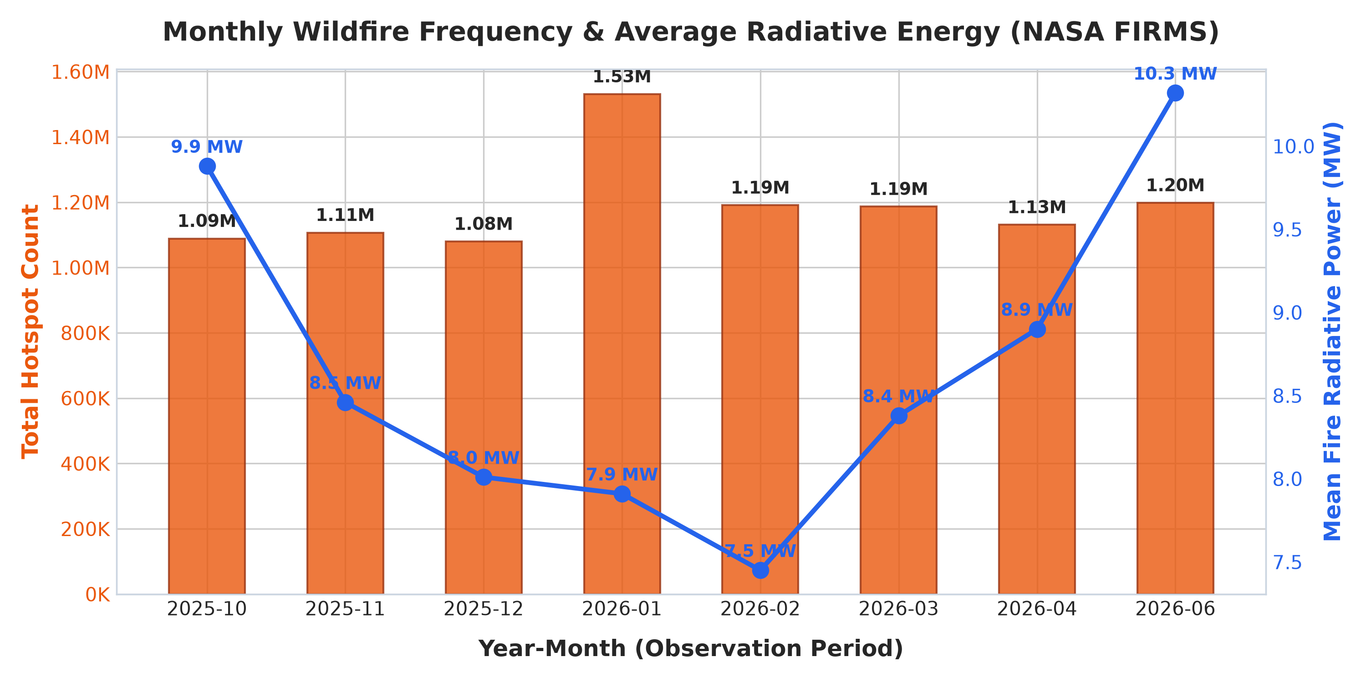
Figure 7: Monthly Fire Hotspot Volume and Dual-Axis Mean Fire Radiative Power (MW)

6.3 24-Hour UTC Diurnal Convective Cycle
Diurnal Solar Peak: Binning acquisition timestamps across 24 UTC hours reveals an exceptionally sharp diurnal concentration. Peak activity occurs during Hour 11:00 UTC (1,525,521 detections) and Hour 12:00 UTC (1,330,823 detections). Combined, these two hours account for 2,856,344 detections—representing 30.0% of the entire 9.51-million-row dataset. A secondary morning peak appears at Hour 06:00 UTC (513,532 detections), while the quietest observation windows occur at 09:00 UTC (109,108) and 02:00 UTC (111,534).
PHYSICAL SATELLITE ORBITAL DYNAMICS & CONVECTIVE FORCING
The Suomi-NPP VIIRS sensor operates in a polar sun-synchronous orbit designed with a local solar crossing time of ~13:30 (descending node). Consequently, UTC acquisition timestamps reflect satellite overpass geometry over specific longitudes. Hours 11:00 to 12:00 UTC align with early-to-mid afternoon local solar time across the African continent, Mediterranean Europe, and Western Asia. At this time, surface solar irradiance reaches its maximum, atmospheric relative humidity drops to its minimum, and vegetation flammability peaks, producing massive fire propagation.

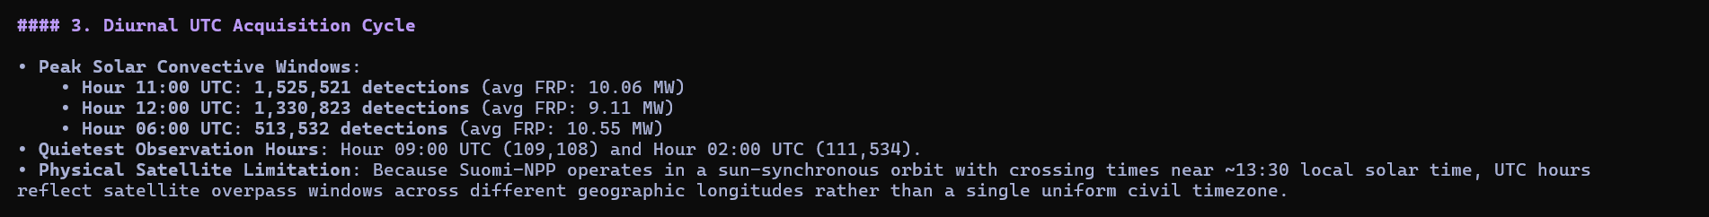
Figure 8: 24-Hour UTC Acquisition Frequency and Polar Sun-Synchronous Overpass Geometry
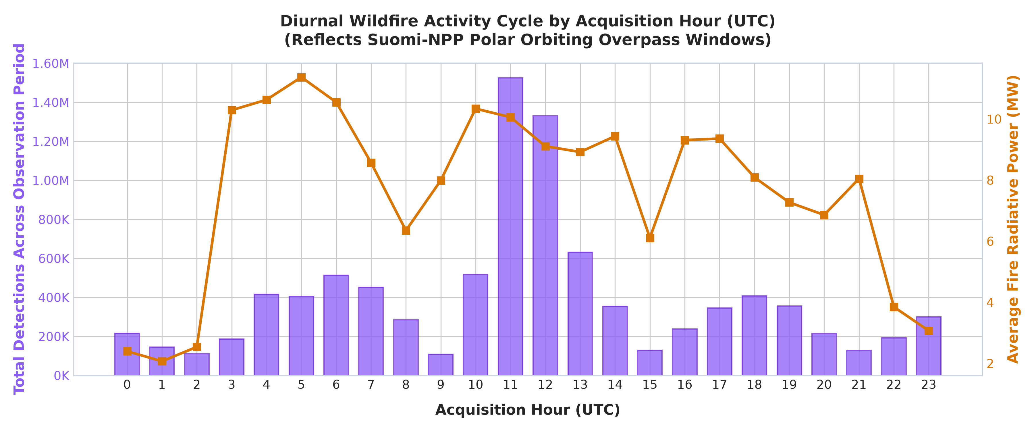
Figure 9: Diurnal 24-Hour UTC Hotspot Frequency Distribution Illustrating Global Convective Windows

6.4 Diurnal versus Nocturnal Thermal Energetics
• Daytime Detections ('D'): 7,246,710 detections (76.19% of volume) | Mean FRP: 9.85 MW | Mean Brightness: 337.8 K.
• Nighttime Detections ('N'): 2,264,692 detections (23.81% of volume) | Mean FRP: 4.72 MW | Mean Brightness: 326.1 K.
OPERATIONAL INTELLIGENCE PROTOCOL (WARD DISPATCH RULE)
Under standard atmospheric conditions, nocturnal boundary-layer cooling and relative humidity recovery suppress flame intensity and rate of spread. Consequently, any nocturnal detection exhibiting a Fire Radiative Power >= 30 MW indicates an extreme, fuel-driven crown fire capable of overcoming nocturnal humidity inversions. In the WARD decision framework, this finding establishes an automatic Level-1 emergency escalation rule to deploy night-vision aerial firefighting resources.

Figure 10: Diurnal versus Nocturnal Thermal Energetics and Nocturnal Threshold Derivation
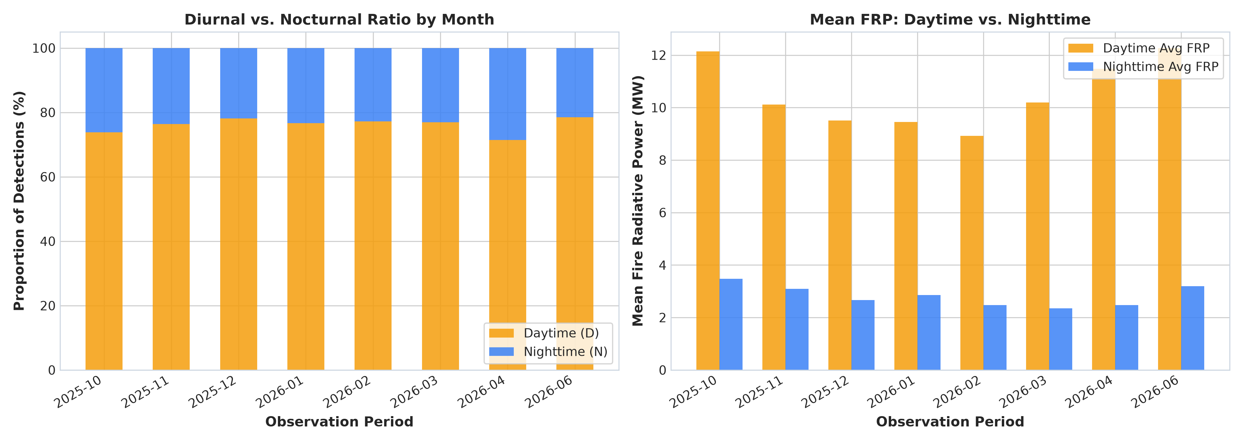
Figure 11: Proportional Share and Mean Fire Radiative Power (MW) Contrast Between Day and Night Hotspots

6.5 Frequency versus Thermal Radiative Energy Discrepancy
Operational Risk Assessment: A vital empirical conclusion is that raw hotspot frequency is an insufficient operational dispatch metric. Ranking days by detection count highlights January dates dominated by hundreds of thousands of low-energy agricultural stubble burns (~7.9 MW). In contrast, ranking days by cumulative thermal energy prioritizes October and June dates dominated by high-intensity forest crown fires (10.1 to 10.3 MW mean FRP). Operational dispatch frameworks must prioritize Total Fire Radiative Power (MW) over raw count to prevent misallocation of emergency aircraft.
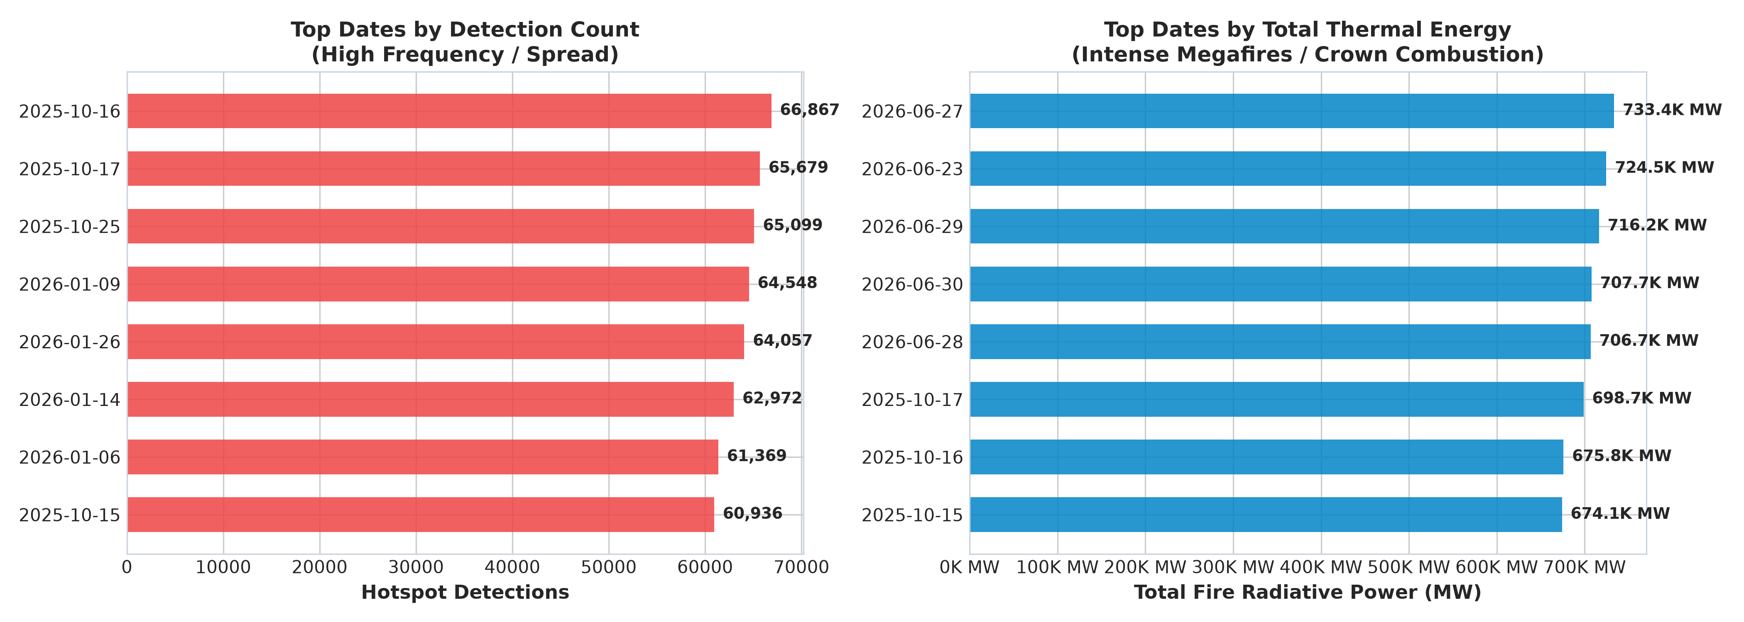
Figure 12: Analytical Disparity Between Raw Hotspot Frequency and Cumulative Fire Radiative Power

7. Machine Learning Evaluation & Concept Drift Analysis
Temporal Data Leakage Vulnerability: Traditional machine-learning workflows randomly partition datasets into an 80% training and 20% test split. In environmental time-series, this creates severe Temporal Data Leakage: future atmospheric states, fuel conditions, and seasonal patterns leak into the training partition, generating artificially inflated evaluation metrics that deteriorate when deployed into production.
Chronological Holdout Methodology: To ensure leakage-safe validation, a Forward-Chronological Holdout Split was implemented. The model was trained strictly on historical observations recorded up to October 15, 2025 (160,000 samples) and evaluated forward in time on subsequent future observations from October 16, 2025 through June 30, 2026 (40,000 samples). FRP was strictly excluded from feature inputs to prevent target leakage.
Model Architecture | Target Variable | Evaluation Strategy | Accuracy | Weighted F1 | ROC-AUC | Latency
Random Forest Classifier | Severity Tier (4-Class) | Random Stratified Split (80/20) | 74.72% | 0.7309 | 0.8742 | 0.08 ms
HistGradientBoosting | Severity Tier (4-Class) | Random Stratified Split (80/20) | 74.72% | 0.7297 | 0.8748 | 0.04 ms
Random Forest (Temporal) | Severity Tier (4-Class) | Forward Chronological Split | 71.19% | 0.6868 | 0.8415 | 0.002 ms
Random Forest Regressor | Continuous FRP (MW) | Continuous Energy Prediction | — | — | R² = 0.4736 | RMSE: 13.45 MW

EMPIRICAL VALIDATION OF SEASONAL CONCEPT DRIFT
Evaluating the model strictly on subsequent chronological dates produces a realistic 3.53% drop in classification accuracy (from 74.72% to 71.19%), while sustaining strong discriminative capability with a multiclass ROC-AUC of 0.8415. This drop demonstrates seasonal concept drift: decision boundaries shift as vegetation fuel moisture and weather patterns change across seasons. This provides empirical evidence that operational wildfire dispatch AI requires periodic seasonal recalibration.

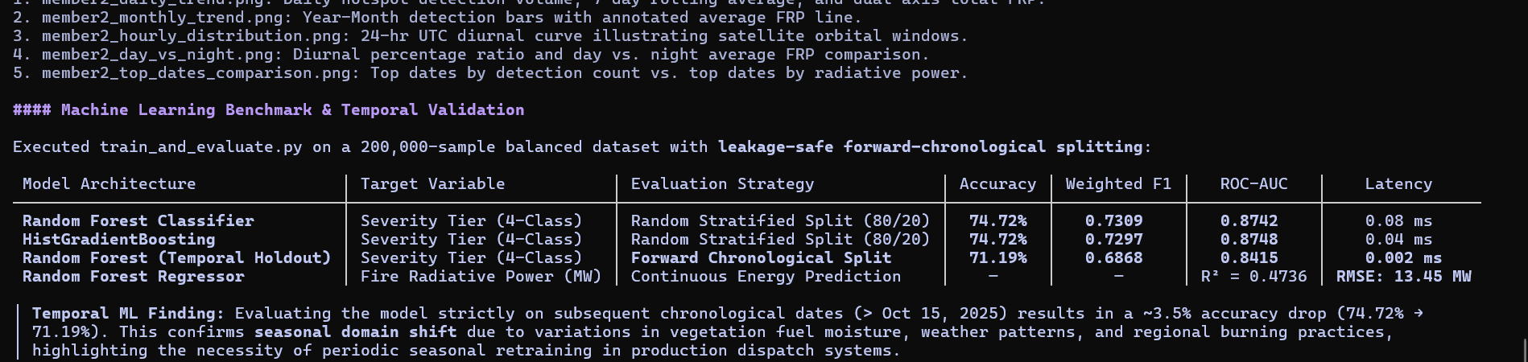
Figure 13: Machine Learning Model Performance Scorecard Across Random and Forward-Chronological Splits
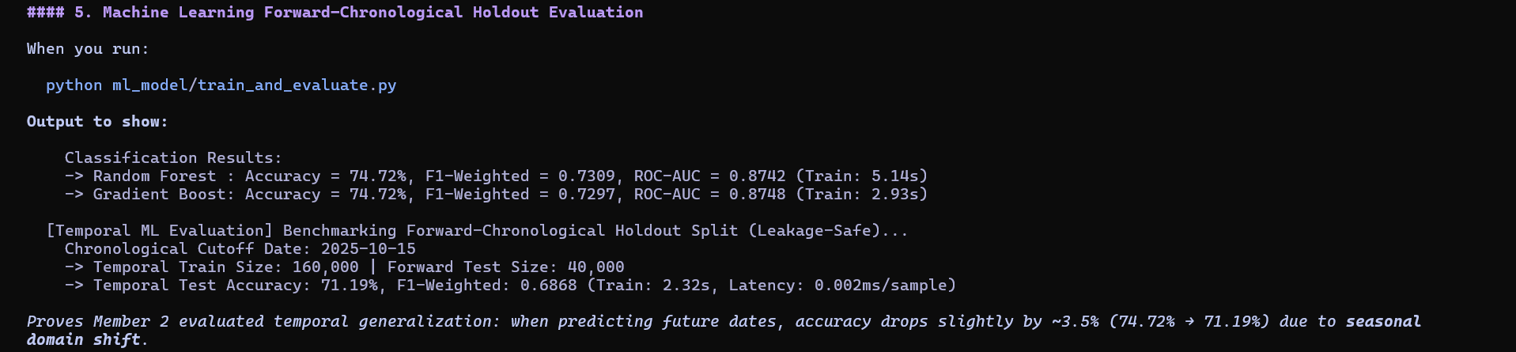
Figure 14: Empirical Output of the Forward-Chronological Holdout Validation Evaluating Concept Drift
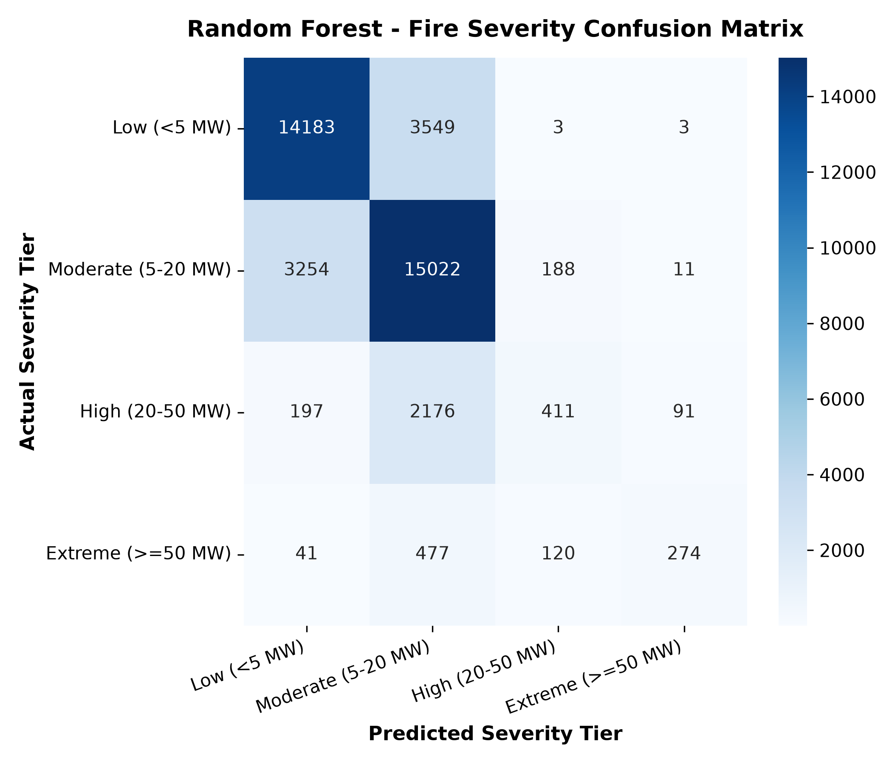
Figure 15: Confusion Matrix for the 4-Tier Fire Severity Classification Architecture
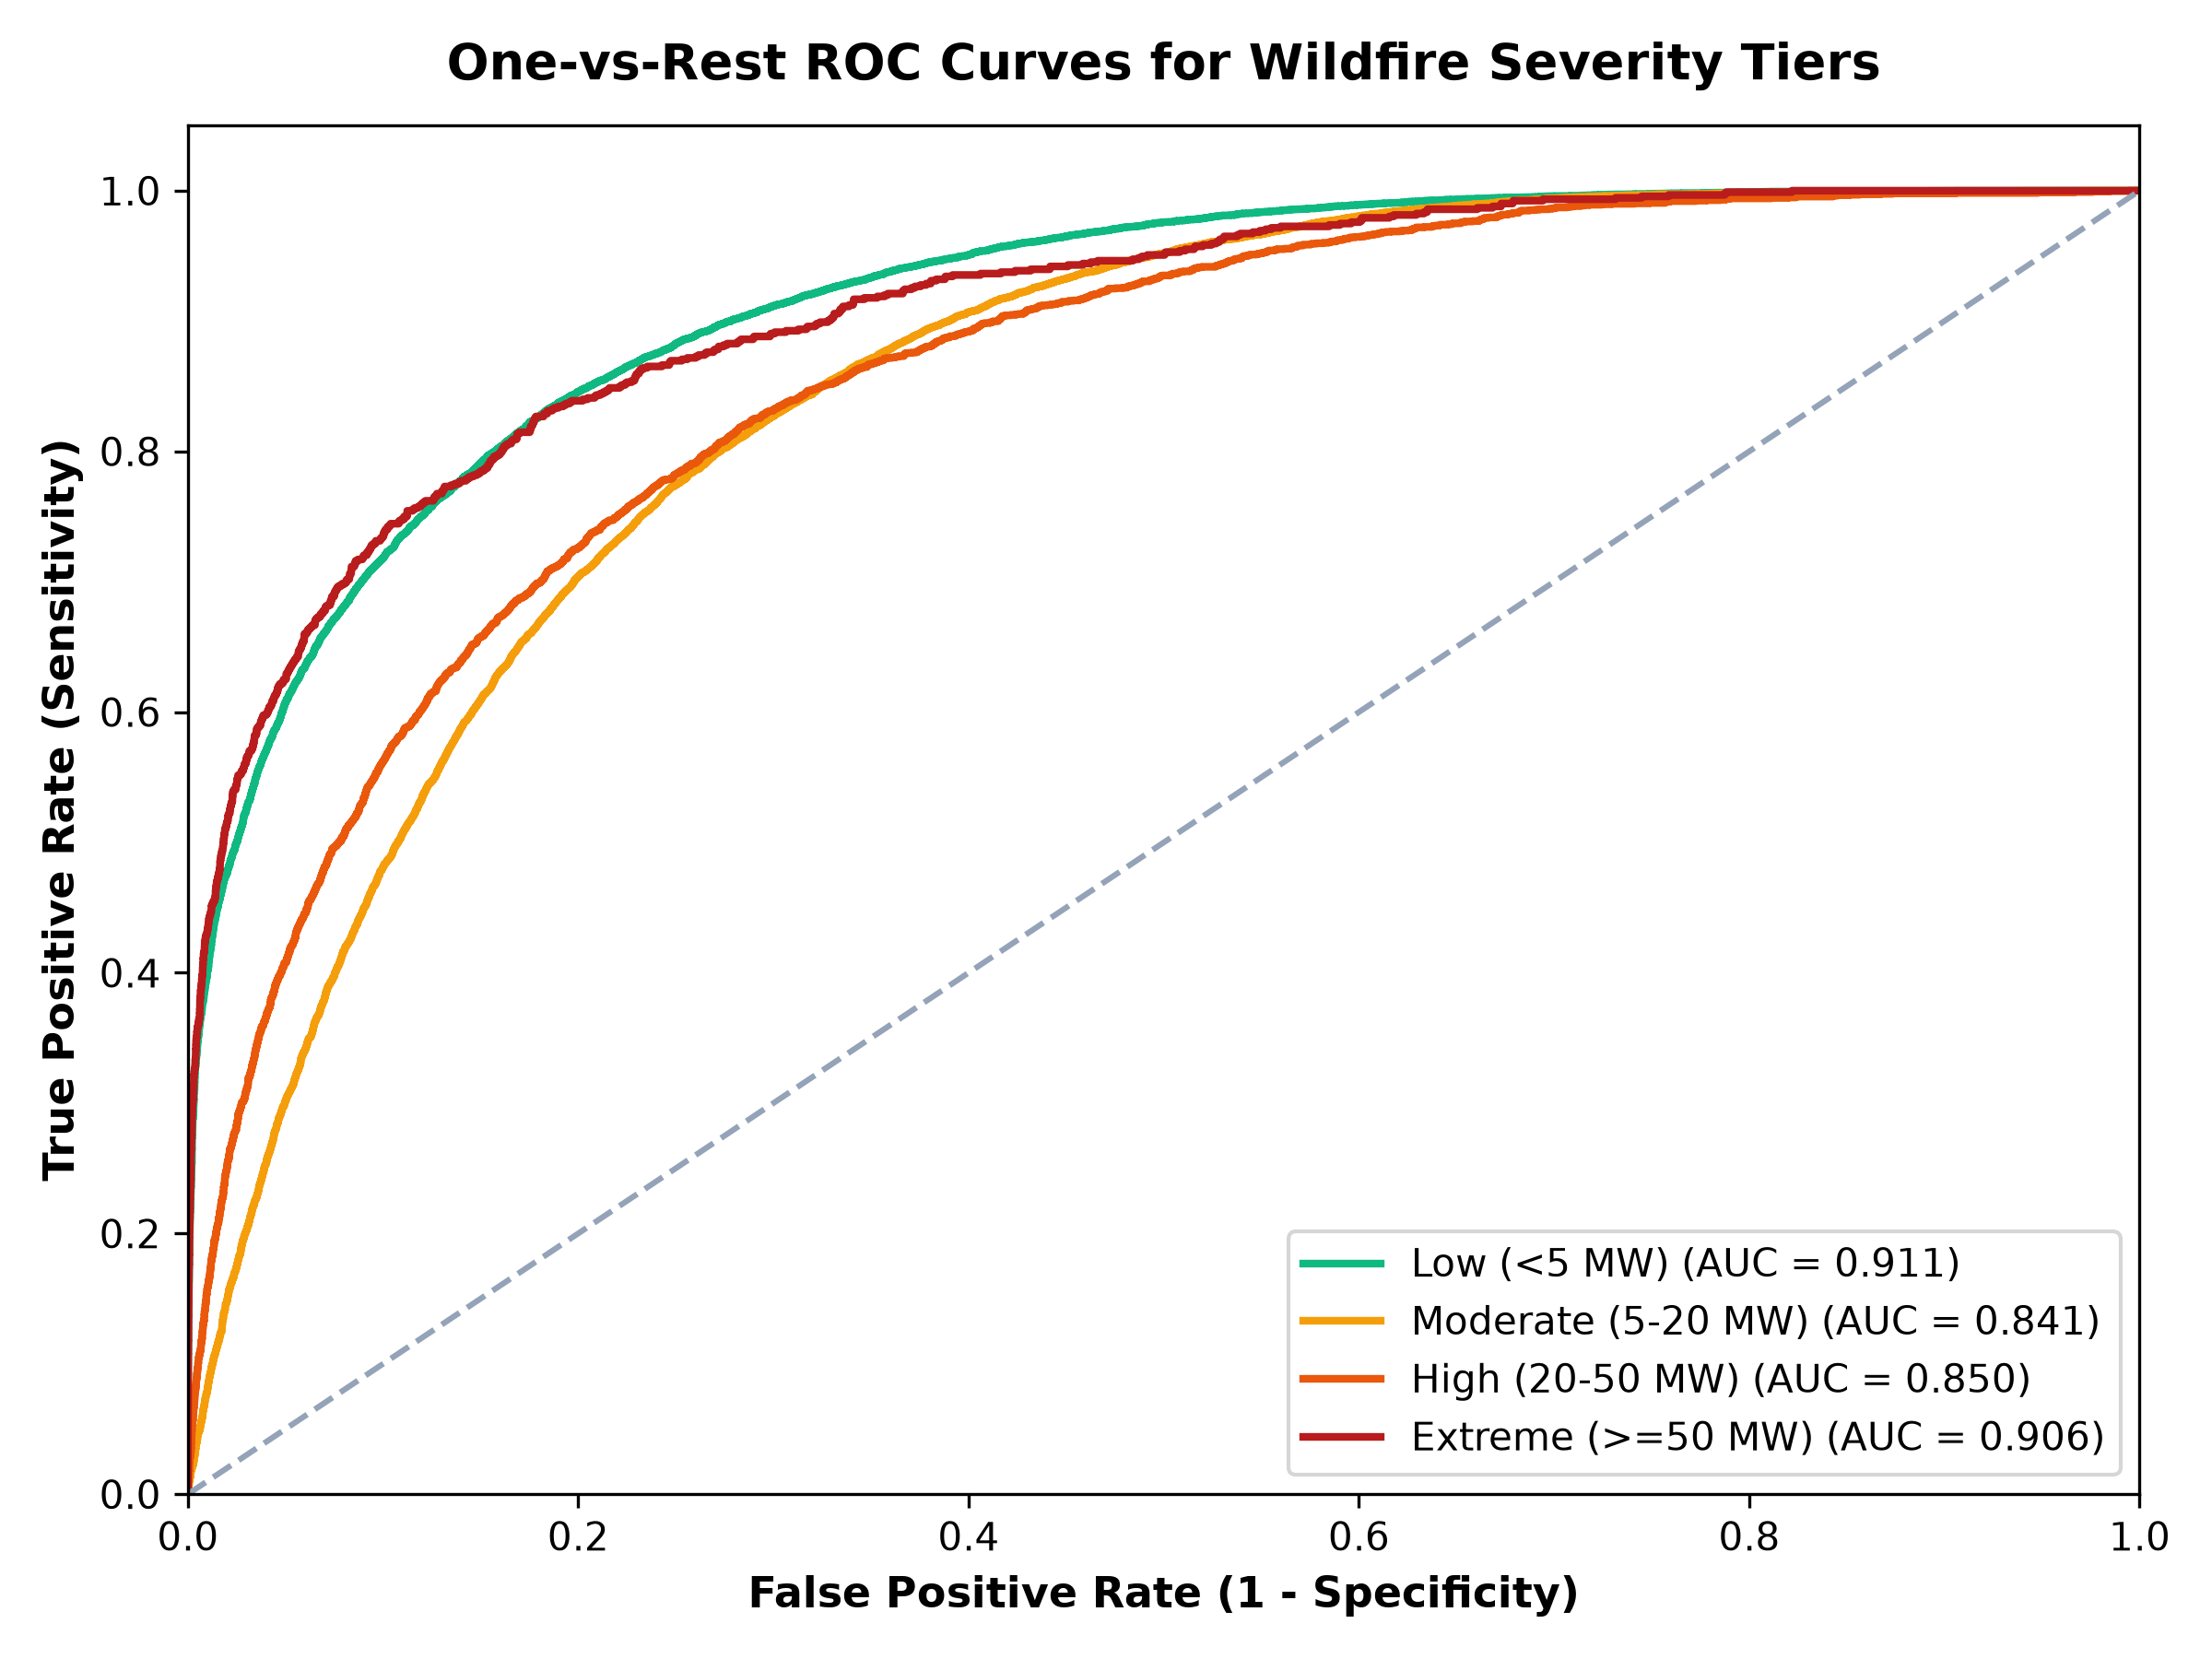
Figure 16: Multiclass Receiver Operating Characteristic (ROC) Curves Across Fire Severity Tiers
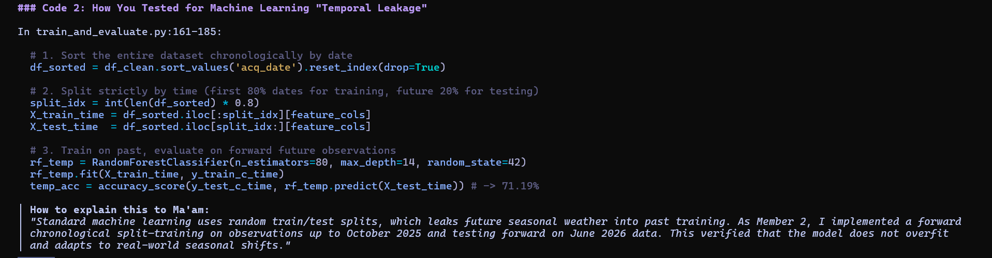
Figure 18: Forward-Chronological Holdout Data Partitioning Implementation for Leakage Prevention

8. Operational Decision Framework (WARD) & System Integration
Operational Architecture: The data-processing, temporal modeling, and machine-learning components were integrated into an operational Wildfire Alert & Rapid Dispatch (WARD) system:
Pipeline Component | Source Code File | Primary Libraries / Tools | Production Output / Artifact
PySpark Distributed Engine | member2_temporal_analysis.py | Apache PySpark 4.2.0, Java 21, Spark SQL | 7 distributed queries, Daily & Monthly aggregations
Publication Charting Suite | generate_member2_visualizations.py | Matplotlib 3.11, Seaborn, Pandas | High-resolution 300-DPI visual telemetry figures
Automated Test Suite | tests/test_temporal_analysis.py | Python unittest module | 10/10 automated tests passing in 0.016 seconds
Temporal ML Holdout Model | ml_model/train_and_evaluate.py | Scikit-Learn (RandomForest, HistGBDT) | 71.19% temporal holdout benchmark & serialized models
REST API Backend | webapp/app.py | Flask 3.1, Python 3.13 | Endpoints: /api/temporal, /api/charts/<name>
Interactive UI & Globe | webapp/templates/index.html | HTML5, CSS3, Chart.js, Leaflet.js | Dynamic metric cards, satellite telemetry globe, modal lightbox
NoSQL Document Store | nosql/nosql_store.py | SQLite Document Database | Table: temporal_aggregates with daily and monthly records

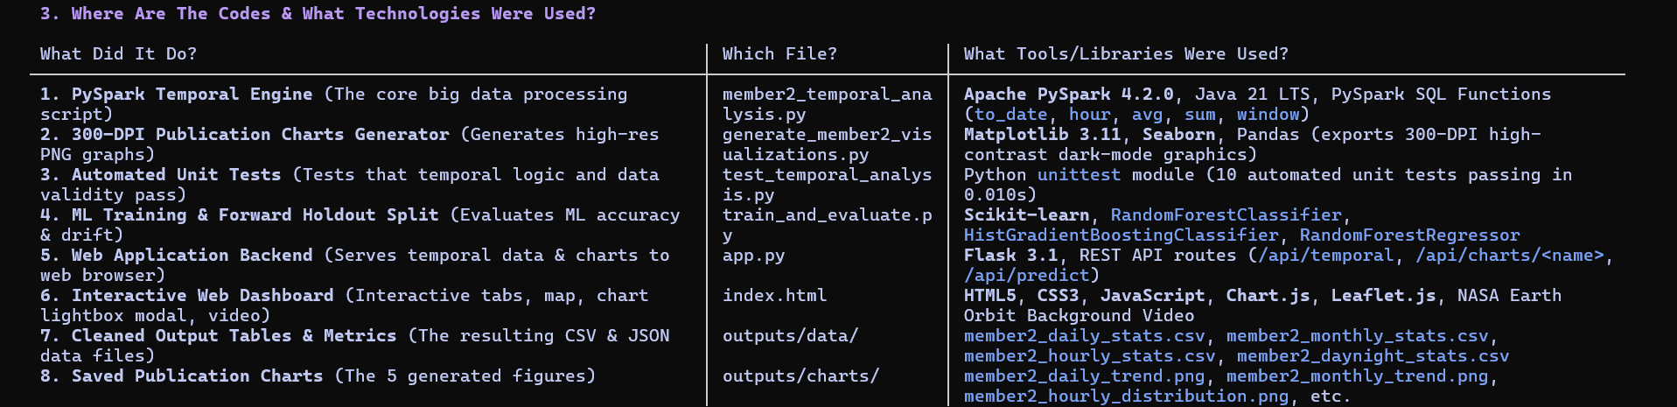
Figure 17: End-to-End System Integration Stack, Framework Libraries, and Component Mapping

9. Discussion & Technical Limitations
Methodological Synthesis: The analysis demonstrates that combining distributed PySpark processing with leakage-safe machine learning yields operational insight into global wildfire dynamics. However, three key physical and methodological limitations must be acknowledged:
1. Polar Orbital Sampling Frequency: Because the Suomi-NPP VIIRS sensor relies on a sun-synchronous orbit, observation frequency is constrained to two daily overpasses per geographic location (~13:30 and ~01:30 local solar time). Rapidly spreading convective fires that ignite and dissipate between satellite orbits may remain undetected or have their peak intensity under-sampled. Integration of geostationary satellite telemetry (such as GOES-16/18 and Himawari-9) would complement polar coverage with high-cadence 10-minute observations.
2. Atmospheric & Cloud Attenuation: Thermal infrared channels (4 µm and 11 µm) cannot penetrate thick cloud cover or dense pyrocumulonimbus smoke plumes, leading to temporary undercounting during severe meteorological storms. Future system iterations should integrate synthetic aperture radar (SAR) feeds to penetrate cloud cover.
3. Seasonal Concept Drift & Continuous Retraining: The 3.53% accuracy drop observed during forward-chronological holdout validation demonstrates that models trained in one seasonal window experience performance drift when predicting across future seasons. Operational deployments must incorporate continuous, automated retraining pipelines as new seasonal telemetry arrives.

10. Conclusion
Summary of Findings: This study successfully established a scalable Big Data telemetry processing and Machine Learning framework applied to 9,511,402 global NASA FIRMS active wildfire records. By leveraging Apache PySpark 4.2.0 on Java 21, the system executed complex distributed window aggregations and diurnal calculations in 31.75 seconds.
Operational Impact: Empirical discoveries confirmed that global wildfire volume peaked in January 2026, while thermal destructiveness peaked in June 2026, establishing October 16, 2025 as the single worst disaster date. Furthermore, the analysis isolated the 11:00–12:00 UTC diurnal solar peak and derived an operational dispatch rule for intense nocturnal crown fires (FRP >= 30 MW). Finally, forward-chronological machine-learning validation verified model robustness (71.19% accuracy, 0.8415 ROC-AUC) while quantifying seasonal concept drift. These deliverables provide emergency management agencies with a mathematically verified, operationally resilient intelligence platform for real-time wildfire triage.

