**PROCESSING DOCUMENT**

File 1: vPublic_PresubmissionCommunityMeetings

File 2: MARC_Stations

**STEP 1:**

File 1 -> Select all –> Sort –> Sort by -> meeting_location_zipcode

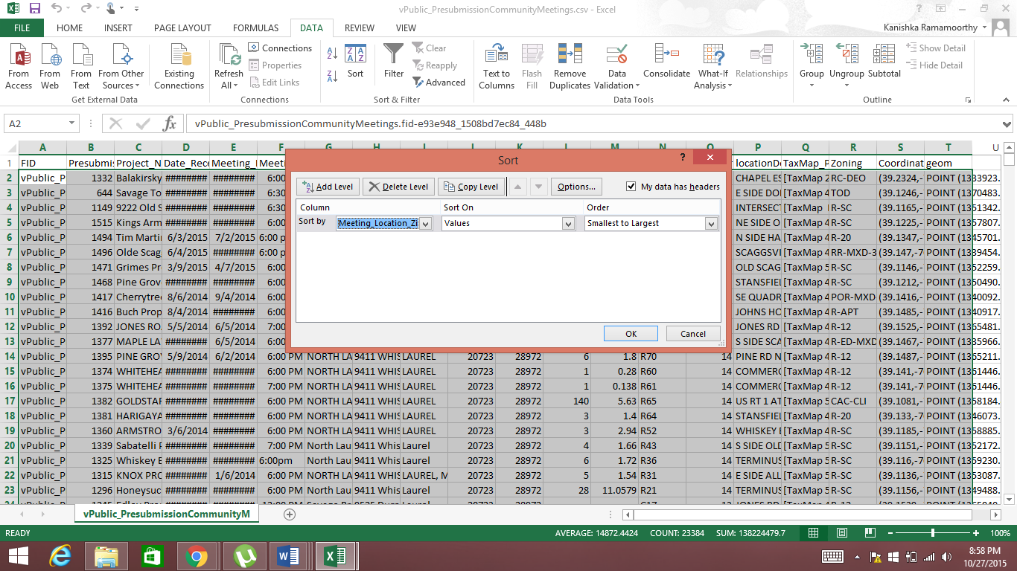

**STEP 2**

Create a new column “2010 Census Population” in file 1

**STEP 3**

File 2 -> Ctrl+F -> Enter the first unique zipcode value available in the “meeting_location_zipcode” column under file 1

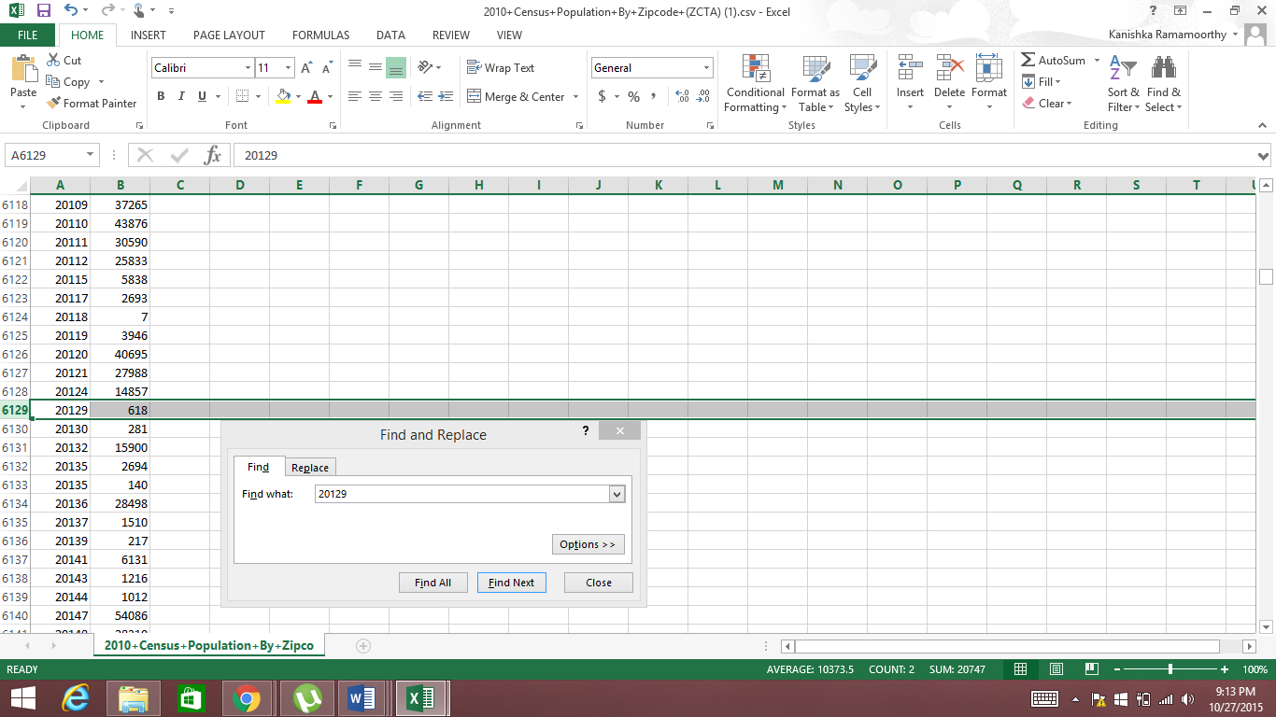

**STEP 4**

Copy the population of the zipcode from file 2 and paste it next to the corresponding zipcode in file 1 under the “2010 Census Population” column

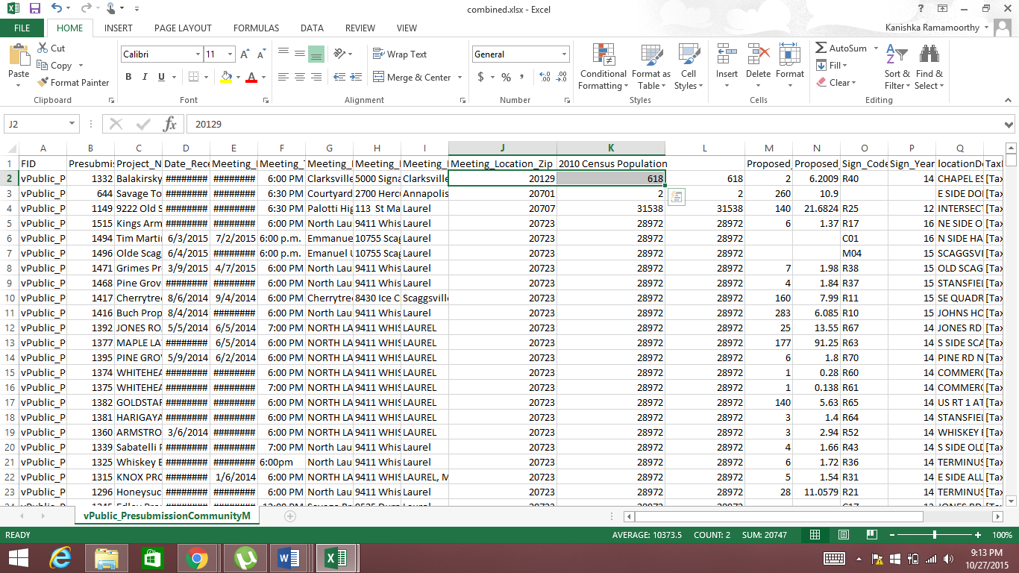

Repeat step 3 and 4 for each unique zipcode in File 1.

**STEP 5:**

**File 1 - Delete columns:**

Proposed_Units

Proposed_Acres

TaxMap_Parcel

Reason for elimination: Not relevant to the research question

**File 1 - Delete rows:**

153, 1133-1136, 1238-1257, 1333, 1344-1338

Reason for elimination: Unable to find population information for these zipcodes on file