File 1: community meetings

File 2: population

Step 1:

Select all – sort – by meeting_location_zipcode

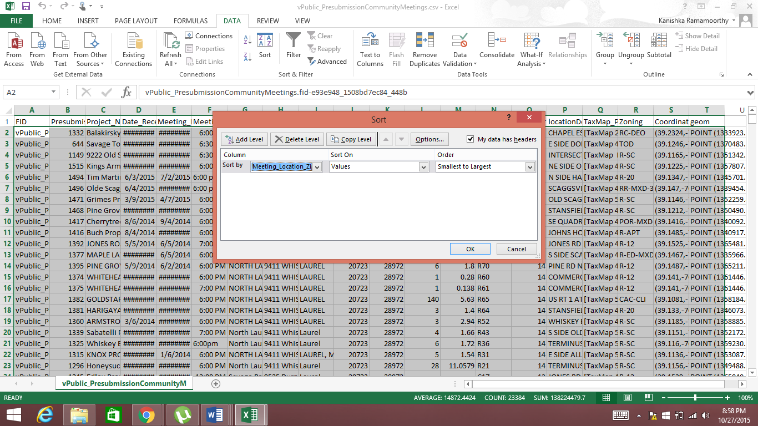

Step 2

Create a new column “2010 Census Population” in file 1

Step 3

In file 2 Ctrl+F enter the first unique zipcode value

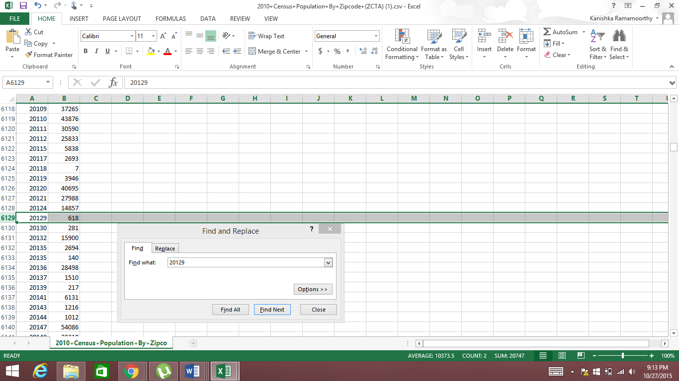

Step 4

Copy the population of the corresponding zipcode from file 2 and paste it next to the corresponding zipcode in file 1

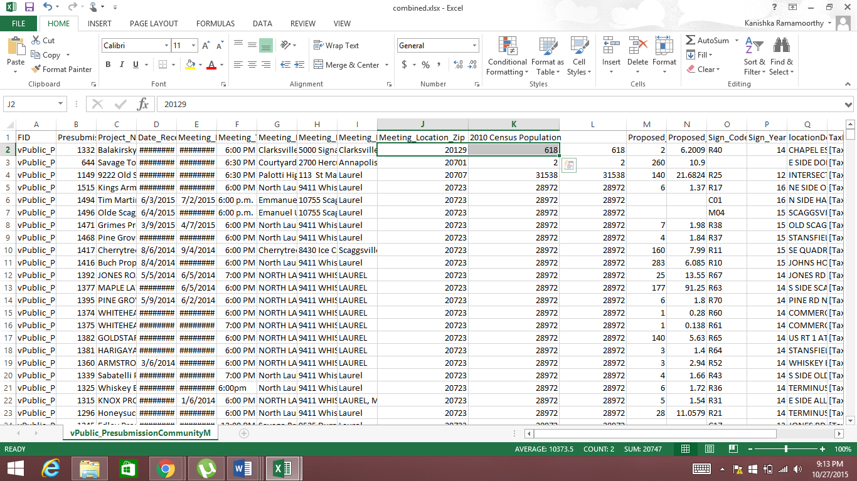

Repeat step 3 and 4 for each unique zipcode.

Step 5:

Eliminate columns

Proposed_Units

Proposed_Acres

TaxMap_Parcel

Eliminate rows:

153