Name: M.Kanishka
Reg.no:192521283
Ex:1 The lexical analyzer should ignore redundant spaces, tabs, and new lines. It should also ignore comments. Although the syntax specification states that identifiers can be arbitrarily long, you may restrict the length to some reasonable value. Develop a lexical Analyzer to identify identifiers, constants, and operators using the C program.
Ans:
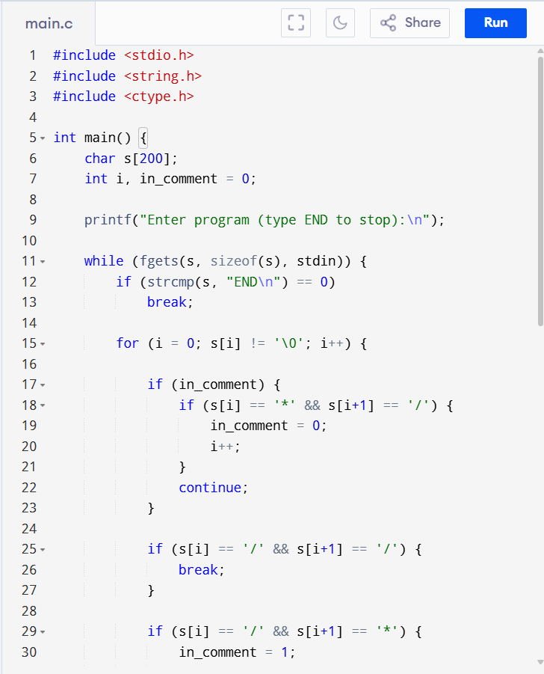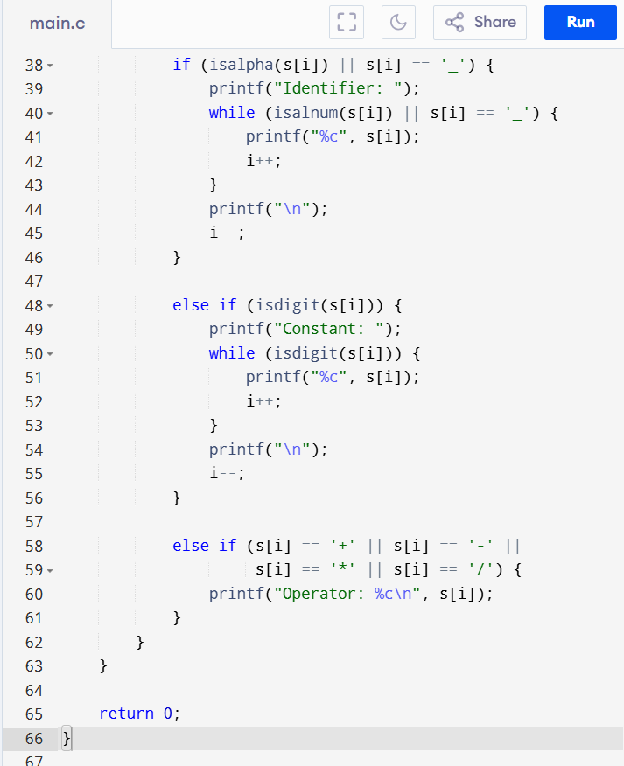
Output:
