Name: M.Kanishka
Reg.no:192521283
Ex:2 Extend the lexical Analyzer to Check comments, defined as follows in C:
a) A comment begins with // and includes all characters until the end of that line.
b) A comment begins with /* and includes all characters through the next occurrence of the
character sequence */Develop a lexical Analyzer to identify whether a given line is a
comment or not.
Ans: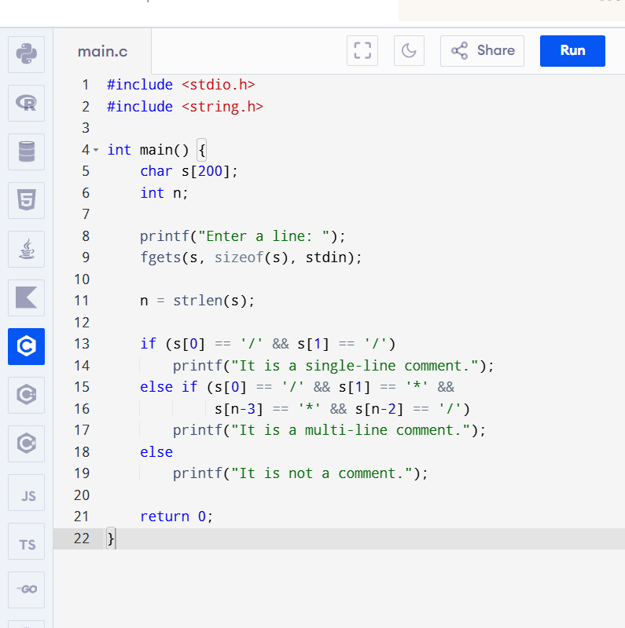

Output:
