UNIVERSITY OF SRI JAYEWARDENEPURA
[Faculty / Department]
MSc in Data Science and Artificial Intelligence
Module: Multi-Agent Systems
CKDu Well-Water Safety Network
A multi-agent risk-indicator and safe-water allocation system
Group project report
Group members
Member | Name | Index number | Responsibility
A | [Member A name] | [Index number] | Data layer, ClockAgent, WellMonitorAgent
B | [Member B name] | [Index number] | Water Quality Index, RiskScoringAgent, HotspotAgent
C | [Member C name] | [Index number] | VillageAgent, ResourceCoordinatorAgent, Contract Net
D | [Member D name] | [Index number] | AlertAgent, evaluation, dashboard
Supervisor: [Supervisor name]
Submission date: [Date]
This is a risk-indicator tool built on published water-quality research. It does not diagnose CKDu and does not claim that water causes CKDu.

1. Introduction
Chronic kidney disease of unknown aetiology (CKDu) affects farming communities in the dry zone of Sri Lanka, mainly in the North Central Province (NCP). Hospital registers in the NCP recorded 30,566 CKD and CKDu patients between 2003 and 2016 (Ranasinghe et al., 2019). Studies report an association between CKDu and the quality of drinking well water, such as hardness, fluoride and dissolved organic carbon (Cooray et al., 2019; Nikagolla et al., 2020), but the cause is still debated. Today, well testing, case surveillance and the response (for example, providing reverse-osmosis (RO) water units) are not connected.
We chose this topic for four reasons: it is a real and local public-health problem; the existing work is disconnected; it is a genuine multi-agent problem, because each village holds only its own data and a very small pool of safe-water resources must be shared; and open published data exist to build on. Our objectives were to (1) score each well's water every month with a published Water Quality Index (WQI), (2) flag hotspots that stay high-risk, (3) allocate scarce RO units and water bowsers by negotiation rather than a fixed rule, and (4) send calm, non-diagnostic alerts.

2. Data
No live well-monitoring network exists, so the system replays monthly well readings from CSV files. Real values were transcribed from published sources and never changed; individual well readings, which are not published, were generated synthetically and labelled as such (Table 1).
Data | Content | Source
Water-quality statistics | Min, average and max of 9 parameters (pH, EC, alkalinity, hardness, F, DOC, Cl, SO4, Fe) by CKDu prevalence class and season | Cooray et al. (2019), Table 1
WQI method | Formula, parameter weights, Sri Lankan drinking-water standards, five WQI classes | Cooray et al. (2019); Nikagolla et al. (2020)
11 DS divisions | Population; location; distance to an Anuradhapura depot (modelling assumption) | Census 2012; OpenStreetMap
Synthetic wells | 440 readings = 20 wells × 11 divisions × 2 seasons; Beta distributions fitted to the published min/average/max; assumed inter-parameter correlation 0.6; random seed 42; every row has source = "synthetic" | Generated (labelled)
Table 1. Data sources (real and synthetic).
The published data have two seasons, so each simulated month reuses its season's values (October–January wet, February–September dry). This follows the dry-zone rainy calendar but not Cooray et al.'s sampling months (dry: December 2016; wet: May 2017), which we note as a limitation.

3. System design
The system has seven agent types and runs 11 village agents, one per DS division. Agents run in SPADE and communicate only through XMPP messages; no agent sees the whole picture. Table 2 lists the agents, and Figure 1 shows how one simulated month works.
Agent | Owner | Job | Main messages
ClockAgent | A | Starts each simulated month and states the season | month_tick
WellMonitorAgent | A | Sends each village's 20 well readings for the month | well_readings (×11)
RiskScoringAgent | B | WQI per well; village median WQI → tier (Excellent … Unsuitable) | risk_record
HotspotAgent | B | Flags villages Poor or worse for 2 consecutive months (project rule) | hotspot_result
AlertAgent | D | Calm alert: use an alternate water source; screening if hotspot | alert
VillageAgent (×11) | C | Holds its own data; proposes a bid or refuses each call for proposals | propose / refuse, inform / failure
ResourceCoordinatorAgent | C | Runs one Contract Net round: ranks bids, awards units | cfp, accept / reject
Table 2. Agents, owners and roles.
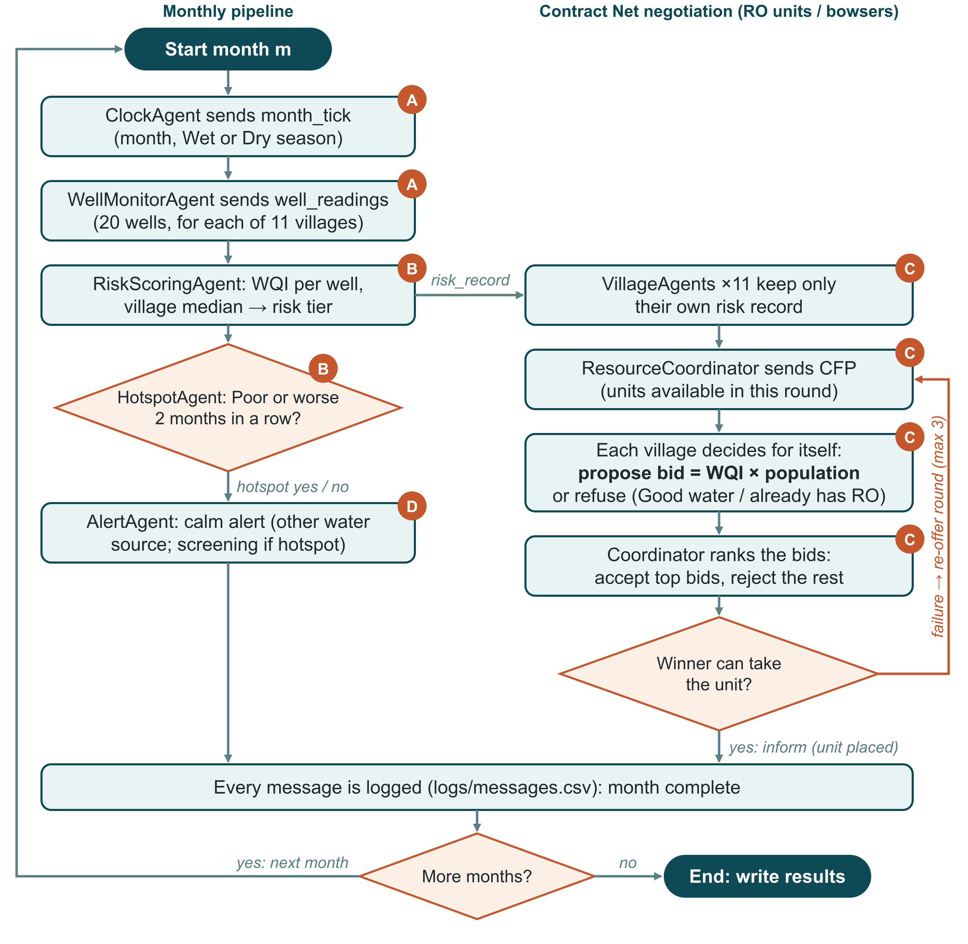
Figure 1. Flowchart of one simulated month. Letters A–D show which team member built each agent.

4. Negotiation (Contract Net)
Resources are allocated with the Contract Net Protocol (Smith, 1980) in its FIPA form (FIPA, 2002). The coordinator sends a call for proposals (CFP) to all villages. A village bids only if its tier is Poor or worse and it does not already hold an RO unit; its bid is WQI × population, so worse water and more people mean higher need. Otherwise it refuses. The highest bids receive accept-proposal (ties are broken alphabetically) and the rest receive reject-proposal. Winners confirm with inform, or reply failure if they cannot take delivery; freed units are then re-offered in a new round (at most three per month). RO units are durable, so a village keeps its unit in later months, whereas bowser trips are needed again every month. In month 0 a simulated delivery failure was added: Talawa won but failed, and the unit went to Padaviya in round 2.

5. Implementation
The system is written in Python 3.12 with SPADE (Palanca et al., 2020), using either SPADE's embedded XMPP server or an external spade run server. Every message body is JSON checked against a shared ontology, every message is logged (timestamp, sender, receiver, performative, thread), and every wait has a timeout. Business logic is in pure functions covered by 320 automated tests. A Streamlit dashboard shows the risk map, allocations and live agent activity. Run instructions are in docs/how_to_run.md.

6. Results and evaluation
A 12-month run (pool of 3 RO units) completed with 0 failures: 31 agents exchanged 1,131 logged messages, all seven performatives were used (cfp 143, propose 7, refuse 136, accept 6, reject 1, inform 837, failure 1), the mean alert latency was 0.36 s, negotiation took one round per month (two in month 0, after the failure), and 5 RO units were placed, never twice in the same village.
Allocation was compared with two baselines on risk-weighted population served: the sum of WQI × population over served villages, counted only for villages with Poor or worse water (a project definition). Equal split gives units in turn without looking at risk; first-come serves needy villages in the order their replies arrive (Table 3).
Resource (pool 3, 12 months) | Contract Net | Equal split | First-come
RO units (durable) | 23.5M | 18.7M | 23.5M
Water bowsers (monthly) | 171.3M | 51.2M | 158.0M
Table 3. Risk-weighted population served (millions; higher is better).
Contract Net beats equal split for both resources and beats first-come for bowsers. For durable RO units it ties first-come: only a few villages ever need a unit and all of them are served eventually, so the total is the same; Contract Net serves the highest need first. Risk-classification alignment could not be evaluated, because no sourced reference mapping of areas to WQI tiers is available.

7. Limitations and ethics
- Well readings are synthetic, so results show how the system works, not real-world outcomes.
- Only two seasons, repeated across months; 8 of the 13 published WQI parameters are available (a reduced WQI).
- The hotspot rule, the risk weight, depot locations and the 0.6 correlation are project assumptions; the delivery failure is a simulated test case.
- No individual patient data is used, only published aggregates. Outputs are risk indicators, never a diagnosis, and no causal claim is made about water and CKDu.

8. Conclusion and future work
We built a working multi-agent system in which agents score well-water risk, flag hotspots, send calm alerts and negotiate scarce safe-water resources through a full Contract Net with failure and re-offer. Negotiation directed resources to the villages with the worst water first and outperformed an equal split. Future work: use real well measurements, all 13 WQI parameters, sampling-aligned seasons, and a distance-based delivery cost for bowsers.

References
Cooray, T., et al. (2019). Assessment of groundwater quality in CKDu affected areas of Sri Lanka. International Journal of Environmental Research and Public Health, 16(10), 1698. https://doi.org/10.3390/ijerph16101698
Department of Census and Statistics, Sri Lanka. (2012). Census of population and housing 2012.
FIPA. (2002). FIPA contract net interaction protocol specification (SC00029H). Foundation for Intelligent Physical Agents.
Nikagolla, C., et al. (2020). Using water quality and isotope studies to inform research in CKDu endemic areas in Sri Lanka. Science of the Total Environment, 745, 140896. https://doi.org/10.1016/j.scitotenv.2020.140896
OpenStreetMap contributors. (n.d.). OpenStreetMap. https://www.openstreetmap.org
Palanca, J., et al. (2020). SPADE 3: Supporting the new generation of multi-agent systems. IEEE Access, 8, 182537–182549.
Ranasinghe, A. V., et al. (2019). The incidence, prevalence and trends of chronic kidney disease and chronic kidney disease of uncertain aetiology (CKDu) in the North Central Province of Sri Lanka: An analysis of 30,566 patients. BMC Nephrology, 20, 338. https://doi.org/10.1186/s12882-019-1501-0
Smith, R. G. (1980). The contract net protocol: High-level communication and control in a distributed problem solver. IEEE Transactions on Computers, C-29(12), 1104–1113.

