

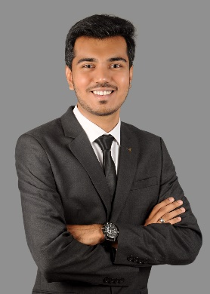

**Dhanraj Panchal**

BTech – Computer Science and engineering

Contact Number – 9167316872/9820268756

E-mail id – dhanrajpanchal2001@gmail.com

Address – Dombivli, Maharashtra. Pin code - 421201

A final year student pursuing undergraduate in BTech Computer science and engineering. I’m a self-taught programming enthusiast and I love to make real world applications.

|  |  |  |  |
| --- | --- | --- | --- |
| Education Qualification | | | |
| Course | Year | University/State Board | Percentage |
| BTech Computer Science and engineering | 2021-persuing | Amity University Mumbai | 7.9/10 |
| Diploma Computer Engineering | 2017-20 | KJ Somaiya Polytechnic | 80% |
| 10th | March - 2017 | S.H Jondhale Vidya mandir  / State Board | 63% |

|  |  |  |
| --- | --- | --- |
| Project’s Handled | | |
| Project Title | Duration | Project Details |
| HealthEngine | Mar 2023 – June 2023 | Created a project that will use Machine Learning algorithms to give personalized health guidance to a use. It can also help users with prescription support and specific condition guidance. |
| Blood Distribution System | Aug 2022 – October 2022 | A Project for managing blood supply and demand and making an efficient distribution system. Connect hospitals and blood banks. So, they will know where the nearest bank with required blood type and number of units is present. |
| Railway Management System | Sep 2021 - Oct 2021 | A web portal to manage train reservations and schedule trains.  Technology used - HTML, CSS, PHP, JS and PhpMyAdmin |
| Examinee | Jun 2020 - Aug 2020 | Developed a website for students and teachers where teachers can upload all study materials and students can fetch through the website.  Technology used: HTML5, CSS, JavaScript, PHP and PhpMyAdmin |

|  |
| --- |
| Work Experience |
| Alpha Labs Pvt ltd – 1 July 2023 to pursuing (Internship) |

|  |
| --- |
| Additional Courses/Certifications |
| 100 days of codes python – Udemy |

|  |
| --- |
| Extra-Curricular Activities |
| Volunteer in cultural fest Rhythm 2k17 in KJ Somaiya Polytechnic |

|  |
| --- |
| Skills |
| Programming Languages- C, C++, Java ,prolog and Python  Web Technologies – HTML, CSS, JavaScript and PHP  Database -MySQL and PhpMyAdmin  Other Technologies - Data Structures, Machine Learning Algorithms, Artificial Intelligence, PowerBI, Data Analytics and Data Visualization |

|  |  |
| --- | --- |
| Personal Details | |
| Father’s Name | Bharat Panchal |
| Nationality | Indian |
| Date of Birth | 08/06/2001 |
| Marital Status | Single |
| Languages Known | English, Hindi, Gujarati, Marathi |