LIBRARY MANAGEMENT SYSTEM BY PIXEL LED

A PROJECT REPORT

Submitted by

**DHANYA R (8115U21CS028)**

**DONA VERGINIYA N (8115U21CS036)**

**GEETHA K N (8115U21CS038)**

**KANISHKA K (8115U21CS056)**

in partial fulfillment of the award of the degree of

# BACHELOR OF ENGINEERING

in

COMPUTER SCIENCE AND ENGINEERING

# K.RAMAKRISHNAN COLLEGE OF ENGINEERING (AUTONOMOUS),

**SAMAYAPURAM, TRICHY– 621112.**



**MAY 2023**

# K. RAMAKRISHNAN COLLEGE OF ENGINEERING (AUTONOMOUS)

**BONAFIDE CERTIFICATE**

Certified that this project report **“A library management system by pixel LED”** is the Bonafide work of **“Dhanya R, Dona Verginiya N, Geetha K N, Kanishka K”** who carried out the project work under my supervision.

## SIGNATURE SIGNATURE

Dr.T.M.NITHYA, M.E., Ph.D Mr.I.INFANT RAJ, Tech.,

Associate Professor Assistant Professor

## HEAD OF THE DEPARTMENT SUPERVISOR

Computer Science & Engineering Computer Science & Engineering K.Ramakrishnan College of K.Ramakrishnan College of Engineering (Autonomous) Engineering (Autonomous)

Samayapuram, Samayapuram,

Trichy–621112 Trichy–621112

Submitted for the Project Viva-Voce Examination held on ………………….

**INTERNAL EXAMINER EXTERNAL EXAMINER**

# ACKNOWLEDGEMENT

We thank the almighty GOD, without whom it would not have been possible for us to complete our project.

We wish to address our profound gratitude to **Dr.K.RAMAKRISHNAN,** Chairman, K.Ramakrishnan College of Engineering (Autonomous), who encouraged and gave us all help throughout the course.

We express our hearty gratitude and thanks to our honourable and grateful Executive Director **Dr.S.KUPPUSAMY,B.Sc.,MBA.,Ph.D.,** K.Ramakrishnan College of Engineering (Autonomous).

We are glad to thank our Principal **Dr.D.SRINIVASAN,M.E., Ph.D.,FIE.,MIIW.,MISTE.,MISAE.,C.Engg,** for giving us permission to carry out this project.

We wish to convey our sincere thanks to **Dr.T.M.NITHYA, M.E., Ph.D.,** Head of the Department, Computer Science and Engineering forgiving us constants encouragement and advice throughout the course.

We are grateful to **Mr.I.INFANT RAJ, M.Tech.,** Assistant Professor in the Department of Computer Science and Engineering, K.Ramakrishnan College of Engineering (Autonomous), for his guidance and valuable suggestions during the course of study.

Finally, we sincerely acknowledge in no less term for all our staff members, our parents and friends for their co-operation and help at various stages of this project work.

# DECLARATION

I hereby declare that the work entitled **“A Library management system by pixel LED”** is submitted in partial fulfilment of the requirement for the reward of the degree in B.E., Anna University, Chennai, is a record of our own work carried out by me during the academic year 2022-2023 under the supervision and guidance of **Mr.I.INFANT RAJ, M.Tech., (Ph.D)** Assistant professor, **Department of Computer Science and Engineering, K.Ramakrishnan College of Engineering (Autonomous).** The extent and source of information are derived from the existing literature and have been indicated through the dissertation at the appropriate places. The matter embodied in this work is original and has not been submitted for the award of any degree or diploma, either in this or any other University.

R.Dhanya

(8115U21CS028)

I certify that the declaration made by above candidate is true.

# DECLARATION

I here by declare that the work entitled **“A Library management system by pixel LED”** is submitted in partial fulfilment of the requirement for the reward of the degree in B.E., Anna University, Chennai, is a record of our own work carried out by me during the academic year 2022-2023 under the supervision and guidance of **Mr.I.INFANT RAJ, M.Tech., (Ph.D)** Assistant professor, **Department of Computer Science and Engineering, K.Ramakrishnan College of Engineering (Autonomous).** The extent and source of information are derived from the existing literature and have been indicated through the dissertation at the appropriate places. The matter embodied in this work is original and has not been submitted for the award of any degree or diploma, either in this or any other University.

N.Dona Verginiya (8115U21CS036)

I certify that the declaration made by above candidate is true.

# DECLARATION

I here by declare that the work entitled **“A Library management system by pixel LED”** is submitted in partial fulfilment of the requirement for the reward of the degree in B.E., Anna University, Chennai, is a record of our own work carried out by me during the academic year 2022-2023 under the supervision and guidance of **Mr.I.INFANT RAJ, M.Tech., (Ph.D)** Assistant professor, **Department of Computer Science and Engineering, K.Ramakrishnan College of Engineering (Autonomous).** The extent and source of information are derived from the existing literature and have been indicated through the dissertation at the appropriate places. The matter embodied in this work is original and has not been submitted for the award of any degree or diploma, either in this or any other University.

K.N.Geetha

(8115U21CS038)

I certify that the declaration made by above candidate is true.

# DECLARATION

I here by declare that the work entitled **“A Library management system by pixel LED”** is submitted in partial fulfilment of the requirement for the reward of the degree in B.E., Anna University, Chennai, is a record of our own work carried out by me during the academic year 2022-2023 under the supervision and guidance of **Mr.I.INFANT RAJ, M.Tech., (Ph.D)** Assistant professor, **Department of Computer Science and Engineering, K.Ramakrishnan College of Engineering (Autonomous).** The extent and source of information are derived from the existing literature and have been indicated through the dissertation at the appropriate places. The matter embodied in this work is original and has not been submitted for the award of any degree or diploma, either in this or any other University.

K.Kanishka

(8115U21CS056)

I certify that the declaration made by above candidate is true.

# TABLE OF CONTENT

**CHAPTER NO TITLE PAGE NO**

ABSTRACT xi

LIST OF ABBERIVATION xii

LIST OF FIGURES xiii

1. INTRODUCTION 1
   1. INTODUCTION 1
2. LITERATURE SURVEY 4
3. SYSTEM ANALYSIS 7
   1. EXSITING SYSTEM 7

3.2 PROPOSED SYSTEM 8

* + 1. ADVANTAGE 9

1. MODULE IMPLEMENTATION 10

4.1 DATABASE DESIGN 10

4.2 ARCHITETURE DESIGN 10

4.2.1 INTERFACE DESIGN 12

4.3 MODULE DESIGN 12

4.4 STEPS TO IMPLEMENT 12

4.4.1 MODULE 1 12

4.4.2 MODULE 2 13

1. SOFTWARE REQUIREMENTS 14
   1. EMBEDDED C PROGRAMMING 14

**6. HARDWARE REQUIREMENTS 14**

6.1 PIXEL LED 16

6.2 ESP8266 16

6.3 POWER SUPPLY 17

6.4 LIQUID CRYSTAL DISPLAY 17

**7.** **SYSTEM TESTING**  **18**

* 1. UNIT TESTING 18
  2. INTERGRATION TESTING 18

7.3 SYSTEM TESTING 18

7.4USER ACCEPTANCE 19

8. CONCLUSION 20

**9. APPENDIX**

9.1 APPENDIX A

(SAMPLE CODING) 21

9.2APPENDIX B

(SCREENSHOTS) 31

**10. REFERENCE 36**

# ABSTRACT

This research project main target is to develop a computerized system that can accomplish the activities in the Asmara Community College of Education (ACCE) by providing easy access to library usage for librarians and users of the library. Although this system provides electronic documents like books, magazines, newspapers, and other useful files that can give access for the users without any restrictions and help librarians keep track of library information. Designing a computerized library management system (LMS) that would support to evacuate the problem encountered in the manual library. The physical library has many limitations to satisfy user’s needs, and most hard copy documents are damaged after a limited time of usage. To eliminate the paperwork in the library, to reduce the high demand for the cost of books, and to avoid problems for missing files, introduce a web-based LMS in ACCE. This will provide services for the entire citizens of the country in a different format without limitation of the period. The objectives of this research are to develop a system that can handle and manage the actions involved in the ACCE library efficiently and reliably which can be a benefit for the entire users to get access at their convenient time. To overcome the above-mentioned limitations of the physical library, The are implementing this new technology to promote digital reading habits for users and to advance the knowledge of the users in every aspect of the technology. The users of ACCE Library have diverse age groups and professions. They require different kinds of documents for different purposes, like research studies, educational purposes, general knowledge, and for recreation. The design parameters are Java Programming language, PHP, HTML, and Database MYSQL.

# 

# LIST OF ABBERIVATIONS

|  |  |  |  |  |
| --- | --- | --- | --- | --- |
| **ABBERIVATION** | **EXPANSION** | |  | |
| **ACCE** | | Asmara Community College Of Education | |  | |
| **DDL** | | Data Definition Language | |  | |
| **HPWS** | | High Performance Work System | |  | |
| **HR** | | Human Resource | |  | |
| **LMS**  **LED**  **LCD** | | Learning Management System  Light Emitting Diode  Liquid Crystal Device | |  | |
| **MIS**  **PWM**  **RGB**  **RAM** | | Management Information System  Pulse Width Modulation  Red Green Blue  Random Access Memory | |  | |
| **STP** | | System Tests Plan | |  | |
| **ILL** | | Inter Library Loan | |  | |
| **UI** | | User Interface | |  | |
| **UTP** | | Unit Test Plans | |  | |
| **UAT** | | User Acceptance Test | |  | |

**LIST OF FIGURES**

**FIGURENO. FIGURENAME PAGENO.**

4.1 LED PIXEL KIT 11

1 SCREENSHOT 1 31

2 SCREENSHOT 2 32

3 SCREENSHOT 3 33

4 SCREENSHOT 4 34

5 SCREENSHOT 5 35

**CHAPTER 1**

**INTRODUCTION**

## 1.1 INTRODUCTION

ACCE (Asmara Community College of Education) is one of the colleges in Eritrea. ACCE library system provides everyday activity manually, which is recording data in a project. In most developing countries like Eritrea LMS are an integral part of the prompt and efficient to record detailed information of books and members.

In Eritrea, an effective information management system on traditional Libraries is very rare and many records tend to lose due to the lack of computerizes systems. For this project, proposing the development of LMS, using ACCE Library as a case study. This system will provide the much-needed information repository that the libraries need to be efficiently managed, which contains the relationships among admin, user, and members.

Presently, the transaction of books in the ACCE library has been prepared manually in most cases, thereby taking more time for a transaction like borrowing of books, returning books, searching for books, and adding new members. Series of difficulties have been occurring in the physical library because of this inefficient use in library management.

The aim of the concept in this is to build a “Smart Library System” with facilities to issue, return and even locate the book using pixel led. Library management is a part of institutional management that focuses on particular set of issues faced by library management professionals and libraries. Library management consists of regular managerial tasks, as well as intellectual decisions and fundraising responsibilities.

Mostly human error happens in keeping records, like some manually written files loss and damaged due to inefficiency use. Nevertheless, the effort in the searching of books that could be labeled to be inadequacy in book Management is a problem in the manual library although causing disorganization and time- consuming in the library. Correspondingly, space shortage for keeping records happens as the number of records added in the library, although the requirement for physical storage of files and records rises. If there is, no computerized system implemented the demand for the cost of books and records will remain a big challenge. Besides overcoming the cumbersome in the manual library, this newly designed computerized project approach can be used to solve these problems.

Library management is a sub-discipline of institutional management that focuses on specific issues faced by libraries and library management professionals. Library management encompasses normal managerial tasks, as well as intellectual freedom and fundraising responsibilities. Issues faced in library management frequently overlap with those faced in managing non-profit organizations.

The basic functions of library management include overseeing all library operations, managing the library budget, planning and negotiating the acquisition of materials, Intra library Loan [ILL] requests, stacks maintenance, overseeing fee collection, event planning, fundraising, and human resources.

**Common library construct**

Most of the libraries that store physical media like books, periodicals, film, and other objects adhere to some derivative of the Dewey Decimal System as their method for tagging, storing, and retrieving materials based on unique identifiers. The use of such systems has been caused librarians to develop and leverage common constructs that act as tools for both library professionals and library users alike. These constructs include master catalogs, domain catalogs, indexes, unique identifiers, unique identifier tokens, and artifacts.

# CHAPTER 2

**LITERATURE SURVEY**

Those papers describe the advantage of using proper management in the information system and the sustainability of library systems. It is mentioned that fast rising in different types of data creates difficulties to get accurate information. However, system focuses on building more valuable information for the ACCE library users and the admin of the system have full control to manage the updated data. Library provides information and services that are essential to the learning and development of one’s knowledge skills. Although we have a collaborative idea with their project in maintaining, the long ran of the library system and information facilities.

This project view management is explained by “the art of performing things through people”. A manager is noticed as a person who accomplishes the organization's goals by inspiring others to perform well. Moreover, there is a subjective question about whether management is an art or a science; however, it can be said without a doubt that modern management in the environment of technology is becoming more of a science than an art. Moreover, describe management for Management Information Systems (MIS) as the procedure for planning, organizing, staffing, coordinating, and controlling the efforts of the members of the organization to accomplish the commonly identified aims of the organization.

As explained that, a library is a place where a collection of books and other informational materials are made accessible to people for reading, study, or reference in their daily life activity.

The library collections have almost contained a diversity of materials making it much easier for everyone who has an interest in reading and finding new things

regarding their interests. Contemporary libraries preserve collections that contain

printed materials such as manuscripts, books, newspapers, magazines, maps, and photographs.

However, it is found that explanation limited to the usage of the library. Converting all the paperwork activities to a computer system and although adding a new e-book system, so the users can get access inside the library room and outside in digital format.

The focal task of a library is to collect, organize, preserve, and provide knowledge and information. In rewarding this mission, libraries preserve valued records of a culture that can convey over the following generations. Libraries are a crucial link in the communication among the past, present, and future generations. Whether the cultural record is limited in books or other Media, libraries must certify the record is preserved and made available for future use. Libraries provide for the users to get access to the information that is essential for work and learning. People in many professions use library materials to assist themselves in their daily work time. Although the use to gain information about their interest or to gain recreational materials such as films and novels. Scholars use library to supplement and boost their classroom proficiency, to learn abilities in discovering sources of information, and to improve reading habits. One of the most valued activities of the library is to provide information and services that are essential to the learning and development of one’s knowledge.

**A Novel Smart Librarian Robot by M. Benisha, p. Deepika**

Librarian robot that is kept in an experimental environment is able to say greeting properly based on estimation results of human behavior using a laser range finder, talk with a library user with a natural language, and search books depending on a user’s request. When the robot explains where a requested book is in the library, it points out a target position using a laser spot while the body and head are also turned around to the direction of the target. This makes detailed oral explanation unnecessary. However, the robot cannot always point out a target position directly using the laser pointer.

**Development of library management by Anita Gade**

Library management robotic system is combination of software used to manage the library database and hardware used to manage the book handling. This system helps to keep the records of whole transactions of books available in a library. A robot is modular design of sensor operated motors to manage the library. Robot acquires the book information from stored database

**Intelligent book positioning system by Toa liu and Ershen**

The book positioning system can search books by typing in the title of them, and get the distance between the tag and the reader referring to the strength of wireless signal. In this paper, the hardware and software of the system are designed in detail, and the experiment results are given. The results show that the system can quickly find the books that bookworms hid, and the books that are not timely put back on the shelves. The reader can also quickly find the books in the library. Therefore, to a certain extent, it can improve the efficiency of the staff in books management for library.

# CHAPTER 3

# SYSTEM ANALYSIS

* 1. **Existing system**

Early days Libraries are managed manually. It required lot of time to record or to retrieve the details. The employees who have to record the details must perform their job very carefully. Even a small mistake would create a lot of problems. Security of information is very less. Report generations of all the information is very tough task. Maintenance of Library catalogue and arrangement of the books to the catalogue is very complex task. In addition to its maintenance of member details, issue dates and return dates etc., manually is a complex task. All the operations must be performed in perfect manner for the maintenance of the library without any degradation which may finally result in the failure of the entire system.

Robot needed for management of books. To lessen curator in convenience that have been created robotization in library to speedy transport of books utilizing robotic arm. Library management robotic system is combination of software used to manage the library database and hardware used to manage the book handling. This system helps to keep the records of whole transactions of books available in a library. A robot is modular design of sensor operated motors to manage the library. A new JRM2030 RFID reader module proposed in [3] is used to locate and search books with electronic labels on the bookshelves. The system software is designed by using LABVIEW. And the book positioning system can search books by typing in the title of them, and get the distance between the tag and the reader referring to the strength of wireless signal. In this project, the hardware and software of the system are designed in detail, and the experiment results are given. traditional library management is time consuming, laborious and low library circulation rate. The Radio Frequency Identification (RFID) has the characteristics of waterproof, anti-magnetic read distance and the label data can be encrypted, large storage data capacity and other technical features.

University library management system based on RFID is proposed in [4] and elaborates the overall structure design of the system including the system hardware and software environment.

# Proposed System

Book details like authors, number of copies totally maintained by library, present available number of books, reference books, non-reference books etc., all this information can be made by hand. Regarding the members designation, number of books was issued. Issue dates and returns of each member is maintained separately and fine charged if there is any delay in returning the book. Administrator can add, update the books. Time consuming is low, gives accurate results, reliability can be improved with the help of security. The location of the books is easily identified by pixel. The entire details of the books are stored in the in the database, through an app it is possible to find the location and all details for a particular book which the user need.

ED Pixel contains its own digital control chip that can receive instructions from a computer. The LED Pixel can therefore be controlled purely at a software level, in much the same way as a psychophysicist might control a standard computer monitor (e.g., using commands sent from mat lab or Python) Multiple LED Pixels can be chained together, often by simply plugging the output lead of one LED Pixel into the input lead of another. This allows effectively limitless numbers of Pixels to be controlled simultaneously. Crucially though, since every LED Pixel contains its own digitally addressable control chip, the behavior (timing, intensity) of each Pixel can be controlled independently. Finally, more advanced LED Pixels house multiple LED elements—each with a different spectral response curve—within a single, light-diffusing enclosure. By additively mixing multiple color channels, a wide range of colors and luminance levels can be produced. The result is a cheap, flexible, and easy-to-use system in which all the necessary hardware can be purchased in ready-made ‘modules’, and can be controlled programmatically, using simple, user-friendly commands.

# Advantages

1. Searching of books is easy compare to manual search. Due to pixel led we can easily find the book.
2. The cost of pixel led is low.

# 

# CHAPTER 4

# MODULE IMPLEMENTAON

* 1. **Database Design**

Database design controls the duplication of data and it is the method of producing a comprehensive data model of a database. The data model consists of all the required conceptual, logical, and physical storage parameters required to create a design in a Data Definition Language (DDL). DDL is used to create a database. A completely attributed data model holds full attributes for each entity. The method of database design usually contains several stages that are supported out by database designers. Generally, the designer needs to follow those procedures

# Architecture Design

The phase of the design of computer architecture and software architecture is denoted as a high-level design. The model in selecting the architecture should understand all typical lists of modules, brief functionalities of each module, their interface relations, dependencies, database table, architecture diagram, and technology details, etc. The assimilation testing design is carried out in a particular phase. After the necessities of the system are determined, the essential specifications for the hardware, software, data resources, and the information products that will satisfy the functional requirement of the proposed system can be determined. This design will help as to outline for the entire system to identify and manage the connections of different section.

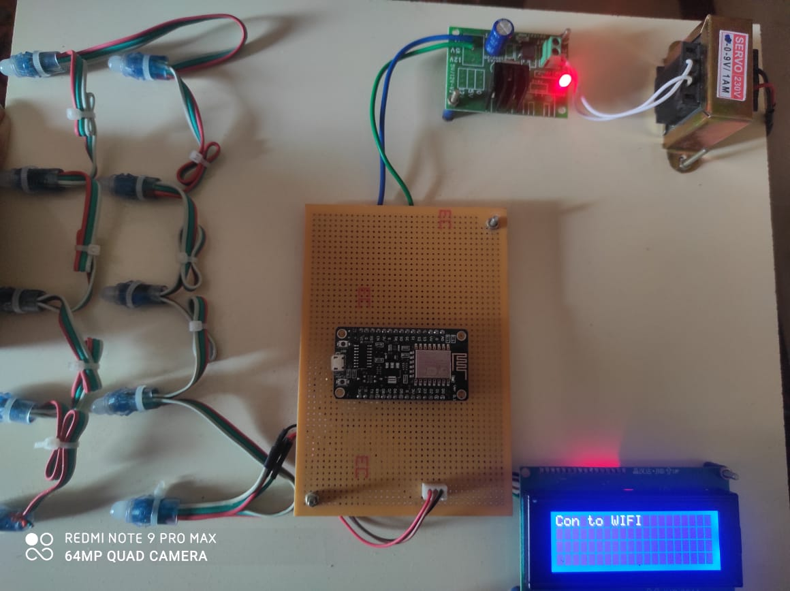**4.1 PIXEL LED KIT**

# 4.2.1 Interface Design

User Interface (UI) Design emphasizes expecting what users want to do and confirming that the interface has features that are easy to access, understand, and uses to smooth those actions. This interface collects the concept from visual design, interaction design, and information architecture.

# Module design

Module design level is mentioned as low-level design. The intended system is fragmented into smaller units or segments and each of them is explained, this indicates that the programmer can start coding. Explained the flowchart of the entire system, which is the low-level design program.

**4.4 STEPS TO IMPLEMENT**

Creating an Account

Getting Familiar

Placing Order

Interact

Reminder

**4.4.1 Module1**

**Creating an Account**

The first step towards opening the door of magic for all the book lovers.

Register your name over the library application by filling the necessary details such as contact details, name, e mail address etc.

Now it is ready to move towards the next module.

**4.4.2 Module2**

**Placing Order**

This is where a student or any registered person can place an order for the books they are looking for. When this task is done manually it consumes a lot of time and is also burdensome at times to search for the books a person is asking for, but with the help of library management system the work is done very easily.

# CHAPTER 5

# SOFTWARE REQUIREMENT

**5.1 EMBEDDED C PROGRAMMING**

Earlier, many embedded applications were developed using assembly level programming. However, it did not provide portability. This disadvantage was overcome by the advent of various high-level languages like C, Pascal, and COBOL. However, it was the C language that got extensive acceptance for embedded systems, and it continues to do so. The C code written is more reliable, scalable, and portable; and in fact, much easier to understand. Embedded C Programming is the soul of the processor functioning inside each and every embedded system we come across in our daily life, such as mobile phones, washing machines, and digital cameras. Each processor is associated with embedded software. The first and foremost thing is the embedded software that decides to function of the embedded system. Embedded C language is most frequently used to program the microcontroller.

In every embedded system project, Embedded C programming plays a key role to make the microcontroller run & perform the preferred actions. At present, we normally utilize several electronic devices like mobile phones, washing machines, security systems, refrigerators, digital cameras, etc. The controlling of these embedded devices can be done with the help of an embedded C program. For example in a digital camera, if we press a camera button to capture a photo then the micro controller will execute the required function to click the image as well as to store it.

Embedded C programming builds with a set of functions where every function is a set of statements that are utilized to execute some particular tasks. Both the embedded C and C languages are the same and implemented through some fundamental elements like a variable, character set, keywords, data types, declaration of variables, expressions, statements.

All these elements play a key role while writing an embedded C program.

The embedded system designers must know about the hardware architecture to write programs. These programs play a prominent role in monitoring and controlling external devices. It also directly operation and use the internal architecture of the microcontroller, such as interrupt handling, timers, serial communication, and other available features. An Embedded system program allows the hardware to check the inputs & control outputs accordingly. In this procedure, the embedded program may have to control the internal architecture of the processor directly like Timers, Interrupt Handling, I/O Ports, serial communications interface, etc. So embedded system programming is very important to the processor. There are different programming languages are available for embedded systems such as C, C++, assembly language, JAVA, JAVA script, visual basic, etc. So this programming language plays a key role while making an embedded system but choosing the language is very essential.

**Main Factors of Embedded C Program**

The main factors to be considered while choosing the programming language for developing an embedded system include the following.

**Program Size**

Every programming language occupies some memory where embedded processor like microcontroller includes an extremely less amount of RAM.

**Speed of the Program**

The programming language should be very fast, so should run as quickly as possible. The speed of embedded hardware should not be reduced because of the slow-running software.

**CHAPTER 6**

**HARDWARE REQUIREMENTS**

**6.1 PIXEL LED**

Then at present smart LEDs are ruling the lighting industry, in those Neo pixels or pixels plays a vital role in decorative field. So here we are going to explain how the smart RGB led strips or chains work and what how is the internal circuit in the pixels RGB LEDs. In this article, we took WS2812B a neo pixel as consideration. All the neo pixels LEDs have a dedicated integrated circuit chip inside each LED which stores 3 Bytes of storage.WS2812B has 3 X 5050 LEDs (5.0 x 5.0 mm) with the basic RGB (Red-Green-Blue) colors.

**6.2 ESP8266**

The chip was popularized in the English-speaking maker community in August 2014 via the ESP-01 module, made by a third-party manufacturer Ai-Thinker. This small module allows microcontrollers to connect to a Wi-Fi network and make simple TCP/IP connections using Hayes-style commands. However, at first, there was almost no English-language documentation on the chip and the commands it accepted. The very low price and the fact that there were very few external components on the module, which suggested that it could eventually be very inexpensive in volume, attracted many hackers to explore the module, the chip, and the software on it, as well as to translate the Chinese documentation. This is the first series of modules made with the ESP8266 by the third-party manufacturer Ai-Thinker and remains the most widely available.

* 1. **POWER SUPPLY**

A power supply is an electrical device that supplies electric power to an electrical load. The main purpose of a power supply is to convert electric current from a source to the correct voltage, current, and frequency to power the load. As a result, power supplies are sometimes referred to as electric power converters. Some power supplies are separate standalone pieces of equipment, while others are built into the load appliances that they power. Examples of the latter include power supplies found in desktop computers and consumer electronics devices.

* 1. **LIQUID CRYSTAL DISPLAY**

LCDs are used in a wide range of applications, including LCD televisions, computer monitors, instrument panels, aircraft cockpit displays, and indoor and outdoor signage. Small LCD screens are common in LCD projectors and portable consumer devices such as digital cameras, watches, calculators, and mobile telephones, including smartphones. LCD screens have replaced heavy, bulky and less energy-efficient cathode-ray tube (CRT) displays in nearly all applications. The phosphors used in CRTs make them vulnerable to image burn-in when a static image is displayed on a screen for a long time, e.g., the table frame for an airline flight schedule on an indoor sign. LCDs do not have this weakness, but are still susceptible to image persistence.

**CHAPTER 7**

**SYSTEM TESTING**

**7.1 Unit Testing**

In the V-Model, Unit Test Plans (UTPs) is developed in the module design phase. This UTPs are implemented to remove bugs at code level or unit level. A Unit is the smallest entity that can exist independently, program module. Unit testing confirms that the smallest entity can function appropriately even though it’s separated from the rest of the codes.

# Integration Testing

Integration Test Plans are implemented in the Architectural Design Period. These tests prove that unit formed and verified independently that can coexist and communicate among themselves. Test results are shared with the customer’s group.

**7.3 System Testing**

System Tests Plans (STP) are developed in System Design Stage. Disparate Unit and Integration Test Plans, STP is composed of the client’s business group. System Test certifies that expectations from an application designer are met. The entire application is verified for its functionality, interdependency, and communication. System Testing proves that functional and non-functional necessities have been met. Load and performance testing, stress testing, regression testing, etc. are subset of system testing.

# 7.4 User Acceptance Testing

User Acceptance Test (UAT) strategies are developed in the analysis phase. Test Strategies are composed of business users. UAT accomplished in a user environment that resembles the production of the environment, using accurate data. UAT proves that the delivered system meets the user’s necessity and the system is ready for use in real-time.

# CHAPTER 8

**CONCLUSION**

This work presents a high-performance LED display based on the idea of local scanning. Each module includes a local memory to store RGB data and its address. With this approach, the display is refreshed quickly, which is independent of the speed of data sampled from the transmitter. In a slow data sampling rate, this system also can show high brightness RGB data without any black screen. For very highspeed data transfer, the bandwidth of wireless transmission may be limited. Since our system uses addressable module control with local scan, high moving data region can be selected first to transmit its PWM data to the LED display, followed by the low moving data region. Static image region can be skipped by the transmitter to save bandwidth. With this approach, the display refresh can be improved. The prototyping system has been implemented using FPGA-based control and driver. Experimental results show that 4 × 3 × 16 × 16 RGB LED matrix can successfully display on real-time operations. The proposed system can have a chance extended to solve the problem of frequency limitation for high resolution system. For low-cost implementation, an ASIC design for such an LED display system will be a challenging task in future.

**APPENDIX A**

# SAMPLE CODING

#include <Adafruit_NeoPixel.h> #include <SPI.h>

#include <BlynkSimpleEsp8266.h> #include <ESP8266WiFi.h>

#define PIN D2

#define NUMPIXELS 10 #define BLYNK_PRINT Serial

Adafruit_NeoPixel pixels = Adafruit_NeoPixel(NUMPIXELS, PIN, NEO_GRB

+ NEO_KHZ800);

void motor(int Data) { if (Data == 1) {

pixels.setPixelColor(0, pixels.Color(255, 0, 0));

pixels.setPixelColor(2, pixels.Color(0, 0, 0));

pixels.setPixelColor(3, pixels.Color(0, 0, 0));

pixels.setPixelColor(4, pixels.Color(0, 0, 0));

pixels.setPixelColor(5, pixels.Color(0, 0, 0));

pixels.setPixelColor(6, pixels.Color(0, 0, 0));

pixels.setPixelColor(7, pixels.Color(0, 0, 0));

pixels.setPixelColor(8, pixels.Color(0, 0, 0));

pixels.setPixelColor(9, pixels.Color(0, 0, 0));

pixels.setPixelColor(1, pixels.Color(0, 0, 0)); pixels.show();

}

if (Data == 2) {

pixels.setPixelColor(2, pixels.Color(0, 0, 0));

pixels.setPixelColor(1, pixels.Color(255, 0, 0));

pixels.setPixelColor(3, pixels.Color(0, 0, 0));

pixels.setPixelColor(4, pixels.Color(0, 0, 0));

pixels.setPixelColor(5, pixels.Color(0, 0, 0));

pixels.setPixelColor(6, pixels.Color(0, 0, 0));

pixels.setPixelColor(7, pixels.Color(0, 0, 0));

pixels.setPixelColor(8, pixels.Color(0, 0, 0));

pixels.setPixelColor(9, pixels.Color(0, 0, 0));

pixels.setPixelColor(0, pixels.Color(0, 0, 0));

pixels.show();

}

if (Data == 3) {

pixels.setPixelColor(1, pixels.Color(0, 0, 0));

pixels.setPixelColor(3, pixels.Color(0, 0, 0));

pixels.setPixelColor(2, pixels.Color(255, 0, 0));

pixels.setPixelColor(4, pixels.Color(0, 0, 0));

pixels.setPixelColor(5, pixels.Color(0, 0, 0));

pixels.setPixelColor(6, pixels.Color(0, 0, 0));

pixels.setPixelColor(7, pixels.Color(0, 0, 0));

pixels.setPixelColor(8, pixels.Color(0, 0, 0));

pixels.setPixelColor(9, pixels.Color(0, 0, 0));

pixels.setPixelColor(0, pixels.Color(0, 0, 0)); pixels.show();

}

if (Data == 4) {

pixels.setPixelColor(1, pixels.Color(0, 0, 0));

pixels.setPixelColor(2, pixels.Color(0, 0, 0));

pixels.setPixelColor(4, pixels.Color(0, 0, 0));

pixels.setPixelColor(3, pixels.Color(255, 0, 0));

pixels.setPixelColor(5, pixels.Color(0, 0, 0));

pixels.setPixelColor(6, pixels.Color(0, 0, 0));

pixels.setPixelColor(7, pixels.Color(0, 0, 0));

pixels.setPixelColor(8, pixels.Color(0, 0, 0));

pixels.setPixelColor(9, pixels.Color(0, 0, 0));

pixels.setPixelColor(0, pixels.Color(0, 0, 0)); pixels.show();

}

if (Data == 5) {

pixels.setPixelColor(1, pixels.Color(0, 0, 0));

pixels.setPixelColor(2, pixels.Color(0, 0, 0));

pixels.setPixelColor(3, pixels.Color(0, 0, 0));

pixels.setPixelColor(5, pixels.Color(0, 0, 0));

pixels.setPixelColor(4, pixels.Color(255, 0, 0));

pixels.setPixelColor(6, pixels.Color(0, 0, 0));

pixels.setPixelColor(7, pixels.Color(0, 0, 0));

pixels.setPixelColor(8, pixels.Color(0, 0, 0));

pixels.setPixelColor(9, pixels.Color(0, 0, 0));

pixels.setPixelColor(0, pixels.Color(0, 0, 0)); pixels.show();

}

if (Data == 6) {

pixels.setPixelColor(0, pixels.Color(0, 0, 0));

pixels.setPixelColor(1, pixels.Color(0, 0, 0));

pixels.setPixelColor(2, pixels.Color(0, 0, 0));

pixels.setPixelColor(3, pixels.Color(0, 0, 0));

pixels.setPixelColor(4, pixels.Color(0, 0, 0));

pixels.setPixelColor(5, pixels.Color(255, 0, 0));

pixels.setPixelColor(6, pixels.Color(0, 0, 0));

pixels.setPixelColor(7, pixels.Color(0, 0, 0));

pixels.setPixelColor(8, pixels.Color(0, 0, 0));

pixels.setPixelColor(9, pixels.Color(0, 0, 0)); pixels.show();

}

if (Data == 7) {

pixels.setPixelColor(0, pixels.Color(0, 0, 0));

pixels.setPixelColor(1, pixels.Color(0, 0, 0));

pixels.setPixelColor(2, pixels.Color(0, 0, 0));

pixels.setPixelColor(3, pixels.Color(0, 0, 0));

pixels.setPixelColor(4, pixels.Color(0, 0, 0));

pixels.setPixelColor(5, pixels.Color(0, 0, 0));

pixels.setPixelColor(6, pixels.Color(255, 0, 0));

pixels.setPixelColor(7, pixels.Color(0, 0, 0));

pixels.setPixelColor(8, pixels.Color(0, 0, 0));

pixels.setPixelColor(9, pixels.Color(0, 0, 0)); pixels.show();

}

if (Data == 8) {

pixels.setPixelColor(0, pixels.Color(0, 0, 0));

pixels.setPixelColor(1, pixels.Color(0, 0, 0));

pixels.setPixelColor(2, pixels.Color(0, 0, 0));

pixels.setPixelColor(3, pixels.Color(0, 0, 0));

pixels.setPixelColor(4, pixels.Color(0, 0, 0));

pixels.setPixelColor(5, pixels.Color(0, 0, 0));

pixels.setPixelColor(6, pixels.Color(0, 0, 0));

pixels.setPixelColor(7, pixels.Color(255, 0, 0));

pixels.setPixelColor(8, pixels.Color(0, 0, 0));

pixels.setPixelColor(9, pixels.Color(0, 0, 0)); pixels.show();

}

if (Data == 9) {

pixels.setPixelColor(0, pixels.Color(0, 0, 0));

pixels.setPixelColor(1, pixels.Color(0, 0, 0));

pixels.setPixelColor(2, pixels.Color(0, 0, 0));

pixels.setPixelColor(3, pixels.Color(0, 0, 0));

pixels.setPixelColor(4, pixels.Color(0, 0, 0));

pixels.setPixelColor(5, pixels.Color(0, 0, 0));

pixels.setPixelColor(6, pixels.Color(0, 0, 0));

pixels.setPixelColor(7, pixels.Color(0, 0, 0));

pixels.setPixelColor(8, pixels.Color(255, 0, 0));

pixels.setPixelColor(9, pixels.Color(0, 0, 0)); pixels.show();

}

if (Data == 10) {

pixels.setPixelColor(0, pixels.Color(0, 0, 0));

pixels.setPixelColor(1, pixels.Color(0, 0, 0));

pixels.setPixelColor(2, pixels.Color(0, 0, 0));

pixels.setPixelColor(3, pixels.Color(0, 0, 0));

pixels.setPixelColor(4, pixels.Color(0, 0, 0));

pixels.setPixelColor(5, pixels.Color(0, 0, 0));

pixels.setPixelColor(6, pixels.Color(0, 0, 0));

pixels.setPixelColor(7, pixels.Color(0, 0, 0));

pixels.setPixelColor(8, pixels.Color(0, 0, 0));

pixels.setPixelColor(9, pixels.Color(255, 0, 0)); pixels.show();

}

if (Data == 0) {

pixels.setPixelColor(0, pixels.Color(0, 0, 0));

pixels.setPixelColor(1, pixels.Color(0, 0, 0));

pixels.setPixelColor(2, pixels.Color(0, 0, 0));

pixels.setPixelColor(3, pixels.Color(0, 0, 0));

pixels.setPixelColor(4, pixels.Color(0, 0, 0));

pixels.setPixelColor(5, pixels.Color(0, 0, 0));

pixels.setPixelColor(6, pixels.Color(0, 0, 0));

pixels.setPixelColor(7, pixels.Color(0, 0, 0));

pixels.setPixelColor(8, pixels.Color(0, 0, 0));

pixels.setPixelColor(9, pixels.Color(0, 0, 0)); pixels.show();

}

}

void setup()

{

Serial.begin(9600);

Blynk.begin(“nmmQkzgLqvDBeAJRNXXVIFSU5VF9ZYCq”, “iot”, “1234567890”);

pixels.begin();

}

BLYNK_WRITE(V8)

{

int Data = param.asInt(); Serial.println(Data); motor(Data);

}

void loop()

{

Blynk.run();

}

**APPENDIX B**

**SCREENSHOT 1**

**DESCRIPTION**

To search a book named virtual networking success.

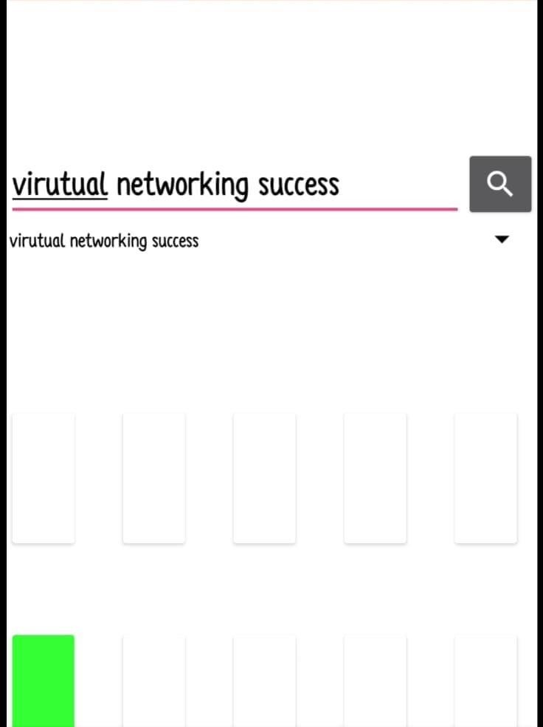

**SCREENSHOT 2**

**DESCRIPTION**

To search a book named rust programming.

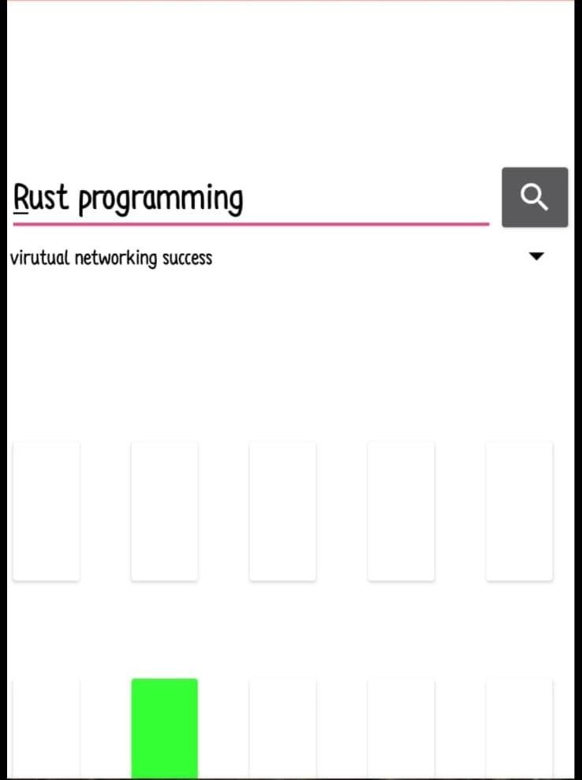

Fig.3

**SCREENSHOT 3**

**DESCRIPTION**

To search a book named power electronic.

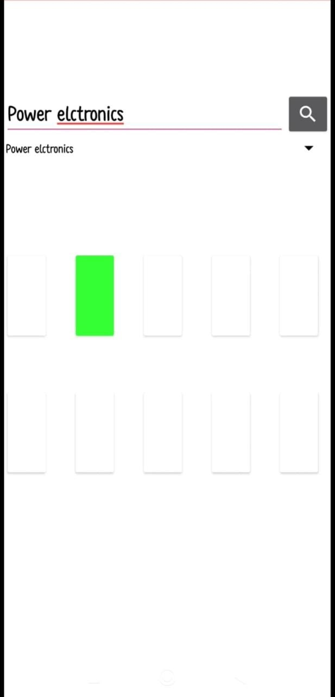

# SCREENSHOT 4

**DESCRIPTION**

To search a book named option electronics.

# 1690645513173

# SCREENSHOT 5

**DESCRIPTION**

To search a book named amplifier books.

# 1690645513147

# REFERENCES

[1] M. Benisha, P. Deepika, L.M. Merlin Livingston,” A Novel Smart Librarian Robot”,

International Journal of Advanced Research in Electronics and Communication

Engineering, 2015

[2] Anita Gade, Yogesh Angel,” Development of Library Management Robotic System”,

International Conference on Data Management, Analytics and Innovation, 2017

[3] He, Tao Liu and Ershen Wang,” Intelligent Book Positioning System for Library Based

on RFID”, IEEE Conference on Industrial Electronics and Applications, 2017

[4] Jin Feng Zhang and Chang Ji Wen,” The University Library Management System Based on

Radio Frequency Identification”, International Congress on Image and Signal Processing,

Bio Medical Engineering and Informatics, 2015

[5] Anita Gade, Yogesh Angel,” Automation in Library Management Using LabVIEW”,

International Conference on Data Management, Analytics and Innovation, 2015

[6] Milan Sekulic, Ivan Lazarevic, Milan Bjelica and Vukota Pekovic,” Asynchronous

application programming interface library for distributed home automation software”, IEEE

International Conference on Consumer Electronics Berlin, 2015

[7] Maneesh Kumar Bajpai,” Researching through QR Codes in Libraries”, International

Symposium on Emerging Trends and Technologies in Libraries and Information Services,

2015

[8] Vandana C.P. Anamika Bhattacharjee and Anubhuti Gupta,” Library Management system

based on IoT”, Journal of Computer Science and Engineering, 2015

[9] S.Vimalraj, S.Sameera, S.Saranya,” RFID BASED LIBRARY MANAGEMENT

SYSTEM”, International Journal of Innovative Research in Advanced Engineering, 2015

[10] Jackrit Suthakom, Sangyoon Lee, Yu Zhou,Rory Thomas, Sayeed Choudhd and Gregory S.

Chirikjian,” A Robotic Library System for an Off-Site Shelving Facility”, Journal of

Computer Science and Engineering, 2015