1. In the below elements which of them are values or an expression? eg:- values can be

integer or string and expressions will be mathematical operators.

\*

&#39;hello&#39;

-87.8

-

/

+

6

Ans. Expressions are - \*, / ,-, +

Values are - 'Hello',-87.8, 6

2. What is the difference between string and variable?

Ans. A Variable means the store of information into it while String is type of data which is stored in a variable.

Ex - String a = "Hello" where a is variable and it stores data type of string.

3. Describe three different data types.

Ans. Integer - It is the numeric data type which stores the number.

ex - int a = 12.

String - It is the sequence of character and is used to store text.

ex - a = "Hello"

Boolean - It represent the value true and false. Computer understands true as 1 and false as 0.

4. What is an expression made up of? What do all expressions do?

Ans. An expression is a combination of values. variables , operators and call to functions.

ex - 15 + 2.0;

When we write an expression then it is evaluated by interpreter and prints the value on screen.

5. This assignment statements, like spam = 10. What is the difference between an

expression and a statement?

Ans. Expression - An expression is a collection of values, variables, operators and call to functions. An expression represent values. Ex – 5 +5

Statement - A statement is a programming instruction that does something. Like spam = 10;

6. After running the following code, what does the variable bacon contain?

bacon = 22

bacon + 1

Ans. After running the above code we will get the result as 22 because after adding 1 it is not reassigning to variable bacon. We will only get result as 23 when we reassign it in bacon variable again.

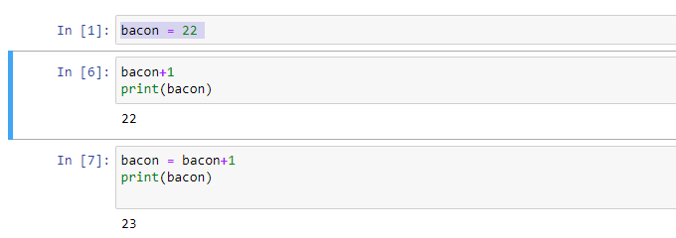

7. What should the values of the following two terms be?

'spam' + 'spamspam'

'spam' \* 3

Ans. 'spamspamspam'

'spamspamspam'

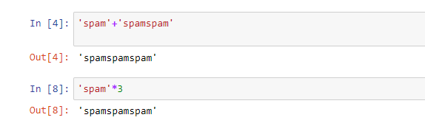

8. Why is eggs a valid variable name while 100 is invalid?

Ans. As per programming language we cant declare variable name as integer.

9. What three functions can be used to get the integer, floating-point number, or string

version of a value?

Ans. The int(), float() and str() function will be used to evaluate to the integer, floating-pointing or string

Versions of the value passed to them.

10. Why does this expression cause an error? How can you fix it?

‘I have eaten’ + 99 + ‘ burritos’.

Ans. It will throw error because integer cannot be concatenated with integer. It will only concatenated with string.

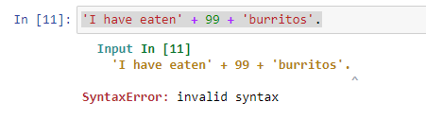

It can be fixed by typecasting integer into string which is shown as below-

