1.What are the two values of the Boolean data type? How do you write them?

Ans. There are two values of Boolean data type which are true and false. A Boolean data type is declared with bool keyword and can only take the values true or false. When the values is returned, true =1 and false = 0.

2. What are the three different types of Boolean operators?

Ans. There are three basic Boolean operators which are explained below –

AND – Searches find all of the search items.

OR – Searches find one or other item.

NOT – eliminates item that contain specified term.

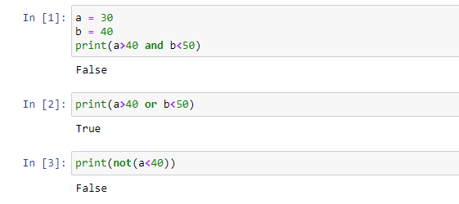

3. Make a list of each Boolean operator’s truth tables (i.e. every possible combination of Boolean

values for the operator and what it evaluate ).

Ans. **: Truth Table for and (&) operator –**

True and True= True

True and False=True

False and True=False

False and False=False

**Truth Table for OR (|) operator -**

True or True = True

True or False = True

False or False= False

False or True= True

**Truth Table for Not operator –**

True= false

False=True

4. What are the values of the following expressions?

(5 > 4) and (3 == 5)

not (5 > 4)

(5 >4) or (3 == 5)

not ((5 > 4) or (3 == 5))

(True and True) and (True == False)

(not False) or (not True)

Ans. (5 > 4) and (3 == 5) - False

not (5 > 4) - False

(5 >4) or (3 == 5) - True

not ((5 > 4) or (3 == 5)) - False

(True and True) and (True == False) - False

(not False) or (not True) – True

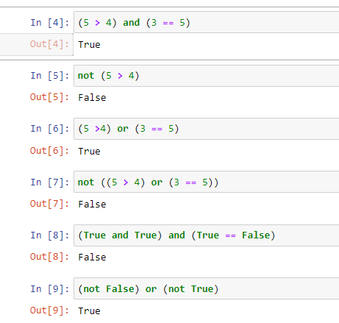

5. What are the six comparison operators?

Ans. The six comparison operator are : ==, !=, <, >, <=, =>.

6. How do you tell the difference between the equal to and assignment operators? Describe a

condition and when you would use one.

Ans. The difference between equal to and assignment operator is –

We only use assignment operator to assign value in variable like a=12 while equal to operator is used to check whether the value is equal to or not ex – a==12.

7. Identify the three blocks in this code:

spam = 0

if spam == 10:

print(‘eggs’)

if spam >5:

print(‘bacon’)

else:

print(‘ham’)

print(‘spam’)

print(spam)

Ans. Three blocks in the above code is mentioned below –

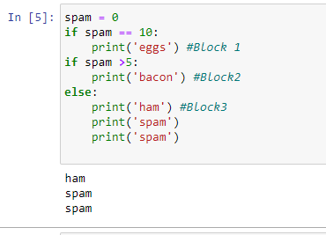

8. Write code that prints Hello if 1 is stored in spam, prints Howdy if 2 is stored in spam, and prints

Greetings! if anything else is stored in spam.

Ans.

Ans. 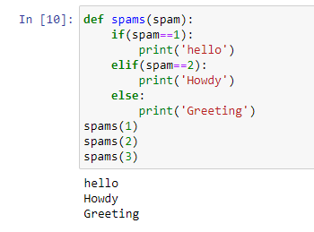

9.If your programme is stuck in an endless loop, what keys you’ll press?

Ans. If Our programme is stuck in an endless loop, We use **CTRL + C**.

10. How can you tell the difference between break and continue?

Ans. Break statement is used to break the loop Whereas Continue statement is used to skip that particular condition and again executing.

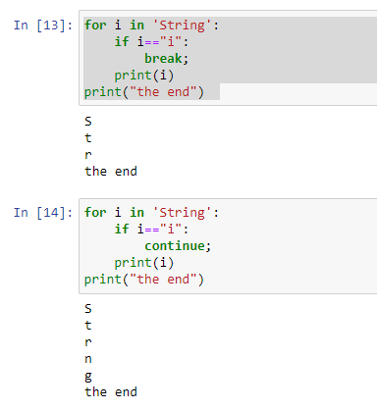

11. In a for loop, what is the difference between range(10), range(0, 10), and range(0, 10, 1)?

Ans. range (10) calls range from 0 to 9 not include 10

range (0,10) tells the range will start from 0 to 9 and

range (0,10,1) tells the range will start from 0 and will increase by 1 with every iteration.

12. Write a short program that prints the numbers 1 to 10 using a for loop. Then write an equivalent

program that prints the numbers 1 to 10 using a while loop.

Ans.

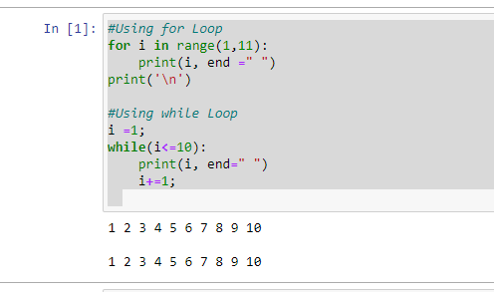

13. If you had a function named bacon() inside a module named spam, how would you call it after

importing spam?

Ans. This function should be called by spam.bacon().