1. Why are functions advantageous to have in your programs?

**Ans.** Function reduces the need for duplicate code. This makes program shorter, easier to read and easier to update.

1. When does the code in a function run: when it’s specified or when it’s called?

**Ans.** A function runs only when it is called not when it is specified.

1. What statement creates a function?

**Ans**. The def() keyword is a statement which is used to create and define a function.

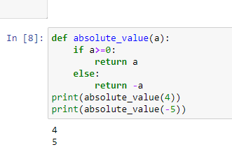

1. What is the difference between a function and a function call?

**Ans**. A function is a block of code or instruction that perform a particular task and return the result while a function call is code that is used to pass control to function.

1. How many global scopes are there in a Python program? How many local scopes?

**Ans**. There is one global scope, and a local scope is created whenever a function is called.

1. What happens to variables in a local scope when the function call returns?

**Ans**. When a function returns, the local scope is destroyed.

1. What is the concept of a return value? Is it possible to have a return value in an expression?

**Ans**. A return statement is used to end the execution of a function call and return the value to

the caller. Like any value, a return value can be used as part of an expression.

1. If a function does not have a return statement, what is the return value of a call to that function?

**Ans**. If a function does not have a return type then it will return default value. That default value will always be none.

1. How do you make a function variable refer to the global variable?

**Ans**. We can use global keyword to make a function variable into a global variable.

1. What is the data type of None?

**Ans**. Data type of None is NoneType.

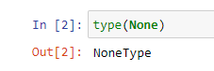

1. What does the sentence import areallyourpetsnamederic do?

**Ans**. That import statement imports a module named areallyourpetsnamederic.

1. If you had a bacon() feature in a spam module, what would you call it after importing spam?

**Ans**. bacon() function can be called with spam.bacon().

1. What can you do to save a programme from crashing if it encounters an error?

**Ans**. Write those codes inside try block from which can crash and use except block to handle.

1. What is the purpose of the try clause? What is the purpose of the except clause?

**Ans**. The purpose of the try clause is to write the codes which can encounters errors and to handle those We use except clause.

