1. What exactly is []?

**Ans**. List is special type of data structure that can store any type of data like – string, float, int, tuple, dict and etc. It is an ordered data structure.

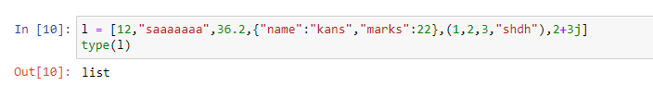

**2**. In a list of values stored in a variable called spam, how would you assign the value ‘hello’ as the

third value? (Assume [2, 4, 6, 8, 10] are in spam.)

Let’s pretend the spam includes the list [‘a’ ,’b’, ‘c’, ‘d’] for the next three queries.

**Ans**.

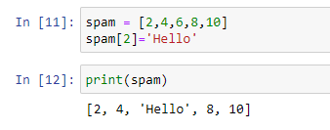

1. What is the value of spam[int(int(’3’ * 2) / 11)]?

**Ans**.

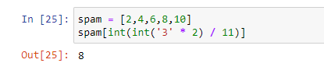

1. What is the value of spam[-1]?

**Ans**.

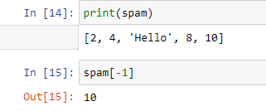

1. What is the value of spam[:2]?

**Ans**.

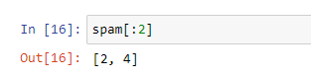

Let’s pretend bacon has the list [3.14, ‘cat’ , 11, ‘cat’, True] for the next three questions.

1. What is the value of bacon.index(’cat’)?

**Ans**.

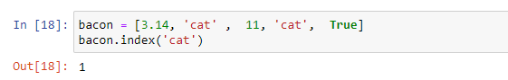

1. How does bacon.append(99) change the look of the list value in bacon?

**Ans**.

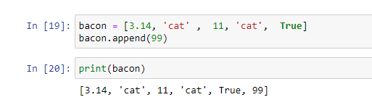

1. How does bacon.remove(’cat’) change the look of the list in bacon?

**Ans**.

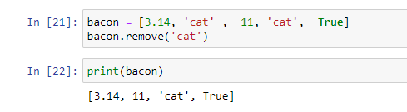

1. What are the list concatenation and list replication operators?

**Ans**. The list concatenation operator is ‘+’ and list replication operator is ‘*’.

1. What is difference between the list methods append() and insert()?

**Ans**. The only difference is that insert() allow us to add an element at any specific index while append() allow us to add an element at last index.

1. What are the two methods for removing items from a list?

**Ans**. The two methods for removing items from a list is pop() and remove().

1. Describe how list values and string values are identical.

**Ans**. The list values and string values are identical because both are sequences.

1. What’s the difference between tuples and lists?

**Ans**. The difference between tuple and list is that list is mutable while tuples are immutable.

1. How do you type a tuple value that only contains the integer 42?

Ans. (42,)

1. How do you get a list value’s tuple form? How do you get a tuple value’s list form?

**Ans**.We can get List values tuple form by using tuple() method and and tuple value list form by using list() method.

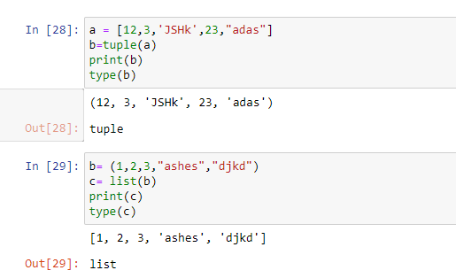

**16**. Variables that “contain” list values are not necessarily lists themselves. Instead, what do they

contain?

**Ans**. Variable contains reference to the list value rather than list themselves.

**17**. How do you distinguish between copy.copy() and copy.deepcopy()?

**Ans**. Copy() creates reference to original object. If you change copy() object you can change original object. But deepcopy() creates a copy of original object.