1. What does an empty dictionary’s code look like?

**Ans**. An empty dictionary looks like {}.

1. What is the value of a dictionary value with the key ‘foo’ and the value 42?

**Ans**. The value of a dictionary value with the key ‘foo’ and the value 42 looks like {‘foo’:42}

1. What is the most significant distinction between a dictionary and a list?

**Ans**. The indices in the case of a list are basically integers that start from the value 0 while The keys present in a dictionary can easily be of any given data type. In List We can access the elements in a key using indices while in dictionary We can access the elements present in a dictionary using the key-values.

1. What happens if you try to access spam[’foo’] if spam is ‘{bar’: 100}?

**Ans**. We get a keyError error.

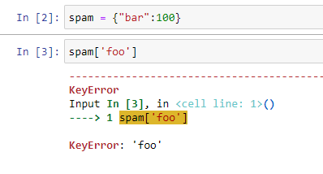

**5**. If a dictionary is stored in spam, what is the difference between the expressions ‘cat’ in spam and

‘cat’ in spam.values()?

**Ans**. There is no difference the operator checks in whether the values exist as a key in the dictionary.

**6**. If a dictionary is stored in spam, what is the difference between the expressions ‘cat’ in spam and

‘cat’ in spam.values()?

**Ans**. ‘cat’ in spam checker whether there is a ‘cat’ key in dictionary or not while ‘cat’ in spam.keys()

**7**. What is a shortcut for the following code?

if ‘color’ not in spam:

spam[‘color’] =’black’

**Ans**. spam.setdefault('color', 'black')

**8**. How do you “pretty print” dictionary values using which module and function?

**Ans**. We can use it in three different ways –

1. by using pprint() function of pprint module
2. by using dumps() method of json module
3. by using dumps() method of yaml module