1. Write a Python program to find sum of elements in list?

Ans.

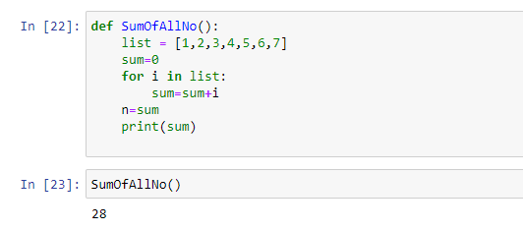

1. Write a Python program to Multiply all numbers in the list?

Ans.

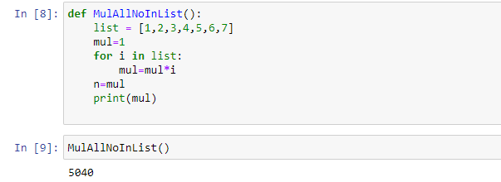

1. Write a Python program to find smallest number in a list?

Ans

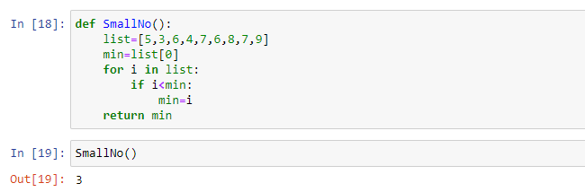

1. Write a Python program to find largest number in a list?

Ans

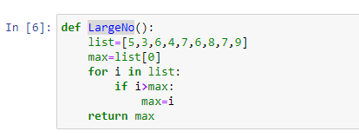

1. Write a Python program to find second largest number in a list?

Ans

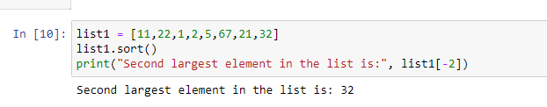

1. Write a Python program to find N largest elements from a list?

Ans

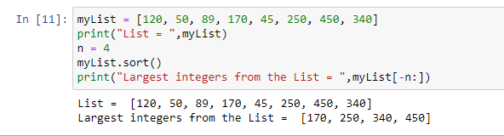

1. Write a Python program to print even numbers in a list?

Ans

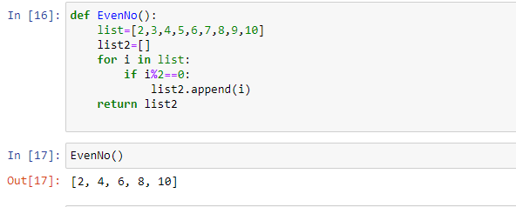

1. Write a Python program to print odd numbers in a List?

Ans

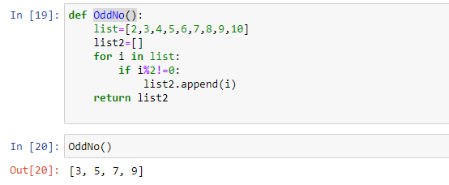

1. Write a Python program to Remove empty List from List?

Ans

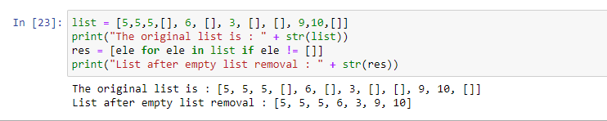

1. Write a Python program to Cloning or Copying a list?

Ans

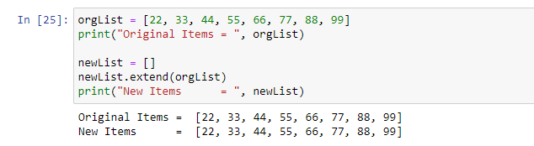

1. Write a Python program to Count occurrences of an element in a list?

Ans

