1. Write a Python program to find words which are greater than given length k?

Ans

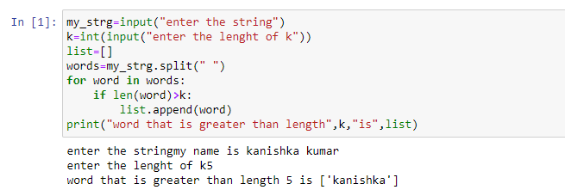

1. Write a Python program for removing i-th character from a string?

Ans

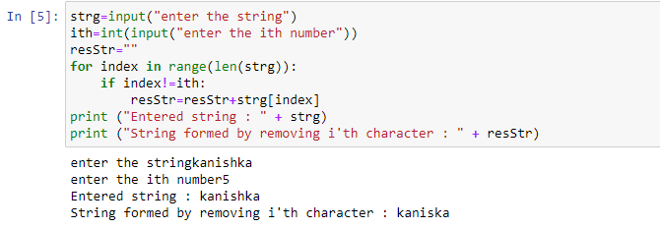

1. Write a Python program to split and join a string?

Ans

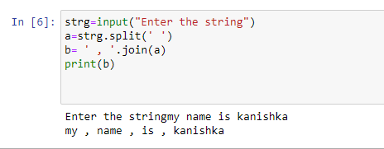

1. Write a Python to check if a given string is binary string or not?

Ans

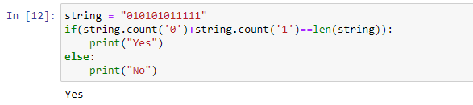

1. Write a Python program to find uncommon words from two Strings?

Ans

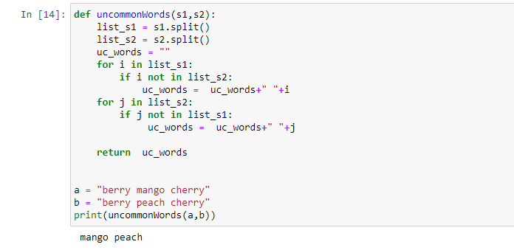

1. Write a Python to find all duplicate characters in string?

Ans

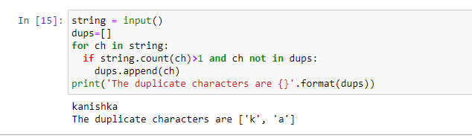

1. Write a Python Program to check if a string contains any special character?

Ans

