1. Write a Python Program to Find LCM?

Ans.

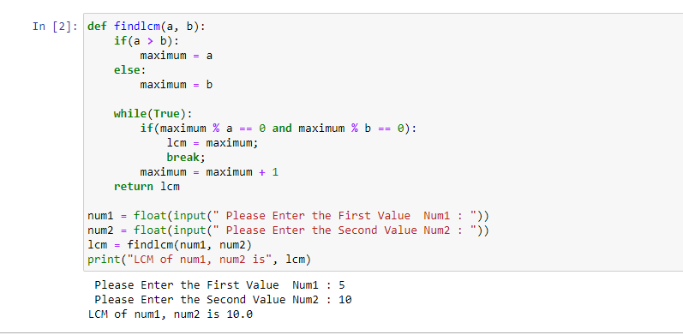

1. Write a Python Program to Find HCF?

Ans

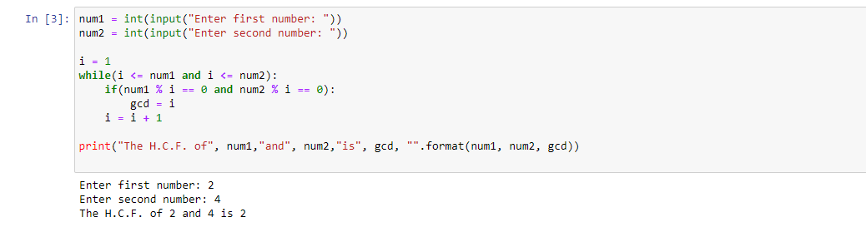

1. Write a Python Program to Convert Decimal to Binary, Octal and Hexadecimal?

Ans

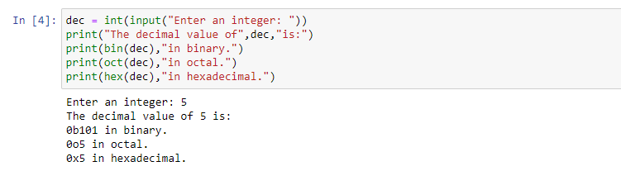

1. Write a Python Program To Find ASCII value of a character?

Ans.

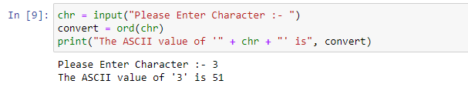

1. Write a Python Program to Make a Simple Calculator with 4 basic mathematical operations?

Ans.

