PROJECT REPORT
AI Resume Screener – Intelligent Recruitment System
Submitted by: KANISHKA P
Reg No: 11524050252
Dhanalakshmi Srinivasan University
Trinoix Internship Project
Date: 11-10-2026
GitHub Repository: https://github.com/kanishkaprabhu05/resume-screener

1. Introduction
The AI Resume Screener is an automated recruitment system developed using Python and Streamlit. The purpose of this project is to reduce manual workload in hiring by automatically matching candidate resumes with job descriptions. The system analyzes text and calculates a match percentage, helping recruiters quickly shortlist candidates. The application operates through a simple web interface.

2. Objective of the Project
- To automate the resume screening process.
- To reduce time and human bias in recruitment.
- To give an instant match score between a job description and a resume.
- To create a user-friendly interface for HR teams and students.

3. System Requirements
Hardware Requirements: Intel i3 processor or above, minimum 4 GB RAM, and 1 GB of free storage.
Software Requirements: Windows 10/11, Python 3.11 or above, Streamlit library, Visual Studio Code, and a web browser such as Google Chrome or Microsoft Edge.

4. Tools and Technologies Used
- Python – Core programming language used to build the screening logic.
- Streamlit – Used to create the web-based user interface.
- Natural Language Processing (NLP) – Text comparison may use TF-IDF, cosine similarity, and keyword matching, depending on the implementation.
- Git and GitHub – Used for version control and project hosting.
- VS Code – Used as the code editor.

5. Project Structure
The project folder, resume-screener, contains the following files:
- app.py – Main application file containing the screening logic and user interface.
- requirements.txt – File containing the required Python libraries.
- resume-result.png – Screenshot of the result showing a 60% match.
- README.md – Project documentation with features and setup steps.
GitHub Link: https://github.com/kanishkaprabhu05/resume-screener

6. Features Implemented
- Job Description Input – Allows the recruiter to paste a job description.
- Resume Input – Allows candidate resume text to be pasted.
- Match Percentage – Displays a compatibility score in percentage (for example, 60% Match).
- Matched Skills – Shows common skills found in both the job description and resume.
- Simple UI – Provides two text areas and a screening button for easy use.
- Instant Result – Displays the result in the local Streamlit app.

7. Working Methodology
- The user opens the application at http://localhost:8501.
- The user pastes the job description into Box 1 and the candidate resume into Box 2.
- The app processes the text before comparison.
- The backend compares keywords or text similarity using the algorithm implemented in app.py.
- The application calculates the match percentage and identifies matched skills.
- The result is displayed in the Streamlit interface.

8. Challenges Faced and Solutions
Challenge 1: Package installation errors. Errors occurred while installing packages such as PyYAML and PyArrow. A very new Python version can sometimes lack compatible pre-built package wheels. The solution was to use a compatible Python version and install the libraries listed in requirements.txt. The command pip install --upgrade pip can also help update the package installer.
Challenge 2: Git push failed because the remote origin was not configured. The GitHub repository was created, then the remote was configured and the code was pushed using git remote add origin, git branch -M main, and git push -u origin main.

9. Output and Testing
The project was tested locally at http://localhost:8501.
Test Case 1: Job Description: Python Developer with Machine Learning. Resume: Python and ML skills. Expected/observed demo output: 60% Match, with Python, SQL, and Machine Learning shown as matched skills in the supplied screenshot.
Result: Pass (demonstration input).
Test Case 2: Empty Job Description. Expected output: a validation message asking the user to enter both the job description and resume.
Result: Pass if the application displays the validation message.
Figure 1: AI Resume Screener Demo Result – 60% Match
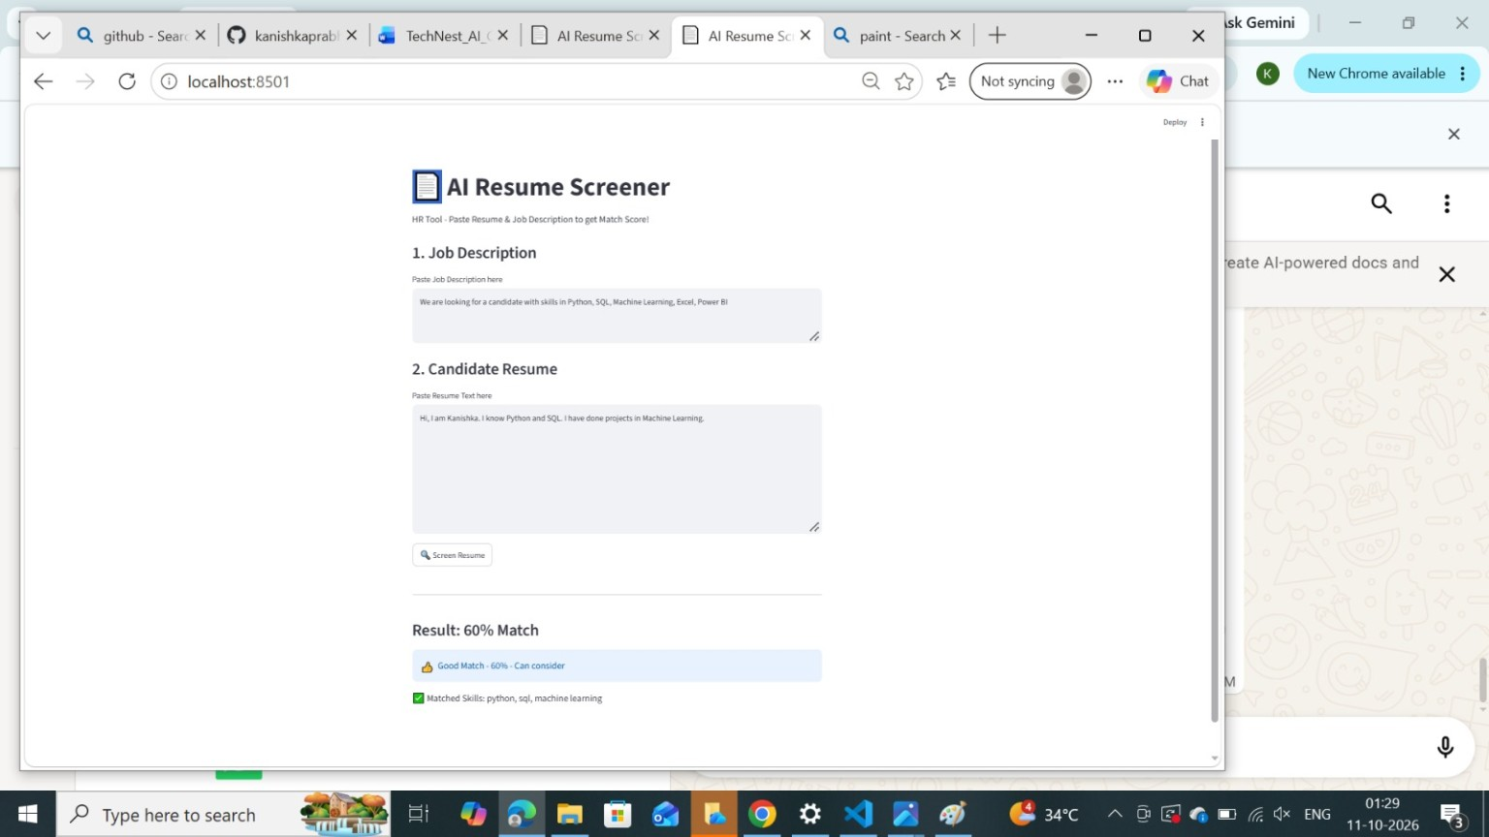
GitHub Proof: https://github.com/kanishkaprabhu05/resume-screener/blob/main/resume-result.png

10. Conclusion
The AI Resume Screener was developed and run as a basic automated recruitment application. It demonstrates how Python and Streamlit can be used to build a simple tool that compares resume text with a job description. The displayed 60% match is an example result from the supplied demonstration screenshot; it should not be treated as a validated hiring decision. The project provided practical experience with application development and GitHub version control.

11. Future Enhancements
- Add PDF and DOCX resume upload options.
- Integrate advanced language models such as BERT for improved semantic matching.
- Add a more detailed applicant-tracking-system (ATS) analysis.
- Deploy the application on Streamlit Community Cloud for public access.
- Add an admin panel and database to store candidate information securely.

12. GitHub Repository
The project code, README, and demo screenshot are intended to be available in the repository below:
GitHub Link: https://github.com/kanishkaprabhu05/resume-screener
Direct Link to View Files: https://github.com/kanishkaprabhu05/resume-screener/tree/main

