PROJECT REPORT
TechNest Mobile Store
AI Customer Support Chatbot
Submitted by | KANISHKA P
Register Number | 11524050252
Institution | Dhanalakshmi Srinivasan University
Internship | Trinoix Internship Project
Date | 11 October 2026
GitHub Repository | https://github.com/kanishkaprabhu05/technest-mobile-store-chatbot

A Python and Streamlit-based customer support chatbot

1. Introduction
The TechNest Mobile Store chatbot is an automated customer support system developed using Python and Streamlit. The purpose of this project is to provide instant assistance to customers regarding mobile products, pricing, stock availability, warranty, and general store policies. The chatbot operates through a simple web interface and responds based on a structured product database.

2. Objective of the Project
The main objectives of the project are:
- To provide automated customer support at any time.
- To reduce the manual workload of support staff.
- To give instant information about products, including price, stock, and warranty.
- To create a user-friendly chat interface for TechNest Mobile Store.

3. System Requirements
Hardware Requirements: Intel Core i3 processor or above, minimum 4 GB RAM, and at least 1 GB of free storage.
Software Requirements: Windows 10/11, Python 3.11 or above (depending on library compatibility), Streamlit, Visual Studio Code, and a web browser such as Google Chrome or Microsoft Edge.

4. Tools and Technologies Used
- Python – Core programming language used to build the chatbot logic.
- Streamlit – Used to create the web-based chat user interface.
- Git and GitHub – Used for version control and project hosting.
- Visual Studio Code (VS Code) – Used as the code editor.

5. Project Structure
The project folder, mini-chatbot, contains the following files:
- app.py – Main application file containing chatbot logic, product details, and the user interface.
- requirements.txt – File containing the required Python libraries.
- chatbot-result.png – Screenshot of the chatbot demonstration output.
- README.md – Project documentation containing features and setup steps.

6. Features Implemented
- Product Enquiry – Users can ask about mobile phones such as iPhone 15, Samsung, OnePlus, Redmi, and laptops.
- Price Display – Displays product prices in Indian Rupees (INR).
- Stock Status – Shows whether a product is in stock or out of stock.
- Warranty Information – Provides the warranty period for a product.
- Support Handling – For return-policy or delivery queries, the chatbot provides a support contact number.
- Interactive UI – Provides a simple chat interface with a text input field.

7. Working Methodology
- The user enters a query in the chat box.
- The app.py file reads the query and searches for relevant product details in the program's data.
- If a product match is found, the chatbot returns its price, stock status, and warranty details.
- If the query is about returns or delivery, the chatbot provides the support contact number.
- The response is displayed in the chat interface using Streamlit.

8. Challenges Faced and Solutions
Challenge 1: Errors occurred while building pyyaml and pyarrow during package installation.
Reason: The Python version being used was very new, so compatible pre-built wheels might not have been available for some packages.
Solution: The requirements.txt file was simplified to include Streamlit, and binary package installation was attempted with pip install streamlit --only-binary :all:. Pip was also upgraded using python -m pip install --upgrade pip.
Challenge 2: A ModuleNotFoundError occurred.
Solution: The package was installed using python -m pip install, and the application was launched with python -m streamlit run app.py.

9. Output and Testing
The project was tested locally using Streamlit. The screenshot below shows the chatbot running in a browser at localhost:8503.
Test Case 1: Input: iPhone 15
Output: Price: ₹79,999; Stock: In Stock; Warranty: 1 Year
Result: Pass
Test Case 2: Input: What is your return policy?
Output: The chatbot provides the support contact number 98765-43210.
Result: Pass
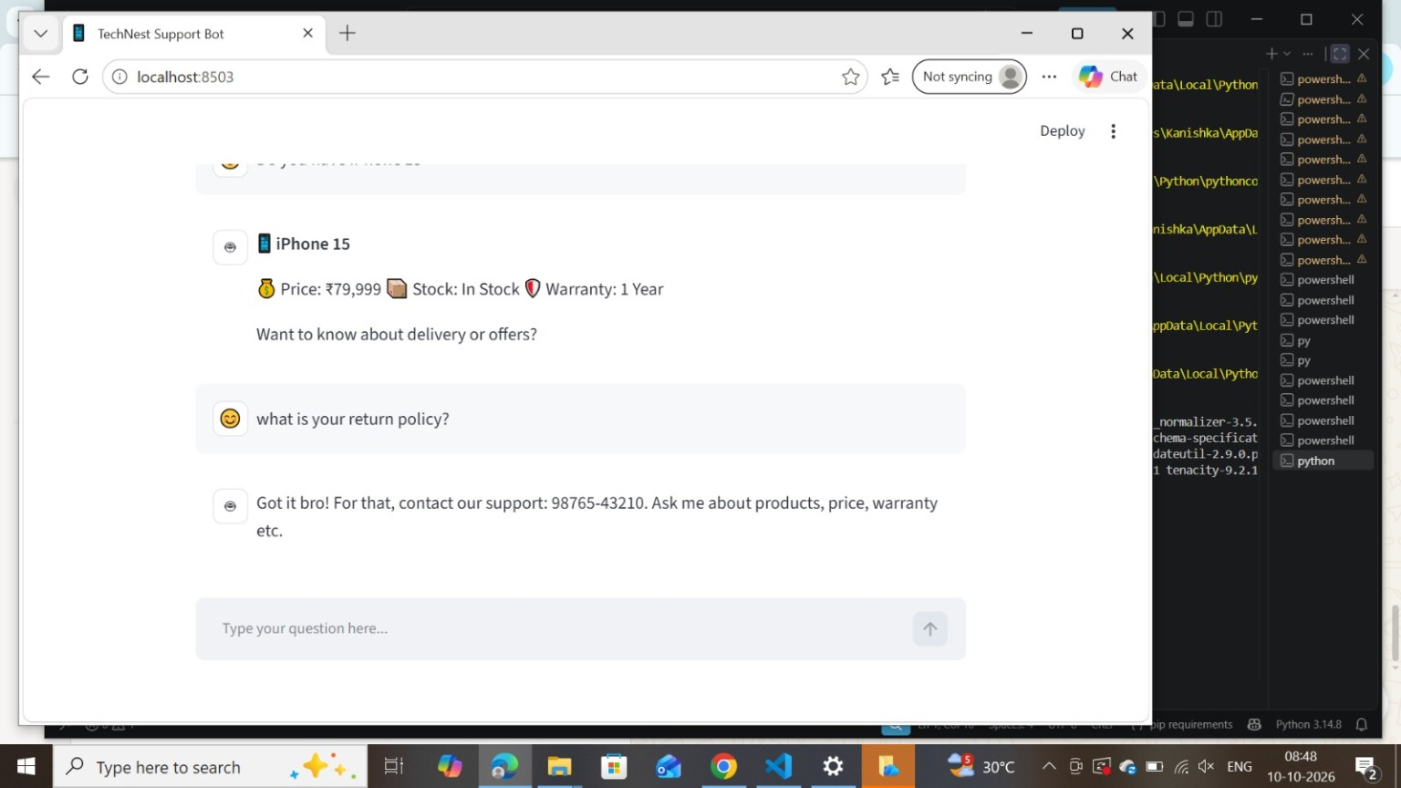
Figure 1: TechNest Mobile Store chatbot demonstration output

10. Conclusion
The TechNest Mobile Store chatbot was successfully developed and executed. It fulfills the basic requirements of an automated customer support system. The project helped in understanding Streamlit, Python package management, and handling version compatibility issues. In the future, the system can be extended by adding more products and deploying it to the cloud.

11. Future Enhancements
- Add more mobile brands and accessories.
- Integrate a real database such as MySQL or Firebase.
- Add voice input and multi-language support.
- Deploy the application on Streamlit Community Cloud for public access.
- Add an admin panel to update stock and prices.

12. GitHub Repository
The project code, README file, and demonstration screenshot can be accessed at:
https://github.com/kanishkaprabhu05/technest-mobile-store-chatbot

