WEEK 3 TASK: ADVANCED DATA ANALYSIS AND VISUALIZATION IN LOGISTICS
Python-Based Exploratory Data Analysis, Visualization and Insights

1. Objective
The objective of this task is to strengthen practical data-analysis skills by exploring a hypothetical logistics dataset using Python. The analysis focuses on delivery performance, shipment volume, transportation cost, fuel usage, distance and fuel efficiency. Exploratory Data Analysis (EDA) is used to understand distributions, central tendencies and relationships between operational variables. Multiple visualizations are then used to identify trends, cost drivers and possible bottlenecks that can support data-driven logistics decisions.

2. Dataset Simulation and Structure
A synthetic dataset containing 300 shipment records was generated using NumPy and pandas. The dataset is hypothetical and is intended for analytical practice rather than representing actual company operations. Variables were designed to reflect common logistics KPIs.
Variable | Type | Description
Shipment_ID | Categorical | Unique shipment identifier
Distance_km | Numeric | Delivery distance in kilometres
Shipment_Volume_kg | Numeric | Shipment weight/volume proxy in kg
Delivery_Time_min | Numeric | Delivery duration in minutes
Transport_Cost_INR | Numeric | Transportation cost in INR
Fuel_Used_L | Numeric | Fuel consumed in litres
Fuel_Efficiency_km_per_L | Numeric | Distance travelled per litre
On_Time | Binary | 1 if delivery is within 90 minutes, otherwise 0

3. Exploratory Data Analysis (EDA)
The EDA process included checking the dataset structure, calculating descriptive statistics, examining distributions and measuring correlations. Mean and median were used to understand typical values, while standard deviation, minimum and maximum values were used to assess variation and operational range.
Metric | Mean | Median | Std. Dev. | Min | Max
Distance_km | 42.14 | 43.38 | 22.08 | 5.38 | 79.25
Shipment_Volume_kg | 257.10 | 250.50 | 134.82 | 20.00 | 499.00
Delivery_Time_min | 68.84 | 68.30 | 19.33 | 26.32 | 114.64
Transport_Cost_INR | 1972.96 | 2031.14 | 662.72 | 538.46 | 3447.91
Fuel_Used_L | 2.19 | 2.06 | 1.07 | 1.00 | 6.04
Fuel_Efficiency_km_per_L | 21.18 | 21.36 | 2.70 | 14.00 | 28.00
Key summary values: average delivery time = 68.84 minutes, average distance = 42.14 km, average transport cost = ₹1972.96, average fuel used = 2.19 L, and average fuel efficiency = 21.18 km/L. The simulated on-time delivery rate is 82.7%.

4. Visualization and Interpretation

4.1 Delivery Time Distribution
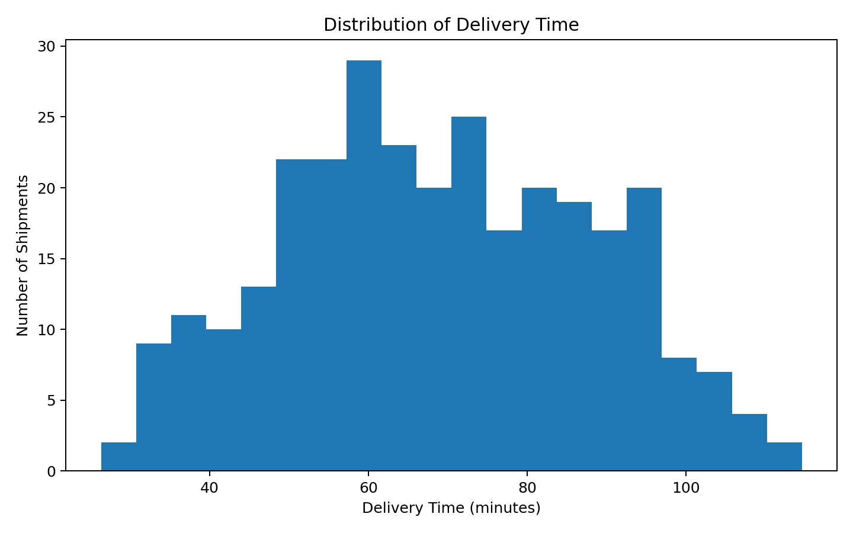
A histogram was selected because it shows how delivery times are distributed across shipments. It helps identify the typical delivery range and whether unusually long deliveries form a visible tail. In a real logistics operation, such a tail could indicate delayed routes, congestion, handling problems or other bottlenecks requiring investigation.

4.2 Distance vs Delivery Time
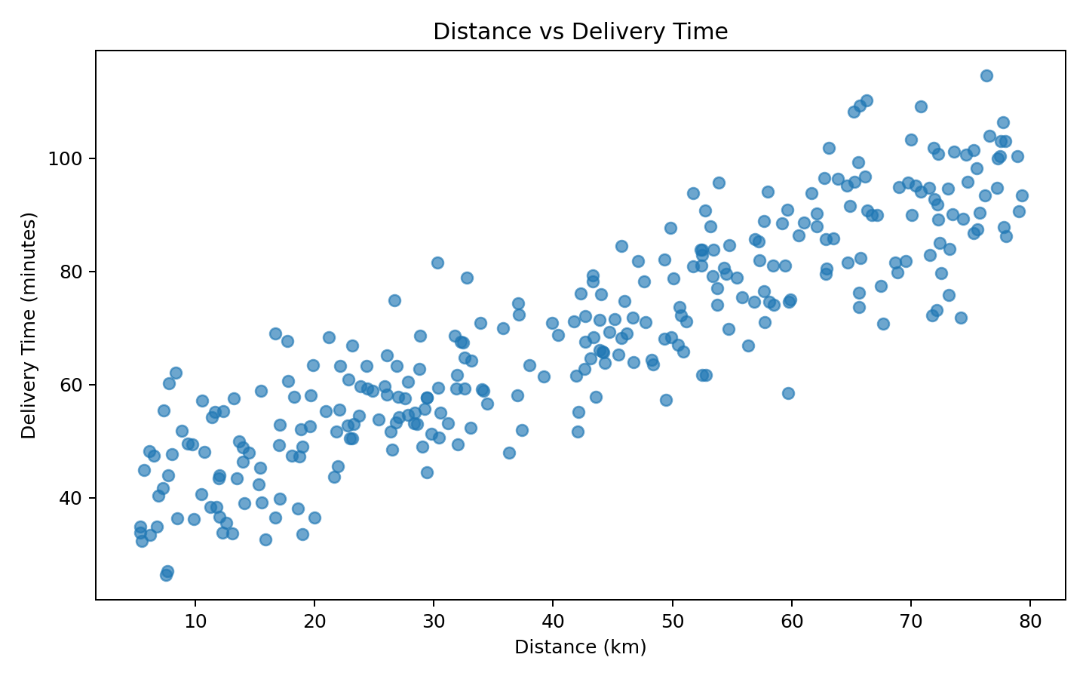
A scatter plot is appropriate for examining the relationship between two continuous variables. The simulated data show that delivery time generally increases as distance increases. This suggests that route length is an important operational factor when estimating delivery duration. However, individual points also show variation, indicating that distance alone does not explain every delay.

4.3 Shipment Volume vs Transport Cost
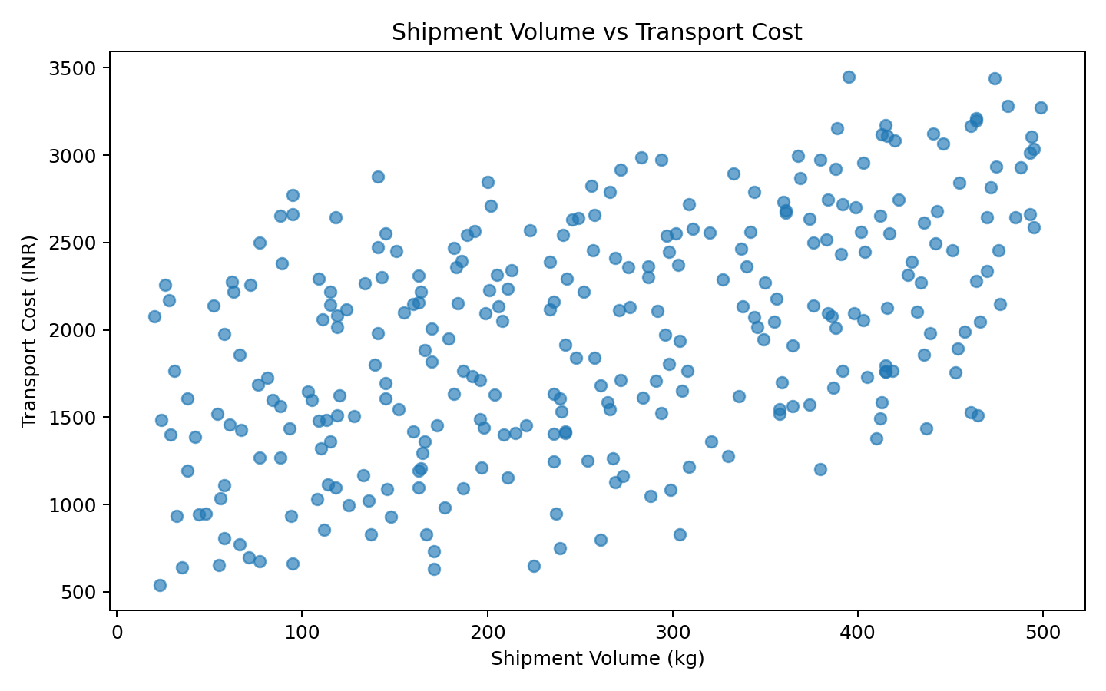
This scatter plot examines whether larger shipments are associated with higher transportation costs. The upward relationship indicates that shipment volume contributes to cost. Logistics managers can use this type of analysis to investigate consolidation opportunities, vehicle utilization and pricing strategies.

4.4 Correlation Matrix
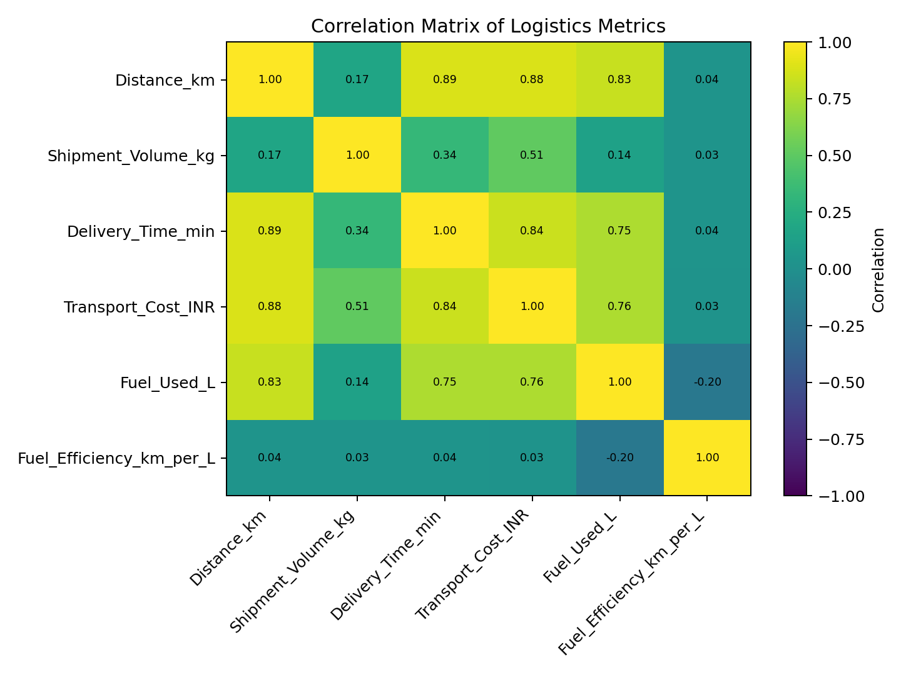
A correlation matrix provides a compact view of linear relationships among numeric KPIs. Strong positive relationships can highlight variables that move together, while values close to zero suggest weaker linear association. Correlation does not prove causation, so operational decisions should also consider business context and additional analysis.

4.5 Average Transport Cost by Distance Group
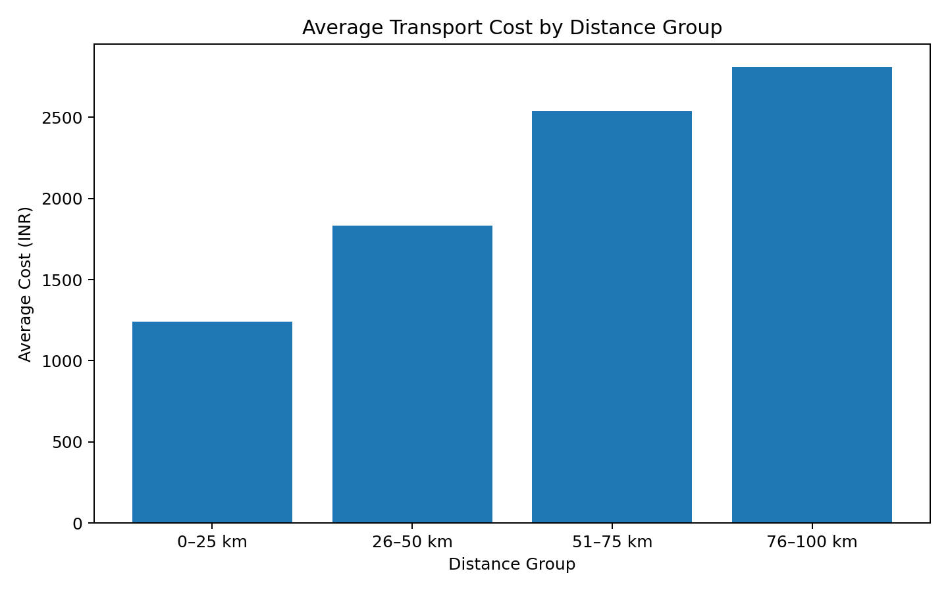
A grouped bar chart was selected to compare average transportation cost across distance ranges. This makes it easy to see how cost changes as routes become longer and can support route planning, budget estimation and cost-control discussions.

5. Key Analytical Insights
- Delivery performance: the simulated average delivery time is 68.84 minutes, while the on-time rate based on the 90-minute threshold is 82.7%. Shipments exceeding the threshold should be examined for route or process-level causes.
- Distance is an important operational driver because longer routes generally require more travel time and fuel. Distance-based segmentation can therefore improve delivery-time estimation.
- Transport cost increases with operational workload. Shipment volume, distance and fuel consumption are relevant cost-related variables and should be monitored together rather than independently.
- Fuel efficiency provides an operational sustainability and cost perspective. Lower efficiency means more fuel is required for the same distance, potentially increasing transportation expense.
- The distribution and scatter plots help identify unusual observations. Outliers should be investigated rather than automatically removed because they may represent genuine delays or exceptional logistics events.

6. Recommendations
- Monitor delivery-time outliers and investigate the operational reason for repeated delays.
- Use distance-based route planning and realistic delivery-time estimates.
- Analyze high-volume shipments for consolidation or improved vehicle utilization opportunities.
- Track fuel efficiency by route or vehicle to identify areas of excessive fuel consumption.
- Combine cost, distance, volume and delivery KPIs in a logistics dashboard for regular monitoring.

7. Python Code Used
import pandas as pd
import numpy as np
import matplotlib.pyplot as plt
# Descriptive statistics
df.describe()
# Correlation analysis
corr = df[["Distance_km", "Shipment_Volume_kg",
"Delivery_Time_min", "Transport_Cost_INR",
"Fuel_Used_L", "Fuel_Efficiency_km_per_L"]].corr()
# Histogram
plt.hist(df["Delivery_Time_min"], bins=20)
plt.xlabel("Delivery Time (minutes)")
plt.ylabel("Number of Shipments")
plt.title("Distribution of Delivery Time")
plt.show()
# Scatter plot
plt.scatter(df["Distance_km"], df["Delivery_Time_min"])
plt.xlabel("Distance (km)")
plt.ylabel("Delivery Time (minutes)")
plt.title("Distance vs Delivery Time")
plt.show()
# Correlation heatmap using matplotlib
plt.imshow(corr, cmap="viridis", vmin=-1, vmax=1)
plt.colorbar()
plt.show()

8. Conclusion
This analysis demonstrates how Python can convert logistics records into meaningful operational information. EDA provides a foundation for understanding typical performance and variation, while visualizations make relationships and potential bottlenecks easier to communicate. The simulated results show that delivery time, distance, shipment volume, transportation cost and fuel usage should be considered together when evaluating logistics performance. In a real-world setting, the same workflow could be extended with vehicle IDs, driver information, weather, traffic, warehouse processing time, delivery zones and historical timestamps. More advanced methods such as regression, clustering and time-series forecasting could then be used for prediction and optimization.

9. Tools and Technologies
Python was used as the main programming language. NumPy was used for numerical simulation, pandas for data manipulation and statistical summaries, and Matplotlib for visualization. Microsoft Word-compatible DOCX format was used for documentation. The workflow can also be adapted to Jupyter Notebook or Google Colab.

Week 3 Logistics Data Analysis Report | Hypothetical Dataset

