SIMATS ENGINEERING
ASSESSMENT TOOL 3

COURSE NAME: Artificial Intelligence COURSE CODE: CSA17

COURSE OUTCOME COVERED

CO2: Experiment search and game-solving techniques such as Greedy Search, A*, CSP, Minimax, and Alpha-Beta pruning with heuristic functions for solving complex AI problems efficiently. (BL3)

Assessment Tool Weightage: 40%

Duration: 1 Hour QUESTIONS: 3 Total Marks:30

Annexure A

Dry Run Evaluation

Code of Conduct:

I B Kanishka Sadana( 1911260097) (Name / Reg No) certify that this submission is my original work and that I have adhered to the guidelines specified for this assessment.
I understand that any violation of academic integrity rules will result in disciplinary action.

Signature of the student:
B Kanishka Sadana

Annexure A

Dry Run Evaluation
1. Question 1 – Breadth-First Search (BFS)
Consider the following graph: A
/ \
B C
/ \ / \
D E F G
Task: Starting from node A, perform a Breadth-First Search (BFS). Complete the following table.
Iteration Queue Visited Node
1
2
3
4
5
6

Questions:
1.Write the BFS traversal order.
2.Show the queue contents after each iteration.
ans:
BFS traversal order:
ABCDEFG
Queue contents after each iteration:
- Iteration 1: B, C
- Iteration 2: C, D, E
- Iteration 3: D, E, F, G
- Iteration 4: E, F, G
- Iteration 5: F, G
- Iteration 6: G
- Iteration 7: Empty
Conclusion: BFS visits every node level by level using a queue.

2. Depth-First Search (DFS) Using the same graph,
A
/ \
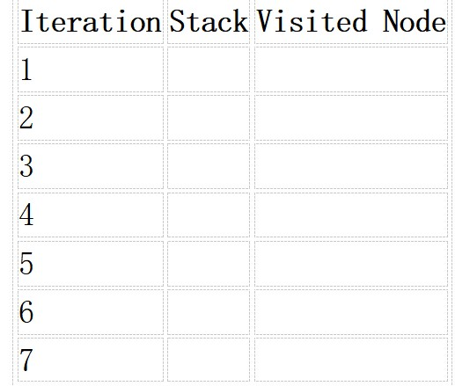
B C
/ \ / \
D E F G
Perform Depth-First Search (DFS) starting from A.
Complete the table.
3. Initial State :
1 3 6
5 0 2
4 7 8

Goal State :
1 2 3
4 5 6
7 8 0

Task
Trace Breadth-First Search (BFS) until the goal state is reached.
Fill in the table.
Iteration Current State Queue Before Expansion Queue After Expansion
1
2
3
4
5

Questions
- Which node is expanded in each iteration?
- How many states are generated in total?
- Write the complete solution path from the initial state to the goal state.
- Why does BFS always find the shortest solution in an unweighted 8-puzzle problem?
Ans:
DFS traversal order:
A B D E C G
1.The first five expanded states are S0, S1, S2, S3 and S4. Continuing the BFS search eventually reaches the goal at depth 8.

2. There are 9 states in the solution path, including the initial and goal states. This means 8 moves are required. The total number of states explored or generated by BFS can be larger because it also considers alternative paths.

3. S0 S1 S2S3 S4 S5 S6 S7 S8

4. BFS explores all states at depth 0, then depth 1, depth 2, and so on. Every legal move has equal cost. Therefore, the first time BFS reaches the goal, it has found a path with the minimum number of moves.

BFS systematically explores the state space using a FIFO queue and finds the shortest solution in terms of the number of moves, provided a solution exists.

