* Ejected the project :

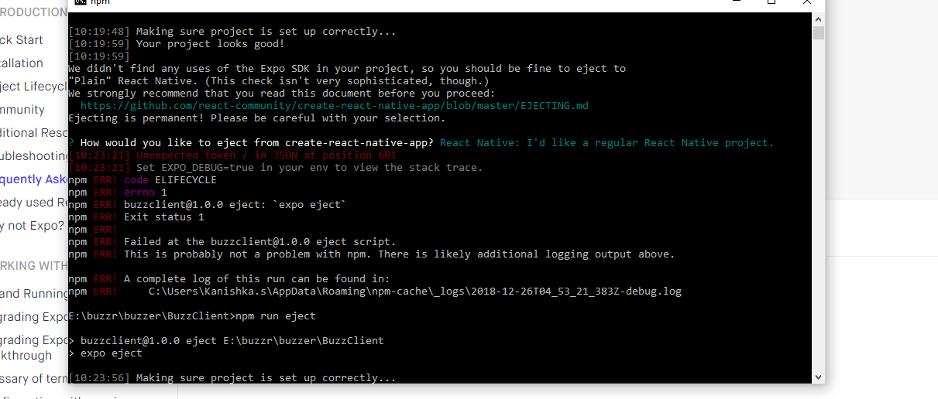

Selected the eject with expo option since it gave an error when trying to eject into a regular react-native project.

* On react-native run-android initially giving the error as below:

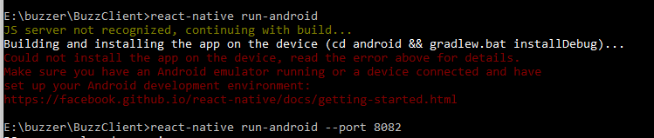

* Fixed the error by running it on port 8082

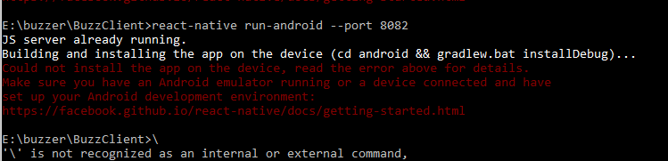

* On building the project on android studio ,

