Software Requirements Specification
for
Hospital Management System (HMS)
Version 1.0 approved
Prepared by Software Engineering Team
Department of Computer Science and Engineering
June 2026
Abstract
The Hospital Management System (HMS) is a comprehensive web-based application designed to automate and simplify the daily operations of a hospital by integrating various administrative, medical, and patient-related services into a single platform. Traditional hospital management methods often rely on manual record keeping, leading to data redundancy, human errors, increased processing time, and difficulty in maintaining patient information. This project aims to overcome these limitations by providing a secure, efficient, and user-friendly digital solution that improves the overall management of hospital activities.

The proposed system enables multiple users, including Administrators, Doctors, Receptionists, Pharmacists, Laboratory Technicians, and Patients, to perform their respective tasks through role-based authentication and authorization. The system provides functionalities such as patient registration, appointment scheduling, doctor management, electronic medical records, prescription generation, laboratory test management, report generation, medicine inventory management, and billing. Each user is provided with a dedicated dashboard to efficiently manage their responsibilities while ensuring data privacy and security.

The application is developed using modern web technologies, with React.js, Vite, and Tailwind CSS for the frontend, Node.js and Express.js for the backend, and Supabase (PostgreSQL) for the relational database, authentication, and file storage. RESTful APIs are used to facilitate communication between the frontend and backend, while Supabase Auth with JSON Web Token (JWT) authentication and Row Level Security (RLS) ensures secure user access. The system is designed with a modular architecture, making it scalable, maintainable, and suitable for future enhancements such as online consultations, AI-assisted symptom analysis, email notifications, cloud storage, and mobile application support.

The Hospital Management System significantly improves operational efficiency by reducing paperwork, minimizing human errors, enabling faster access to patient records, and streamlining communication among different hospital departments. It provides a centralized database that ensures accurate record management, secure storage of medical information, and quick retrieval of data whenever required. The system also enhances patient satisfaction by offering convenient appointment booking, access to medical history, downloadable prescriptions, and laboratory reports.

Overall, the proposed Hospital Management System serves as an effective digital healthcare solution that enhances the quality of hospital services, optimizes resource utilization, and supports informed decision-making through efficient data management. This project demonstrates the practical application of Software Engineering principles, database management, web technologies, and system design concepts to develop a reliable, secure, and scalable healthcare management platform suitable for real-world hospital environments.

Table of Contents
Table of Contents ii
Revision History ii
1. Introduction 1
1.1 Purpose 1
1.2 Document Conventions 1
1.3 Intended Audience and Reading Suggestions 1
1.4 Product Scope 1
1.5 References 2
2. Overall Description 2
2.1 Product Perspective 2
2.2 Product Functions 2
2.3 User Classes and Characteristics 3
2.4 Operating Environment 8
2.5 Design and Implementation Constraints 9
2.6 User Documentation 9
2.7 Assumptions and Dependencies 9
3. External Interface Requirements 10
3.1 User Interfaces 10
3.2 Hardware Interfaces 10
3.3 Software Interfaces 10
3.4 Communications Interfaces 10
4. System Features 10
4.1 Authentication and User Management 11
4.2 Patient Management 11
4.3 Appointment Management 11
4.4 Doctor Management 12
4.5 Medical Records 12
4.6 Prescription Management 13
4.7 Pharmacy and Medicine Inventory 13
4.8 Laboratory Tests and Reports 13
4.9 Billing 14
4.10 Notifications 14
4.11 Admin Management 15
5. Other Nonfunctional Requirements 15
5.1 Performance Requirements 15
5.2 Safety Requirements 15
5.3 Security Requirements 15
5.4 Software Quality Attributes 16
5.5 Business Rules 16
6. Other Requirements 16
Appendix A: Glossary 16
Appendix B: Analysis Models 16
Appendix C: To Be Determined List 17

Revision History
Name | Date | Reason For Changes | Version

Introduction

Purpose
This Software Requirements Specification (SRS) document describes the functional and non-functional requirements for the Hospital Management System (HMS), Version 1.0. The HMS is a comprehensive web-based software application designed to automate and streamline the day-to-day administrative, clinical, and financial operations of a hospital or healthcare center. This document covers the complete system scope including patient registration, appointment scheduling, electronic medical records, billing, pharmacy management, and laboratory management. It serves as the primary reference for design, development, testing, and validation of the HMS.

Document Conventions
This document follows the IEEE Std 830-1998 standard for Software Requirements Specifications. The following conventions apply:
• Requirements are written using the keyword SHALL for mandatory requirements and SHOULD for recommended features.
• Each functional requirement is assigned a unique identifier in the format FR-XX.
• Non-functional requirements are prefixed with NFR-XX.
• Section headings follow a hierarchical decimal numbering system.
• Bold text is used to highlight critical terms and important definitions.

Intended Audience and Reading Suggestions
• Software Developers and Engineers – responsible for designing and implementing the HMS modules; they should read all sections thoroughly.
• Project Managers – responsible for project planning and tracking; they should focus on Sections 1, 2, and 5.
• System Testers and QA Engineers – responsible for verifying that the system meets the specified requirements; they should focus on Sections 3 and 4.
• Hospital Administrators and Stakeholders – end-users who need to understand system capabilities; they should read Sections 1, 2, and 4.
• Database Administrators – responsible for schema design and management; they should focus on the data requirements in Section 4.

Product Scope
The Hospital Management System (HMS) is a full-stack, role-based web application designed to manage major hospital operations through a centralized system. The primary goal of the HMS is to replace manual, paper-based processes with a secure, efficient, and easy-to-use digital platform.
The scope of the system includes:
• Patient registration and patient record management.
• Appointment booking, rescheduling, cancellation, and doctor availability.
• Consultation, medical records, and prescription management.
• Pharmacy management, medicine inventory, and prescription dispensing.
• Laboratory test requests, results, and reports.
• Billing and payment tracking.
• Notifications and user/staff management for six roles: Administrator, Doctor, Receptionist, Pharmacist, Lab Technician, and Patient.
The HMS is intended for small to medium-sized hospitals, clinics, and healthcare centers seeking to modernize their operations. The main workflow is: Patient Registration → Login → Book Appointment → Receptionist Management → Doctor Consultation → Medical Record → Prescription/Lab Test → Pharmacy/Lab Processing → Report → Billing → Notification.

References
The following references were used in preparing this document:
1. IEEE Std 830, “IEEE Recommended Practice for Software Requirements Specifications,” IEEE, 1998.
2. Pressman, R. S., “Software Engineering: A Practitioner’s Approach,” 8th Edition, McGraw-Hill, 2014.
3. Supabase Documentation (Database, Auth, Storage, Row Level Security), https://supabase.com/docs.
4. PostgreSQL Documentation, PostgreSQL Global Development Group, https://www.postgresql.org/docs/.
5. React.js Documentation, Meta Open Source, https://reactjs.org/docs/.
6. Vite Documentation, https://vitejs.dev/guide/.
7. Tailwind CSS Documentation, https://tailwindcss.com/docs.
8. Node.js Documentation, OpenJS Foundation, https://nodejs.org/en/docs/.
9. Express.js API Reference, https://expressjs.com/en/api.html.

Overall Description

Product Perspective
The Hospital Management System is a new, self-contained web application developed to replace the existing manual and paper-based hospital management processes. It consolidates patient, appointment, clinical, pharmacy, laboratory, and billing functions into a single platform accessible through a web browser. The system follows a three-tier architecture:
• Presentation Layer: React.js with Vite, Tailwind CSS, and React Router provides role-specific dashboards, forms, tables, and notifications.
• Application Layer: A Node.js and Express.js REST API performs authentication validation, role authorization, business logic, and data validation.
• Data Layer: Supabase provides the PostgreSQL database, authentication, and file storage, protected by Row Level Security (RLS).
User identity is connected through Supabase Auth → profiles → role-specific record, so the actual logged-in doctors, pharmacists, and other users are displayed in the system. The HMS is designed to be standalone but can be extended in the future to integrate with external systems such as insurance portals, national health registries, or telemedicine platforms.

Product Functions
The Hospital Management System shall provide the following major functions:
1. Authentication and User Management
• Secure login through Supabase Auth and JWT with role-specific access for all users.
• Creation and maintenance of user profiles and role-specific records.
2. Patient Management
• Register new patients, update demographics, and maintain patient information.
3. Appointment Management
• Book, reschedule, and cancel appointments with doctor availability tracking.
4. Doctor Management
• Manage doctor profiles, specializations, departments, and availability.
5. Medical Records
• Store diagnosis details, consultation notes, and treatment plans digitally.
6. Prescription Management
• Create prescriptions with multiple medicine items for patients and pharmacists to view.
7. Pharmacy and Medicine Inventory
• Maintain medicine stock, dispense prescribed medicines, and update inventory.
8. Laboratory Tests and Reports
• Raise test requests, record results, and upload lab reports.
9. Billing
• Generate itemized bills for consultation, laboratory, and pharmacy services and record payments.
10. Notifications
• Notify users about appointments, prescriptions, reports, and bills.
11. Admin Management
• Manage users, staff, departments, medicines, appointments, and system settings.

User Classes and Characteristics
1.Patient.

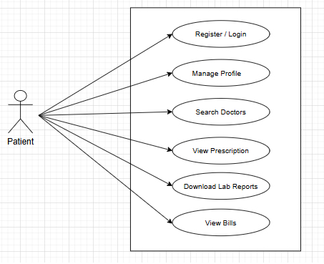

Use Case: View Prescription and Bills
Primary Actor: Patient
Secondary Actor: System
Precondition: Patient has registered and logged in.
Postcondition: Patient can access and manage their health information.
Trigger: Patient logs in or navigates to respective functions.

Main Access Scenario:
- Register/ Login
- Search and update profile information.
- Searching doctors
- Select prescription to view.
- Downloading lab reports
- Viewing bills
Exception Scenario:
- Incorrect login details.
- No prescriptions or lab reports available.

2. Doctor:

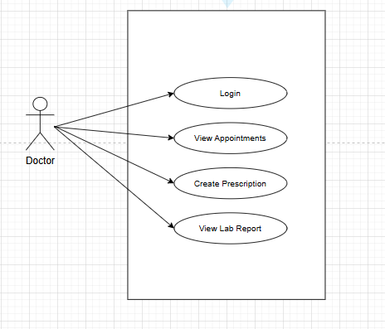

Use Case: View Lab Report and Create Prescription
Primary Actor: Doctor
Secondary Actor: System
Precondition: Doctor is registered and logged in.
Postcondition: Prescriptions are created and lab reports viewed.
Trigger: Doctor logs in or accesses respective functions.

Main Access Scenario:
- Log in process.
- View scheduled appointments.
- Create and save prescriptions.
- View lab reports.
Exception Scenario:
- Invalid login.
- No appointments or lab reports available.

3. Lab Technician:
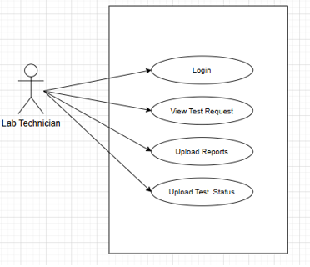
Use Case: Upload Lab Reports
Primary Actor: Lab Technician
Secondary Actor: System
Precondition: Lab Technician registered and logged in.
Postcondition: Test reports uploaded successfully.
Trigger: Login or test request received.

Main Access Scenario:
- Log in.
- View test requests.
- Upload reports and test status.
Exception Scenario:
- Invalid login.
- Network/server failure.

4. Receptionist:
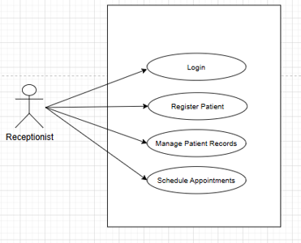

Use Case: Schedule Appointments
Primary Actor: Receptionist
Secondary Actor: System
Precondition: Receptionist is registered and logged in.
Postcondition: Patient records and appointments are updated.
Trigger: Login or managing records.

Main Access Scenario:
- Log in.
- Register new patients.
- Manage existing patient records.
- Schedule appointments.
Exception Scenario:
- Invalid login.
- Missing required information.

5. Pharmacist:
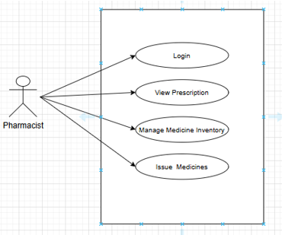
Use Case: Issue Medicines
Primary Actor: Pharmacist
Secondary Actor: System
Precondition: Pharmacist registered and logged in.
Postcondition: Medicines issued and inventory updated.
Trigger: Login or issuing medicines.

Main Access Scenario:
- Log in.
- View prescriptions.
- Manage medicine inventory.
- Issue medicines.
Exception Scenario:
- Invalid login.
- Insufficient medicine stock.

6. Admin:
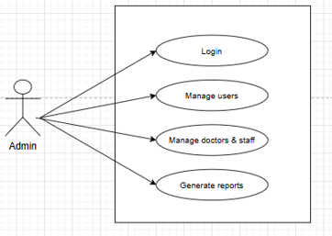
Use Case: Manage Users
Primary Actor: Admin
Secondary Actor: System
Precondition: Admin registered and logged in.
Postcondition: Users, staff, and reports managed successfully.
Trigger: Login or administrative actions.

Main Access Scenario:
- Log in.
- Manage user accounts.
- Manage doctors and staff details.
- Generate various reports.
Exception Scenario:
- Invalid login.
- System errors during management.

Operating Environment
• Client Devices: Desktop computers, laptops, tablets, and smartphones.
• Operating Systems: Windows, Linux, macOS, Android, and iOS.
• Frontend: React.js, Vite, Tailwind CSS, React Router, HTML, CSS, and JavaScript.
• Backend: Node.js and Express.js REST API services.
• Database and Services: Supabase (PostgreSQL, Authentication, and Storage).
• Web Browsers: Google Chrome, Microsoft Edge, Mozilla Firefox, and Safari.
• Internet Connection required for system access.

Design and Implementation Constraints
• The system shall be developed as a web-based application using React.js, Vite, Tailwind CSS, Node.js, Express.js, and Supabase (PostgreSQL).
• User authentication shall be implemented securely using Supabase Auth and JWT.
• The application shall provide role-based access for Administrator, Doctor, Receptionist, Pharmacist, Lab Technician, and Patient users.
• Supabase Row Level Security (RLS) policies shall protect data at the database level.
• The system shall have a simple, clean, and responsive user interface accessible through all modern web browsers.
• The database shall be designed to minimize data redundancy and ensure data consistency.
• All backend APIs shall follow RESTful standards and exchange data in JSON format.
• Patient information and uploaded files shall be stored securely and handled according to healthcare data privacy practices.
• Secret keys and credentials shall be kept in secure environment variables and never exposed in frontend code.
• The application shall provide reliable performance and be suitable for demonstration in a local development environment.

User Documentation
The following documentation shall be provided:
• User Guide.
• Administrator Manual.
• Installation and Deployment Guide.
• Online Help Documentation.
• Frequently Asked Questions (FAQ).
• Software Requirements Specification (SRS) Document.

Assumptions and Dependencies
The following assumptions and dependencies apply to this project:
Assumptions:
• Users are assumed to have basic computer knowledge.
• The hospital is assumed to have a stable internet or network connection.
• Patient information entered into the system is assumed to be accurate.
• The database is assumed to be regularly backed up and maintained.
• User accounts and roles are assumed to be assigned correctly by the Administrator.
Dependencies:
• The system depends on React.js, Vite, and Tailwind CSS for the frontend.
• The backend depends on Node.js and Express.js.
• The database, authentication, and file storage depend on Supabase (PostgreSQL).
• Authentication depends on Supabase Auth and JWT for secure user access.
• PDF reports and bills depend on a PDF generation library.

External Interface Requirements

User Interfaces
• The user interface shall have a simple, clean, and professional hospital design using white, light gray, and soft medical-red colors.
• The interface shall be responsive and usable on desktops, laptops, tablets, and smartphones.
• Each user role shall have a role-specific dashboard with a sidebar for navigation.
• The interface shall include forms, tables, status badges, and notifications for daily hospital tasks.
• Dashboards shall focus on operational information instead of statistics or analytics.
• Neon effects, excessive animations, and complex charts shall not be used.
• Validation and error messages shall be displayed clearly near the related input fields.
• Login, logout, and notification access shall be available on every page after login.

Hardware Interfaces
• The system shall not require any specialized hardware.
• Client Side: Desktop computers, laptops, tablets, or smartphones with a modern web browser and internet connection.
• Server Side: A server or cloud environment capable of running Node.js and connecting to Supabase.
• Optional Peripherals: Printers for printing prescriptions, lab reports, and bills.

Software Interfaces
• Frontend: React.js, Vite, Tailwind CSS, and React Router running in the user’s web browser.
• Backend: Node.js and Express.js REST API that receives frontend requests and applies business logic.
• Database: Supabase PostgreSQL storing profiles, appointments, medical records, prescriptions, lab reports, bills, and notifications.
• Authentication: Supabase Auth and JWT for user login and session validation.
• Storage: Supabase Storage for lab reports and other uploaded files.
• Data Exchange: JSON is used for all data exchanged between the frontend, backend, and Supabase.

Communications Interfaces
• All communication between the browser, backend, and Supabase shall use HTTP/HTTPS.
• The frontend shall communicate with the backend through REST APIs using JSON messages.
• Protected API requests shall send the JWT in the Authorization header.
• The backend shall communicate with Supabase for database, authentication, and storage services.
• Files shall be uploaded and downloaded through Supabase Storage with proper access control.
• Notifications shall be generated by the system and displayed inside the application.

System Features
The major services of the Hospital Management System are organized below by system feature. The features follow the main hospital workflow: Patient Registration → Login → Book Appointment → Receptionist Management → Doctor Consultation → Medical Record → Prescription/Lab Test → Pharmacy/Lab Processing → Report → Billing → Notification.

Authentication and User Management
4.1.1 Description and Priority
Allows users to register and log in through Supabase Auth and directs each user to the dashboard for their role. Priority: High.
4.1.2 Stimulus/Response Sequences
• User enters login credentials → System validates them and issues a JWT.
• User logs in successfully → System opens the role-specific dashboard.
• User enters invalid credentials → System displays an error message and denies access.
• User logs out → System ends the session.
4.1.3 Functional Requirements
FR-01: The system shall allow patients to register and all users to log in using their credentials.
FR-02: The system shall authenticate users through Supabase Auth and use JWT for each session.
FR-03: The system shall link each user to a profile and a role-specific record.
FR-04: The system restrict pages and API endpoints according to the user’s role.
FR-05: The system shall display an error message for invalid login details.

Patient Management
4.2.1 Description and Priority
Allows the receptionist to register and manage patients, and patients to view their own profile. Priority: High.
4.2.2 Stimulus/Response Sequences
• Receptionist submits the registration form → System validates and saves the patient record.
• User updates profile details → System saves the changes.
• Receptionist searches for a patient → System displays matching patients.
4.2.3 Functional Requirements
FR-06: The system shall allow registration of new patients with personal and contact details.
FR-07: The system shall allow authorized users to update patient information.
FR-08: The system shall allow searching of patients by name or ID.
FR-09: The system shall allow patients to view and update only their own profile.

Appointment Management
4.3.1 Description and Priority
Allows booking, rescheduling, and cancellation of appointments based on doctor availability. Priority: High.
4.3.2 Stimulus/Response Sequences
• User selects doctor, date, and time slot → System checks availability and confirms the appointment.
• User cancels or reschedules → System updates the appointment status.
• Doctor opens the appointment list → System displays scheduled appointments.
4.3.3 Functional Requirements
FR-10: The systemallow appointments to be booked only for available doctor slots.
FR-11: The system shall prevent double booking of the same slot.
FR-12: The system shall allow appointments to be rescheduled or cancelled.
FR-13: The system shall allow doctors to view their scheduled appointments.
FR-14: The system shall allow receptionists to manage doctor availability and appointment status.

Doctor Management
4.4.1 Description and Priority
Allows the administrator to manage doctor profiles and departments, and users to find doctors. Priority: Medium.
4.4.2 Stimulus/Response Sequences
• Administrator adds or updates a doctor → System saves the profile and department.
• User searches for doctors → System lists doctors by department or specialization.
4.4.3 Functional Requirements
FR-15: The system shall allow the administrator to add, update, and deactivate doctor records.
FR-16: The system shall maintain departments and link doctors to them.
FR-17: The system shall allow searching of doctors by name, department, or specialization.
FR-18: The system shall display the actual details of registered doctors from their profile records.

Prescription Management
4.5.1 Description and Priority
Allows doctors to create prescriptions that pharmacists dispense and patients view. Priority: High.
4.5.2 Stimulus/Response Sequences
• Doctor adds medicines, dosage, and duration → System saves the prescription.
• Pharmacist opens a prescription → System displays its medicine items.
• Patient opens prescriptions → System displays and allows download.
4.5.3 Functional Requirements
FR-19: The system shall allow doctors to create prescriptions with one or more medicine items.
FR-20: The system make prescriptions available to pharmacists for dispensing.
FR-21: The system shall allow patients to view and download their prescriptions.
FR-22: The system shall allow only doctors to create or modify prescriptions.

Pharmacy and Medicine Inventory
4.6.1 Description and Priority
Allows pharmacists to manage medicine stock and dispense prescribed medicines. Priority: High.
4.6.2 Stimulus/Response Sequences
• Pharmacist adds or updates medicine stock → System updates the inventory.
• Pharmacist dispenses medicines → System reduces stock and marks the prescription as dispensed.
• Stock is insufficient → System displays an error message.
4.6.3 Functional Requirements
FR-23: The system shall maintain a medicine catalog with stock quantities.
FR-24: The system shall update stock automatically when medicines are dispensed.
FR-25: The system shall prevent dispensing when stock is insufficient.
FR-26: The system shall indicate low-stock medicines to the pharmacist.

Laboratory Tests and Reports
4.7.1 Description and Priority
Allows doctors to request lab tests and lab technicians to process tests and upload reports. Priority: High.
4.7.2 Stimulus/Response Sequences
• Doctor raises a lab test request → System adds it to the technician’s queue.
• Lab technician uploads results → System stores the report and updates the test status.
• Doctor or patient opens a report → System displays or downloads it.
4.7.3 Functional Requirements
FR-27: The system shall allow doctors to request laboratory tests for patients.
FR-28: The system allow lab technicians to view requests and update test status.
FR-29: The system allow lab technicians to upload results and reports to Supabase Storage.
FR-30: The system allow doctors to view reports and patients to view only their own reports.

Admin Management
4.8.1 Description and Priority
Allows the administrator to manage users, staff, departments, medicines, and system settings. Priority: High.
4.8.2 Stimulus/Response Sequences
• Administrator creates or updates a user account → System saves the changes.
• Administrator manages departments, medicines, or settings → System updates the records.
• Administrator opens the dashboard → System displays operational information.
4.8.3 Functional Requirements
FR-32: The system shall allow the administrator to manage user accounts and roles.
FR-33: The system shall allow the administrator to manage staff details and departments.
FR-34: The system allow the adminiator to manage medicines and system settings.
FR-35: The system shall provide operational reports on appointments and users.

Other Nonfunctional Requirements

Performance Requirements
• The system shall load main pages within 3 seconds under normal network conditions.
• Common operations such as login, search, and booking shall respond within 2 seconds.
• The system shall support at least 100 concurrent users without performance degradation.
• Report, bill, and lab report downloads shall start within 5 seconds.
• Database queries shall be designed to retrieve patient, appointment, and billing data efficiently.

Safety Requirements
• Prescriptions shall be created only by authorized doctors and linked to the correct patient.
• The system shall prevent dispensing of medicines when stock is insufficient.
• Medical records, prescriptions, and lab reports shall not be deleted accidentally; critical actions shall require confirmation.
• The system shall display clear warnings and error messages for invalid or missing data.
• The database shall be backed up regularly to prevent loss of medical information.

Security Requirements
• Users shall be authenticated using Supabase Auth and JWT.
• The system shall enforce role-based authorization for all pages and API endpoints.
• Supabase Row Level Security (RLS) shall restrict database access to authorized users.
• All input data shall be validated at the backend.
• Medical information shall be protected, and patients shall access only their own records.
• Secret keys and credentials shall be stored in secure environment variables.
• Files shall be accessed only through Supabase Storage with proper access control.
• All communication shall use HTTPS.

Software Quality Attributes
• Usability: The interface shall be simple, clean, and easy for hospital staff and patients to use.
• Reliability: The system shall handle errors gracefully and keep stored data consistent.
• Availability: The system shall be available during hospital working hours.
• Maintainability: The modular architecture shall make the system easy to update and extend.
• Scalability: The system shall support additional users, departments, and modules.
• Portability: The system shall run on all modern web browsers and devices.
• Interoperability: REST APIs with JSON shall allow future integration with other systems.
• Correctness: Billing, stock, and appointment data shall be calculated and stored accurately.

Business Rules
• Administrator: manages users, staff, departments, medicines, appointments, and system settings.
• Doctor: manages appointments, patients, medical records, prescriptions, and lab requests.
• Receptionist: manages patient registration, appointments, doctor availability, and billing.
• Pharmacist: manages medicines, inventory, and prescription dispensing.
• Lab Technician: manages lab tests, results, and reports.
• Patient: manages own appointments and views own medical records, prescriptions, lab reports, and bills.
• An appointment can be booked only for an available doctor slot.
• Only doctors can create prescriptions and lab test requests.
• Medicines can be dispensed only against a prescription and only when stock is available.
• Bills shall be generated for consultation, laboratory, and pharmacy services.

Other Requirements
<Define any other requirements not covered elsewhere in the SRS. This might include database requirements, internationalization requirements, legal requirements, reuse objectives for the project, and so on. Add any new sections that are pertinent to the project.>
Appendix A: Glossary
<Define all the terms necessary to properly interpret the SRS, including acronyms and abbreviations. You may wish to build a separate glossary that spans multiple projects or the entire organization, and just include terms specific to a single project in each SRS.>
Appendix B: Analysis Models

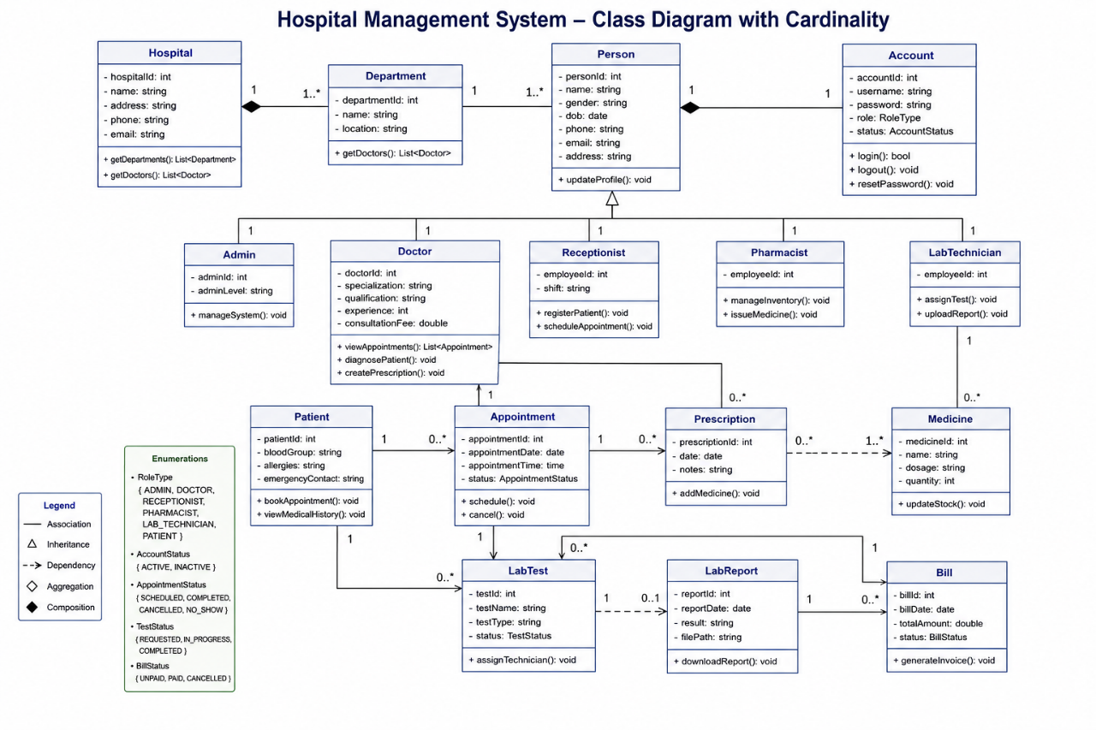
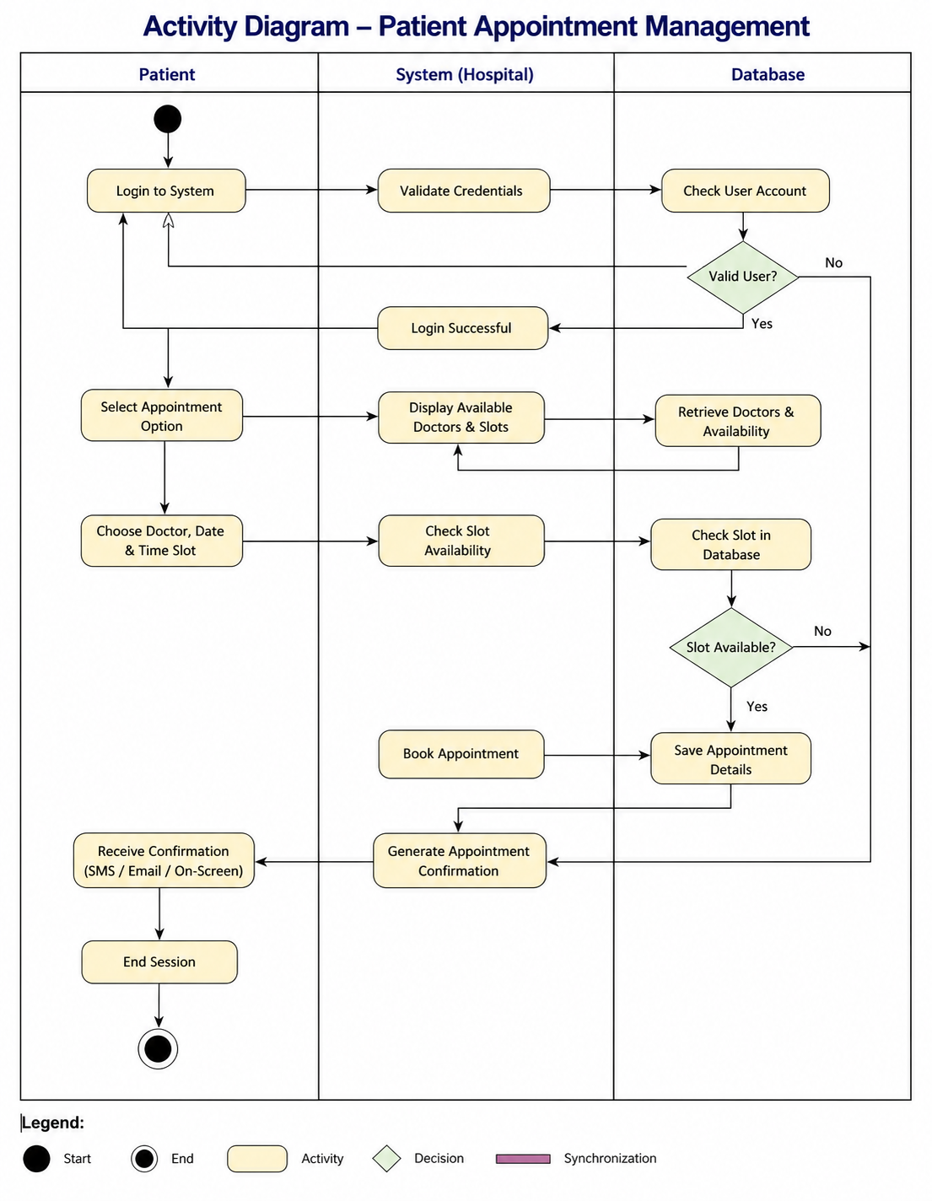

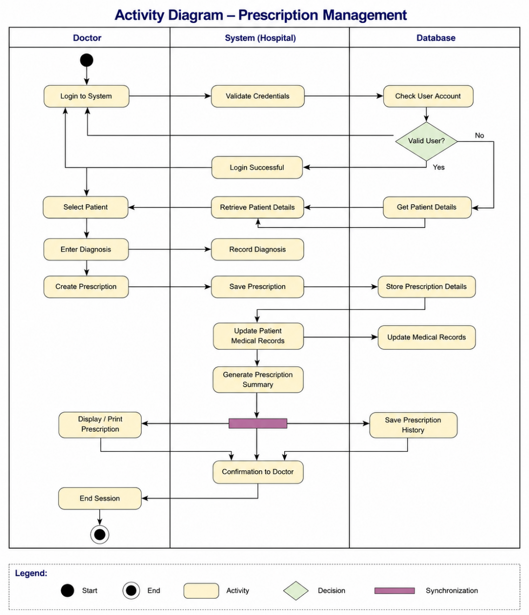

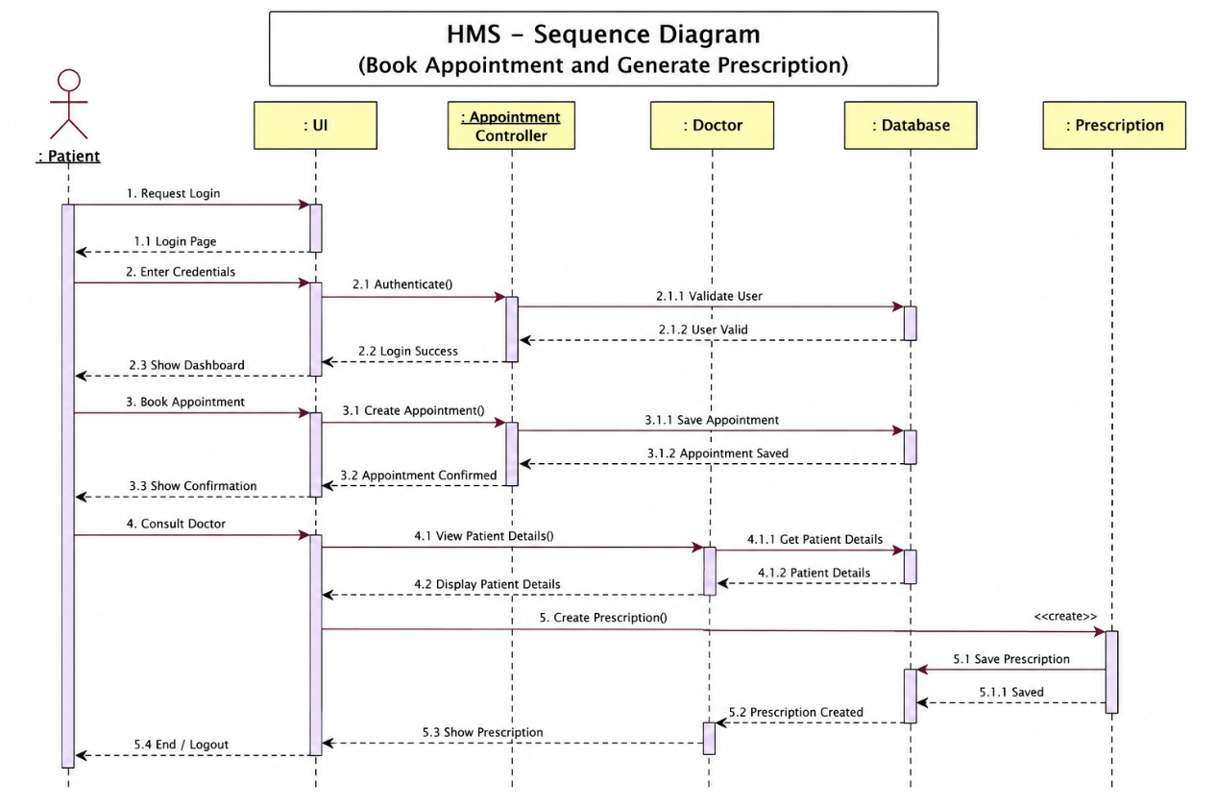

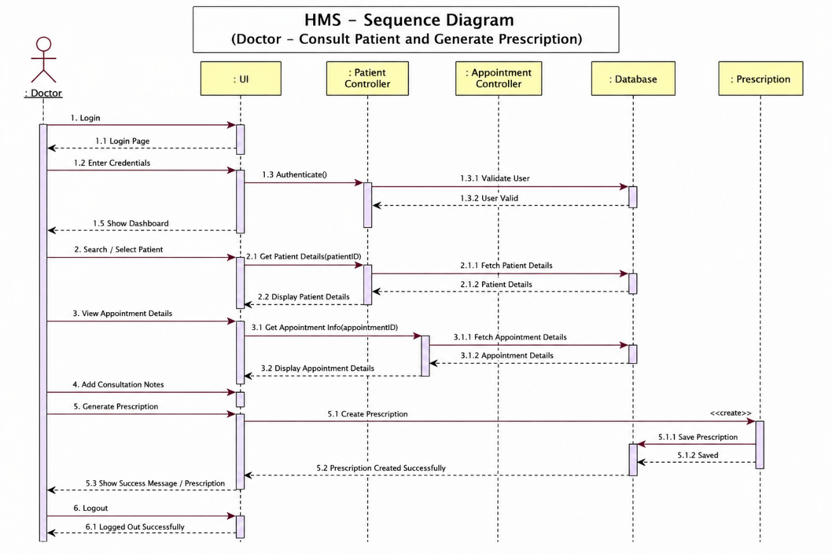

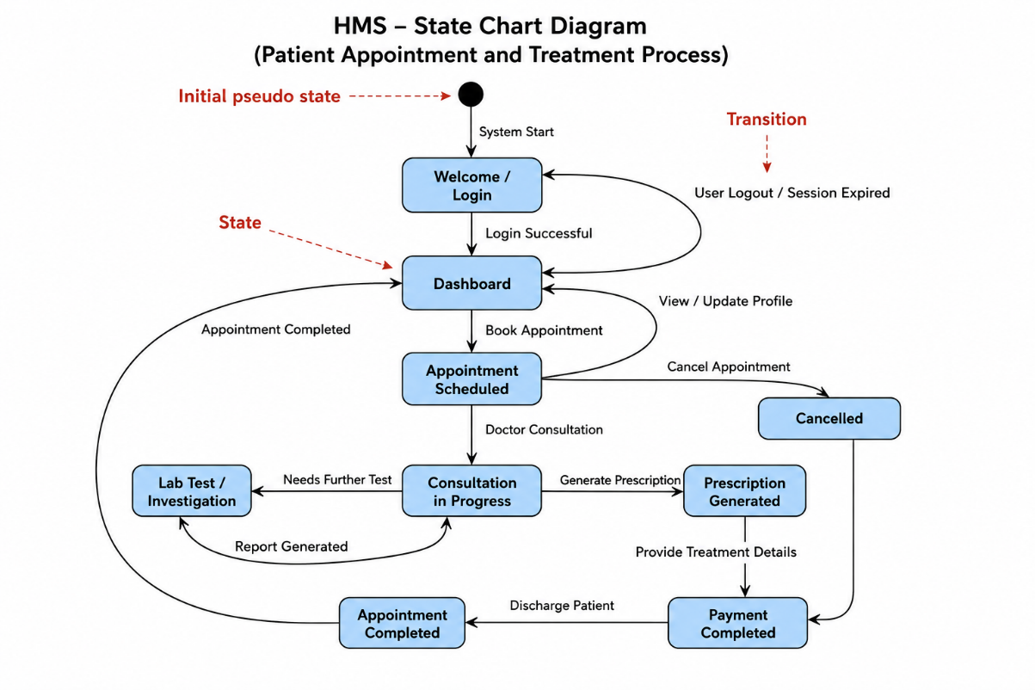

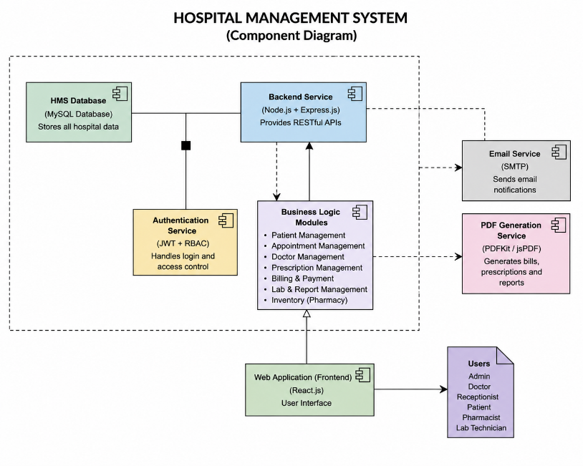

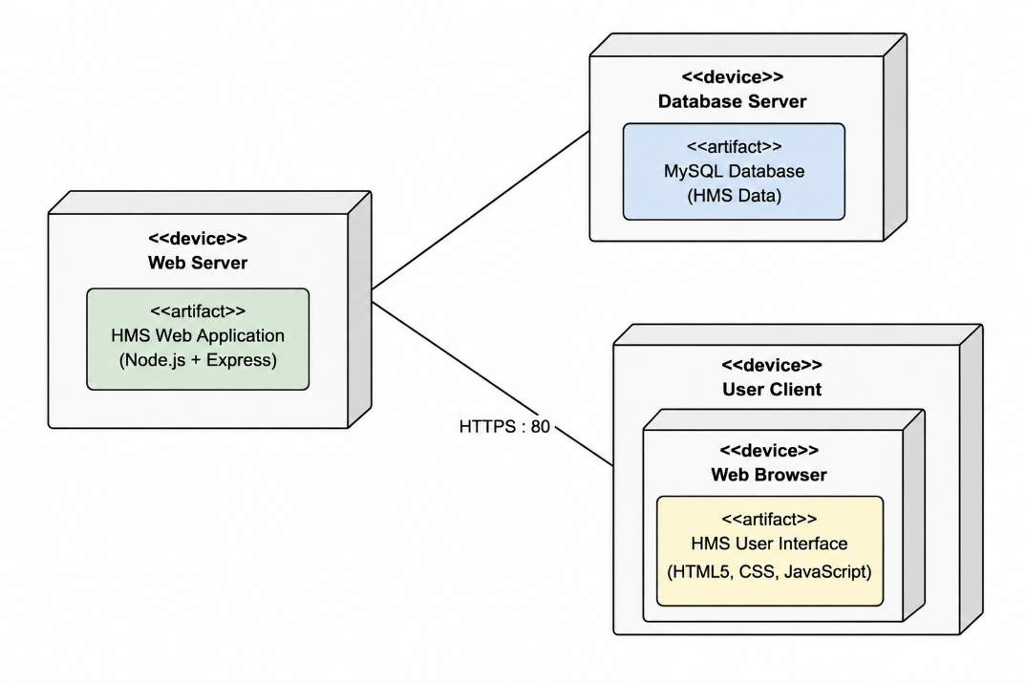
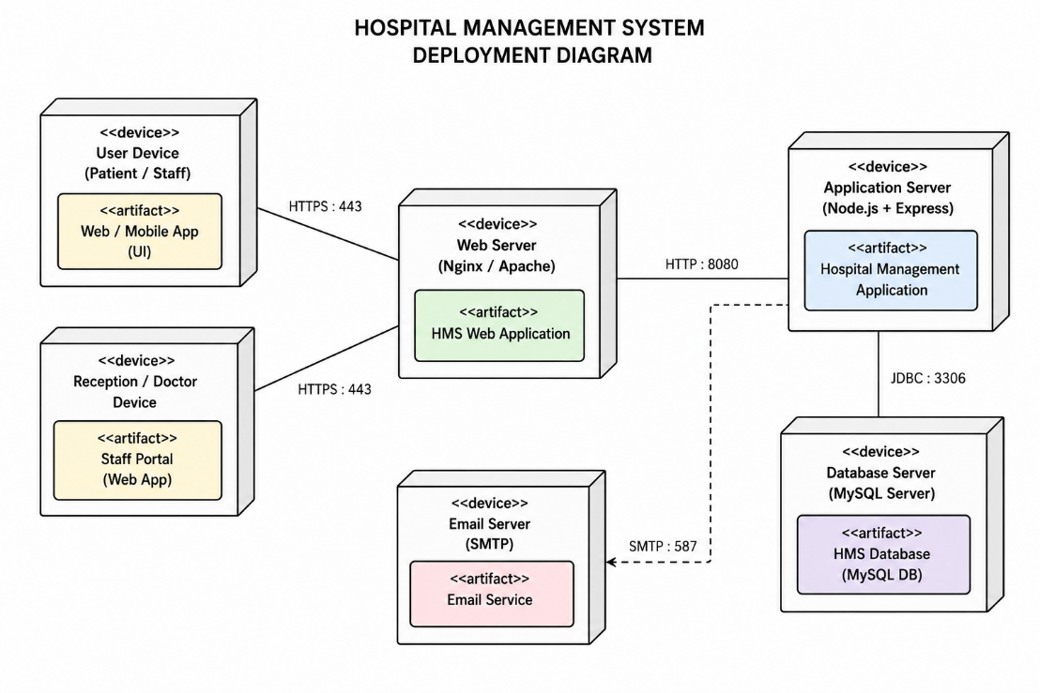

Appendix C: To Be Determined List
<Collect a numbered list of the TBD (to be determined) references that remain in the SRS so they can be tracked to closure.>

Appendix D: SOURCE CODE:

Demonstration:
Code:
src/context/HospitalContext.jsx (Central Hospital State Management, Auth Context & CRUD Actions)
import React, { createContext, useContext, useState, useEffect, useCallback } from 'react';
import {
INITIAL_USERS, INITIAL_DEPARTMENTS, INITIAL_PATIENTS, INITIAL_APPOINTMENTS,
INITIAL_PRESCRIPTIONS, INITIAL_MEDICINES, INITIAL_LAB_TESTS, INITIAL_LAB_REPORTS,
INITIAL_BILLS, INITIAL_MEDICAL_HISTORY, INITIAL_NOTIFICATIONS, INITIAL_SETTINGS,
INITIAL_ACTIVITY_LOGS
} from '../mockData'; import {
authService, departmentService, doctorService, patientService, appointmentService, prescriptionService, medicineService,
labService,
billingService, settingsService
} from '../services/apiServices';
const HospitalContext = createContext(null); const getStored = (key, fallback) => {
try {
const item = localStorage.getItem(`carepoint_${key}`); return item ? JSON.parse(item) : fallback;
} catch (e) {
return fallback;
}
};

const ROLE_DEFAULT_EMAILS = {
Administrator: 'admin@carepoint.com', Doctor: 'doctor@carepoint.com', Receptionist: 'reception@carepoint.com', Pharmacist: 'pharmacy@carepoint.com', 'Lab Technician': 'lab@carepoint.com', Patient: 'patient@carepoint.com'
};

export const HospitalProvider = ({ children }) => {
const [settings, setSettings] = useState(() => getStored('settings', INITIAL_SETTINGS));
const [users, setUsers] = useState(() => getStored('users',
INITIAL_USERS));
const [departments, setDepartments] = useState(() => getStored('departments', INITIAL_DEPARTMENTS));
const [patients, setPatients] = useState(() => getStored('patients',
INITIAL_PATIENTS));
const [appointments, setAppointments] = useState(() => getStored('appointments', INITIAL_APPOINTMENTS));
const [prescriptions, setPrescriptions] = useState(() => getStored('prescriptions', INITIAL_PRESCRIPTIONS));
const [medicines, setMedicines] = useState(() => getStored('medicines', INITIAL_MEDICINES));
const [labTests, setLabTests] = useState(() => getStored('labTests', INITIAL_LAB_TESTS));
const [labReports, setLabReports] = useState(() => getStored('labReports', INITIAL_LAB_REPORTS));
const [bills, setBills] = useState(() => getStored('bills', INITIAL_BILLS));
const [medicalHistory, setMedicalHistory] = useState(() =>
getStored('medicalHistory', INITIAL_MEDICAL_HISTORY)); const [notifications, setNotifications] = useState(() =>
getStored('notifications', INITIAL_NOTIFICATIONS)); const [activityLogs, setActivityLogs] = useState(() =>
getStored('activityLogs', INITIAL_ACTIVITY_LOGS));
const [isBackendConnected, setIsBackendConnected] = useState(false);

// Authenticated user state
const [currentUser, setCurrentUser] = useState(() => { const saved = getStored('currentUser', null); return saved || INITIAL_USERS[0];
});

// Local storage persistence
useEffect(() => { localStorage.setItem('carepoint_settings', JSON.stringify(settings)); }, [settings]);
useEffect(() => { localStorage.setItem('carepoint_users', JSON.stringify(users)); }, [users]);

useEffect(() => { localStorage.setItem('carepoint_departments', JSON.stringify(departments)); }, [departments]);
useEffect(() => { localStorage.setItem('carepoint_patients', JSON.stringify(patients)); }, [patients]);
useEffect(() => { localStorage.setItem('carepoint_appointments', JSON.stringify(appointments)); }, [appointments]);
useEffect(() => { localStorage.setItem('carepoint_prescriptions', JSON.stringify(prescriptions)); }, [prescriptions]);
useEffect(() => { localStorage.setItem('carepoint_medicines', JSON.stringify(medicines)); }, [medicines]);
useEffect(() => { localStorage.setItem('carepoint_labTests',
JSON.stringify(labTests)); }, [labTests]);
useEffect(() => { localStorage.setItem('carepoint_labReports', JSON.stringify(labReports)); }, [labReports]);
useEffect(() => { localStorage.setItem('carepoint_bills',
JSON.stringify(bills)); }, [bills]);
useEffect(() => { localStorage.setItem('carepoint_currentUser', JSON.stringify(currentUser)); }, [currentUser]);

// Synchronize with backend API
const refreshBackendData = useCallback(async () => { try {
const [deptsRes, patientsRes, apptsRes, rxRes, medsRes, testsRes, billsRes] = await Promise.allSettled([
departmentService.getDepartments(), patientService.getPatients(), appointmentService.getAppointments(), prescriptionService.getPrescriptions(), medicineService.getMedicines(), labService.getLabTests(), billingService.getBills()
]);
if (deptsRes.status === 'fulfilled' && Array.isArray(deptsRes.value)) setDepartments(deptsRes.value);
if (patientsRes.status === 'fulfilled' && Array.isArray(patientsRes.value)) setPatients(patientsRes.value);
if (apptsRes.status === 'fulfilled' && Array.isArray(apptsRes.value)) setAppointments(apptsRes.value);
if (rxRes.status === 'fulfilled' && Array.isArray(rxRes.value)) setPrescriptions(rxRes.value);
if (medsRes.status === 'fulfilled' && Array.isArray(medsRes.value)) setMedicines(medsRes.value);
if (testsRes.status === 'fulfilled' &&
Array.isArray(testsRes.value)) setLabTests(testsRes.value); if (billsRes.status === 'fulfilled' &&
Array.isArray(billsRes.value)) setBills(billsRes.value); setIsBackendConnected(true);
} catch (err) {
console.warn('Backend sync in background:', err.message);
}
}, []);

useEffect(() => { refreshBackendData(); }, [refreshBackendData]);

// Auth Actions
const login = async (role, customUser = null) => {
if (customUser) { setCurrentUser(customUser); return customUser; } const email = ROLE_DEFAULT_EMAILS[role] ||
`${role.toLowerCase().replace(/\s+/g, '')}@carepoint.com`; try {
const loginRes = await authService.login(email, 'password123',
role);
if (loginRes?.user) {
const userObj = { ...loginRes.user, name: loginRes.user.fullName, avatar: loginRes.user.avatarUrl };
setCurrentUser(userObj); refreshBackendData(); return userObj;
}
} catch (e) {
console.warn('Local fallback for login:', e.message);
}
const user = users.find(u => u.role === role) || { id: 'USR-' + Math.floor(100 + Math.random() * 900), name: `Demo ${role}`, email, role, status: 'Active'
};
setCurrentUser(user); return user;
};

const logout = async () => {
try { await authService.logout(); } catch (e) {} setCurrentUser(null);
};

// Patient Registration & Management
const addPatient = async (patientData) => {
const newId = 'PAT-' + (1000 + patients.length + 1); const newPatient = {
...patientData, id: newId, patientCode: newId, status: 'Active', registeredDate: new Date().toISOString().split('T')[0],
lastVisit: 'Never'
};
setPatients(prev => [newPatient, ...prev]); patientService.createPatient(patientData).catch(() => {}); return newPatient;
};

// Appointment Actions
const addAppointment = async (apptData) => {
const newId = 'APT-' + (100 + appointments.length + 1);
const newAppt = { ...apptData, id: newId, appointmentCode: newId, status: 'Scheduled', createdAt: new Date().toISOString() };
setAppointments(prev => [newAppt, ...prev]); appointmentService.createAppointment(apptData).catch(() => {}); return newAppt;
};

const updateAppointmentStatus = async (id, status) => { setAppointments(prev => prev.map(a => a.id === id ? { ...a, status
} : a));
appointmentService.updateStatus(id, status).catch(() => {});
};

// Prescription & Pharmacy Dispensation const addPrescription = async (rxData) => {
const newId = 'RX-' + (1000 + prescriptions.length + 1); const newRx = { ...rxData, id: newId, prescriptionCode: newId,
status: 'Pending', date: new Date().toISOString().split('T')[0] }; setPrescriptions(prev => [newRx, ...prev]); prescriptionService.createPrescription(rxData).catch(() => {}); return newRx;
};

const dispensePrescription = async (id) => { const rx = prescriptions.find(p => p.id === id); if (!rx) return;
setPrescriptions(prev => prev.map(p => p.id === id ? { ...p, status: 'Dispensed' } : p));
if (rx.medicinesList) { rx.medicinesList.forEach(item => {
setMedicines(prev => prev.map(med => {
if (med.name.toLowerCase() === item.name.toLowerCase() || med.id === item.id) {
const updatedStock = Math.max(0, med.stock -
(item.quantity || 1));
return { ...med, stock: updatedStock, status: updatedStock
<= med.minThreshold ? 'Low Stock' : 'Available' };
}
return med;
}));
});
}
prescriptionService.dispense(id).catch(() => {});
};

// Billing Actions
const createBill = async (billData) => {
const newId = 'INV-' + (1000 + bills.length + 1);
const newBill = { ...billData, id: newId, invoiceNo: newId, status: 'Unpaid', date: new Date().toISOString().split('T')[0] };
setBills(prev => [newBill, ...prev]); billingService.createBill(billData).catch(() => {}); return newBill;
};

const markBillPaid = async (id, paymentMethod = 'Credit Card') => { setBills(prev => prev.map(b => b.id === id ? { ...b, status:
'Paid', paymentMethod, paidDate: new Date().toISOString().split('T')
[0] } : b));
billingService.updateStatus(id, 'Paid').catch(() => {});
};

return (
<HospitalContext.Provider value={{
currentUser, settings, users, departments, patients, appointments,
prescriptions, medicines, labTests, labReports, bills, medicalHistory,
notifications, activityLogs, isBackendConnected, login, logout,

addPatient, addAppointment, updateAppointmentStatus, addPrescription,
dispensePrescription, createBill, markBillPaid, refreshBackendData
}}>
{children}
</HospitalContext.Provider>
);
};

export const useHospital = () => {
const context = useContext(HospitalContext);
if (!context) throw new Error('useHospital must be used within HospitalProvider');
return context;
};

src/services/apiServices.js (Centralized REST API Client & Interceptors Layer)
import axios from 'axios';

const API_BASE_URL = import.meta.env.VITE_API_URL || 'http://localhost:5000/api';
export const apiClient = axios.create({ baseURL: API_BASE_URL,
timeout: 15000,
headers: { 'Content-Type': 'application/json' }
});

// Attach Supabase/JWT authentication token & user headers apiClient.interceptors.request.use(
(config) => {
const token = localStorage.getItem('carepoint_token');
const userRole = localStorage.getItem('carepoint_user_role'); const userEmail = localStorage.getItem('carepoint_user_email'); if (token) config.headers.Authorization = `Bearer ${token}`; if (userRole) config.headers['x-user-role'] = userRole;
if (userEmail) config.headers['x-user-email'] = userEmail; return config;
},
(error) => Promise.reject(error)
);

// Response interceptor for unwrapping standardized API envelope apiClient.interceptors.response.use(
(response) => {
if (response.data && response.data.data !== undefined) return response.data.data;
return response.data;
},
(error) => {
const message = error.response?.data?.message || error.message || 'API request failed';
console.warn(`[HMS API Error] ${error.config?.url}:`, message); return Promise.reject(error);
}
);

// 1. Authentication Services export const authService = {
login: async (email, password, role) => {
const data = await apiClient.post('/auth/login', { email, password, role });
if (data?.token || data?.session?.accessToken) { localStorage.setItem('carepoint_token', data.token ||
data.session.accessToken);
if (data.user?.role) localStorage.setItem('carepoint_user_role', data.user.role);
if (data.user?.email)
localStorage.setItem('carepoint_user_email', data.user.email);
}
return data;
},
getMe: async () => apiClient.get('/auth/me'), getProfile: async () => apiClient.get('/auth/profile'), registerPatient: async (patientData) =>
apiClient.post('/auth/register', patientData), logout: async () => {
try { await apiClient.post('/auth/logout'); } finally { localStorage.removeItem('carepoint_token'); localStorage.removeItem('carepoint_user_role'); localStorage.removeItem('carepoint_user_email');
}
}

};

// 2. Department Services
export const departmentService = {
getDepartments: async () => apiClient.get('/departments'), getById: async (id) => apiClient.get(`/departments/${id}`), createDepartment: async (data) => apiClient.post('/departments',
data)
};

<Router>
<Routes>
{/* Public Landing & Marketing */}
<Route path="/" element={<PublicLandingPage />} />
<Route path="/departments" element={<PublicLandingPage />}
/>
<Route path="/doctors" element={<PublicLandingPage />} />
<Route path="/services" element={<PublicLandingPage />} />
<Route path="/contact" element={<PublicLandingPage />} />

// 3. Patient Services
export const patientService = {
getPatients: async () => apiClient.get('/patients'), getById: async (id) => apiClient.get(`/patients/${id}`),
createPatient: async (data) => apiClient.post('/patients', data),
updatePatient: async (id, data) => apiClient.put(`/patients/${id}`, data)
};

// 4. Appointment Services

/>} />

/>} />

{/* Authentication Pages */}
<Route path="/login" element={<LoginPage />} />
<Route path="/register" element={<RegisterPage />} />
<Route path="/forgot-password" element={<ForgotPasswordPage

<Route path="/reset-password" element={<ResetPasswordPage

{/* Patient Portal Routes */}
<Route path="/patient" element={<PatientPortal

export const appointmentService = { getAppointments: async (filter = {}) =>
apiClient.get('/appointments', { params: filter }),
getById: async (id) => apiClient.get(`/appointments/${id}`), createAppointment: async (data) => apiClient.post('/appointments',
data),
updateStatus: async (id, status) => apiClient.patch(`/appointments/${id}/status`, { status }),
reschedule: async (id, date, time) =>
apiClient.patch(`/appointments/${id}/reschedule`, { date, time }), cancel: async (id, reason) =>
apiClient.post(`/appointments/${id}/cancel`, { reason })
};

// 5. Prescription Services
export const prescriptionService = {
getPrescriptions: async () => apiClient.get('/prescriptions'), createPrescription: async (data) => apiClient.post('/prescriptions',
data),
dispense: async (id) => apiClient.post(`/prescriptions/${id}/dispense`)
};

// 6. Medicine & Pharmacy Inventory export const medicineService = {
getMedicines: async () => apiClient.get('/medicines'), createMedicine: async (data) => apiClient.post('/medicines', data), updateStock: async (id, stock) =>
apiClient.patch(`/medicines/${id}/stock`, { stock })
};

// 7. Lab Diagnostic Services export const labService = {
getLabTests: async () => apiClient.get('/lab/tests'),
requestTest: async (data) => apiClient.post('/lab/tests', data), getLabReports: async () => apiClient.get('/lab/reports')
};

// 8. Billing Services
export const billingService = {
getBills: async () => apiClient.get('/billing'),
createBill: async (data) => apiClient.post('/billing', data), updateStatus: async (id, status) =>
apiClient.patch(`/billing/${id}/status`, { status })
};
src/App.jsx (Application Routing, Multi-Role Portal Navigation & Layout Shell)
import React from 'react';
import { BrowserRouter as Router, Routes, Route, Navigate } from 'react-router-dom';
import { HospitalProvider } from './context/HospitalContext'; import { PublicLandingPage } from './pages/PublicPages'; import { LoginPage, RegisterPage, ForgotPasswordPage, ResetPasswordPage } from './pages/AuthPages';
import { PatientPortal } from './pages/PatientPortal'; import { DoctorPortal } from './pages/DoctorPortal';
import { ReceptionistPortal } from './pages/ReceptionistPortal'; import { PharmacistPortal } from './pages/PharmacistPortal'; import { LabTechnicianPortal } from './pages/LabTechnicianPortal'; import { AdminPortal } from './pages/AdminPortal';

export function App() { return (
<HospitalProvider>

view="dashboard" />} />
<Route path="/patient/book" element={<PatientPortal view="book" />} />
<Route path="/patient/appointments" element={<PatientPortal view="appointments" />} />
<Route path="/patient/history" element={<PatientPortal
view="history" />} />
<Route path="/patient/prescriptions" element={<PatientPortal view="prescriptions" />} />
<Route path="/patient/lab-reports" element={<PatientPortal view="lab-reports" />} />
<Route path="/patient/bills" element={<PatientPortal view="bills" />} />

{/* Doctor Portal Routes */}
<Route path="/doctor" element={<DoctorPortal view="dashboard" />} />
<Route path="/doctor/appointments" element={<DoctorPortal view="appointments" />} />
<Route path="/doctor/patients" element={<DoctorPortal
view="patients" />} />
<Route path="/doctor/records" element={<DoctorPortal view="records" />} />
<Route path="/doctor/prescriptions" element={<DoctorPortal view="prescriptions" />} />
<Route path="/doctor/lab-tests" element={<DoctorPortal view="lab-tests" />} />

{/* Receptionist Portal Routes */}
<Route path="/receptionist" element={<ReceptionistPortal view="dashboard" />} />
<Route path="/receptionist/register" element=
{<ReceptionistPortal view="register" />} />
<Route path="/receptionist/appointments" element=
{<ReceptionistPortal view="appointments" />} />
<Route path="/receptionist/billing" element=
{<ReceptionistPortal view="billing" />} />

{/* Pharmacist Portal Routes */}
<Route path="/pharmacist" element={<PharmacistPortal view="dashboard" />} />
<Route path="/pharmacist/prescriptions" element=
{<PharmacistPortal view="prescriptions" />} />
<Route path="/pharmacist/inventory" element=
{<PharmacistPortal view="inventory" />} />
<Route path="/pharmacist/dispense" element=
{<PharmacistPortal view="dispense" />} />

{/* Lab Technician & Admin Portals */}
<Route path="/lab" element={<LabTechnicianPortal view="dashboard" />} />
<Route path="/lab/tests" element={<LabTechnicianPortal
view="tests" />} />
<Route path="/lab/reports" element={<LabTechnicianPortal view="reports" />} />
<Route path="/admin" element={<AdminPortal view="dashboard"
/>} />
<Route path="/admin/users" element={<AdminPortal view="users" />} />
<Route path="/admin/departments" element={<AdminPortal view="departments" />} />
<Route path="/admin/billing" element={<AdminPortal
view="billing" />} />

{/* Fallback */}

<Route path="*" element={<Navigate to="/" replace />} />
</Routes>
</Router>
</HospitalProvider>
);
}

export default App;
src/pages/DoctorPortal.jsx (Doctor Clinical Workspace, OPD Consultations & E-Prescriptions)
import React, { useState } from 'react';
import { useHospital } from '../context/HospitalContext';
import { DashboardLayout, PageHeader, DataTable, StatusBadge, Modal } from '../components/CommonComponents';
import { Calendar, Users, FileText, Pill, FlaskConical, Stethoscope, Clock, CheckCircle2, Plus } from 'lucide-react';

export const DoctorPortal = ({ view = 'dashboard' }) => { const {
currentUser, patients, appointments, updateAppointmentStatus, prescriptions, addPrescription, labTests, requestLabTest,
medicines
} = useHospital();

const currentDocName = currentUser?.name || 'Dr. Sarah Jenkins'; const docAppointments = appointments.filter(a =>
a.doctorName?.toLowerCase().includes(currentDocName.toLowerCase()) ||
a.doctorId === currentUser?.id);
const [activeModal, setActiveModal] = useState(null); const [selectedRecord, setSelectedRecord] = useState(null);

// Consultation & Vitals Form State
const [consultForm, setConsultForm] = useState({ patientId: 'PAT-1001', patientName: 'Johnathan Doe',
appointmentId: '',
diagnosis: '', notes: '', bp: '120/80 mmHg', pulse: '72 bpm', weight: '70 kg',
temperature: '98.6 °F', prescribeNow: false, orderLabNow: false
});

// E-Prescription State
const [rxForm, setRxForm] = useState({
patientId: 'PAT-1001', patientName: 'Johnathan Doe', diagnosis:
'',
instructions: 'Take medications as prescribed after meals. Hydrate well.',
medicinesList: [
{ id: 'MED-101', name: 'Amlodipine 5mg', dosage: '5mg', frequency: 'Once daily (Morning)', duration: '30 Days', quantity: 30 }
]
});

const handleStartConsultation = (appt) => { setSelectedRecord(appt); setConsultForm({
patientId: appt.patientId, patientName: appt.patientName, appointmentId: appt.id,
diagnosis: '', notes: '', bp: '120/80 mmHg', pulse: '74 bpm', weight: '72 kg',
temperature: '98.4 °F', prescribeNow: false, orderLabNow: false
});
setActiveModal('consultation');
};

const handleSaveConsultation = (e) => { e.preventDefault();
if (selectedRecord) { updateAppointmentStatus(selectedRecord.id, 'Completed');
}
if (consultForm.prescribeNow) { addPrescription({
patientId: consultForm.patientId, patientName: consultForm.patientName,
doctorId: currentUser?.id || 'USR-002', doctorName: currentDocName,
diagnosis: consultForm.diagnosis, instructions:
rxForm.instructions,
medicinesList: rxForm.medicinesList
});
}
setActiveModal(null);
};

const handleAddMedicineRow = () => {

setRxForm({
...rxForm, medicinesList: [
...rxForm.medicinesList,
{ id: 'MED-' + Date.now().toString().slice(-3), name: medicines[0]?.name || 'Amoxicillin 500mg', dosage: '500mg', frequency: 'Twice daily', duration: '5 Days', quantity: 10 }
]
});
};

return (
<DashboardLayout title="Doctor Clinical Workstation">
<PageHeader
title={`Dr. Workspace - ${currentDocName}`} subtitle="Manage daily OPD appointments, record clinical
consultations, and issue e-prescriptions"
/>

<div className="grid grid-cols-1 lg:grid-cols-3 gap-6 mb-8">
<div className="bg-white p-5 rounded-xl border border-slate-200 shadow-xs">
<div className="flex items-center gap-3">
<div className="p-3 bg-blue-50 text-blue-600 rounded-lg">
<Calendar className="w-6 h-6" /></div>
<div>
<p className="text-xs font-semibold text-slate-500 uppercase">Today's Schedule</p>
<h3 className="text-2xl font-bold text-slate-900">
{docAppointments.length} Patients</h3>
</div>
</div>
</div>
<div className="bg-white p-5 rounded-xl border border-slate-200 shadow-xs">
<div className="flex items-center gap-3">
<div className="p-3 bg-emerald-50 text-emerald-600 rounded-lg"><CheckCircle2 className="w-6 h-6" /></div>
<div>
<p className="text-xs font-semibold text-slate-500 uppercase">Completed Consults</p>
<h3 className="text-2xl font-bold text-slate-900">
{docAppointments.filter(a => a.status === 'Completed').length} Consults</h3>
</div>
</div>
</div>
<div className="bg-white p-5 rounded-xl border border-slate-200 shadow-xs">
<div className="flex items-center gap-3">
<div className="p-3 bg-purple-50 text-purple-600 rounded-lg"><Pill className="w-6 h-6" /></div>
<div>
<p className="text-xs font-semibold text-slate-500 uppercase">Prescriptions Issued</p>
<h3 className="text-2xl font-bold text-slate-900">
{prescriptions.length} Records</h3>
</div>
</div>
</div>
</div>

{/* OPD Appointments Queue */}
<div className="bg-white rounded-xl border border-slate-200 shadow-xs overflow-hidden">
<div className="p-4 border-b border-slate-100 flex justify-between items-center">
<h2 className="text-sm font-bold text-slate-900">OPD Patient
Queue & Consultations</h2>
</div>
<DataTable columns={[
{ header: 'Patient', accessor: 'patientName' },
{ header: 'Time Slot', accessor: 'time' },
{ header: 'Reason', accessor: 'reason' },
{ header: 'Status', accessor: (row) => <StatusBadge status={row.status} /> },
{
header: 'Actions', accessor: (row) => (
<button
onClick={() => handleStartConsultation(row)} className="px-3 py-1.5 bg-rose-600 hover:bg-rose-700
text-white rounded-lg text-xs font-semibold"
>

Consult Patient
</button>
)
}
]}
data={docAppointments}
/>
</div>

{/* Consultation & Vitals Modal */}
{activeModal === 'consultation' && (
<Modal title={`Clinical Consultation -
${consultForm.patientName}`} onClose={() => setActiveModal(null)}>
<form onSubmit={handleSaveConsultation} className="space-y-
4">
<div className="grid grid-cols-2 sm:grid-cols-4 gap-3 bg-slate-50 p-3 rounded-lg border border-slate-200">
<div><label className="text-[11px] font-semibold text-
slate-600">BP</label><input value={consultForm.bp} onChange={e => setConsultForm({...consultForm, bp: e.target.value})} className="w-full text-xs p-1.5 border rounded" /></div>
<div><label className="text-[11px] font-semibold text-slate-600">Pulse</label><input value={consultForm.pulse} onChange={e
=> setConsultForm({...consultForm, pulse: e.target.value})} className="w-full text-xs p-1.5 border rounded" /></div>
<div><label className="text-[11px] font-semibold text-
slate-600">Weight</label><input value={consultForm.weight} onChange={e
=> setConsultForm({...consultForm, weight: e.target.value})} className="w-full text-xs p-1.5 border rounded" /></div>
<div><label className="text-[11px] font-semibold text-slate-600">Temp</label><input value={consultForm.temperature} onChange={e => setConsultForm({...consultForm, temperature: e.target.value})} className="w-full text-xs p-1.5 border rounded" />
</div>

</div>
))}
</div>
)}
<div className="flex justify-end gap-2 pt-2">
<button type="button" onClick={() => setActiveModal(null)} className="px-4 py-2 border rounded-lg text-xs">Cancel</button>
<button type="submit" className="px-4 py-2 bg-rose-600 text-white rounded-lg text-xs font-semibold">Complete Consultation</button>
</div>
</form>
</Modal>
)}
</DashboardLayout>
);
};
src/pages/PatientPortal.jsx (Patient Self-Service Dashboard, Appointments & Lab Results)
import React, { useState } from 'react';
import { useHospital } from '../context/HospitalContext';
import { DashboardLayout, PageHeader, DataTable, StatusBadge, Modal } from '../components/CommonComponents';
import { Calendar, CalendarPlus, Pill, FlaskConical, Receipt, Clock, CheckCircle2, ArrowRight } from 'lucide-react';
export const PatientPortal = ({ view = 'dashboard' }) => { const {
currentUser, patients, appointments, addAppointment,
prescriptions, labReports, bills, markBillPaid, departments, users
} = useHospital();

</div>
<div>
<label className="text-xs font-semibold text-slate-700">Clinical Diagnosis</label>
<input required value={consultForm.diagnosis} onChange=
{e => setConsultForm({...consultForm, diagnosis: e.target.value})} placeholder="e.g. Essential Hypertension Grade I" className="w-full text-xs p-2 border rounded-lg mt-1" />
</div>
<div>
<label className="text-xs font-semibold text-slate-700">Clinical Examination & Doctor Notes</label>
<textarea value={consultForm.notes} onChange={e =>
setConsultForm({...consultForm, notes: e.target.value})} rows={3} placeholder="Observations, symptoms, and dietary recommendations..." className="w-full text-xs p-2 border rounded-lg mt-1" />
</div>
<div className="flex items-center gap-2">
<input type="checkbox" id="rxCheck" checked=
{consultForm.prescribeNow} onChange={e => setConsultForm({...consultForm, prescribeNow: e.target.checked})} />
<label htmlFor="rxCheck" className="text-xs font-semibold text-slate-700">Issue Electronic Prescription (E-Rx)</label>
</div>
{consultForm.prescribeNow && (
<div className="p-3 bg-slate-50 border rounded-lg space-
y-2">
<div className="flex justify-between items-center">
<span className="text-xs font-bold text-slate-800">Prescription Medications</span>
<button type="button" onClick={handleAddMedicineRow}
className="text-xs text-rose-600 font-semibold">+ Add Drug</button>
</div>
{rxForm.medicinesList.map((m, idx) => (
<div key={idx} className="grid grid-cols-4 gap-2">
<input value={m.name} onChange={e => { const list
= [...rxForm.medicinesList]; list[idx].name = e.target.value; setRxForm({...rxForm, medicinesList: list}); }} className="text-xs p-
1.5 border rounded" />
<input value={m.dosage} onChange={e => { const list = [...rxForm.medicinesList]; list[idx].dosage = e.target.value; setRxForm({...rxForm, medicinesList: list}); }} className="text-xs p-
1.5 border rounded" />
<input value={m.frequency} onChange={e => { const list = [...rxForm.medicinesList]; list[idx].frequency = e.target.value; setRxForm({...rxForm, medicinesList: list}); }} className="text-xs p-1.5 border rounded" />
<input value={m.duration} onChange={e => { const list = [...rxForm.medicinesList]; list[idx].duration = e.target.value; setRxForm({...rxForm, medicinesList: list}); }} className="text-xs p-
1.5 border rounded" />

const currentPatId = currentUser?.patientId || 'PAT-1001'; const patientData = patients.find(p => p.id === currentPatId) ||
patients[0] || {};
const myAppointments = appointments.filter(a => a.patientId === currentPatId || a.patientName === patientData.name);
const myPrescriptions = prescriptions.filter(p => p.patientId === currentPatId || p.patientName === patientData.name);
const myBills = bills.filter(b => b.patientId === currentPatId ||
b.patientName === patientData.name);

const [bookingForm, setBookingForm] = useState({
department: 'Cardiology', doctorId: 'USR-002', doctorName: 'Dr.
Sarah Jenkins',
date: new Date(Date.now() + 86400000).toISOString().split('T')[0], time: '10:00 AM', reason: '', type: 'Regular Consultation'
});
const [bookingSuccess, setBookingSuccess] = useState(false); const [activeModal, setActiveModal] = useState(null);
const [selectedBill, setSelectedBill] = useState(null);

const handleBookSubmit = (e) => { e.preventDefault(); addAppointment({
...bookingForm, patientId: currentPatId, patientName: patientData.name || patientData.fullName
});
setBookingSuccess(true);
setTimeout(() => { setBookingSuccess(false); }, 3000);
};

const handlePayBill = (bill) => { setSelectedBill(bill); setActiveModal('payBill');
};

const confirmBillPayment = () => { if (selectedBill) {
markBillPaid(selectedBill.id, 'Credit Card'); setActiveModal(null);
}
};

return (
<DashboardLayout title="Patient Self-Service Portal">
<PageHeader
title={`Welcome, ${patientData.name || currentUser?.name}`} subtitle={`Patient ID: ${currentPatId} | Blood Group:
${patientData.bloodGroup || 'O+'} | Status: Active`}
/>

<div className="grid grid-cols-1 md:grid-cols-4 gap-4 mb-6">

200">

<div className="bg-white p-4 rounded-xl border border-slate-

<p className="text-xs text-slate-500 font-semibold">Upcoming

white"

className="w-full text-xs p-2.5 border rounded-lg bg-

>

Visits</p>
<h4 className="text-xl font-bold text-slate-900">
{myAppointments.filter(a => a.status === 'Scheduled').length}</h4>
</div>
<div className="bg-white p-4 rounded-xl border border-slate-
200">
<p className="text-xs text-slate-500 font-semibold">Active Prescriptions</p>
<h4 className="text-xl font-bold text-slate-900">
{myPrescriptions.length}</h4>
</div>
<div className="bg-white p-4 rounded-xl border border-slate-
200">
<p className="text-xs text-slate-500 font-semibold">Diagnostic Reports</p>
<h4 className="text-xl font-bold text-slate-900">
{labReports.length}</h4>
</div>
<div className="bg-white p-4 rounded-xl border border-slate-
200">
<p className="text-xs text-slate-500 font-semibold">Pending Invoices</p>
<h4 className="text-xl font-bold text-rose-600">
{myBills.filter(b => b.status === 'Unpaid').length}</h4>
</div>
</div>

{/* Online Appointment Booking Wizard */}
<div className="bg-white p-6 rounded-xl border border-slate-200 shadow-xs mb-8">
<h3 className="text-base font-bold text-slate-900 mb-4 flex items-center gap-2">
<CalendarPlus className="w-5 h-5 text-rose-600" /> Book
Clinical Consultation
</h3>
{bookingSuccess && (
<div className="mb-4 p-3 bg-emerald-50 border border-emerald-200 text-emerald-800 rounded-lg text-xs font-semibold">
Appointment successfully scheduled! Check your upcoming visits list below.
</div>
)}
<form onSubmit={handleBookSubmit} className="grid grid-cols-1 md:grid-cols-3 gap-4">
<div>
<label className="block text-xs font-semibold text-slate-700 mb-1">Clinical Department</label>
<select value={bookingForm.department} onChange={(e) => {
const dept = e.target.value;
const doc = users.find(u => u.role === 'Doctor' && u.department === dept);
setBookingForm({ ...bookingForm, department: dept, doctorName: doc ? doc.name : 'Dr. Sarah Jenkins' });
}}
className="w-full text-xs p-2.5 border rounded-lg bg-
white"
>
{departments.map(d => <option key={d.id} value={d.name}>
{d.name}</option>)}
</select>
</div>
<div>
<label className="block text-xs font-semibold text-slate-700 mb-1">Preferred Date</label>
<input
type="date" required
value={bookingForm.date}
onChange={(e) => setBookingForm({ ...bookingForm, date: e.target.value })}
className="w-full text-xs p-2.5 border rounded-lg"
/>
</div>
<div>
<label className="block text-xs font-semibold text-slate-700 mb-1">Time Slot</label>
<select
value={bookingForm.time}
onChange={(e) => setBookingForm({ ...bookingForm, time: e.target.value })}

<option value="09:00 AM">09:00 AM</option>
<option value="10:00 AM">10:00 AM</option>
<option value="11:30 AM">11:30 AM</option>
<option value="02:00 PM">02:00 PM</option>
<option value="04:00 PM">04:00 PM</option>
</select>
</div>
<div className="md:col-span-2">
<label className="block text-xs font-semibold text-slate-700 mb-1">Reason for Visit / Symptoms</label>
<input
required
placeholder="e.g. Routine cardiovascular checkup, chest discomfort..."
value={bookingForm.reason}
onChange={(e) => setBookingForm({ ...bookingForm, reason: e.target.value })}
className="w-full text-xs p-2.5 border rounded-lg"
/>
</div>
<div className="flex items-end">
<button type="submit" className="w-full py-2.5 bg-rose-600 hover:bg-rose-700 text-white rounded-lg text-xs font-semibold flex items-center justify-center gap-2">
Confirm & Book Slot <ArrowRight className="w-4 h-4" />
</button>
</div>
</form>
</div>

{/* Patient Invoices & Checkout */}
<div className="bg-white rounded-xl border border-slate-200 overflow-hidden mb-8">
<div className="p-4 border-b border-slate-100"><h3 className="text-sm font-bold text-slate-900">Hospital Billing & Invoices</h3></div>
<DataTable columns={[
{ header: 'Invoice #', accessor: 'invoiceNo' },
{ header: 'Date', accessor: 'date' },
{ header: 'Amount ($)', accessor: (row) =>
`$${row.totalAmount || row.amount}` },
{ header: 'Status', accessor: (row) => <StatusBadge status={row.status} /> },
{
header: 'Action',
accessor: (row) => row.status === 'Unpaid' ? (
<button onClick={() => handlePayBill(row)} className="px-3 py-1 bg-emerald-600 text-white rounded-lg text-xs font-semibold">
Pay Now
</button>
) : <span className="text-xs text-slate-400 font-semibold">Settled</span>
}
]}
data={myBills}
/>
</div>

{/* Pay Bill Modal */}
{activeModal === 'payBill' && (
<Modal title={`Pay Invoice #${selectedBill?.invoiceNo}`} onClose={() => setActiveModal(null)}>
<div className="space-y-4">
<div className="p-4 bg-slate-50 border rounded-lg text-
center">
<p className="text-xs text-slate-500">Total Outstanding
Balance</p>
<h2 className="text-2xl font-bold text-slate-900 mt-1">${selectedBill?.totalAmount || selectedBill?.amount}</h2>
</div>
<div>
<label className="text-xs font-semibold text-slate-700">Payment Gateway</label>
<select className="w-full text-xs p-2 border rounded-lg
mt-1 bg-white">
<option>Credit / Debit Card (Instant Gateway)</option>
<option>Health Insurance Direct Claim</option>
<option>Hospital Digital Wallet</option>
</select>
</div>

<div className="flex justify-end gap-2 pt-2">
<button onClick={() => setActiveModal(null)} className="px-4 py-2 border rounded-lg text-xs">Cancel</button>
<button onClick={confirmBillPayment} className="px-4 py-
2 bg-emerald-600 text-white rounded-lg text-xs font-semibold"> Authorize & Pay Now
</button>
</div>
</div>
</Modal>
)}
</DashboardLayout>
);
};
src/pages/PharmacistPortal.jsx (Pharmacy Stock Inventory & Real-Time Prescription Dispensing)
import React, { useState } from 'react';
import { useHospital } from '../context/HospitalContext';
import { DashboardLayout, PageHeader, DataTable, StatusBadge, Modal } from '../components/CommonComponents';
import { Pill, CheckCircle2, AlertTriangle, Package, Plus, Eye } from 'lucide-react';
export const PharmacistPortal = ({ view = 'dashboard' }) => { const {
prescriptions, dispensePrescription, medicines, addMedicine, updateMedicine
} = useHospital();

const [activeModal, setActiveModal] = useState(null); const [selectedRecord, setSelectedRecord] = useState(null); const [medForm, setMedForm] = useState({
name: '', category: 'Antibiotics', genericName: '', stock: 100, unit: 'Tablets', minThreshold: 30, batchNo: 'BATCH-2026-01', expiryDate: '2027-12-31', price: 15.00, manufacturer: 'Pfizer
Global Health'
});

const handleConfirmDispense = () => { if (selectedRecord) {
dispensePrescription(selectedRecord.id);
setActiveModal(null);
}
};

const pendingRx = prescriptions.filter(p => p.status === 'Pending'); const lowStockMeds = medicines.filter(m => m.status === 'Low Stock'
|| m.status === 'Expired');

return (
<DashboardLayout title="Central Pharmacy Management">
<PageHeader
title="Pharmacy Operations & Dispensing Desk" subtitle="Electronic prescription verification, stock
maintenance, and drug dispensing"
actionButton={
<button onClick={() => setActiveModal('addMed')} className="px-3.5 py-2 bg-rose-600 text-white rounded-lg text-xs font-semibold flex items-center gap-1.5">
<Plus className="w-4 h-4" /> Add Medication
</button>
}
/>

<div className="grid grid-cols-1 md:grid-cols-3 gap-6 mb-6">
<div className="bg-white p-5 rounded-xl border border-slate-
200">
<p className="text-xs font-semibold text-slate-500 uppercase">Pending Dispensation</p>
<h3 className="text-2xl font-bold text-amber-600">
{pendingRx.length} Prescriptions</h3>
</div>
<div className="bg-white p-5 rounded-xl border border-slate-
200">
<p className="text-xs font-semibold text-slate-500 uppercase">Inventory Stock Items</p>
<h3 className="text-2xl font-bold text-slate-900">
{medicines.length} Drugs</h3>
</div>
<div className="bg-white p-5 rounded-xl border border-slate-
200">
<p className="text-xs font-semibold text-slate-500 uppercase">Low Stock Alerts</p>
<h3 className="text-2xl font-bold text-rose-600">

{lowStockMeds.length} Items</h3>
</div>
</div>

{/* Pending Prescriptions for Dispensing */}
<div className="bg-white rounded-xl border border-slate-200 shadow-xs mb-8">
<div className="p-4 border-b border-slate-100 flex justify-
between items-center">
<h3 className="text-sm font-bold text-slate-900">Incoming Doctor Prescriptions</h3>
</div>
<DataTable columns={[
{ header: 'Rx Code', accessor: 'prescriptionCode' },
{ header: 'Patient', accessor: 'patientName' },
{ header: 'Prescribing Doctor', accessor: 'doctorName' },
{ header: 'Diagnosis', accessor: 'diagnosis' },
{ header: 'Status', accessor: (row) => <StatusBadge status={row.status} /> },
{
header: 'Actions', accessor: (row) => (
<button
onClick={() => { setSelectedRecord(row); setActiveModal('dispense'); }}
disabled={row.status === 'Dispensed'} className={`px-3 py-1 rounded-lg text-xs font-
semibold ${row.status === 'Dispensed' ? 'bg-slate-100 text-slate-400'
: 'bg-emerald-600 hover:bg-emerald-700 text-white'}`}
>
{row.status === 'Dispensed' ? 'Dispensed' : 'Verify
& Dispense'}
</button>
)
}
]}
data={prescriptions}
/>
</div>

{/* Dispense Confirmation Modal */}
{activeModal === 'dispense' && selectedRecord && (
<Modal title={`Dispense Rx -
${selectedRecord.prescriptionCode}`} onClose={() => setActiveModal(null)}>
<div className="space-y-4">
<div className="p-3 bg-slate-50 rounded-lg border">
<p className="text-xs text-slate-600"><strong>Patient:
</strong> {selectedRecord.patientName}</p>
<p className="text-xs text-slate-600"><strong>Doctor:
</strong> {selectedRecord.doctorName}</p>
<p className="text-xs text-slate-600"><strong>Diagnosis:
</strong> {selectedRecord.diagnosis}</p>
</div>
<div>
<h4 className="text-xs font-bold text-slate-800 mb-2">Medication Line Items to Deduct:</h4>
<div className="space-y-2">
{selectedRecord.medicinesList?.map((m, i) => (
<div key={i} className="flex justify-between items-center text-xs p-2 bg-slate-50 border rounded">
<span><strong>{m.name}</strong> - {m.dosage} ({m.frequency})</span>
<span className="font-bold text-rose-600">Qty:
{m.quantity || 1}</span>
</div>
))}
</div>
</div>
<div className="flex justify-end gap-2 pt-2">
<button onClick={() => setActiveModal(null)} className="px-4 py-2 border rounded-lg text-xs">Cancel</button>
<button onClick={handleConfirmDispense} className="px-4 py-2 bg-emerald-600 text-white rounded-lg text-xs font-semibold">
Confirm Dispense & Deduct Stock
</button>
</div>
</div>
</Modal>
)}
</DashboardLayout>
);
};

src/pages/AuthPages.jsx (Multi-Role Authentication & Patient Registration System)
import React, { useState } from 'react';
import { Link, useNavigate } from 'react-router-dom'; import { useHospital } from '../context/HospitalContext';
import { HeartPulse, Mail, Lock, UserCheck, AlertCircle } from 'lucide-react';

export const LoginPage = () => {
const { login, users } = useHospital(); const navigate = useNavigate();
const [email, setEmail] = useState(''); const [password, setPassword] = useState(''); const [error, setError] = useState('');
const handleLoginSubmit = (e) => { e.preventDefault();
if (!email || !password) {
setError('Please enter email and password.'); return;
}
const matchedUser = users.find(u => u.email.toLowerCase() === email.toLowerCase());
let role = matchedUser?.role; if (!role) {
if (email.includes('admin')) role = 'Administrator';
else if (email.includes('doctor')) role = 'Doctor';
else if (email.includes('reception')) role = 'Receptionist'; else if (email.includes('pharm')) role = 'Pharmacist';
else if (email.includes('lab')) role = 'Lab Technician'; else role = 'Patient';
}
login(role, matchedUser); redirectToRole(role);
};

const handleQuickRoleSelect = (roleName) => {
const roleUser = users.find(u => u.role === roleName); login(roleName, roleUser);
redirectToRole(roleName);
};

const redirectToRole = (role) => { switch (role) {
case 'Patient': navigate('/patient'); break; case 'Doctor': navigate('/doctor'); break;
case 'Receptionist': navigate('/receptionist'); break;
case 'Pharmacist': navigate('/pharmacist'); break; case 'Lab Technician': navigate('/lab'); break; case 'Administrator': navigate('/admin'); break; default: navigate('/admin'); break;
}
};

return (
<div className="min-h-screen bg-slate-50 flex flex-col justify-center py-12 px-4 sm:px-6 lg:px-8">
<div className="sm:mx-auto sm:w-full sm:max-w-md text-center">
<Link to="/" className="inline-flex items-center gap-2.5 mb-
3">
<div className="w-10 h-10 rounded-xl bg-rose-600 flex items-center justify-center text-white">
<HeartPulse className="w-6 h-6" />
</div>
<span className="text-2xl font-bold text-slate-900">CarePoint HMS</span>
</Link>
<h2 className="text-xl font-bold text-slate-900">Sign in to Hospital Portal</h2>
</div>

<div className="mt-6 sm:mx-auto sm:w-full sm:max-w-md">
<div className="bg-white py-8 px-6 shadow-sm rounded-xl border border-slate-200">
{error && (
<div className="mb-4 p-3 bg-rose-50 border border-rose-200 rounded-lg text-rose-700 text-xs flex items-center gap-2">
<AlertCircle className="w-4 h-4" /> <span>{error}</span>
</div>
)}

<form className="space-y-4" onSubmit={handleLoginSubmit}>
<div>
<label className="block text-xs font-semibold text-

slate-700 mb-1">Email Address</label>
<input
type="email" required value={email}
onChange={(e) => setEmail(e.target.value)} placeholder="doctor@carepoint.com"
className="w-full text-xs p-2.5 border rounded-lg"
/>
</div>
<div>
<label className="block text-xs font-semibold text-slate-700 mb-1">Password</label>
<input
type="password" required value={password}
onChange={(e) => setPassword(e.target.value)} placeholder="••••••••"
className="w-full text-xs p-2.5 border rounded-lg"
/>
</div>
<button type="submit" className="w-full py-2.5 bg-rose-600 text-white rounded-lg text-xs font-semibold">
Sign In to Workstation
</button>
</form>

{/* Quick Demo Role Selector */}
<div className="mt-6 pt-6 border-t border-slate-100">
<p className="text-[11px] font-bold text-slate-400 uppercase tracking-wider text-center mb-3">
One-Click Role Demo Sign In
</p>
<div className="grid grid-cols-2 gap-2">
{['Doctor', 'Patient', 'Receptionist', 'Pharmacist', 'Lab Technician', 'Administrator'].map((role) => (
<button key={role} type="button"
onClick={() => handleQuickRoleSelect(role)} className="p-2 bg-slate-50 hover:bg-rose-50 border
border-slate-200 hover:border-rose-300 rounded-lg text-xs font-
semibold text-slate-700 hover:text-rose-700 text-left flex items-center gap-1.5"
>
<UserCheck className="w-3.5 h-3.5" /> {role}
</button>
))}
</div>
</div>
</div>
</div>
</div>
);
};

backend/src/app.js (Express Server Gateway, Security Middleware & Global Routing)
import express from 'express'; import cors from 'cors'; import morgan from 'morgan';
import config from './config/config.js'; import apiRoutes from './routes/index.js'; import { notFoundHandler, errorHandler } from './middleware/errorMiddleware.js';
const app = express();

// CORS configuration for multi-origin client requests app.use(cors({
origin: (origin, callback) => {
if (!origin || origin.includes('localhost') || origin.includes('127.0.0.1') || origin === config.frontendUrl) {
callback(null, true);
} else { callback(null, true);
}
},
credentials: true,
methods: ['GET', 'POST', 'PUT', 'PATCH', 'DELETE', 'OPTIONS'],
allowedHeaders: ['Content-Type', 'Authorization', 'x-user-role', 'x-user-email']
}));

if (config.nodeEnv !== 'test') { app.use(morgan('dev'));
}

// Request Parsers app.use(express.json({ limit: '10mb' }));
app.use(express.urlencoded({ extended: true, limit: '10mb' }));

// Health & Root Status Route app.get('/', (req, res) => {
res.json({
name: 'CarePoint Hospital Management System API', version: '1.0.0',
status: 'online', documentation: '/api/health'
});
});

// Mount Main API Router Gateway app.use('/api', apiRoutes);

// Catch-all 404 & Centralized Error Handlers app.use(notFoundHandler); app.use(errorHandler);

export default app;
backend/src/middleware/authMiddleware.js (JWT Authentication & Role-Based Access Guard)
import { supabasePublic } from '../lib/supabase.js'; import db from '../lib/db.js';
import { errorResponse } from '../utils/response.js';

/**
* Authentication Middleware: Extracts JWT Bearer token, validates via Supabase Auth,
* attaches HMS user profile and resolved doctorId/patientId to req.user.
*/
export const authenticate = async (req, res, next) => { try {
const authHeader = req.headers.authorization;
if (!authHeader || !authHeader.startsWith('Bearer ')) {
return errorResponse(res, 401, 'Authentication token required.
Please sign in.');
}

const token = authHeader.split(' ')[1];
if (!token) return errorResponse(res, 401, 'Malformed authorization header.');

let authUser = null;

if (token.startsWith('mock-jwt-token') || token.startsWith('demo-')) {
const requestedEmail = req.headers['x-user-email'];
const requestedRole = req.headers['x-user-role'] || 'Patient'; if (requestedEmail) {
authUser = await db.findProfileByEmail(requestedEmail);
} else {
const profiles = await db.getProfiles(requestedRole); authUser = profiles[0] || (await db.getProfiles())[0];
}
} else { try {
const { data: { user }, error } = await supabasePublic.auth.getUser(token);
if (error || !user) {
authUser = await db.findProfileByUserId(token);
if (!authUser) return errorResponse(res, 401, 'Invalid authentication session.');
} else {
authUser = await db.findProfileByUserId(user.id) || await db.findProfileByEmail(user.email);
}
} catch (err) {
authUser = await db.findProfileByUserId(token) || (await db.getProfiles())[0];
}
}

if (!authUser) return errorResponse(res, 404, 'User profile record not found.');
if (authUser.status === 'Inactive') return errorResponse(res, 403,
'Account is inactive.');

let patientRecord = null; let doctorRecord = null;
if (authUser.role === 'Patient') patientRecord = await
db.findPatientById(authUser.id);
else if (authUser.role === 'Doctor') doctorRecord = await db.findDoctorById(authUser.id);
req.user = {
id: authUser.id, userId: authUser.userId, email: authUser.email, role: authUser.role,
fullName: authUser.fullName, patientId: patientRecord?.id || null,
patientCode: patientRecord?.patientCode || null, doctorId: doctorRecord?.id || null,
department: doctorRecord?.departmentName || null
};

next();
} catch (err) {
return errorResponse(res, 500, 'Authentication error: ' + err.message);
}
};
backend/src/middleware/roleMiddleware.js (Role Authorization & Patient Data Access Guards)
import { errorResponse } from '../utils/response.js';

/**
* Role-Based Access Control (RBAC) Guard Middleware
*/
export const requireRole = (allowedRoles = []) => { return (req, res, next) => {
if (!req.user) {
return errorResponse(res, 401, 'Unauthorized. Sign in required.');
}
const roles = Array.isArray(allowedRoles) ? allowedRoles : [allowedRoles];
if (!roles.includes(req.user.role)) { return errorResponse(
res,
403,
`Access denied. Role '${req.user.role}' lacks permission.
Required: ${roles.join(', ')}`
);
}
next();
};
};

/**
* Ensures a patient can only access their own records unless accessed by authorized staff.
*/
export const requireSelfOrStaff = (paramKey = 'id', staffRoles = ['Administrator', 'Doctor', 'Receptionist']) => {
return (req, res, next) => {
if (!req.user) return errorResponse(res, 401, 'Unauthorized.'); if (staffRoles.includes(req.user.role)) return next();

const targetId = req.params[paramKey] || req.body[paramKey]; if (
req.user.role === 'Patient' &&
targetId &&
targetId !== req.user.id && targetId !== req.user.patientId && targetId !== req.user.patientCode
) {
return errorResponse(res, 403, 'Access denied. You can only view your own records.');
}
next();
};
};
backend/src/controllers/appointmentController.js (Appointment Scheduling & Status Lifecycle Management)
import { appointmentService } from '../services/appointmentService.js';
import { sendSuccess, sendNotFound } from '../utils/response.js';

export const appointmentController = { getAll: async (req, res, next) => {
try {
const appointments = await appointmentService.getAll(req.query); return sendSuccess(res, 200, 'Appointments retrieved
successfully', appointments);
} catch (err) { next(err); }
},

getById: async (req, res, next) => { try {
const appointment = await appointmentService.getById(req.params.id);
if (!appointment) return sendNotFound(res, 'Appointment not found');
return sendSuccess(res, 200, 'Appointment retrieved', appointment);
} catch (err) { next(err); }
},

create: async (req, res, next) => { try {
const appointment = await appointmentService.create(req.body, req.user);
return sendSuccess(res, 201, 'Appointment booked successfully', appointment);
} catch (err) { next(err); }
},

updateStatus: async (req, res, next) => { try {
const { status } = req.body; const updated = await
appointmentService.updateStatus(req.params.id, status, req.user);
if (!updated) return sendNotFound(res, 'Appointment not found'); return sendSuccess(res, 200, `Appointment marked as ${status}`,
updated);
} catch (err) { next(err); }
},

reschedule: async (req, res, next) => { try {
const { date, time } = req.body;
const updated = await appointmentService.reschedule(req.params.id, date, time, req.user);
if (!updated) return sendNotFound(res, 'Appointment not found'); return sendSuccess(res, 200, 'Appointment rescheduled
successfully', updated);
} catch (err) { next(err); }
},

cancel: async (req, res, next) => { try {
const { reason } = req.body;
const cancelled = await appointmentService.cancel(req.params.id, reason, req.user);
if (!cancelled) return sendNotFound(res, 'Appointment not found');
return sendSuccess(res, 200, 'Appointment cancelled successfully', cancelled);
} catch (err) { next(err); }
}
};

backend/src/services/appointmentService.js (Appointment Business Logic, Conflict Detection & Notifications)
import db from '../lib/db.js';

export const appointmentService = { getAll: async (filter = {}) => {
let list = await db.getAppointments();
if (filter.patientId) list = list.filter(a => a.patientId === filter.patientId || a.patientName === filter.patientName);
if (filter.doctorId) list = list.filter(a => a.doctorId ===
filter.doctorId || a.doctorName === filter.doctorName);
if (filter.status) list = list.filter(a => a.status === filter.status);
if (filter.date) list = list.filter(a => a.date === filter.date); return list;
},
getById: async (id) => db.findAppointmentById(id), create: async (data, currentUser) => {
// Conflict detection: prevent booking if doctor is already booked

for this date and time
const existing = await db.getAppointments(); const hasConflict = existing.some(
a => (a.doctorId === data.doctorId || a.doctorName ===
data.doctorName) &&
a.date === data.date && a.time === data.time && a.status === 'Scheduled'
);

if (hasConflict) {
throw new Error(`Doctor is already booked for ${data.date} at
${data.time}. Please select another time slot.`);
}

const appt = await db.createAppointment({
...data,
patientId: data.patientId || currentUser?.patientId, patientName: data.patientName || currentUser?.fullName
});

// Notify doctor and receptionist staff await db.createNotification({
targetRole: 'Doctor',
title: 'New Appointment Scheduled',
message: `${appt.patientName} booked consultation for
${appt.date} at ${appt.time}.`
});

await db.createNotification({ targetRole: 'Receptionist', title: 'New OPD Booking',
message: `Appointment ${appt.appointmentCode} registered for
${appt.patientName}.`
});

return appt;
},

updateStatus: async (id, status, currentUser) => {
const updated = await db.updateAppointment(id, { status }); if (updated) {
await db.createNotification({
profileId: updated.patientId, targetRole: 'Patient',
title: `Appointment ${status}`,
message: `Your appointment with ${updated.doctorName} is now marked as ${status}.`
});
}
return updated;
},

reschedule: async (id, date, time, currentUser) => {
return await db.updateAppointment(id, { date, time, status: 'Scheduled' });
},

cancel: async (id, reason, currentUser) => {
return await db.updateAppointment(id, { status: 'Cancelled', cancelReason: reason });
}
};

backend/src/controllers/prescriptionController.js (Prescription Creation & Pharmacy Dispensing Lifecycle)
import { prescriptionService } from '../services/prescriptionService.js';
import { sendSuccess, sendNotFound } from '../utils/response.js';

export const prescriptionController = { getAll: async (req, res, next) => {
try {
const prescriptions = await prescriptionService.getAll(req.query);
return sendSuccess(res, 200, 'Prescriptions retrieved', prescriptions);
} catch (err) { next(err); }
},

getById: async (req, res, next) => { try {
const prescription = await prescriptionService.getById(req.params.id);
if (!prescription) return sendNotFound(res, 'Prescription not

found');
return sendSuccess(res, 200, 'Prescription retrieved', prescription);
} catch (err) { next(err); }
},

create: async (req, res, next) => { try {
const created = await prescriptionService.create(req.body, req.user);
return sendSuccess(res, 201, 'Prescription created
successfully', created);
} catch (err) { next(err); }
},

dispense: async (req, res, next) => { try {
const dispensed = await
prescriptionService.dispense(req.params.id, req.user);
return sendSuccess(res, 200, 'Prescription medicines dispensed and stock deducted', dispensed);
} catch (err) { next(err); }
}
};

backend/src/controllers/billingController.js (Hospital Invoicing & Payment Processing)
import { billingService } from '../services/billingService.js'; import { sendSuccess, sendNotFound } from '../utils/response.js';

export const billingController = { getAll: async (req, res, next) => {
try {
const bills = await billingService.getAll(req.query); return sendSuccess(res, 200, 'Bills retrieved', bills);
} catch (err) { next(err); }
},

getById: async (req, res, next) => { try {
const bill = await billingService.getById(req.params.id); if (!bill) return sendNotFound(res, 'Bill not found'); return sendSuccess(res, 200, 'Bill retrieved', bill);
} catch (err) { next(err); }
},

create: async (req, res, next) => { try {
const created = await billingService.create(req.body, req.user);
return sendSuccess(res, 201, 'Bill generated successfully', created);
} catch (err) { next(err); }
},

updateStatus: async (req, res, next) => { try {
const { status } = req.body;
const updated = await billingService.updateStatus(req.params.id, status, req.user);
if (!updated) return sendNotFound(res, 'Bill not found');
return sendSuccess(res, 200, `Bill status updated to ${status}`, updated);
} catch (err) { next(err); }
}
};

backend/database/schema.sql (PostgreSQL Relational Schema & Table Definitions)
--
======================================================================
======
-- CarePoint Hospital Management System (HMS) - PostgreSQL Relational Schema
--
======================================================================
======

CREATE EXTENSION IF NOT EXISTS "uuid-ossp"; CREATE EXTENSION IF NOT EXISTS "pgcrypto";

CREATE TYPE user_role AS ENUM (
'Administrator', 'Doctor', 'Receptionist', 'Pharmacist', 'Lab Technician', 'Patient'
);
CREATE TYPE account_status AS ENUM ('Active', 'Inactive',

'Suspended');
CREATE TYPE appointment_status AS ENUM ('Scheduled', 'Completed', 'Cancelled', 'No Show');
CREATE TYPE prescription_status AS ENUM ('Pending', 'Dispensed',
'Cancelled');
CREATE TYPE medicine_status AS ENUM ('Available', 'Low Stock', 'Expired');
CREATE TYPE lab_test_status AS ENUM ('Requested', 'In Progress',
'Completed', 'Cancelled');
CREATE TYPE bill_status AS ENUM ('Unpaid', 'Paid', 'Cancelled');

-- 1. Hospital Settings
CREATE TABLE IF NOT EXISTS hospital_settings ( id UUID PRIMARY KEY DEFAULT gen_random_uuid(),
hospital_name VARCHAR(255) NOT NULL DEFAULT 'CarePoint Super
Specialty Hospital',
email VARCHAR(255) NOT NULL DEFAULT 'contact@carepointhospital.org', phone VARCHAR(100) NOT NULL DEFAULT '+1 (800) 456-7890', emergency_phone VARCHAR(100) NOT NULL DEFAULT '+1 (800) 911-CARE',
address TEXT NOT NULL DEFAULT '742 Evergreen Healthcare Ave, Medical City, MC 54321',
created_at TIMESTAMPTZ NOT NULL DEFAULT NOW()
);

-- 2. User Profiles
CREATE TABLE IF NOT EXISTS profiles (
id UUID PRIMARY KEY DEFAULT gen_random_uuid(), user_id UUID UNIQUE,
full_name VARCHAR(255) NOT NULL,
email VARCHAR(255) NOT NULL UNIQUE, phone VARCHAR(50),
gender VARCHAR(20) DEFAULT 'Male',
role user_role NOT NULL DEFAULT 'Patient', status account_status NOT NULL DEFAULT 'Active', avatar_url TEXT,
created_at TIMESTAMPTZ NOT NULL DEFAULT NOW()
);

-- 3. Clinical Departments
CREATE TABLE IF NOT EXISTS departments (
id UUID PRIMARY KEY DEFAULT gen_random_uuid(), name VARCHAR(150) NOT NULL UNIQUE,
code VARCHAR(50) NOT NULL UNIQUE,
head_doctor_name VARCHAR(255), total_doctors INTEGER DEFAULT 0, status VARCHAR(20) DEFAULT 'Active',
created_at TIMESTAMPTZ NOT NULL DEFAULT NOW()
);

-- 4. Doctors & Availability
CREATE TABLE IF NOT EXISTS doctors (
id UUID PRIMARY KEY DEFAULT gen_random_uuid(),
profile_id UUID NOT NULL REFERENCES profiles(id) ON DELETE CASCADE, department_id UUID REFERENCES departments(id) ON DELETE SET NULL, specialization VARCHAR(255) NOT NULL,
qualification VARCHAR(255) NOT NULL,
consultation_fee DECIMAL(10, 2) NOT NULL DEFAULT 75.00, created_at TIMESTAMPTZ NOT NULL DEFAULT NOW()
);

CREATE TABLE IF NOT EXISTS doctor_availability ( id UUID PRIMARY KEY DEFAULT gen_random_uuid(),
doctor_id UUID NOT NULL REFERENCES doctors(id) ON DELETE CASCADE, available_days TEXT[] NOT NULL,
start_time TIME NOT NULL DEFAULT '09:00:00',
end_time TIME NOT NULL DEFAULT '17:00:00',
slot_duration_minutes INTEGER NOT NULL DEFAULT 30
);

-- 5. Patients
CREATE TABLE IF NOT EXISTS patients (
id UUID PRIMARY KEY DEFAULT gen_random_uuid(),
profile_id UUID REFERENCES profiles(id) ON DELETE SET NULL, patient_code VARCHAR(50) NOT NULL UNIQUE,
date_of_birth DATE NOT NULL,
blood_group VARCHAR(10) NOT NULL, emergency_contact VARCHAR(255), allergies TEXT, chronic_conditions TEXT,
created_at TIMESTAMPTZ NOT NULL DEFAULT NOW()
);

-- 6. Appointments
CREATE TABLE IF NOT EXISTS appointments (
id UUID PRIMARY KEY DEFAULT gen_random_uuid(),

appointment_code VARCHAR(50) NOT NULL UNIQUE,
patient_id UUID NOT NULL REFERENCES patients(id) ON DELETE CASCADE, doctor_id UUID NOT NULL REFERENCES doctors(id) ON DELETE CASCADE, department_id UUID REFERENCES departments(id) ON DELETE SET NULL, appointment_date DATE NOT NULL,
appointment_time TIME NOT NULL, reason TEXT NOT NULL,
status appointment_status NOT NULL DEFAULT 'Scheduled',
created_at TIMESTAMPTZ NOT NULL DEFAULT NOW()
);

-- 7. Electronic Prescriptions & Line Items CREATE TABLE IF NOT EXISTS prescriptions (
id UUID PRIMARY KEY DEFAULT gen_random_uuid(), prescription_code VARCHAR(50) NOT NULL UNIQUE,
patient_id UUID NOT NULL REFERENCES patients(id) ON DELETE CASCADE, doctor_id UUID NOT NULL REFERENCES doctors(id) ON DELETE CASCADE, diagnosis TEXT NOT NULL,
instructions TEXT,
status prescription_status NOT NULL DEFAULT 'Pending', created_at TIMESTAMPTZ NOT NULL DEFAULT NOW()
);

CREATE TABLE IF NOT EXISTS prescription_items ( id UUID PRIMARY KEY DEFAULT gen_random_uuid(),
prescription_id UUID NOT NULL REFERENCES prescriptions(id) ON DELETE
CASCADE,
medicine_name VARCHAR(255) NOT NULL, dosage VARCHAR(100) NOT NULL,
frequency VARCHAR(100) NOT NULL, duration VARCHAR(100) NOT NULL, quantity INTEGER NOT NULL DEFAULT 1
);

-- 8. Pharmacy Medicine Inventory CREATE TABLE IF NOT EXISTS medicines (
id UUID PRIMARY KEY DEFAULT gen_random_uuid(), medicine_code VARCHAR(50) NOT NULL UNIQUE, name VARCHAR(255) NOT NULL,
category VARCHAR(100) NOT NULL, stock INTEGER NOT NULL DEFAULT 0,
min_threshold INTEGER NOT NULL DEFAULT 20, price DECIMAL(10, 2) NOT NULL DEFAULT 0.00,
status medicine_status NOT NULL DEFAULT 'Available', expiry_date DATE NOT NULL
);

-- 9. Billing & Invoices
CREATE TABLE IF NOT EXISTS bills (
id UUID PRIMARY KEY DEFAULT gen_random_uuid(), invoice_no VARCHAR(50) NOT NULL UNIQUE,
patient_id UUID NOT NULL REFERENCES patients(id) ON DELETE CASCADE, total_amount DECIMAL(10, 2) NOT NULL,
status bill_status NOT NULL DEFAULT 'Unpaid',
payment_method VARCHAR(50),

created_at TIMESTAMPTZ NOT NULL DEFAULT NOW()
);
src/index.css (Design System, Medical Color Tokens & Print Utilities)
/*
======================================================================
======
CarePoint Hospital Management System — Design System & Custom Print Tokens

======================================================================
====== */

@tailwind base; @tailwind components; @tailwind utilities;
@layer base { body {
@apply bg-slate-50 text-slate-900 selection:bg-rose-100
selection:text-rose-900;
}
}

/* Custom Healthcare UI Scrollbars */
::-webkit-scrollbar { width: 6px; height: 6px;
}
::-webkit-scrollbar-track { background: #f1f5f9;
}
::-webkit-scrollbar-thumb { background: #cbd5e1; border-radius: 3px;
}
::-webkit-scrollbar-thumb:hover { background: #94a3b8;
}

/* Print Styling for Clinical Documents & Invoices */ @media print {
body * {
visibility: hidden;
}
#printable-area, #printable-area * { visibility: visible;
}
#printable-area { position: absolute; left: 0;
top: 0;
width: 100%;
}
}

