AI/ML for Analog Circuit Design
Hackathon Problem Statement
A Reinforcement Learning Framework for Automated
Sizing of a PCIe Gen2 Equalizer
1-stage CTLE with source degeneration and a 1-tap DFE, in the SkyWater 130 nm PDK
Team Sillycon
Birla Institute of Technology and Science,
Pilani — Pilani Campus
Kanishk Jain
Karthik Raj Palleboyina
The framework designs and fully verifies an equalizer in a median of 37 seconds, and meets 9 of 10 unseen target specifications at all 20 PVT corners.

Abstract
Sizing an analog circuit by hand is slow, and sweeping every device parameter is not possible: this equalizer has 11 free device parameters, so even a coarse ten-point sweep of each would need 10^11 circuit simulations. We present a framework that sizes the circuit automatically using reinforcement learning. The one practical obstacle is that a SPICE simulation is slow and the design must be checked at 20 process, voltage and temperature corners, so a learning agent cannot afford to call the simulator for every attempt. We solve this by training a neural network to predict what SPICE would say. The network is built around the closed-form circuit equations rather than replacing them: it predicts only a bounded correction to the hand calculation, so its answers stay close to real physics. A goal-conditioned agent then learns inside this fast model, and every design it proposes is confirmed in real SPICE before it is reported. Given a target specification, the agent proposes eight candidate circuits in about 1.2 seconds with no simulation at all; 50% of specifications are met by the very first candidate and 80% within 7. A complete design, verified at all 20 corners, takes a median of 37 seconds (range 28 to 102 seconds).

1. Introduction
This work was carried out for the AI/ML for Analog Circuit Design problem statement. The problem statement is reproduced below exactly as it was given.

1.1 Problem statement
Demonstrate a fully automated framework for schematic design of analog circuits using Reinforcement Learning. Given circuit specifications, build an automated design flow that sizes devices using fewer search spaces (lowest design time) to reach near-optimal solutions. Use case: Equalizer circuit design (PCIe PHY). Should take significantly lower time than sweeping all MOS, R, C, L parameter space, with zero human intervention.

1.2 Specifications
Nyquist Freq (PCIe Gen 2, 5.0 Gbps): 2.5 GHz; HF peaking boost 3–12 dB (tunable 1.25–2.5 GHz); 1-Stage CTLE w/ source degeneration (variable Rs, Cs) + 1-Tap DFE; NRZ signaling; Linearity HD3 < −30 dB (100 MHz diff input); Input-referred noise < 1.5 mVrms (10 MHz–5 GHz); Power < 15 mW; Area < 0.05 mm² (130nm PDK); Eye opening > 0.4 UI (H) & > 100 mV (V); Meet across PVT (TT,SS,FF,SF,FS; VDD±5%; 0–125°C).

1.3 Objective
Develop a RL based automation framework to automatically design an equalizer for the given specs, with minimal to zero human intervention.

1.4 Deliverables
A Reinforcement Learning based Python framework that takes target specs as input, seamlessly integrates with a spice simulator — outputs the final schematic and resulting specs. Bonus: LLM-based human interaction with wrapper to fine-tune.

1.5 Tools and resources
Python, Anaconda; LLM, Gym Utils; Spice Simulators (NGSpice or PySpice); Open-Source PDK (IHP 130nm BiCMOS or Skywater SKY 130nm).
We used Python with Gymnasium and Stable-Baselines3 for the reinforcement learning, PyTorch for the neural network, ngspice as the simulator, and the open-source SkyWater SKY130 process design kit. All devices in the signal path are real SKY130 devices.

1.6 How this document is organised
Section 2 describes the circuit we size and where the topology came from. Section 3 states the one practical obstacle that shapes the whole design: simulation is slow. Section 4 describes the neural network we trained to get around it, and explains why that network cannot drift away from real physics. Section 5 describes the reinforcement learning agent, and Section 6 the verification flow that decides whether a design actually passes. Section 7 reports the two results that matter: how often the framework meets a target specification, and how long it takes. Section 8 describes the language-model wrapper built as the bonus deliverable.

2. The circuit
The equalizer has two stages. The first is a continuous-time linear equalizer, or CTLE: a differential pair whose two sources are joined by a resistor Rs in parallel with a capacitor Cs. At low frequency the resistor sets the gain down; at high frequency the capacitor shorts it out and the gain rises. That rise is the high-frequency boost the specification asks for, and its shape is controlled by Rs and Cs. The second stage is the summing stage of a 1-tap decision-feedback equalizer, or DFE. It adds the CTLE output to a scaled copy of the previous decided bit, which cancels the part of that bit still smeared into the current one.
We took the topology from the open-source receiver design published by Muhammad Aldacher [1], which implements exactly this CTLE plus 1-tap DFE receiver for a SerDes link. We re-implemented it in the SkyWater SKY130 process, with every device in the signal path a real PDK device: no ideal resistors, capacitors or current sources are used where a real one would be needed. The channel in front of the equalizer is a lossy FR4-like model, 40 sections per leg, which loses 16.8 dB at the 2.5 GHz Nyquist frequency.
One design choice is worth stating because it affects every number later in this report. The two stages have their own separate load resistors: the CTLE loads are RL, and the DFE summing stage has its own load pair Rsum. The tap branch does not share the CTLE's loads. This keeps the peaking set by the CTLE independent of the gain set by the summer.
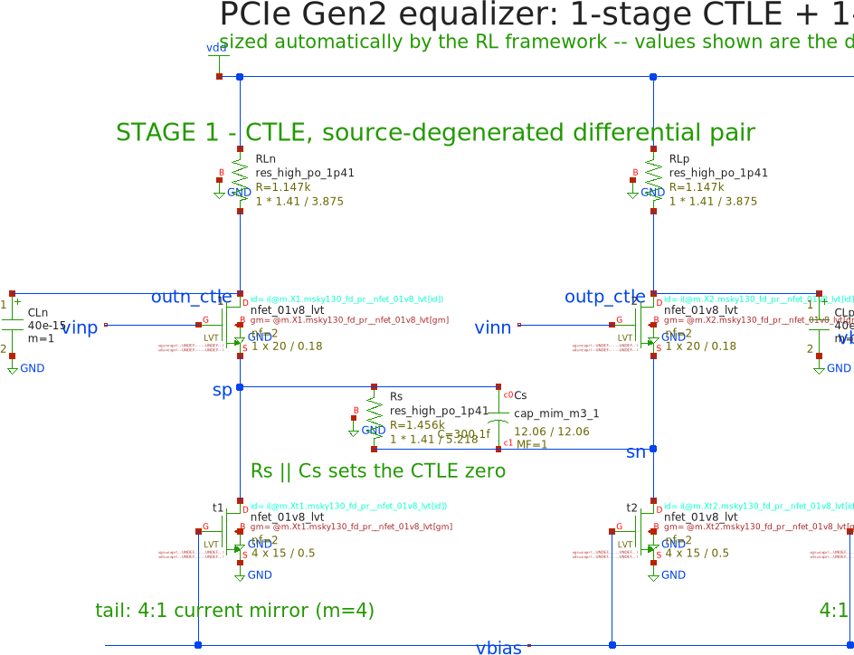
Figure 1. Stage 1, the CTLE. The input pair X1 and X2 drive the load resistors RLn and RLp. Rs and Cs between the two sources set the high-frequency boost. The tail current comes from a 4:1 current mirror. Exported from the project's xschem schematic.
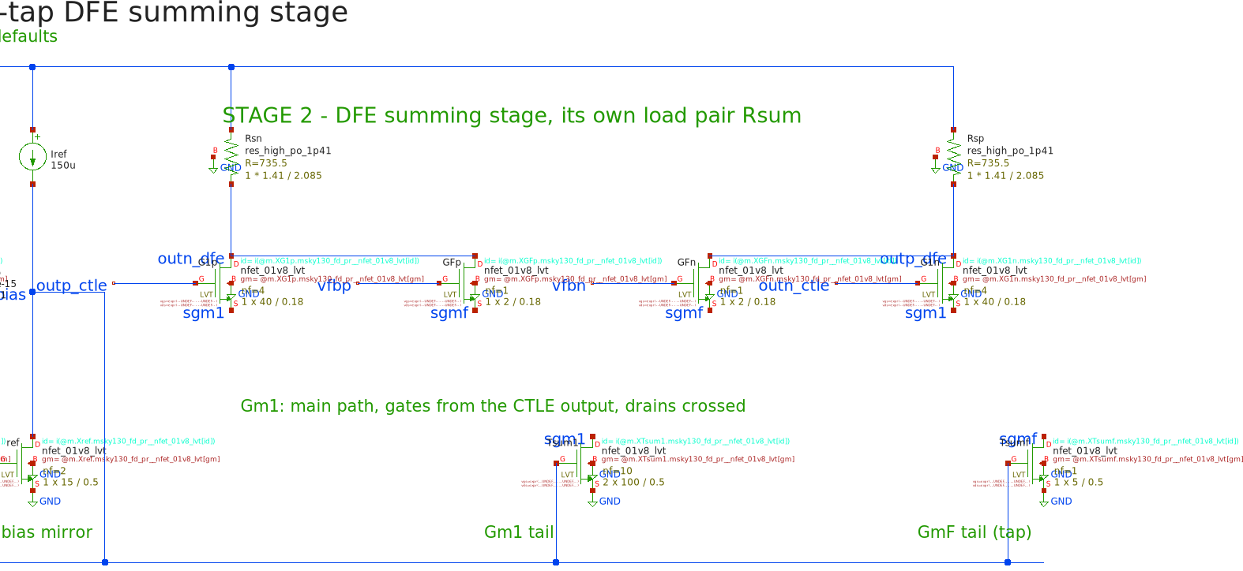
Figure 2. Stage 2, the DFE summing stage, with its own load pair Rsum. The main path Gm1 takes the CTLE output; the tap pair GmF takes the previous decided bit. Both drive the same summing nodes but have separate tail currents, which is what sets the tap weight.

2.1 What the framework is allowed to change
The framework sizes 11 device parameters. Everything else about the circuit — the topology, the number of stages, which device connects to which — is fixed. Table 1 lists the 11 parameters and the range each one may take.
Table 1. The 11 device parameters the framework sizes.
parameter | what it sets | minimum | maximum | unit
W | CTLE input pair width | 1 | 100 | µm
L | CTLE input pair length | 0.15 | 1 | µm
RL | CTLE load resistance | 100 | 5000 | Ω
Rs | degeneration resistance | 50 | 1e+04 | Ω
Cs | degeneration capacitance | 1e-14 | 3e-12 | F
Itail | CTLE tail current | 5e-05 | 0.002 | A
Wtail | CTLE tail device width | 5 | 200 | µm
Rsum | summing-stage load | 100 | 2000 | Ω
Wg1 | summing-stage main pair width | 1 | 100 | µm
Ig1 | summing-stage tail current | 0.0001 | 0.004 | A
tap_pct | DFE tap weight, as a share of the main path | 1 | 30 | %

2.2 What counts as passing
A design passes only if it meets every specification at every one of the 20 process, voltage and temperature corners named in the problem statement: the 5 process corners (FF, FS, SF, SS, TT), the supply at 1.71 V and 1.89 V, which is 1.8 V plus and minus five percent, and both 0 °C and 125 °C. 5 × 2 × 2 gives 20 corners. Passing at the typical corner alone does not count.

3. The obstacle: simulation is slow
The problem statement asks for a design flow that takes significantly less time than sweeping the whole parameter space. It is worth being concrete about why sweeping is not an option. With 11 free parameters, even a very coarse sweep of ten values per parameter is 10^11, or a hundred billion, combinations. Each one would need a SPICE run, and each design has to be checked at 20 corners. At a few seconds per simulation this is not a long computation; it is an impossible one.
A search is the obvious alternative, and a search does work. But a reinforcement learning agent has the same difficulty in a sharper form: learning needs a very large number of attempts, and if every attempt costs a real SPICE run then training is far too slow to be practical. Training an agent directly against ngspice would take weeks.
This is the single obstacle that shapes the rest of the design. Everything in the next two sections follows from it: the agent needs to try millions of designs, and the simulator can only supply thousands.
Our answer is to train a neural network to predict what ngspice would report for a given set of device sizes, and let the agent learn inside that fast model instead. The simulator is then used where it is genuinely needed: to check the finished answer.

4. A fast model of the simulator
We collected 5,993 SPICE measurements from 1,500 different designs, each simulated at several corners, and trained a neural network to reproduce them. The network takes the device sizes and the corner conditions and predicts the circuit's measured behaviour: the peaking, the frequency at which it peaks, the gain, the power, the input-referred noise, the distortion and the eye opening. It runs in well under a millisecond, against seconds for a real simulation.
Five copies of the network are trained together with different random starts. Where the five disagree, the prediction is uncertain, and the agent is discouraged from going there. A quarter of the collected designs were held out of training entirely and used only to measure accuracy: 375 designs, 1,495 measurements.

4.1 Why the network cannot drift away from real physics
The usual objection to putting a neural network in the middle of a design loop is that the network is free to be wrong in any direction it likes, and an optimiser will find wherever it is wrong and settle there. A circuit that looks excellent to the model and does not work in the simulator is the standard failure of this approach.
We avoid it by not asking the network to predict the circuit at all. The prediction starts from the textbook hand calculation, and the network is only allowed to correct it.

The hand calculation comes first
For a source-degenerated differential pair the small-signal transfer function is standard and can be written down by hand. With k = 1 + gm·Rs/2, the half-circuit response is
H(s) = (gm·RL / k) · (1 + s·Rs·Cs) / [ ((k + s·Rs·Cs)/k) · (1 + s·RL·Cout) ]
This is the equation that gives the low-frequency gain, the zero that produces the boost, and the pole that ends it. We evaluate it for every candidate design. Crucially, gm and Cout are not taken from an idealised model: they are measured from a single SPICE operating-point run on the real SKY130 devices. So the starting point is a hand calculation that has already been calibrated against the real transistors.

The network only supplies a correction
The network never outputs a peaking value or a power. It outputs a correction to the number the equation already produced. For the quantities measured in decibels the correction is added; for the rest it multiplies. The final prediction is the hand calculation times that correction.
Three properties follow, and together they are the reason the model stays tied to real physics:
- It starts as the physics. before any training the correction is exactly one, so an untrained model is precisely the hand calculation. Learning can only move away from the equations as far as measured data pushes it, and a model that has learned nothing is no worse than the equations.
- The correction is hard-bounded. the correction is clipped at a factor of 7.4 in either direction, and no amount of training can exceed that. In practice the corrections the network actually learned are around 1.8×, well inside the limit. The network can sharpen the equations; it cannot overrule them.
- The failure mode is bounded too. the worst case is therefore a slightly mis-scaled version of the correct physics, not an invented circuit. There is no set of device sizes for which the model can report a fictitious result, because the physics term is always there underneath.
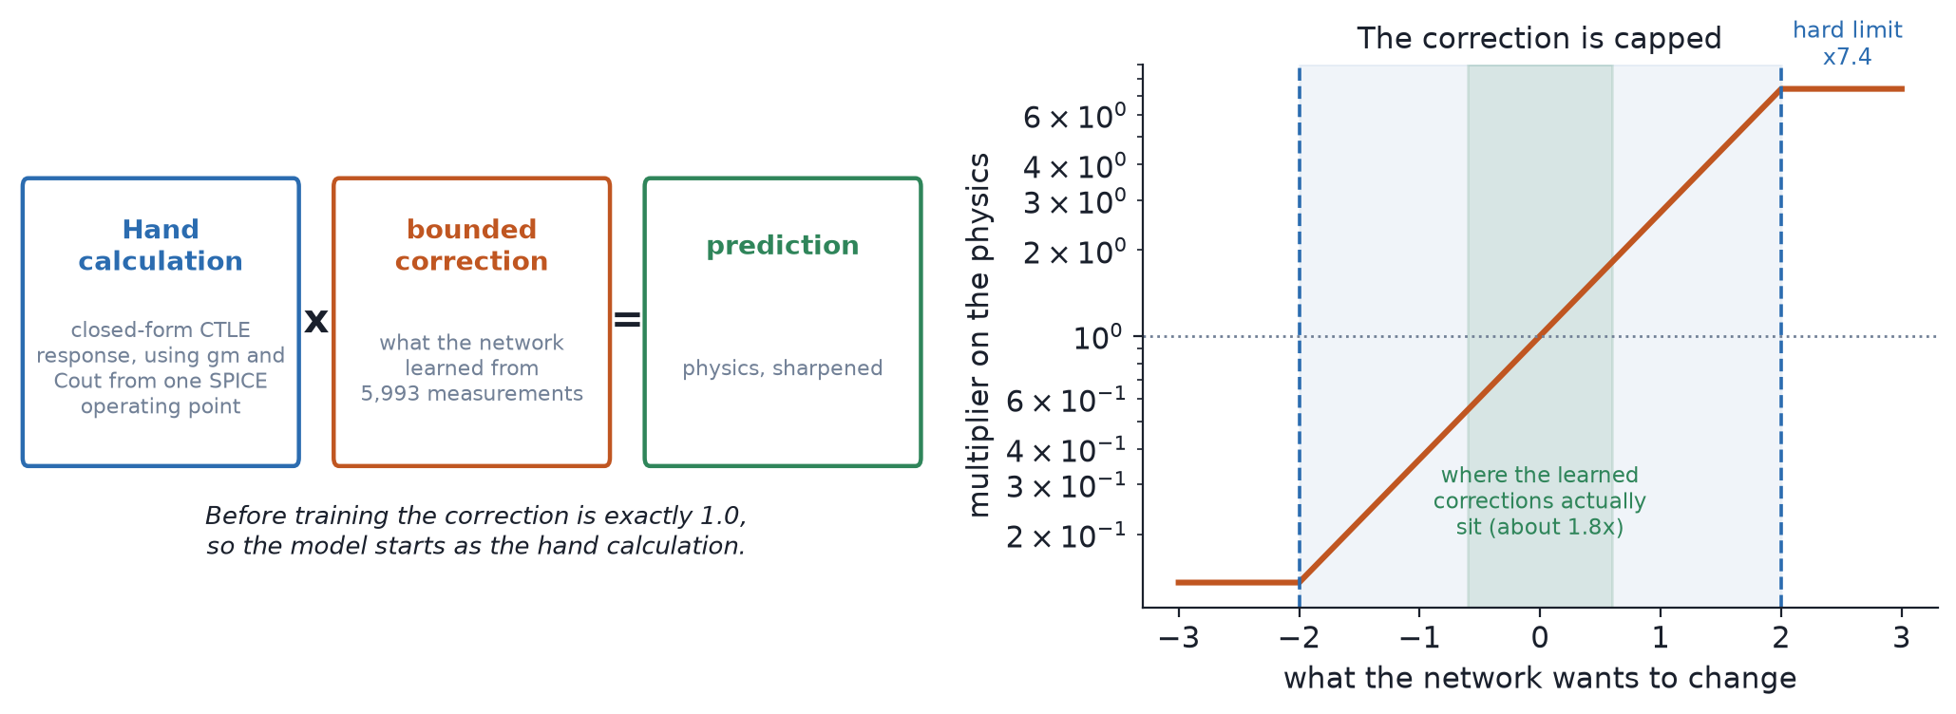
Figure 3. How one prediction is assembled. The closed-form circuit equation supplies the value; the network supplies a multiplier that is clipped at the dashed lines. The green band shows where the learned corrections actually sit.
Two quantities have no usable closed form: the height and width of the eye at the slicer, which depend on the channel, the feedback loop and the data pattern together. Those are predicted directly, and this is exactly why the flow in Section 6 measures the eye in SPICE rather than trusting a prediction of it.

4.2 How well the model agrees with the simulator
The question that matters for this framework is not how close a predicted number is, but whether the model and the simulator agree on the decision: does this design meet this specification or not. Measured on the held-out designs the two agree between 82% and 100% of the time, depending on the specification.
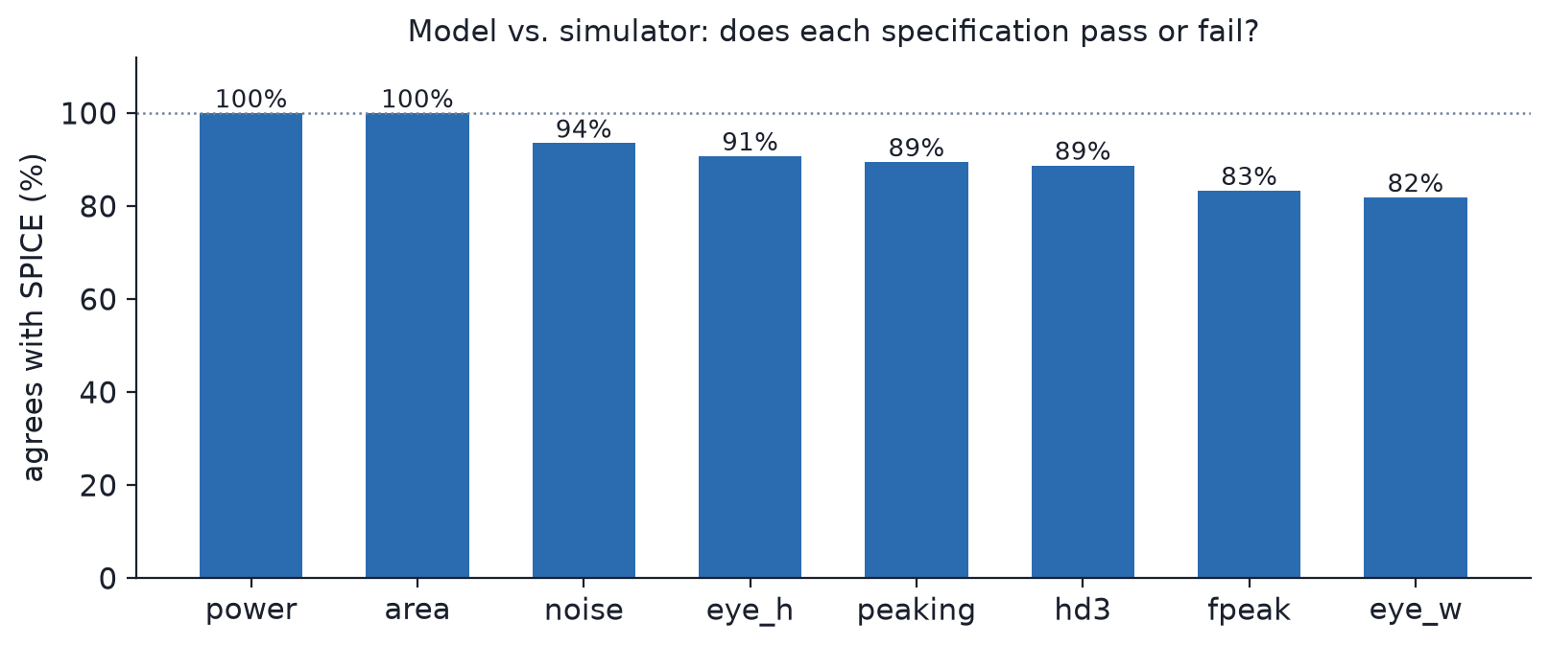
Figure 4. How often the model and ngspice reach the same pass-or-fail verdict, per specification, on designs the model never saw during training.
Table 2. Accuracy of the model on held-out designs. R² is how much of the variation it explains; the rank correlation is how reliably it puts designs in the right order, which is what a search actually needs.
quantity | R² | rank correlation
power | 0.97 | 0.98
low-frequency gain | 0.96 | 0.98
gain at Nyquist | 0.94 | 0.97
peaking | 0.90 | 0.92
distortion (HD3) | 0.82 | 0.91
eye height | 0.80 | 0.81

5. The reinforcement learning agent
With a fast model available, an agent can afford the millions of attempts that learning needs. We use Soft Actor-Critic, a standard continuous-control algorithm, trained for 120,000 steps.
The agent is goal-conditioned. That means the target specification is part of what it sees, not something fixed at training time: it is given the limits it has to meet and learns a general policy for meeting them. This is what lets one trained agent answer a specification it has never seen, rather than having to be retrained for every new target. Its observation is a 35-number vector holding the current device sizes, the circuit's present measured behaviour, how far each specification is from being met, and the target itself. Its action adjusts the 11 device parameters.

5.1 The reward
The reward deserves a word because it is the part of the design that does the most work. Passing is conjunctive: a design is acceptable only if it meets every specification at once. A reward that counts how many specifications are met would let the agent improve its score by making five of them better while making a sixth worse, which is not progress toward a working circuit.
So we express every pass condition as a continuous margin — how much room it has, as a fraction of the limit — and reward the agent on the minimum of those margins. A minimum cannot be gamed by trading: the only way to raise it is to improve whichever condition is currently worst. When the minimum reaches zero, every condition is met, and the reward keeps paying beyond that so the agent buys margin rather than stopping on the boundary.
The agent is also penalised for going where the five networks disagree with each other. That keeps it inside the region the training data actually covered.
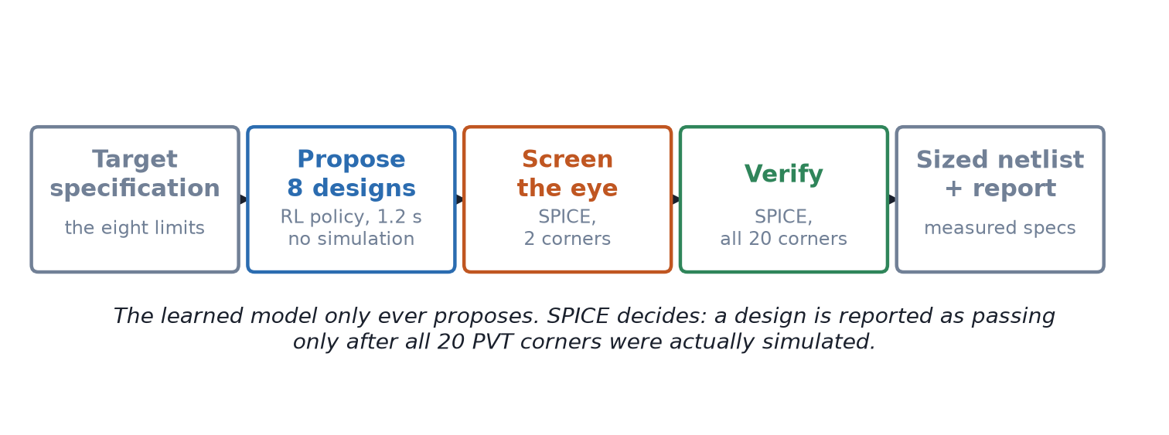
Figure 5. The complete flow. The learned model proposes; ngspice decides.

6. Verification: the simulator decides
A prediction is never reported as a result. When a target specification arrives, the flow is:
- Propose. the agent proposes eight candidate designs in about 1.2 seconds. This costs no simulation at all — it is a single forward pass through the trained network.
- Screen. each candidate is simulated at two corners chosen to expose a closing eye. Candidates that fail here are dropped before spending a full corner sweep on them.
- Verify. the best surviving candidate is simulated at all 20 PVT corners, with the channel in place and the feedback loop closed. Only if every specification passes at every corner is the design reported as meeting the specification.
This ordering is what makes the framework trustworthy. The learned model is used where it is cheap and its errors are recoverable — choosing what to try next — and the simulator is used where the answer counts. A design that the model likes but SPICE rejects simply does not get reported, so model error costs time, never correctness.
The framework also checks two conditions beyond the eight in the specification: that the transistors are actually biased in saturation, and that the eye is more open at the slicer than at the input. The first catches a circuit whose small-signal numbers look fine but whose bias point is invalid. The second catches a circuit that merely amplifies instead of equalising, which is possible because the summing stage's gain is a free parameter. Ten conditions in total are checked at all twenty corners.

7. Results
Two questions decide whether this framework is useful: how often does it meet a target specification, and how long does it take. Everything below was measured on specifications the agent had never seen during training, with every candidate design verified in ngspice at all 20 PVT corners.

7.1 How often it meets the specification
We drew 10 target specifications that the agent had not been trained on, and let each method propose candidates. A specification counts as solved only if one of the candidates meets every specification at every corner — nothing weaker.
The trained agent meets 50% of the specifications with its very first candidate, and 80% within 7 candidates. The search needs 20 candidates to reach the same 80%. Running both methods and keeping whichever succeeds meets 9 of 10.
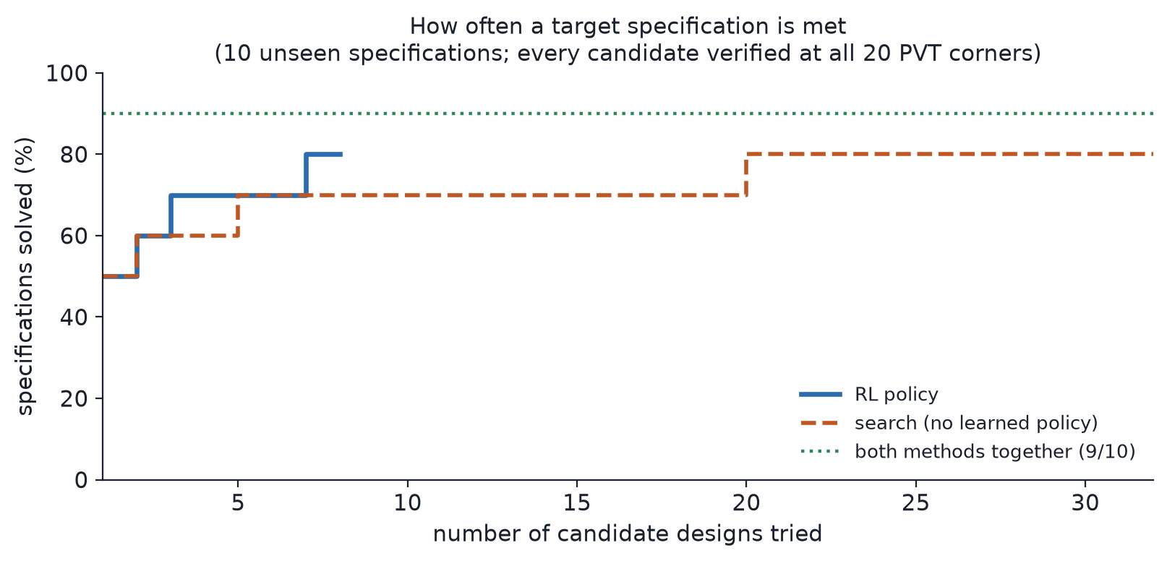
Figure 6. Share of target specifications met, against the number of candidate designs tried. The agent reaches its full coverage in 7 candidates where the search needs 20.
Table 3. Meeting an unseen target specification.
 | first candidate | within 7 candidates | time to propose
RL agent | 50% | 80% | 1.2 s
Search | 50% | 70% | 20 s
Both together | — | 9/10 | —

The difference in proposal cost is the practical one. The agent produces its eight candidates in 1.2 seconds without touching the simulator, because answering is a single forward pass through a trained network. The search has to run an optimisation every time a new specification arrives, which is why it takes 20 seconds to produce the same eight.

7.2 How long a design takes
Measured over 16 complete runs, a design takes a median of 37 seconds from receiving the specification to having a netlist verified at all 20 corners, with a range of 28 to 102 seconds. That total is almost entirely simulation: the machine learning part of it is the 1.2 seconds spent proposing.
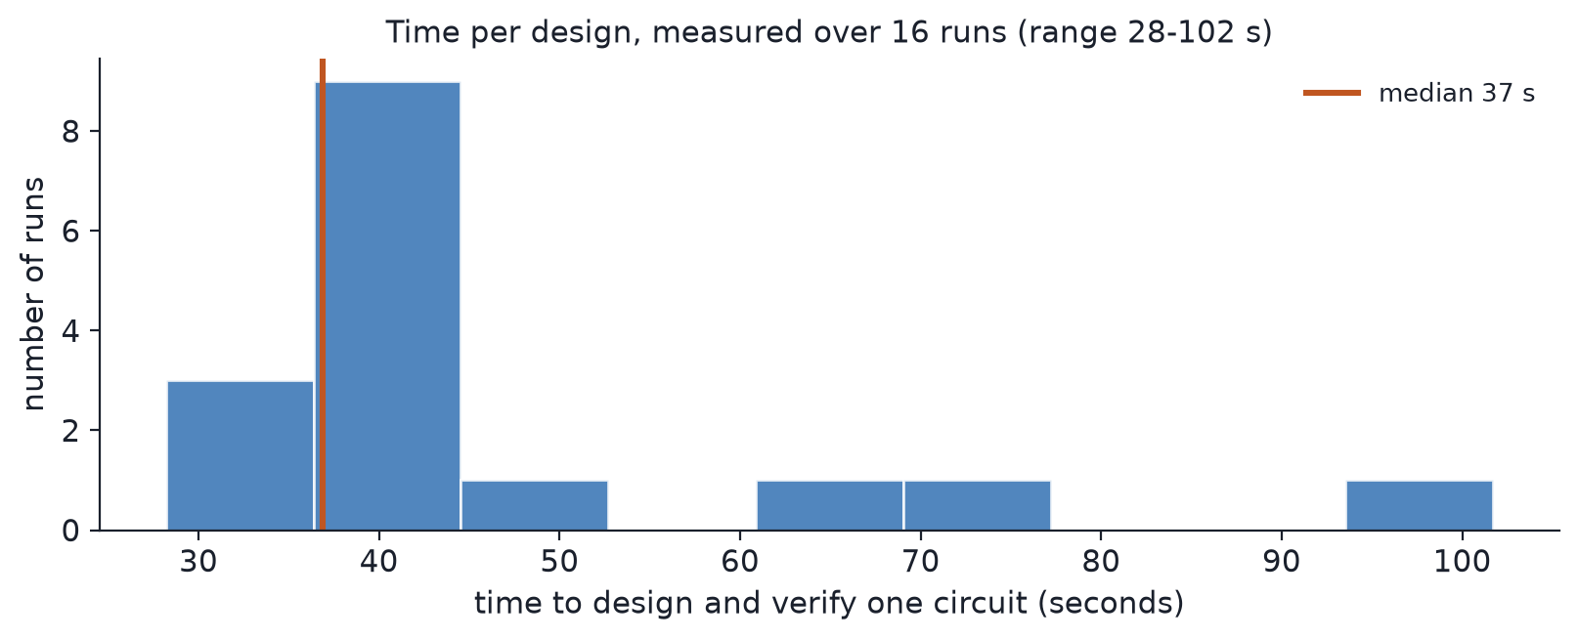
Figure 7. Time to design and fully verify one circuit, over 16 runs.
Table 4. Where the time goes in a typical run.
step | simulations | time
propose 8 candidates | 0 | 1.2 s
screen the candidates | 16 | ~16 s
verify the winner at 20 corners | 20 | ~20 s
eye and frequency-response plots | 2 | ~10 s
total | ~38 | median 37 s

For comparison, the exhaustive sweep the problem statement asks us to beat would need 10^11 simulations at ten points per parameter, before multiplying by 20 corners. The framework reaches a verified design in roughly 38 simulations.

7.3 A worked example: the specification in the brief
As a concrete case we gave the framework the exact specification from the problem statement. It returned a verified design in 44.5 seconds, meeting all ten conditions at all 20 corners. The margin column is how much room each specification has, as a fraction of its limit; every value is the worst case across all corners, not the typical one.
Table 5. The brief's own specification, verified at all 20 PVT corners. The last two rows are the framework's own validity checks.
condition | required | worst-case margin | result
peaking | 3 - 12 dB | +0.418 | pass
fpeak | 1.25 - 2.5 GHz | +0.199 | pass
hd3 | < -30 dBc | +0.399 | pass
noise | < 1.5 mVrms | +0.332 | pass
power | < 15 mW | +0.718 | pass
area | < 0.05 mm2 | +0.992 | pass
eye_h | > 100 mV | +0.591 | pass
eye_w | > 0.4 UI | +0.133 | pass
bias | devices biased in saturation | not applicable | pass
equalises | eye openness improved vs the equaliser input | not applicable | pass

The measured eye at the slicer is 217.9 mV high and 0.484 UI wide, against requirements of 100 mV and 0.4 UI.
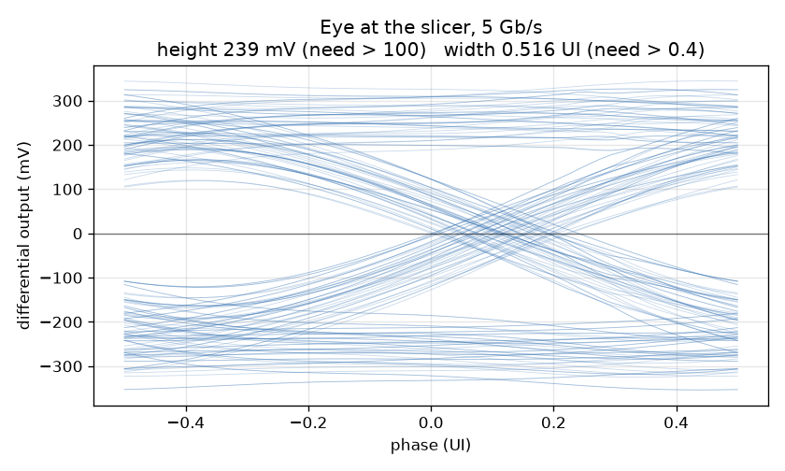
Figure 8. The eye at the slicer for the design in Table 5, simulated with the channel in place and the decision-feedback loop closed.
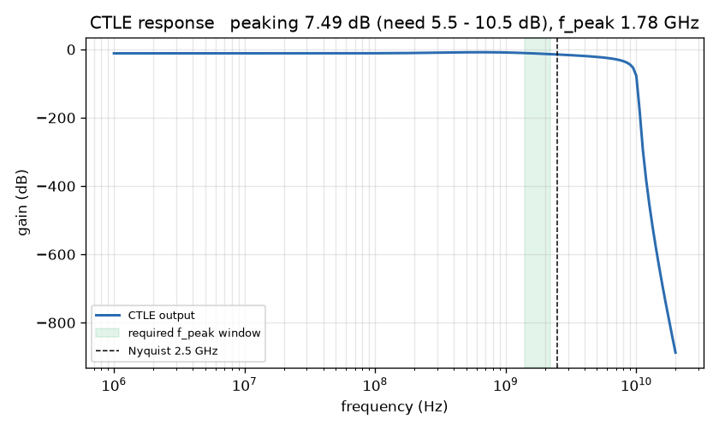
Figure 9. Frequency response of the same design. The shaded band is the range in which the specification requires the peak to fall.
The framework also writes the sized netlist, which runs in ngspice unchanged and reproduces these numbers.

8. Bonus deliverable: a language-model wrapper
The problem statement lists an LLM-based interface as a bonus deliverable. We built one as an MCP server, the open protocol that lets a language model call external tools. Once it is connected, a user can describe what they want in ordinary English —
“Design a PCIe Gen2 equalizer with about 8 dB of peaking between 1.4 and 2.2 GHz, drawing under 10 mW.”
— and the model calls the framework, waits for the simulations, and returns the eleven device sizes, the corner-by-corner scorecard, the eye diagram, the frequency response and a runnable netlist.
The wrapper exposes three tools:
- design_equalizer — size a circuit to a specification and verify it at all twenty corners.
- check_spec — a free check, with no simulation, of whether a request looks reachable and whether it falls inside the range the agent was trained on.
- explain_capabilities — report what the framework can and cannot do, so the model quotes measured limits rather than inferring them.
The rules that keep the answers honest are enforced in the server's code rather than requested in a prompt, because a prompt is advice and code is a guarantee. A design is reported as passing only after all twenty corners have actually been simulated. A failure still returns the closest design found, together with which specifications it missed and by how much. Margins are reported as measured and are never rounded toward passing. The method used, and whether the request fell inside the agent's trained range, are always stated.
Running the brief's own specification through this interface produced the verified design in Section 7.3 in 44.5 seconds.

9. Conclusion
We set out to size a PCIe Gen2 equalizer automatically from a target specification, with no human in the loop, and in far less time than sweeping the parameter space. The framework does this. Given a specification it returns device sizes and a runnable netlist in a median of 37 seconds, verified in ngspice at all 20 PVT corners, and it meets 80% of unseen target specifications within 7 candidate designs — 9 out of 10 when both of its methods are used.
The step that made reinforcement learning practical here was replacing the simulator with a fast model during training, and the step that made that model trustworthy was refusing to let it predict the circuit on its own. Because every prediction is the closed-form circuit equation multiplied by a bounded, learned correction, the model cannot wander away from real physics, and an agent optimising against it cannot exploit a fantasy. The simulator then has the final word on every design that is reported.
The result is a design flow in which the machine learning does what it is good at — deciding what to try next, instantly — and the simulator does what it is good at, which is telling the truth about the circuit.

References
[1] M. Aldacher, “SERDES Design of RX Decision Feedback Equalizer,” open-source design. https://github.com/muhammadaldacher/SERDES-Design-of-RX-Decision-Feedback-Equalizer
[2] T. Haarnoja et al., “Soft Actor-Critic: Off-Policy Maximum Entropy Deep Reinforcement Learning with a Stochastic Actor,” ICML, 2018.
[3] SkyWater Technology and Google, “SKY130 Open Source PDK.” https://github.com/google/skywater-pdk
[4] Model Context Protocol specification. https://modelcontextprotocol.io

