AI/ML for Analog Circuit Design
Reference Report
A reinforcement-learning framework that sizes a PCIe Gen2 receive equalizer
Supporting detail for the project presentation. Every figure quoted here is read from a committed artifact, and the artifact is named beside it.
Team: Team Sillycon
College: BITS Pilani – Pilani Campus
Members: Kanishk Jain · Karthik Raj Palleboyina

Contents
1. The problem statement
2. Signalling, the channel, and what goes wrong
3. The circuit
4. Why simulation cost decides the architecture
5. Choosing the starting point
6. PhysFit: the fast evaluator
7. The reinforcement-learning agent
8. Requests outside the trained range
9. Verification: the simulator decides
10. The language-model wrapper
11. Results
12. Reproducing all of this
A. The ten measurement specifications
B. Design-variable bounds
C. The twenty PVT corners
D. Artifact index — which file backs which claim

1. The problem statement
Quoted verbatim, because it is the contract the work is measured against.
Demonstrate a fully automated framework for schematic design of analog circuits using Reinforcement Learning. Given circuit specifications, build an automated design flow that sizes devices using fewer search spaces (lowest design time) to reach near-optimal solutions. Use case: Equalizer circuit design (PCIe PHY). Should take significantly lower time than sweeping all MOS, R, C, L parameter space, with zero human intervention.
Specifications: Nyquist Freq (PCIe Gen 2, 5.0 Gbps): 2.5 GHz; HF peaking boost 3–12 dB (tunable 1.25–2.5 GHz); 1-Stage CTLE w/ source degeneration (variable Rs, Cs) + 1-Tap DFE; NRZ signaling; Linearity HD3 < -30 dB (100 MHz diff input); Input-referred noise < 1.5 mVrms (10 MHz–5 GHz); Power < 15 mW; Area < 0.05 mm² (130nm PDK); Eye opening > 0.4 UI (H) & > 100 mV (V); Meet across PVT (TT,SS,FF,SF,FS; VDD±5%; 0–125°C).
Objective: Develop a RL based automation framework to automatically design an equalizer for the given specifications, with minimal to zero human intervention.
Deliverables: A Reinforcement Learning based Python framework that takes target specs as input, seamlessly integrates with a spice simulator — outputs the final schematic and resulting specs. Bonus: LLM-based human interaction with wrapper to fine-tune.

1.1 The two demands that shape everything
Read closely, the brief asks for two things that pull in opposite directions. It wants a design that meets a long list of analog specifications at every process corner — and it wants that design found using FEWER SEARCH SPACES, in the LOWEST DESIGN TIME, faster than sweeping the parameter space, with ZERO HUMAN INTERVENTION.
Meeting the specifications is circuit design. Meeting them quickly, automatically, and without sweeping is the problem this project actually solves. Section 4 shows why those two demands conflict, and the rest of the document is the resolution.

1.2 What counts as passing
Ten conditions are scored. Eight are the brief's. Two are validity checks the framework adds, because a circuit can satisfy every electrical number while being physically meaningless.
Table 1. The ten scored conditions.
# | condition | requirement
1 | peaking | 3 - 12 dB
2 | fpeak | 1.25 - 2.5 GHz
3 | hd3 | < -30 dBc
4 | noise | < 1.5 mVrms
5 | power | < 15 mW
6 | area | < 0.05 mm2
7 | eye_h | > 100 mV
8 | eye_w | > 0.4 UI
9 | bias | devices biased in saturation
10 | equalises | eye openness improved vs the equaliser input

Source: eqrl/mcp_server.py::_limits, eqrl/specs.py::EqualizerSpec
Condition 9, bias, asks whether every device is biased in saturation. A design can hit all eight electrical numbers while sitting in triode, where the small-signal model that produced those numbers does not apply.
Condition 10, equalises, asks whether the eye is more open at the slicer than at the equaliser input — measured as openness, a fraction of the swing at the same node, so it is invariant under gain. Without it a circuit could enlarge the eye with plain amplification, magnifying the distortion along with the signal, and still be reported as passing.

1.3 And it must hold at twenty corners
Five process corners (tt, ss, ff, sf, fs) × two supplies (1.71 V and 1.89 V, i.e. 1.8 V ±5 %) × two temperatures (0 °C and 125 °C) = 20 corners. Every one of the ten conditions must hold at every one of them. The full list is Appendix C.
A design is only ever reported as passing after all twenty were actually simulated. This is enforced in code, not asserted in prose: see Section 9.

2. Signalling, the channel, and what goes wrong

2.1 NRZ, data rate and Nyquist
NRZ — non-return-to-zero — is the simplest line code: each bit slot holds one of two voltage levels, high for a 1 and low for a 0, and the line does not return to a rest level in between. One symbol carries one bit.
At 5 Gb/s one bit slot, the Unit Interval, is 1 / 5 GHz = 200 ps.
The Nyquist frequency is half the data rate, 2.5 GHz. The fastest pattern NRZ can produce is alternating 1010…, which takes two bit slots to complete one full cycle, so the highest fundamental the line ever carries is 5 GHz / 2. Everything above it is edge detail rather than new symbols. That single number is what the brief's frequency requirements are built around.

2.2 The channel is bandlimited and lossy
A copper trace is a low-pass filter. Series resistance rises with frequency through the skin effect, and the dielectric absorbs more as frequency climbs, so fast content is attenuated far more than slow content.
The channel model is a differential lossy ladder: 40 sections per leg, 1.2 ns total delay (about 7 inch of FR4), 50 Ω per leg, each section carrying a DC resistance plus two staggered skin-effect stages, with 50 Ω series at the source and 100 Ω differential termination at the receiver.
Table 2. Channel loss against frequency.
frequency | loss
1 kHz | -6.09 dB
1 GHz | -10.33 dB
2.5 GHz | -16.77 dB
5 GHz | -22.07 dB

Source: eqrl/netlist.py::channel_netlist, eqrl/physics.py::channel_H
The loss at DC is -6.09 dB — that is the source and termination divider, not dissipation, and it applies equally at all frequencies. What the equaliser has to undo is the SHAPE: 10.7 dB more loss at Nyquist than at DC.
Set that against the brief's required peaking of 3–12 dB. The specification is sized to this channel; the numbers are not arbitrary.

2.3 In the time domain: intersymbol interference
A filter that removes high frequencies cannot keep a sharp edge. Send one isolated bit and what arrives is not a 200 ps rectangle but a smeared hump that is still present when the next bit arrives.
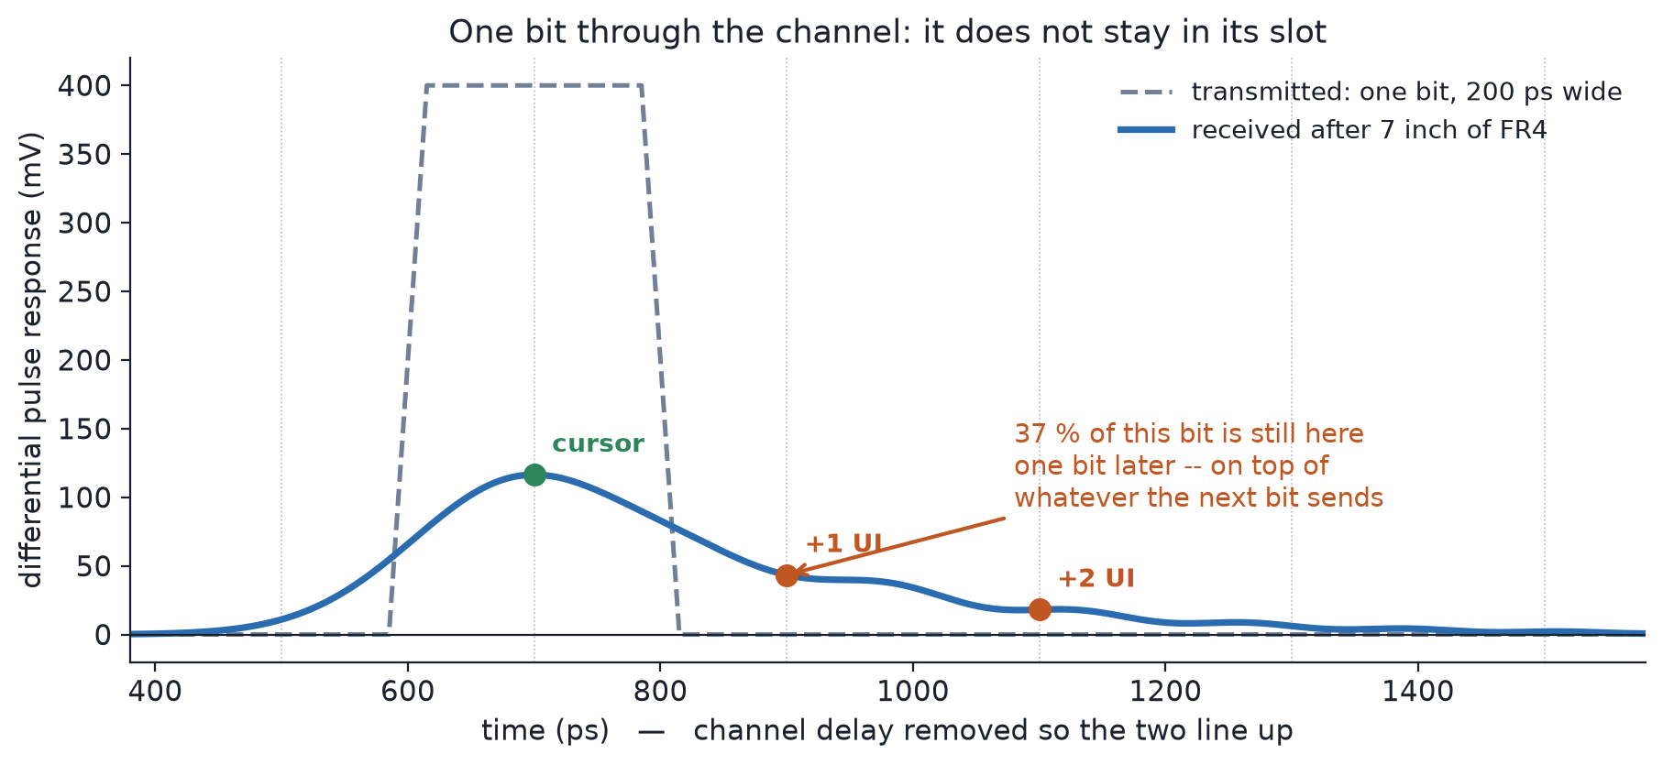
Figure 1. One isolated bit driven through the channel model. Transmitted, a clean 200 ps rectangle; received, a hump whose tail is still 37 % of its own peak one Unit Interval later. The channel's 1.2 ns delay has been removed so the two traces line up.
Table 3. The received pulse, sampled at the receiver's own clock phase.
sampled at | fraction of the cursor
the cursor — its own slot | 1.000
+1 UI — the next bit's slot | +0.373
+2 UI | +0.155

Source: scripts/make_channel_figures.py. The +0.373 reproduces the +0.372 measured independently in docs/findings-ctle-dfe.md §2, by a different method.
So roughly 37 % of every bit is still sitting in the following bit's slot, added to whatever that bit is sending. With random data those leftovers accumulate constructively and destructively at random, and the eye closes. That is intersymbol interference.
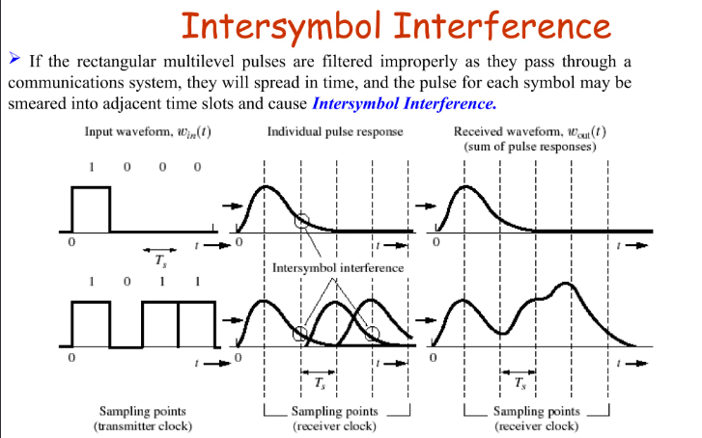
Figure 2. Intersymbol interference in general: individual pulse responses spread, overlap, and sum at the receiver's sampling instants.
Two different problems follow, and the architecture has one block for each. The loss is frequency-shaped, so it is undone with a filter shaped the opposite way — the CTLE. What remains is a known fraction of a bit that has already been decided, so it is simply subtracted — the DFE tap.

3. The circuit
One CTLE stage with source degeneration, feeding a summing stage that also receives a scaled copy of the previously decided bit, feeding a slicer. Fixed by the brief and unchanged throughout the project.
The topology follows the open reference design at github.com/muhammadaldacher/SERDES-Design-of-RX-Decision-Feedback-Equalizer, a 1-tap DFE for NRZ over FR4.
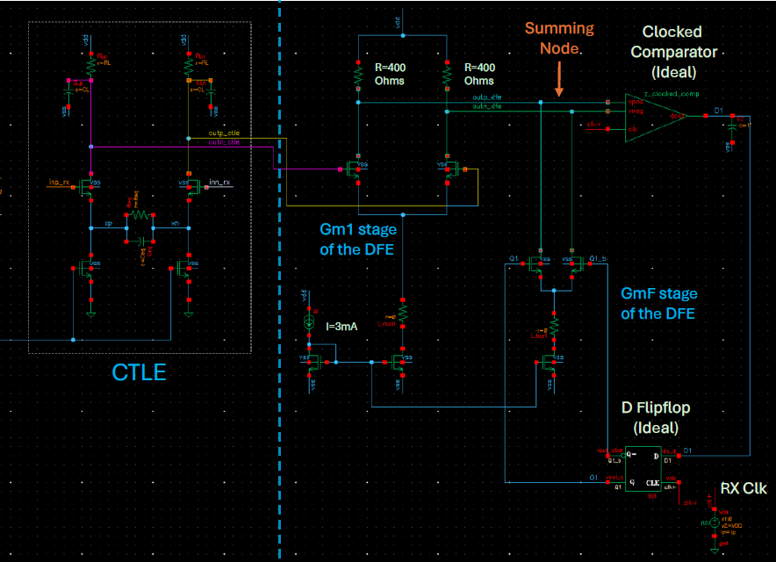
Figure 3. The implementation: CTLE, the Gm1 and GmF stages of the DFE, the summing node, the clocked comparator and the D flip-flop that closes the loop.

3.1 What each block does
The CTLE is a differential pair whose source degeneration is a resistor Rs in parallel with a capacitor Cs. At low frequency Cs is effectively open, so Rs degenerates the pair and the gain is low. At high frequency Cs shorts Rs out, the degeneration disappears, and the gain rises. That rise is the boost: the amplifier deliberately favours exactly the frequencies the channel attenuated.
- Rs ∥ Cs sets where the boost starts — the zero.
- RL · Cout sets where the response rolls off — the output pole.
- The gap between them is how much boost you get.
The summing stage adds two currents into one pair of load resistors Rsum: the CTLE output through the main transconductor Gm1, and a scaled copy of the previously decided bit through the feedback transconductor GmF. Subtracting that copy cancels the tail the previous bit left behind.
The slicer decides 1 or 0 at the sampling instant, and a D flip-flop holds that decision for one clock period — which is what makes the feedback exactly one bit long, and the DFE exactly one tap. The comparator and flip-flop are ideal models; this project sizes the analog path.

3.2 The eleven design variables
These are the framework's entire output. Everything else about the circuit — topology, device flavours, the channel, the measurement conditions — is fixed.
Table 4. The eleven variables and the range each may take.
variable | what it sets | range
W | CTLE input pair width | 1 µm – 100 µm
L | CTLE input pair length | 150 mµm – 1 µm
RL | CTLE load resistance | 100 Ω – 5 kΩ
Rs | degeneration resistance | 50 Ω – 10 kΩ
Cs | degeneration capacitance | 10 fF – 3 pF
Itail | CTLE tail current | 50 µA – 2 mA
Wtail | CTLE tail device width | 5 µm – 200 µm
Rsum | summing-stage load | 100 Ω – 2 kΩ
Wg1 | main transconductor width | 1 µm – 100 µm
Ig1 | main transconductor current | 100 µA – 4 mA
tap_pct | DFE tap strength | 1 % – 30 %

Source: eqrl/netlist.py::PARAM_NAMES, PARAM_BOUNDS
Three of these are not independent in the way the list suggests. The DFE tap branch is never sized on its own: its current, its device width and its tail width are all derived from tap_pct, so the whole feedback stage is one knob. Section 5.3 gives the relations.

3.3 The schematic is checked against what is simulated
netlists/eq_core.sch opens in xschem. A test netlists it with xschem and diffs the resulting connectivity against the netlist the framework actually simulates, so the drawing and the circuit cannot drift apart.
Source: tests/test_schematic_sch.py
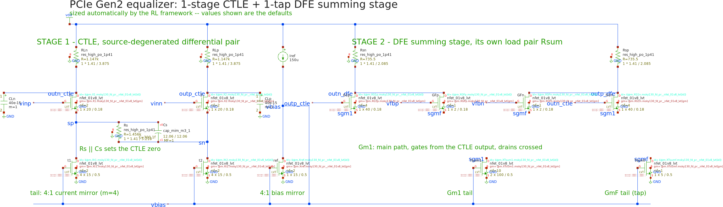
Figure 4. The complete equalizer, both stages, exported from the verified schematic file.

4. Why simulation cost decides the architecture
One design, evaluated at four corners, costs 4.42 seconds of ngspice. That is measured, not estimated: 95 candidates took 420.3 s of wall clock and launched 760 ngspice processes — 8 per design, two per corner.
Source: results/baseline.json
And that is the fast path already. Trimmed per-corner model libraries, built and validated once, make these evaluations 22.4× faster than loading the full SKY130 library each time. 4.42 s is what the cost looks like after optimisation.
Source: scripts/build_trimlib.py; README.md

4.1 What that means for a sweep
Table 5. The arithmetic of brute force, at the measured cost per design.
what | designs | ngspice time
one design, 4 corners | 1 | 4.42 s
one design, all 20 corners | 1 | ~22 s
the agent's training budget | 120,000 | 6.1 days
a 3-point grid over 11 variables | 177,147 | 217.7 hours
a 5-point grid over 11 variables | 48,828,125 | 6.8 years

An exhaustive sweep is not slow. It is arithmetically out of reach, and it is the thing the brief explicitly asks to beat. Three points per variable is not a design space worth searching; five points is longer than anyone will wait.

4.2 And what it means for learning
The same number rules out the obvious approach to the RL problem. An agent needs to evaluate a design at every training step. At 120,000 steps and 4.42 s per evaluation, training with the simulator in the loop is 6.1 days of simulation alone, before any learning is counted.
This is the whole reason the architecture has a learned evaluator in it. Not because a neural network is interesting, but because the search and the training both need an evaluator thousands of times faster than the one that decides the answer. That evaluator is the subject of Section 6.

4.3 Where the time actually goes, per request
Measured by timing each phase through the same functions a design request calls. Three independent runs:
Table 6. Per-phase wall clock for one design request.
phase | run 1 | run 2 | run 3
language-model and MCP layer | 0.3 ms | 0.1 ms | 0.1 ms
derive the starting point | 0.64 s | 0.61 s | 0.58 s
PhysFit ⇄ RL loop, all 8 candidates | 0.26 s | 0.23 s | 0.23 s
everything before verification | 0.90 s | 0.84 s | 0.81 s
ngspice screen and 20-corner verify | 53.4 s | 52.2 s | 52.2 s
ngspice share of the run | 98.3 % | 98.4 % | 98.5 %

Those runs verified corners sequentially, so their totals are larger than the 36.9 s production median in Section 11.2, which runs them in parallel. Parallelism changes only the ngspice part; the sub-second thinking phase is the same either way.
The point to take from this table: all of the searching, all of the learned inference, and all of the reasoning together cost under one second. Essentially the entire wall clock is the one thing the framework refuses to approximate — the final verdict in a real simulator.

5. Choosing the starting point

5.1 Why a specification does not pick one circuit
A specification is a set of inequalities: boost between 3 and 12 dB, power under 15 mW, eye wider than 0.4 UI. Inequalities do not have unique solutions. Many completely different sizings satisfy the same set.
- a wide device at low current, or a narrow device at high current — the same gm, different bandwidth, different area
- a large RL with a small gm, or the reverse — the same DC gain, with the poles in different places
- more CTLE boost with a smaller tap, or less boost with a bigger one
They are not equally good. They sit in different basins — regions of the eleven-dimensional space with different amounts of room around them before some constraint is violated.
So the starting point is not a convenience, it is a decision. It selects which basin the search explores, and eleven dimensions is far too large for a search to stumble into a better basin on its own. The brief's demand for zero human intervention means that decision has to be derived, per specification, with no hand tuning. The rest of this section is that derivation.

5.2 Device lengths, assumed once
Tail devices use L = 500 nm — long, for output resistance and matching. Every other device uses L = 180 nm, close to the process minimum, for speed. (Presentation slides round this to 200 nm; the netlist value is 180 nm.)
Source: eqrl/netlist.py::L_TAIL, eqrl/start_physfit.py::derive

5.3 The order, and why it is forced
The three stages cannot be sized in any order. The CTLE sets the shape of the response, so it comes first. The summing stage only needs a common-mode condition, so it can follow. The DFE tap cannot be calculated at all until the other two exist — it is measured off a pulse driven through the finished path.

5.4 The CTLE
Table 7. The CTLE derivation, in dependency order.
# | step | why
1 | f_target = centre of the required peak band | where the boost must sit
2 | f_p2 = 2.13 × f_target | output pole placed ABOVE the peak, so the boost completes before the roll-off begins
3 | RL = 1 / (2π · f_p2 · Cout) | the load that puts the pole there
4 | k = 10^(peaking_dB × k_pk / 20) | over-ask; k_pk is the measured optimism of the closed form
5 | gm = k / RL | this is what pins DC gain at 0 dB
6 | Rs = 2(k − 1) / gm | the degeneration for that boost
7 | Cs = k / (2π · Rs · f_p1), f_p1 = 0.8 × f_target | puts the zero below the pole
8 | Vov = (Vcm − 0.1 − Vt) / 2 | from the input common-mode range budget, splitting the headroom between tail and pair
9 | Vt and Vov characterised in SPICE → Vgs ≈ Vt + Vov; gm/ID then picks the branch current and the tail current
10 | gm/ID gives the widths — diff pair and tail MOSFET

Source: eqrl/start_physfit.py::derive
Steps 1 to 7 are algebra on the transfer function. Steps 8 to 10 are the standard gm/ID sizing flow, anchored on a threshold voltage measured once in SPICE rather than taken from a datasheet.
Step 5 is the one worth pausing on. Writing gm = k / RL is equivalent to fixing the DC gain at exactly 0 dB, because the closed-form DC gain is gm·RL/k. Left unconstrained, DC gain wanders — and a design with gain at DC is an amplifier, not an equaliser.

5.5 The summing stage
Table 8. The summing-stage derivation.
# | step | why
1 | Wg1 = 100 × W_min = 42 µm | the tap device is Wg1 × tap%; at the smallest tap setting of 1 % it must still clear the PDK's 0.42 µm minimum width
2 | Ig1 = 1 mA | free — nothing downstream is sensitive to it
3 | Rsum = VDD / Ig1 = 1.8 kΩ | half the current flows in each leg, so (Ig1/2)·Rsum = VDD/2 and the output common mode lands at mid-supply, which is where the comparator wants it

Source: eqrl/start_physfit.py::derive lines 108–110

5.6 The DFE tap
Sized last, and measured rather than calculated.
1. the CTLE and summing stage are already designed
2. a single isolated pulse is driven through that path
3. the intersymbol interference is read one Unit Interval after the cursor — that residue is exactly what the tap must cancel
4. that reading sets the tap coefficient
5. every device value in the tap branch follows from it
I_tap = Ig1 × tap %
W_pair = Wg1 × tap % (floored at the PDK's 0.42 µm)
W_tail = Wtail × I_tap / Itail
Source: eqrl/netlist.py lines 297, 307, 289
So the entire feedback stage collapses to one variable. Current, pair width and tail width are not three independent choices, they are three consequences of the tap coefficient. Sizing them separately would let the tap weight and the bias point drift apart, and the tap weight is the only thing that matters.
For scale: after the channel the post-cursor is +0.373 of the cursor. By the time it reaches the summing node with 7.4 dB of CTLE boost in front of it, it is down to +0.090 — and that remainder is what the tap removes.
Source: docs/findings-ctle-dfe.md §2

5.7 What it costs, and what it achieves
The whole derivation runs in about 0.2 seconds per specification and uses one SPICE operating point, for the threshold voltage, cached across the run. Seven of the ten measurement specifications are solved by the very first proposal made from this start.
Source: results/solve_rate_physfit.json, docs/systematic-starting-point.md

6. PhysFit: the fast evaluator
This document uses PhysFit for the whole fast evaluator: the closed-form circuit equations together with the neural correction trained on top of them. In the codebase PhysFit is the device-model layer and Surrogate is the network; they are one component as far as the system is concerned.
It is two fitted things stacked, and the order is forced — the correction can only be defined once there is something to correct.
Table 9. The two layers.
layer | what it is | how it is fitted
1 | device physics: gm, Cout, tail headroom, plus two calibration factors | least squares, closed form, seconds
2 | a bounded correction on top | gradient descent

6.1 How the training points were sampled
The designs simulated to train the model are not random. They come from four deliberately chosen regions, interleaved in the collection plan so that any prefix of the plan is representative.
Table 10. How the training designs were sampled. Each design is simulated at four corners, giving several rows per design.
region | how it is sampled | designs | rows
sobol | Sobol sequence over the whole 11-dimensional box | 299 | 1,191
seed | Gaussian scatter, σ = 0.25, around the analytic start for the default specification | 294 | 1,176
final | Gaussian scatter, σ = 0.15, around a known-good final design | 148 | 592
goal_start | Gaussian scatter, σ = 0.12, around the analytic start for many DIFFERENT sampled specifications | 759 | 3,034
total |  | 1,500 | 5,993

Source: scripts/collect_data.py::plan; counts recomputed from the evaluation log in eqrl/cache.py
- sobol — teaches the model where circuits FAIL — most of the box is broken designs, and the model has to know that
- seed — density where designs are plausible
- final — density where designs are GOOD, which is where the search ends up
- goal_start — density where the goal-conditioned agent actually begins each episode
The fourth region deserves its own note, because it was added in response to a measurement rather than anticipated. A goal-conditioned agent starts from a different analytic design for every specification it is given. Trained without that region, the model judged those starting designs unsaturated, which clips the reward to a constant — so every training episode began on a flat plateau with no gradient, while real SPICE showed the same designs biased correctly and scoring well. The model was accurate everywhere except the one place training starts. Collecting that region fixed it.

6.2 Fitting the device physics
Least squares, in log space. Square law says gm = sqrt(2·µCox·(W/L)·Id), which is a straight line in logs with slope one half on both W/L and Id. Short-channel devices in this process do not obey square law, so the shape of the equation is kept and the exponents are fitted:
log(gm) = a + b·log(W/L) + c·log(Id) + d·log(T/T0)
Four unknowns, one least-squares solve. The same treatment is applied to the summing stage's transconductance — which needs an additional Vgs term, because geometry and current alone fit it poorly — and to the tail device's saturation voltage and drain-source voltage.
Table 11. Quality of the closed-form device fits, in log space.
quantity | R² (log) | median relative error | n
gm_m1 | 0.743 | 23.8% | 5993
gm_g1 | 0.567 | 68.8% | 5993
vdsat_tail | 0.875 | — | 5993
vds_tail | 0.737 | — | 5993

Source: models/surrogate/…/physfit.json, written by eqrl/physics.py::PhysFit.fit

6.3 Measuring how optimistic the formula is
Two calibration factors, measured across the whole dataset as the median ratio of closed-form prediction to measured value:
k_pk = 1.677 the closed form reads this many times high on peaking
k_f = 1.428 ... and this much high on where the peak lands
The design procedure pre-multiplies its targets by these, so asking for 7.5 dB of boost means asking the formula for about 12.6 dB. Neither factor is hand-tuned.
One subtlety worth knowing if asked: these must be computed with the FITTED gm, not the square-law default. Computed against an unfitted model, the device error folds into the calibration factor and the result comes out below 1 — the opposite direction to the real optimism.
Source: eqrl/physics.py::PhysFit.fit, final block

6.4 Splitting the data honestly
Each design is simulated at four corners, producing four rows with almost identical features. Splitting those rows at random would put some corners of a design in training and others in validation — and the held-out score would then measure memorisation rather than generalisation, because the model has already seen that design at another corner.
The split is therefore keyed on the DESIGN. 25% of designs are held out: 375 designs, 1495 rows, never trained on.
Source: eqrl/surrogate.py::split_by_candidate

6.5 The inputs
32 features, every one a physically meaningful quantity rather than a raw knob: transconductances, output capacitance, the zero and both pole positions and their ratio, the closed-form predictions themselves, computed pulse-response cursors, the tap ratio, common-mode headroom, supply, temperature and the process corner.
Giving the network log(gm) rather than W and Itail separately means it does not have to rediscover the square law. It starts from quantities that already carry the physics.
Source: eqrl/physics.py::FEATURE_NAMES

6.6 What the network is asked to predict
Fifteen outputs per design, per corner, in three groups.
Table 12. The model's outputs.
group | count | quantities
physics × correction | 5 | peaking_db, f_peak, dc_gain_db, power_w, vn_in_rms
predicted directly | 9 | gain_nyq_db, hd3_db, eye_height_v, eye_width_ui, eye_improvement, eye_openness_in, gm_m1, gm_g1, out_cm_v
pass/fail flag | 1 | saturated

The first group are not predicted as absolute values. The target the network sees is how wrong the equation was:
quantities in dB: target = measured − closed_form
ratio quantities: target = log( measured / closed_form )
A log ratio, so the head's output passes through exp() and becomes a multiplier on the physics. Zero means the physics was already right.
One masking rule matters here. A design with no peak reports a peak frequency of 1 MHz, the sweep's start frequency. Its residual target would be log(1e6 / 1.8e9) ≈ −7.5, an outlier an order of magnitude larger than any real correction, which would dominate that output's loss. Those rows are masked out; it costs no pass/fail agreement, because both the real and the predicted design fail the peak-frequency band in that case anyway.
Source: eqrl/surrogate.py::residual_targets
The directly-predicted group is standardised and then clipped at eight standard deviations. A heavy-tailed metric otherwise lets a handful of samples own the whole loss, and the model spends its capacity on outliers instead of the bulk it will actually be asked about. All normalisation statistics are computed on the training set alone and then applied to the validation set.

6.7 The network, and why it cannot drift from physics
A shared trunk of two hidden layers, 32 inputs into 128 and 128 again with SiLU activations, then three small output heads — one per group above. About 22,700 parameters.
SiLU rather than ReLU is deliberate. The RL agent searches inside this model by nudging knobs and asking whether the result improved. ReLU's kinks put creases and flat spots in that landscape, where a small nudge produces either nothing or a sudden jump. SiLU is smooth, so every small move produces a small, informative change.
The correction head is initialised to exactly zero:
nn.init.zeros_(self.head_res.weight)
nn.init.zeros_(self.head_res.bias)
Since the correction is applied as exp(g), and exp(0) = 1, an untrained network multiplies the physics by exactly one. The model BEGINS as the hand calculation. Training can only move it away from there, and the correction is hard-clipped so it can never move the answer by more than a factor of 7.4. In practice the learned corrections sit around 1.8×.
Source: eqrl/surrogate.py::Net, MAX_LOG_RESIDUAL
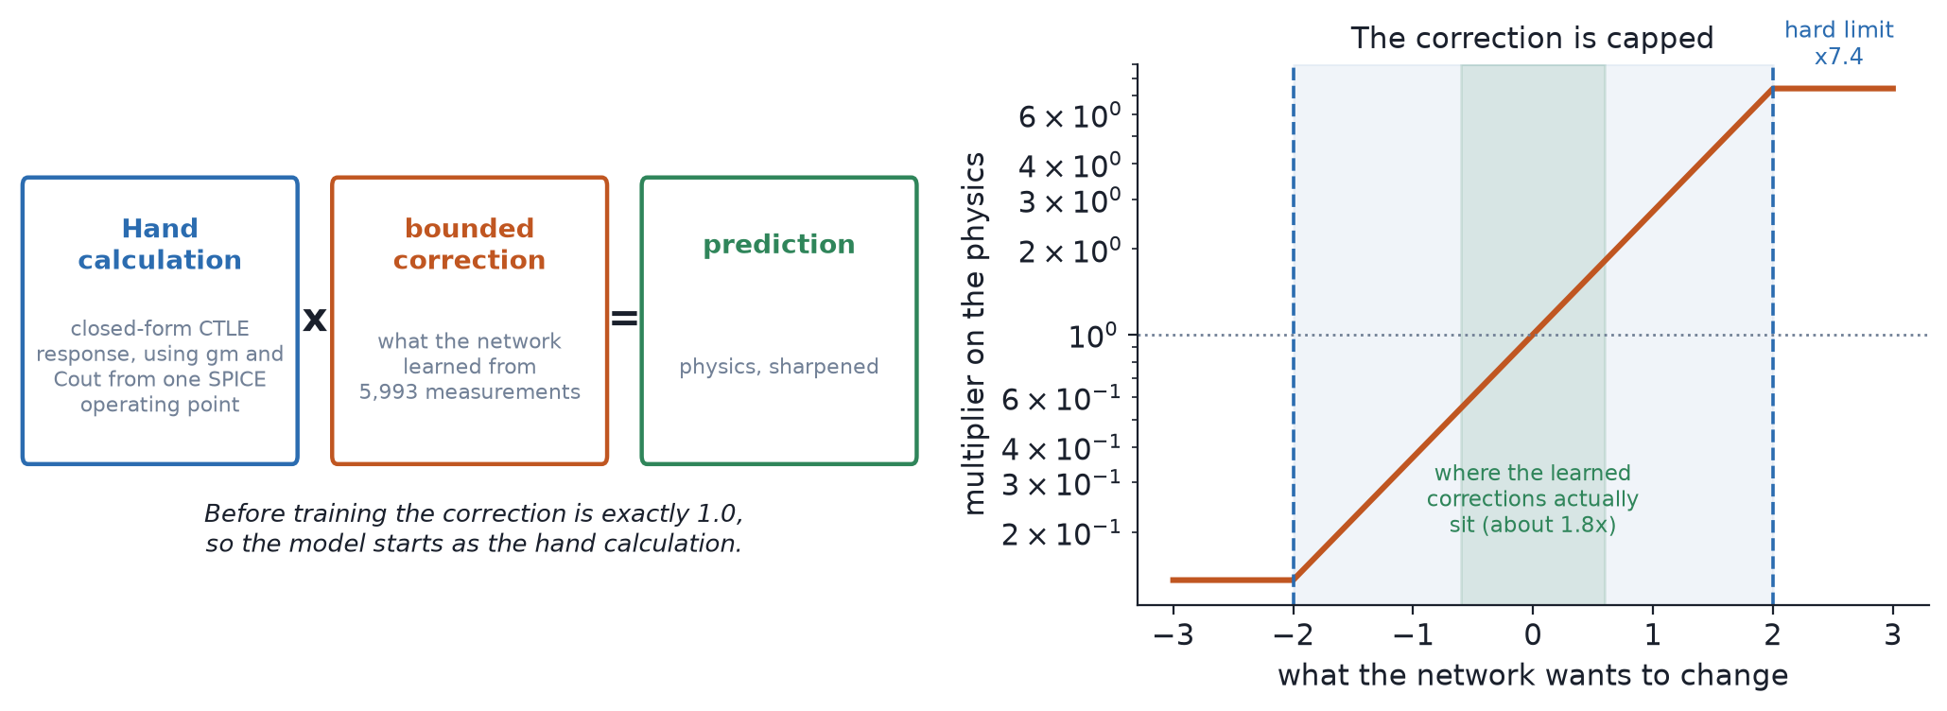
Figure 5. Left: a prediction is the hand calculation multiplied by a bounded correction. Right: the correction is capped at ×7.4, and the learned corrections sit well inside that bound.

6.8 The training loop
- Adam, learning rate 3e-3, full batch — all training rows every step, no minibatching
- up to 3,000 epochs
- loss = masked MSE on the corrections + masked MSE on the direct outputs + 0.1 × binary cross-entropy on the saturation flag
- early stopping with patience 300; the BEST validation state is restored at the end, not the last epoch's weights
Two of those deserve explanation. The loss is masked because not every design has every measurement — a design with no peak has no peak frequency. A mask makes a missing value contribute nothing, where scoring it as zero would teach the network that a missing peak means a peak at 0 Hz. And the flag loss carries a weight of 0.1 because a yes/no loss sits on a different scale from the regression terms; at equal weight it dominates, and the result is an excellent saturation detector that predicts gain badly.
Source: scripts/train_surrogate.py::train_member

6.9 How much time it saves
Table 13. The same design, the same four corners, evaluated both ways.
evaluator | time per design | source
ngspice | 4424 ms | results/baseline.json
PhysFit | 0.77 ms | measured, 200 repetitions
ratio | ≈ 5,745×

This ratio is what makes the rest of the project possible. It turns a six-day training run into a fifty-minute one, and it turns a search that would be unaffordable into one that costs a quarter of a second.

6.10 How accurate it is
All of the following is measured on the held-out designs — designs the model never saw at any corner.
Table 14. Does the model agree with the simulator about whether each condition passes?
condition | agreement
power | 100 %
area | 100 %
noise | 94 %
eye_h | 91 %
peaking | 89 %
hd3 | 89 %
fpeak | 83 %
eye_w | 82 %

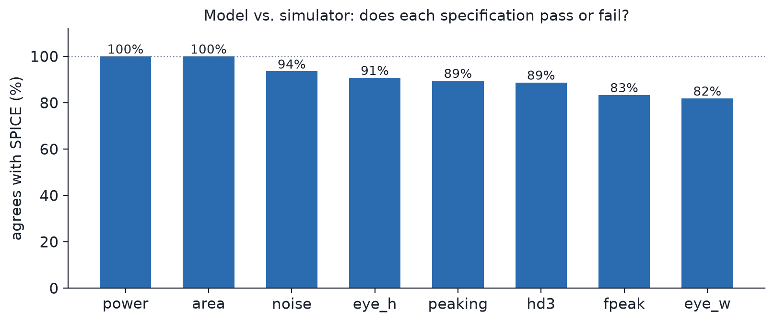
Figure 6. The same data as a chart. Gain and current are near-exact; the eye is the softest, which is why the eye is measured rather than predicted at verification time.
Table 15. Numerical accuracy on held-out designs.
quantity | R² | Spearman ρ | n
power_w | 0.965 | 0.979 | 1495
dc_gain_db | 0.956 | 0.979 | 1495
gain_nyq_db | 0.937 | 0.966 | 1495
peaking_db | 0.903 | 0.923 | 1495
hd3_db | 0.816 | 0.912 | 1495
eye_height_v | 0.800 | 0.806 | 1495
eye_width_ui | 0.565 | 0.728 | 1495

For a search, ranking matters more than absolute accuracy: the agent needs to know which of several designs is best. The rank correlation between predicted and simulated worst-over-corner reward is 0.805 across all held-out designs, rising to 0.884 when restricted to properly-biased designs — which is the only population the agent ever chooses among. Top-20 % precision is 78.7%.
Source: models/surrogate/…/validation.json

6.11 Does the model fool itself?
A model you optimise against will find its own blind spots and report a fantasy. So the check is direct: let a search hunt for the model's single favourite design, then simulate that exact design for real.
Table 16. The optimism check.
 | reward
what the model predicted for its favourite design | 0.99864
what ngspice measured for the same design | 0.99769
over-optimism | 0.00095

Under a tenth of one percent, and the design passed every condition at every corner. The model's favourite design was genuinely good rather than a hole in its own coverage.
Source: results/surrogate_check.json

7. The reinforcement-learning agent
Given a specification and a starting design, the agent moves the eleven knobs until the specification is met.

7.1 What it is
- Soft Actor-Critic, goal-conditioned: the target specification is part of the observation, so one trained agent serves any specification inside its range rather than being retrained per request.
- The action is eleven real numbers at once — a continuous control policy, like driving every joint of a robot simultaneously, not a classifier choosing from a list.
- Twenty steps per episode, each a small adjustment to all eleven. The agent steers toward a design; it does not answer in one shot.
- 120,000 training steps, learning rate 3e-4.
Source: eqrl/env_goal.py::GoalCtleEnv, scripts/train_policy.py

7.2 The cost function
Two stages, and the second is the one that matters.
First, each of the ten conditions is scored on its own — not as a hard pass or fail, but as a soft ramp: full marks inside the requirement, falling off smoothly outside it. A smooth score gives the agent a direction to move in even while it is still failing. A bare pass/fail would be flat almost everywhere and teach nothing.
Second, the reward is the WORST of those scores, taken across every corner. Never the average.
Averaging is the trap. A design that is superb on nine conditions and fails the tenth scores well on an average and is worthless in reality. Taking the minimum means the agent can only improve its reward by fixing whatever is currently worst, at whatever corner is currently worst — which is exactly what a circuit designer does.
A bonus is added when a design passes everything, so the agent is pulled past 'nearly meets specification' rather than settling just short of it.
Source: eqrl/specs.py::score, min_margin; eqrl/env_goal.py reward_mode='margin'

7.3 The choices, and the reasons
Table 17. Design decisions in the learning setup.
choice | why
Soft Actor-Critic rather than PPO | SAC keeps a deliberately stochastic policy. Eight different candidates are needed from one starting design; a near-deterministic agent returns eight copies and best-of-eight buys nothing.
Goal-conditioned — the specification is an input | one trained agent serves any specification in range; the alternative is retraining per request, which defeats the purpose
Twenty small steps rather than one shot | the agent can react to what it has produced so far; a one-shot regression from specification to eleven numbers cannot
Worst-margin reward | a design is only as good as its weakest condition at its worst corner
Start from the derived design, not from random | an eleven-dimensional space is far too large to find the working region blind

7.4 Deliberately random, reproducibly
The policy samples from a distribution rather than returning a fixed answer, so running it eight times from the same starting design yields eight genuinely different candidates. The seeds are fixed, so the same eight come back on a re-run.
Source: scripts/best_of_n.py::propose_policy, deterministic=False

7.5 How it was trained, and what that would have cost
Training runs entirely inside PhysFit. The simulator is never called during learning.
Table 18. Training cost, measured and counterfactual.
 | time
as actually run, inside PhysFit | 120,000 steps in 50 minutes
the same training with ngspice in the loop | 6.1 days — simulation alone
building the dataset PhysFit learned from | 1,500 designs × 4.42 s = 1.8 hours, paid once

Source: results/policy_train_eval.json; results/baseline.json
The counterfactual is the optimistic figure — it counts only the simulation, not the learning on top of it. Training the agent at all is possible only because the evaluator is thousands of times faster than the simulator.
During training the share of sampled specifications the agent could satisfy rose as follows — 10k: 0.24, 10k: 0.24, 20k: 0.24, 10k: 0.88, 20k: 0.96, 80k: 1.00, 110k: 1.00, 120k: 0.96. These are measured against PhysFit during training, not against SPICE; the simulator-verified figure is in Section 7.6.

7.6 Measured performance
On ten unseen specifications, with every candidate verified at all twenty corners: 45 of 80 proposals survived verification, a per-proposal rate of 56.2%. 8 of 10 specifications were solved within eight candidates. All eight candidates are produced in 0.26 s, because proposing touches no simulator at all.
Source: results/best_of_n_policy.json
Those two rates answer different questions and are easy to confuse. The per-proposal rate is how often one roll of the dice works. The coverage is how often at least one of eight rolls works, which is what a user actually experiences.

8. Requests outside the trained range
The agent was trained on a bounded range of specifications. Asked for something outside it, a neural network still answers — networks always answer — but the answer carries none of the measured reliability above. So the framework checks, switches method, and says which one it used.

8.1 What the range actually bounds
This is worth stating precisely. The range is the span of SPECIFICATIONS the agent saw during training. It is a limit on what you may ask for, not on which circuits PhysFit can evaluate — PhysFit will score any design put in front of it. It is the agent that has only been taught to aim at targets inside the box.
Table 19. The range of specifications the agent was trained on.
field | range
peaking target | 5.0 – 10.0 dB
peak frequency, lower edge | 1.10 – 1.60 GHz
peak frequency, upper edge | 2.00 – 2.80 GHz
HD3 limit | -34 – -26 dBc
power limit | 3 – 15 mW
eye height limit | 60 – 130 mV
eye width limit | 0.35 – 0.50 UI

Source: results/goal_space.json, via eqrl/env_goal.py::GoalSpace
Every incoming request is compared against this field by field before anything runs, and the result reports both whether the request was inside it and which fields were not.
Source: eqrl/mcp_server.py::envelope_check

8.2 The fallback search
Outside the range the framework uses a cross-entropy search instead: scatter forty variations around the same derived starting design, score them all with PhysFit, keep the best, move the centre toward them and narrow the spread, repeat. Two thousand evaluations, about twenty seconds, still entirely inside PhysFit.
A search has no trained range, because it is a search rather than a learned map. That is exactly why it can go where the agent cannot.
Source: eqrl/agents/cem.py, scripts/best_of_n.py::propose_surrogate_cem
Table 20. The two methods compared.
 | agent | search
per-proposal success | 56.2% | 32.5%
time to produce eight candidates | 0.26 s | ~20 s
works outside the trained range | no | yes
specifications solved | 8 of 10 | 8 of 10

Source: results/best_of_n_policy.json, results/best_of_n_surrogate_cem.json. The search's per-proposal rate is over its first eight proposals (26 of 80), so the comparison is like for like.
The two succeed on DIFFERENT specifications. Running both and keeping whichever passes reaches 9 of 10, where either alone reaches 8. No new method — just spending more time.

9. Verification: the simulator decides
One rule governs the whole framework: the learned model only ever proposes. SPICE decides. The all_pass flag is never set from the model's opinion — it becomes true only after twenty real corner simulations have all passed.

9.1 The cheap screen, and which corners it uses
The eye is the one condition with a comparator in it, and a comparator has no closed form. So rather than predicting it at verification time, the framework measures it — but at two corners rather than twenty.
Which two is a measured result, not a guess. Over 280 designs simulated at the full grid, the corner that decides eye width most often is sf at 0 °C. Screening at the two sf 0 °C corners recovers the true twenty-corner worst case 89.6 % of the time, with a mean overestimate of 0.008 UI. A third corner takes it to 91.4 %, which is not worth the cost.
Source: scripts/best_of_n.py::SCREEN_CORNERS, HANDOVER.md §20.3
Table 21. What the screen saves on one request.
approach | SPICE evaluations | time
verify every proposal at 20 corners | 540 | ~10 min
screen 8 × 2, then verify the survivors | 56 | ~1.5 min

The screen is a filter, not a verdict. Anything it lets through still faces all twenty corners, and any design it wrongly passes is caught there. Designs the screen let through that the full grid then rejected are recorded, so the screen's own error rate stays measured rather than assumed.

9.2 The twenty-corner verdict
Every surviving candidate is simulated at all twenty corners. For each condition the framework keeps the WORST margin across all of them, and all_pass is true only when every one of the ten worst-case margins is non-negative.
Margins are reported exactly as measured. Nothing is rounded toward passing, and a design that misses is still returned — with the conditions it missed and by how much — rather than withheld.
Source: scripts/deploy_policy.py::verify, eqrl/mcp_server.py::_scorecard
If the time budget expires mid-run, the best design found so far is returned with all_pass hard-coded false, because a truncated search has not finished the corners that would justify a pass.

10. The language-model wrapper
The brief's bonus deliverable. Three tools exposed over the Model Context Protocol, so any MCP-capable language-model host can drive the framework in plain English.
Table 22. The three tools.
tool | what it does | cost
check_spec | is this request reachable, and which method would answer it | < 1 s, no simulation
design_equalizer | size a design and verify it at twenty corners | ~40 s, real SPICE
explain_capabilities | what the framework can and cannot do | instant

Source: eqrl/mcp_server.py, scripts/run_mcp_server.py, MCP.md
Honesty is enforced in code rather than requested in a prompt. Every answer states which method ran, whether the request was inside the trained range, and which starting derivation produced the design. A design that misses is returned with its failing conditions and is never described as meeting the specification.
Each run also writes a self-contained HTML report: the ten-condition scorecard, the eye diagram, the AC response, the eleven sized devices with units, which limits were asked for versus defaulted from the brief, and the netlist.

11. Results

11.1 How often a specification is met
Ten unseen specifications, drawn from the trained range with a fixed seed, every candidate verified at all twenty corners. The ten are listed in full in Appendix A.
Table 23. Coverage.
method | specifications solved | per-proposal success
RL agent, 8 candidates | 8 of 10 | 56.2% (45/80)
search alone, 8 candidates | 8 of 10 | 32.5% (26/80)
both together | 9 of 10 | —

Source: results/best_of_n_policy.json, results/best_of_n_surrogate_cem.json
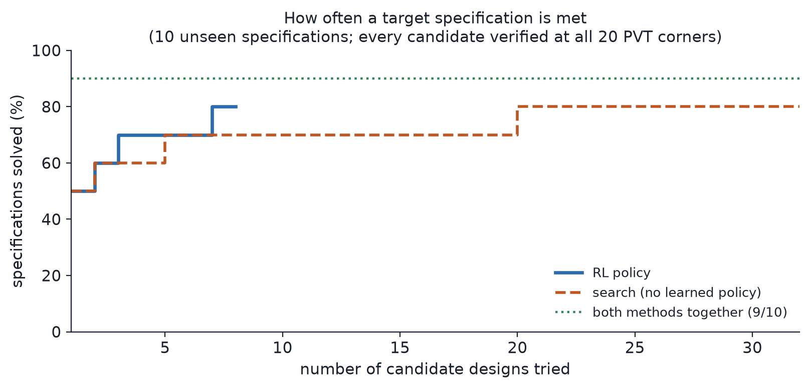
Figure 7. Specifications solved against the number of candidates tried. The agent reaches its coverage in far fewer candidates than the search needs.

11.2 How long it takes
Median 36.9 s, range 28.2 to 101.7 s, over 16 measured runs through the language-model wrapper.
Source: results/mcp_e2e.json
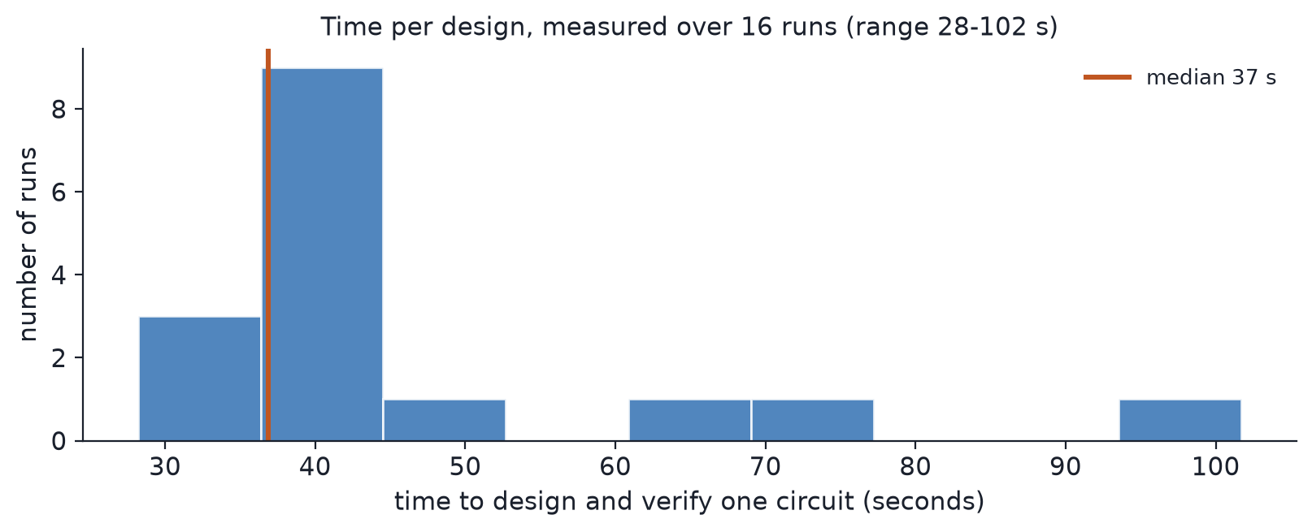
Figure 8. Time to design and verify one circuit, with the median marked.
Section 4.3 breaks that time down: under a second of it is derivation and search, and essentially all the rest is ngspice.

11.3 Against the sweep the brief asks us to beat
The brief asks for something faster than sweeping the parameter space, so the comparison was run directly: random search, the same candidate budget, the same simulator, the same corners, the same scorer, the same channel and eye measurement.
Table 24. Random search against the framework, at an equal budget.
 | best reward | designs passing
random search, 95 candidates | 0.726 | 0 of 95
this framework | 0.987 | a passing design

Source: results/baseline.json
And the exhaustive version stays arithmetic rather than empirical: Section 4.1 gives 217.7 hours for a three-point grid and 6.8 years for a five-point grid over eleven variables.

11.4 A verified design
Table 25. Every condition at its worst corner, for the design in results/report_design.json.
condition | requirement | worst-case margin | result
peaking | 3 - 12 dB | +41.8 % | pass
fpeak | 1.25 - 2.5 GHz | +19.9 % | pass
hd3 | < -30 dBc | +39.9 % | pass
noise | < 1.5 mVrms | +33.2 % | pass
power | < 15 mW | +71.8 % | pass
area | < 0.05 mm2 | +99.2 % | pass
eye_h | > 100 mV | +59.1 % | pass
eye_w | > 0.4 UI | +13.3 % | pass
bias | devices biased in saturation | pass | pass
equalises | eye openness improved vs the equaliser input | pass | pass

Source: results/report_design.json
The margins are worst-case across all twenty corners, not typical values. The tightest is eye width, and it still clears its requirement by 13.3 %.
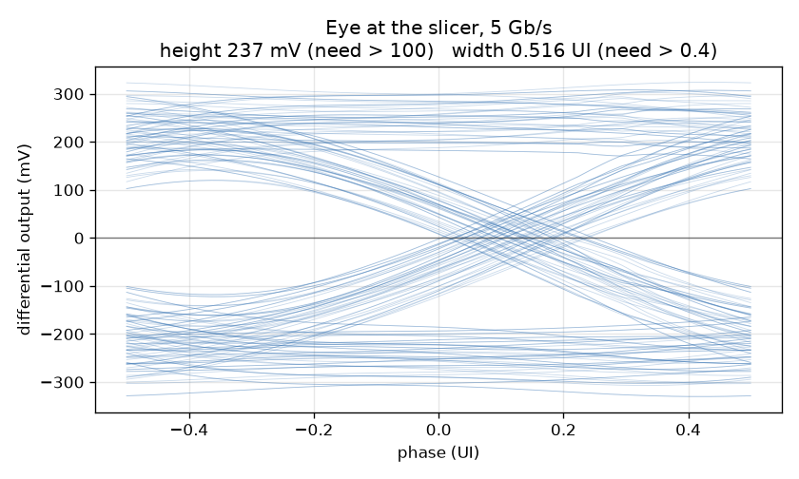
Figure 9. The measured eye at the slicer for a design produced by the current framework: 237 mV high against 100 mV required, 0.516 UI wide against 0.4 UI.
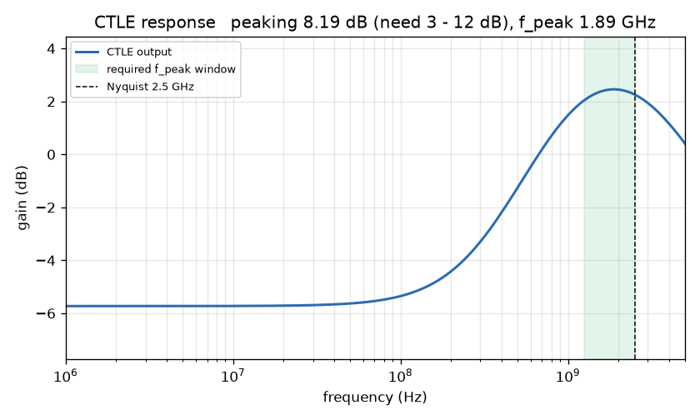
Figure 10. The measured CTLE response for the same design: 8.19 dB of boost peaking at 1.89 GHz, inside the required window and just below the 2.5 GHz Nyquist frequency, which is where the channel's loss is worst.

11.5 Against the brief, point by point
Table 26. The brief's requirements against what was delivered.
the brief asked for | delivered
an RL framework: specifications in, schematic and resulting specifications out | yes
integrates with a SPICE simulator | yes — ngspice, 20 corners
zero human intervention | yes — the starting point is derived per specification, not hand-seeded
faster than sweeping the parameter space | yes — under a minute against an intractable sweep
meets specifications across PVT | yes — all 20 corners simulated for every reported pass
bonus: a language-model interaction wrapper | yes — three MCP tools

11.6 Engineering quality
327 automated tests pass — 282 that need no PDK and 45 that run real ngspice. They check the claims, not only the code: that the schematic matches the netlist that is simulated, that the reported margins match the per-corner data, that a plotted curve agrees with the measurement printed above it, and that documented numbers match the artifacts they came from.
Source: tests/, VERIFY.md

12. Reproducing all of this
Everything quoted in this document is regenerated by the commands below. They are listed in dependency order.
the full test suite
python3 -m pytest tests/ -q
the pure tier only, no PDK needed
python3 -m pytest tests/ -q -m "not needs_pdk"
collect training designs
python3 scripts/collect_data.py --n-sobol 1000 --n-seed 1000 --n-final 500 --n-goal-starts 800
fit PhysFit and train the network
python3 scripts/train_surrogate.py --tag collect,goalstart,goalstart2 --members 5 --val-frac 0.25
train the agent
python3 scripts/train_policy.py --steps 120000
measure coverage over ten specifications
python3 scripts/best_of_n.py --method policy --k 8 --n-specs 10
the random-search baseline
python3 scripts/baseline.py --budget 95
design one circuit end to end
python3 scripts/run_mcp_server.py --self-test
rebuild the figures
python3 scripts/make_report_figures.py && python3 scripts/make_channel_figures.py
rebuild this document
python3 scripts/make_reference_docx.py
The trained model and policy are committed, so the measurement commands run without repeating the collection and training steps.

Appendix A. The ten measurement specifications
These are the ten specifications every coverage number in this document is measured on. They are drawn from the agent's trained range with a fixed seed (deploy_seed = 999), so the same ten come back on every re-run and the policy and the search are measured on identical targets.
None of them is the brief's own specification, and none was seen during training. Two fields do not vary: input-referred noise stays at the brief's 1.5 mV rms and area at 0.05 mm², because the goal space does not sample them.
Source: results/best_of_n_policy.json, field spec_fields; generated by scripts/deploy_policy.py::deploy_specs
Table 27. The ten specifications. Peaking in dB, peak-frequency band in GHz, HD3 in dBc, power in mW, eye height in mV, eye width in UI.
spec | peaking band | target | f_peak band | HD3 | power | eye H | eye W
spec0 | 6.39–11.39 | 8.89 | 1.186–2.571 | -28.00 | 5.05 | 123.1 | 0.3713
spec1 | 5.56–10.56 | 8.06 | 1.555–2.153 | -29.54 | 10.34 | 95.9 | 0.4457
spec2 | 4.91–9.91 | 7.41 | 1.244–2.033 | -32.50 | 6.52 | 111.0 | 0.4242
spec3 | 3.29–8.29 | 5.79 | 1.316–2.324 | -30.45 | 11.06 | 80.9 | 0.4054
spec4 | 5.33–10.33 | 7.83 | 1.126–2.325 | -27.98 | 14.33 | 69.6 | 0.4360
spec5 | 5.64–10.64 | 8.14 | 1.455–2.766 | -31.51 | 5.05 | 103.7 | 0.4772
spec6 | 7.34–12.34 | 9.84 | 1.362–2.078 | -26.37 | 12.80 | 99.2 | 0.3548
spec7 | 6.30–11.30 | 8.80 | 1.199–2.575 | -28.94 | 13.33 | 88.7 | 0.4233
spec8 | 5.54–10.54 | 8.04 | 1.546–2.680 | -32.59 | 11.61 | 77.5 | 0.4792
spec9 | 7.07–12.07 | 9.57 | 1.120–2.052 | -30.68 | 14.31 | 86.4 | 0.4127

Table 28. How the agent did on each of them, verified at all twenty corners.
spec | proposals passing | rank of first success | outcome
spec0 | 7/8 | 1 | solved
spec1 | 1/8 | 3 | solved
spec2 | 8/8 | 1 | solved
spec3 | 8/8 | 1 | solved
spec4 | 8/8 | 1 | solved
spec5 | 0/8 | — | not solved within 8
spec6 | 7/8 | 1 | solved
spec7 | 2/8 | 7 | solved
spec8 | 0/8 | — | not solved within 8
spec9 | 4/8 | 2 | solved

Source: results/best_of_n_policy.json
Two of the ten are not solved within eight candidates by either method. Both are bound by eye width: spec5 asks for 0.4772 UI and spec8 for 0.4792 UI, against the brief's own 0.4000 UI — close to twenty percent more. spec5 additionally caps power at 5.05 mW, a third of the brief's 15 mW, so it cannot buy eye opening with current.

Appendix B. Design-variable bounds
The search is confined to this box. Any proposal outside it is clipped before simulation, so no reported design can lie outside these ranges.
Table 29. The eleven variables and their bounds.
variable | what it sets | minimum | maximum
W | CTLE input pair width | 1 µm | 100 µm
L | CTLE input pair length | 150 mµm | 1 µm
RL | CTLE load resistance | 100 Ω | 5 kΩ
Rs | degeneration resistance | 50 Ω | 10 kΩ
Cs | degeneration capacitance | 10 fF | 3 pF
Itail | CTLE tail current | 50 µA | 2 mA
Wtail | CTLE tail device width | 5 µm | 200 µm
Rsum | summing-stage load | 100 Ω | 2 kΩ
Wg1 | main transconductor width | 1 µm | 100 µm
Ig1 | main transconductor current | 100 µA | 4 mA
tap_pct | DFE tap strength | 1 % | 30 %

Source: eqrl/netlist.py::PARAM_BOUNDS
The tap branch is not sized independently: its current, device width and tail width are all derived from tap_pct, as set out in Section 5.6.

Appendix C. The twenty PVT corners
Every reported pass was simulated at all twenty. The worst margin across them is what the scorecard reports.
Table 30. The acceptance grid: 5 processes × 2 supplies × 2 temperatures.
# | process | supply | temperature
1 | tt | 1.71 V | 0 °C
2 | tt | 1.71 V | 125 °C
3 | tt | 1.89 V | 0 °C
4 | tt | 1.89 V | 125 °C
5 | ss | 1.71 V | 0 °C
6 | ss | 1.71 V | 125 °C
7 | ss | 1.89 V | 0 °C
8 | ss | 1.89 V | 125 °C
9 | ff | 1.71 V | 0 °C
10 | ff | 1.71 V | 125 °C
11 | ff | 1.89 V | 0 °C
12 | ff | 1.89 V | 125 °C
13 | sf | 1.71 V | 0 °C
14 | sf | 1.71 V | 125 °C
15 | sf | 1.89 V | 0 °C
16 | sf | 1.89 V | 125 °C
17 | fs | 1.71 V | 0 °C
18 | fs | 1.71 V | 125 °C
19 | fs | 1.89 V | 0 °C
20 | fs | 1.89 V | 125 °C

Source: eqrl/pdk.py::pvt_grid('spec')
The two corners used for the cheap eye screen — sf at 1.710 V and sf at 1.890 V, both at 0 °C — are members of this same grid, chosen by measurement as described in Section 9.1.

Appendix D. Artifact index
Which file backs which claim. This is the table to open when someone asks where a number came from.
Table 31. Artifacts and the claims they support.
file | what it holds | backs
results/best_of_n_policy.json | the agent on ten specifications: every proposal, its verification result, the rank of the first success, and the ten specifications themselves | coverage, per-proposal rate, Appendix A
results/best_of_n_surrogate_cem.json | the same ten specifications through the search | the search's coverage and rate, the union figure
results/mcp_e2e.json | timed end-to-end runs through the wrapper | the median and range of design time
results/baseline.json | random search at an equal candidate budget | the sweep comparison, and the measured cost per design
results/report_design.json | one fully verified design with its per-corner margins | the scorecard and worst-case margins
results/surrogate_check.json | the model's favourite design, then simulated for real | the optimism gap
results/solve_rate_physfit.json | coverage from the derived starting point | seven of ten solved at the first proposal
results/goal_space.json | the range of specifications the agent was trained on | the envelope check, Section 8.1
models/surrogate/…/validation.json | held-out accuracy: per-metric R², pass agreement, rank correlation, accuracy by sampling region | all of Section 6.10
models/surrogate/…/config.json | the network's shape, targets, epochs and split fraction | Sections 6.5 to 6.8
models/surrogate/…/physfit.json | the fitted device coefficients and calibration factors | Sections 6.2 and 6.3
results/policy_train_eval.json | training wall clock and in-training success rate | Section 7.5
docs/findings-ctle-dfe.md | the pulse-response characterisation of the CTLE and tap | the post-cursor figures in Sections 2.3 and 5.6
docs/systematic-starting-point.md | the derivation of the starting point and its measurement | Section 5
netlists/eq_core.sch | the schematic, checked against the simulated netlist by a test | Section 3.3

