Code:

#include <stdio.h>

int main(){
int first, last, T;

scanf("%d", &T);

while(T--){
scanf("%d", &first);

last = first % 10;

while(first >= 10){
first = first / 10;
}

printf("%d\n", first + last);
}

return 0;
}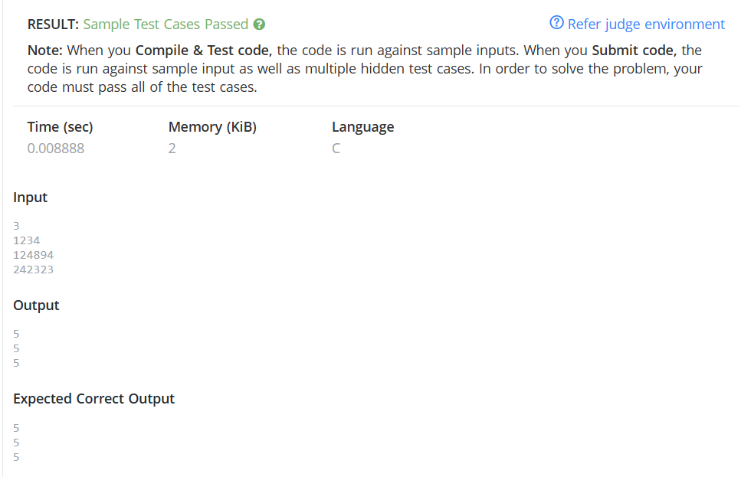

Link to code:
A.Digit Sum | Practice Problems

