Code:

#include <stdio.h>

int main(){
int num, flag = 1;

scanf("%d", &num);

for(int i = 2; i < num; i++){
if(num % i == 0){
flag = 0;
break;
}
}

printf("%d\n", flag);

return 0;
}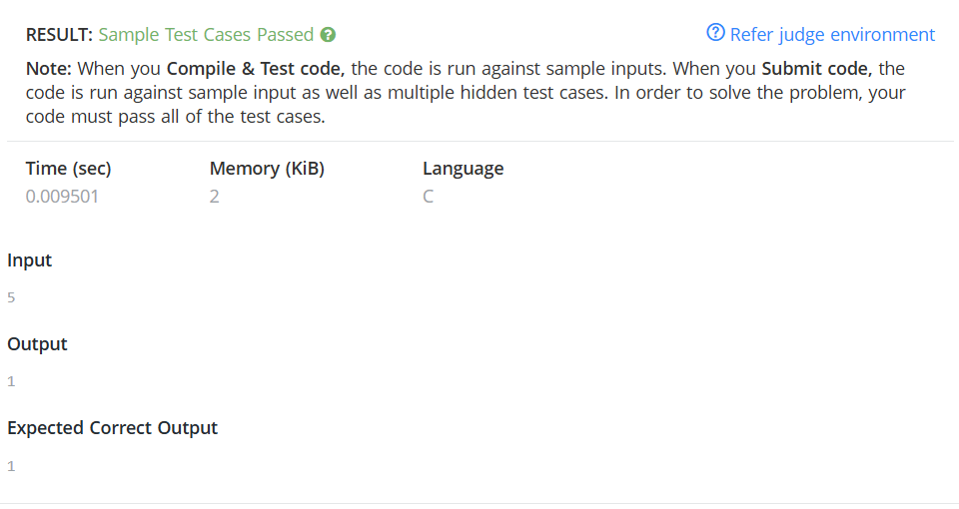

Link to code:
Prime Numbers | Practice Problems

