Code:
#include <stdio.h>

int main() {
int L, N, W, H;

scanf("%d", &L);
scanf("%d", &N);

for (int i = 0; i < N; i++) {
scanf("%d %d", &W, &H);

if (W < L || H < L) {
printf("UPLOAD ANOTHER\n");
}
else if (W == H) {
printf("ACCEPTED\n");
}
else {
printf("CROP IT\n");
}
}

return 0;
}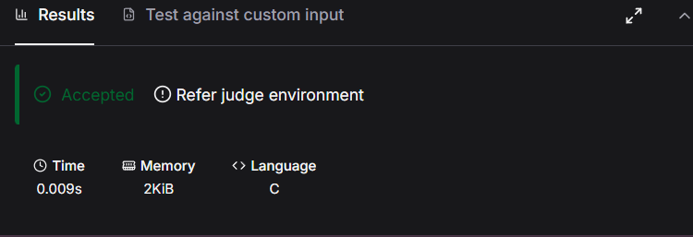

Link to code:
https://www.hackerearth.com/practice/basic-programming/input-output/basics-of-input-output/practice-problems/algorithm/roy-and-profile-picture/

