Code:
#include <assert.h>
#include <limits.h>
#include <math.h>
#include <stdbool.h>
#include <stddef.h>
#include <stdint.h>
#include <stdio.h>
#include <stdlib.h>
#include <string.h>

char* readline();

int main()
{
char* n_endptr;
char* n_str = readline();
int n = strtol(n_str, &n_endptr, 10);

if (n_endptr == n_str || *n_endptr != '\0') { exit(EXIT_FAILURE); }

if (n == 1) {
printf("one");
}
else if (n == 2) {
printf("two");
}
else if (n == 3) {
printf("three");
}
else if (n == 4) {
printf("four");
}
else if (n == 5) {
printf("five");
}
else if (n == 6) {
printf("six");
}
else if (n == 7) {
printf("seven");
}
else if (n == 8) {
printf("eight");
}
else if (n == 9) {
printf("nine");
}
else {
printf("Greater than 9");
}

return 0;
}

char* readline() {
size_t alloc_length = 1024;
size_t data_length = 0;
char* data = malloc(alloc_length);

while (true) {
char* cursor = data + data_length;
char* line = fgets(cursor, alloc_length - data_length, stdin);

if (!line) { break; }

data_length += strlen(cursor);

if (data_length < alloc_length - 1 || data[data_length - 1] == '\n') { break; }

size_t new_length = alloc_length << 1;
data = realloc(data, new_length);

if (!data) { break; }

alloc_length = new_length;
}

if (data[data_length - 1] == '\n') {
data[data_length - 1] = '\0';
}

data = realloc(data, data_length);

return data;
}

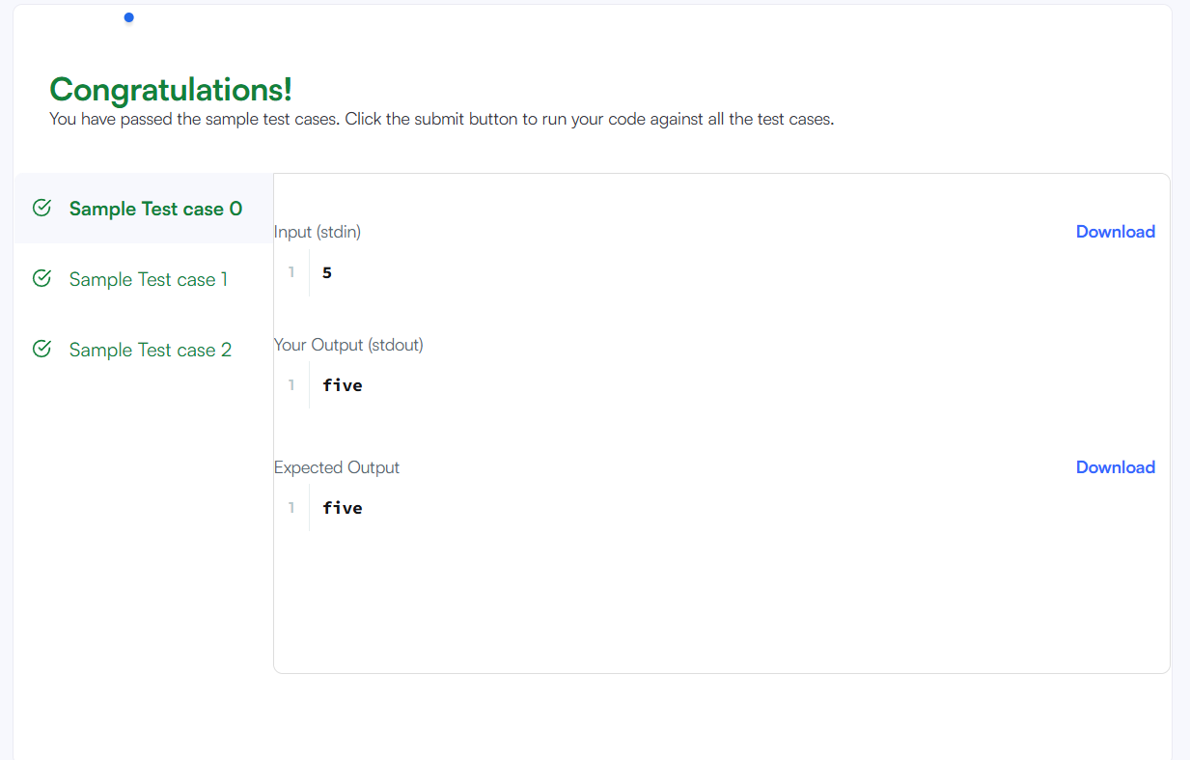

Link to code:
Conditional Statements in C | HackerRank

