Code:
#include <stdio.h>

int main() {

for (int i = 1; i <= 100; i++) {

if (i % 3 == 0 && i % 5 == 0) {
printf("FizzBuzz\n");
}
else if (i % 3 == 0) {
printf("Fizz\n");
}
else if (i % 5 == 0) {
printf("Buzz\n");
}
else {
printf("%d\n", i);
}
}

return 0;
}
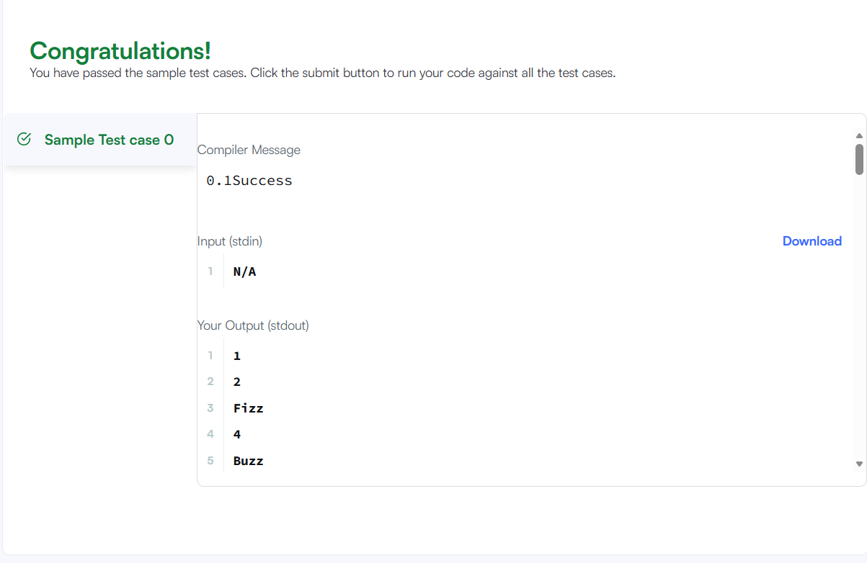

Link to code:
FizzBuzz | HackerRank

