Code:
#include <stdio.h>
#include <string.h>
#include <math.h>
#include <stdlib.h>

int main()
{
int a, b;
scanf("%d\n%d", &a, &b);
#include <stdio.h>

for (int i = a; i <= b; i++) {

if (i >= 1 && i <= 9) {
if (i == 1) printf("one\n");
else if (i == 2) printf("two\n");
else if (i == 3) printf("three\n");
else if (i == 4) printf("four\n");
else if (i == 5) printf("five\n");
else if (i == 6) printf("six\n");
else if (i == 7) printf("seven\n");
else if (i == 8) printf("eight\n");
else if (i == 9) printf("nine\n");
}
else {
if (i % 2 == 0)
printf("even\n");
else
printf("odd\n");
}
}

return 0;
}

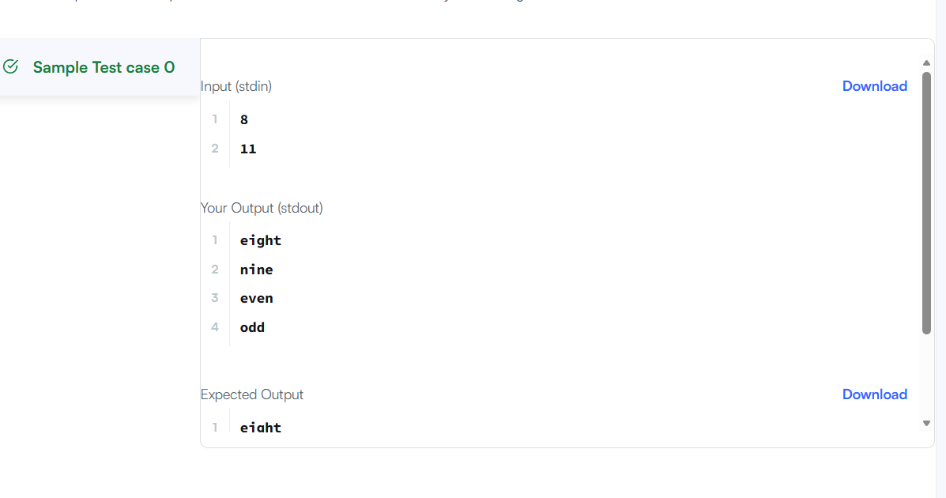

Link to code:
For Loop in C | HackerRank

